Application for a holiday- let cabin known as Summit Cabin, adj. Salley Street, Calderbrook Road. Littleborough PL15 9NG
Retrospective

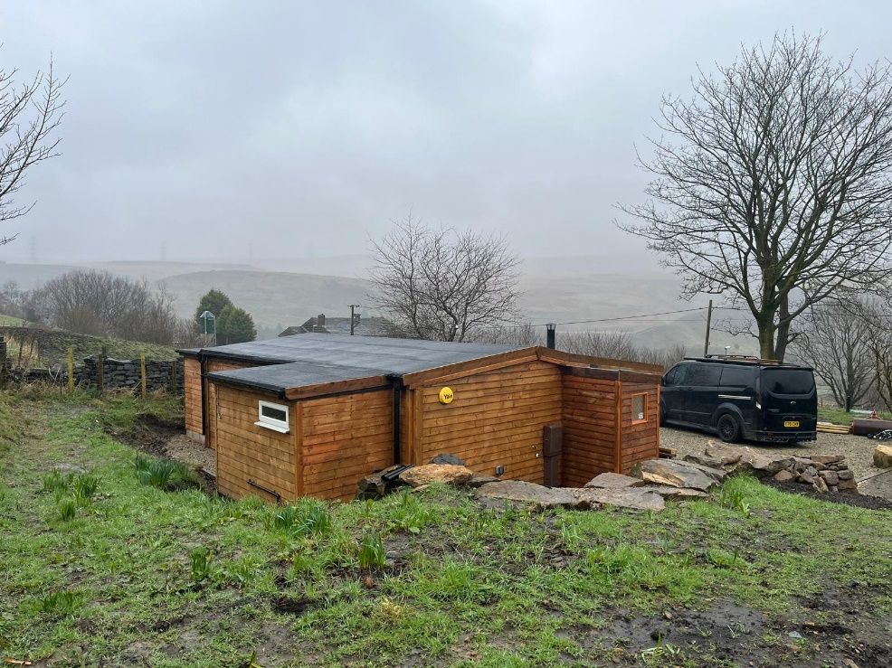

H | P
D | A

July 2024

Prepared by Hartley Planning and Development Associates Ltd

The application site, known as Summit Cabin, is located between Calderbrook Road and Higher Calderbrook Road and provides single storey accommodation for mainly walkers and cyclists as a holiday let, with one bedroom.
It has a website on AirBnB (Find Summit View Cabin in Littleborough).
Application is made retrospectively for development already constructed.
Access is via a long established track leading from Calderbrook Road
Main Issues
The site lies within the Green Belt. Therefore, the main issues are (i) whether the proposed extension is inappropriate development within the Green Belt; (ii) the effect of the development upon the character and appearance of the area and (iii) if the proposal is inappropriate development in the Green Belt, whether the harm by reason of inappropriateness, and any other harm, is clearly outweighed by other considerations so as to amount to very special circumstances to justify development.

Whether inappropriate development in the Green Belt
Policy JP-G9 of the Greater Manchester Places for Everyone 2024 (GMLP) states:-
‘The beneficial use of the Green Belt will be enhanced where this can be achieved without harm to its openness, permanence or ability to serve its five purposes. In particular, the enhancement of its green infrastructure functions will be encouraged, such as improved public access and habitat restoration, helping to deliver environmental and social benefits for our residents and providing the high quality green spaces that will support economic growth’.
Paragraph 152 of the National Planning Policy Framework 2023 (the Framework) states that inappropriate development is, by definition, harmful to the Green Belt, and should not be approved except in very special circumstances. Paragraph 154 of the Framework makes it clear that, other than in specified circumstances, the construction of new buildings is inappropriate development, though subject to specified exceptions, including at paragraph 154 (b) :-
‘The provision of appropriate facilities (in connection with the existing use of land or a change of use) for outdoor sport, outdoor recreation, cemeteries and burial grounds and allotments; as long as the facilities preserve the openness of the Green Belt and do not conflict with the purposes of including land within it ‘.

The application site provides a one bedroom, temporary accommodation for 4 or 5 people, mainly for walkers and cyclists visiting the area. Its web site includes the following photographs amongst others.

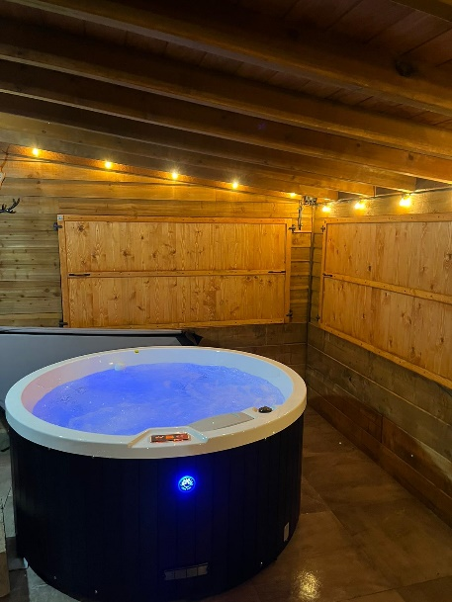
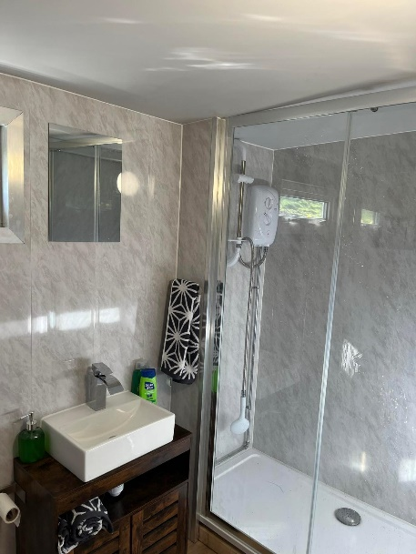

The Mary Towneley Loop is immediately to the rear of the application site, along Higher Calderbrook Way, providing a 47 mile diversion as part of the Pennine Bridle way.

The Pennine Bridleway itself is 205 miles long, and while it is specially designed for horse riders, the submitted information states that it is ‘also a fantastic trail for mountain bikes and walkers’.

There is clearly a need for accommodation along this nationally acclaimed outdoor recreational route.

In addition, there are other gravel tracks in the area providing mountain biking and walking routes.

Therefore, the proposal would not amount to inappropriate development in the Green Belt. Consequently, there would be no conflict with the Green Belt requirements of chapter 13 of the Framework. Moreover, it would accord with policy JP-G9 of GMLP which encourages improved public access to deliver social benefits for the plan area that will support economic growth.

As the proposed development is not inappropriate in the Green Belt , it is not necessary for consideration to be given to other considerations which would amount to very special circumstances necessary to justify the proposed development within the Green Belt.

Character and appearance

The proposed development is within the character type defined as ‘open moorlands and enclosed upland fringes(West/Soth Pennines) in the Greater Manchester Landscape Character and Sensitivity Assessment 2018 (GMLA) and in the GMLP.

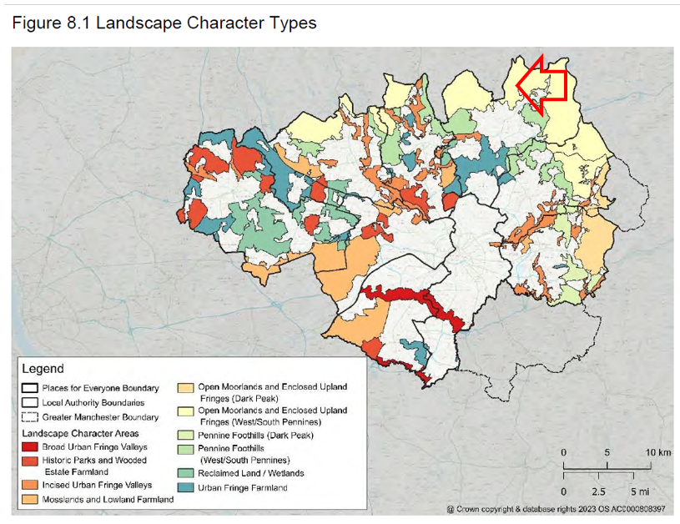

The area is characterised by stone terraces bordering the road, and by as scattering of more isolated buildings, all set within a rural area with fields bound by stone walls, all described in the GMLA.

Its appearance is marked by wooden outbuildings, garages and other farm buildings: -

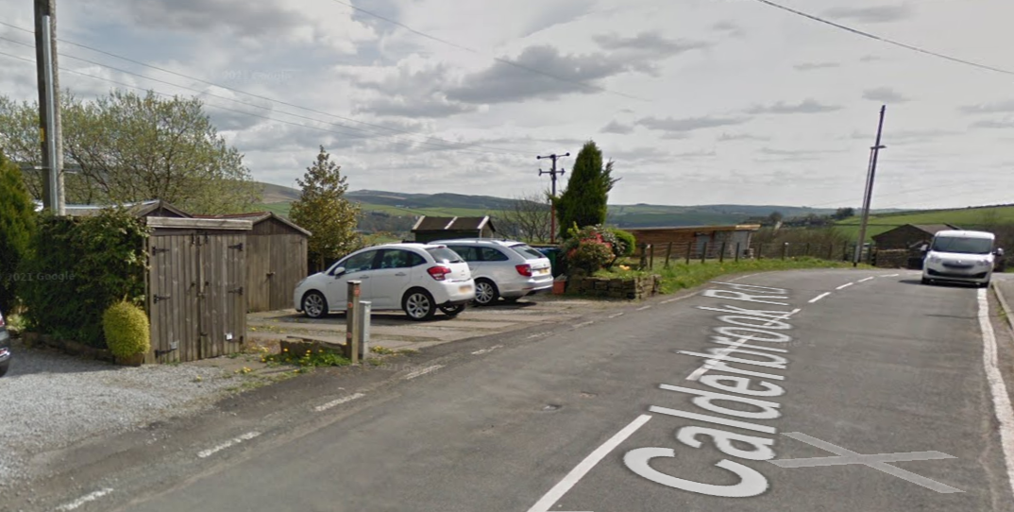

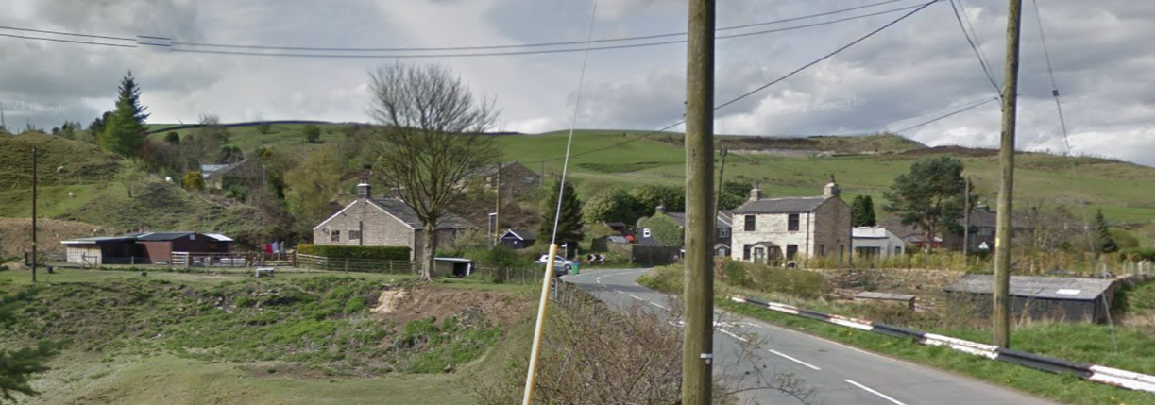

The cabin is single storey with wooden external walls. It does not break the skyline .It has the appearance of a rural outbuilding of the sort which is found in the area. In other words, it assimilates well into its surroundings.

Therefore, the proposal accords with Policy JP-G1 of the GMLP which requires that development, as in this instance, conforms with the character and appearance of Landscape Character Area Open Moorlands and Enclosed upland Fringes (West/South Pennines’ ) as outlined in the GMLA. It avoids development on the open moorland and it does not break the skyline when seen from the main public vantage points. The latter document also stresses ‘the importance of the uplands for recreation activity’.
The development also accords with chapter 12 of the Framework which requires development to be sympathetic to local character including the surrounding built environment and landscape setting, while not preventing or discouraging appropriate innovation or change.
Other Matters
Biodiversity Net Gain (BNG)
The access road, parking area and the building are all hard surfaced with no prospect of such net gain. The BNG metric is submitted.
Coal Mining High Risk area
The site is not within a coal mining high risk area: -
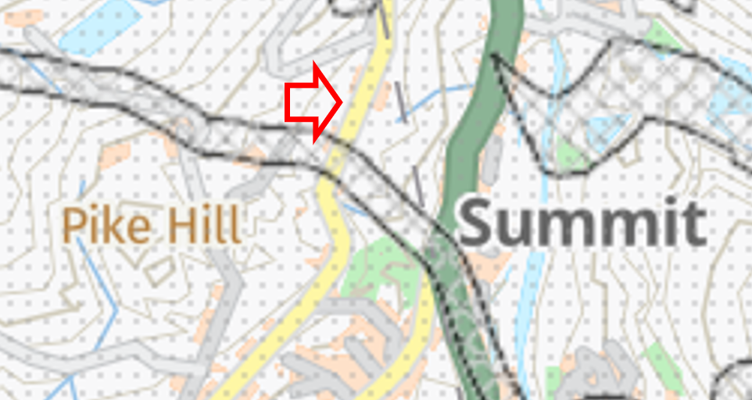
Flood Risk
It is not in a high risk flood zone
