HOUSEHOLDER FLOOD RISK ASSESSMENT (FRA)

IN RELATION TO DOMESTIC HOUSE EXTENSION AT:
410 BIRCH ROAD
WARDLE
ROCHDALE
OL12 9LX

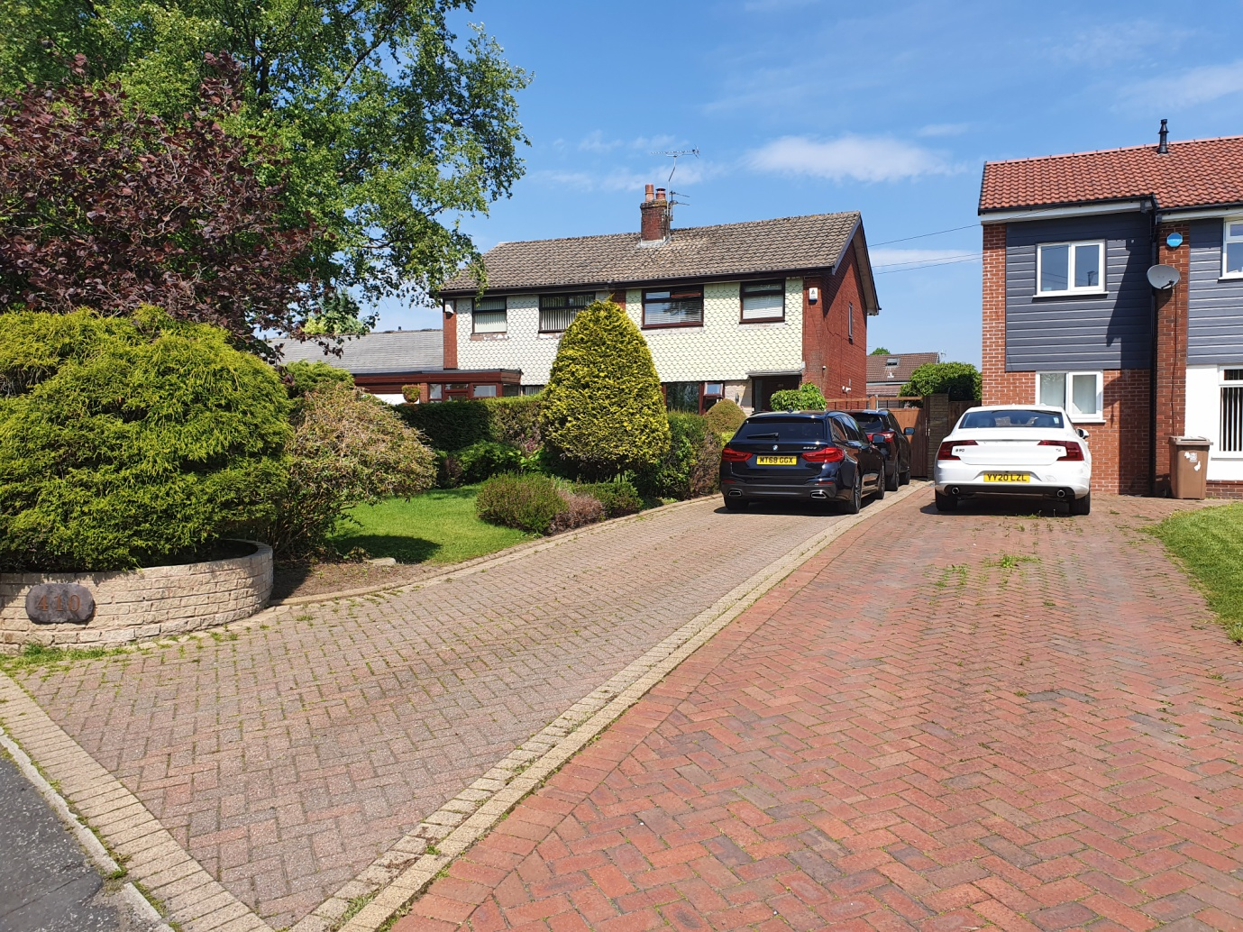

REVISION: V3
DATE: 31ST JANUARY 2025

CONTENTS

1.0: Introduction 3

2.0: Current Situation 4

2.1: The Site / Property 4

2.2: Hydrology and Flooding 5

3.0: Proposed Development 6

3.1: Development Proposals 6

3.2: Flood Risk 6

3.3: Foul and Surface Water Drainage 7

3.4: Effect on Culverted Watercourse (Wardle Brook) 7

APPENDIX 1 8

SITE LOCATION PLANS 8

APPENDIX 2 11

SITE LOCATION TOPOGRAPHICAL LEVELS 11

APPENDIX 3 12

ENVIRONMENT AGENCY FLOOD MAPPING 12

APPENDIX 4 14

ENVIRONMENT AGENCY APPROXIMATE SURFACE WATER MAPPING 14

APPENDIX 5 18

ENVIRONMENT AGENCY FLOOD DATA 18

APPENDIX 6 21

WARDLE BROOK CATCHMENT 21

APPENDIX 7 22

UNITED UTILITIES DRAINAGE RECORDS 22

APPENDIX 8 23

UNITED UTILITIES WATERGROVE RESERVOIR MAP 23

APPENDIX 9 24

GOV.UK FLOOD RISK ASSESSMENT STANDING ADVICE 24

APPENDIX 10 30

ILLUSTRATED CULVERT AND PROPOSED EXTENSION PLAN 30

APPENDIX 11 31

EXISTING PROPERTY ELEVATION IMAGES AND PROPOSED EXTENSION PLANS 31

1.0: Introduction
The objective of this FRA is to identify potential flooding issues and any consequent implications in relation to the proposed domestic extension at 410 Birch Road, Wardle. OL12 9LX.
This document has been prepared to accompany the householder planning application for a proposed a rear extension with conversion and extension of the roof space to create a 3-storey rear elevation, together with an entrance porch to the front elevation at 410 Birch Road, Wardle, Rochdale, OL129LX.
The findings and opinions in the report are based on information derived from a variety of different sources. No acceptance is taken of any liability for the accuracy or otherwise of any information provided by third parties.
Reference should be made to the supporting drawings & documents accompanying this document.

2.0: Current Situation
2.1: The Site / Property
The property is located on Birch Road, comprising of a semi-detached two storey property, with the principle front elevation facing south at a slight easterly angle. A driveway is situated to the front of the house, leading down the side of the property, with gardens to the front and rear. A double garage is also positioned to the rear of the property, accessed via an access road off Newhouse Close (around the rear of the property).
The property location is as per the following references:
- Grid Ref: SD 91458 16580
- 6 Figure Grid Ref: SD914165
- Easting, Northing: 391458, 416580
There is known to be a culverted watercourse (Wardle Brook) routed below ground to the side of the property bordering the property line between 410 and 408 Birch Road. The culverted watercourse is understood from United Utilities drain maps to be comprised of 1050 x 1050mm square section at a depth of circa 1800mm below ground level.
From liaison with United Utilities regarding the culvert, it has been advised that the watercourse running though the property is a private water course. Albeit from liaison with The Environment Agency, they have advised that it would not be permitted to build over the culverted water course.
Noting also that the previous extension proposal has not been progressed due to The Environment Agency advising it would not be permitted to build over the culverted watercourse to the side of the existing house.
The Environment Agency flood and river maps detail the culverted watercourse (Wardle Brook) routed to the side of the property as being a ‘Main River’. Albeit a short distance upstream (circa 130 meters), the watercourse is not marked as a ‘Main River’ and is detailed as an ordinary watercourse (See extract from mapping below):
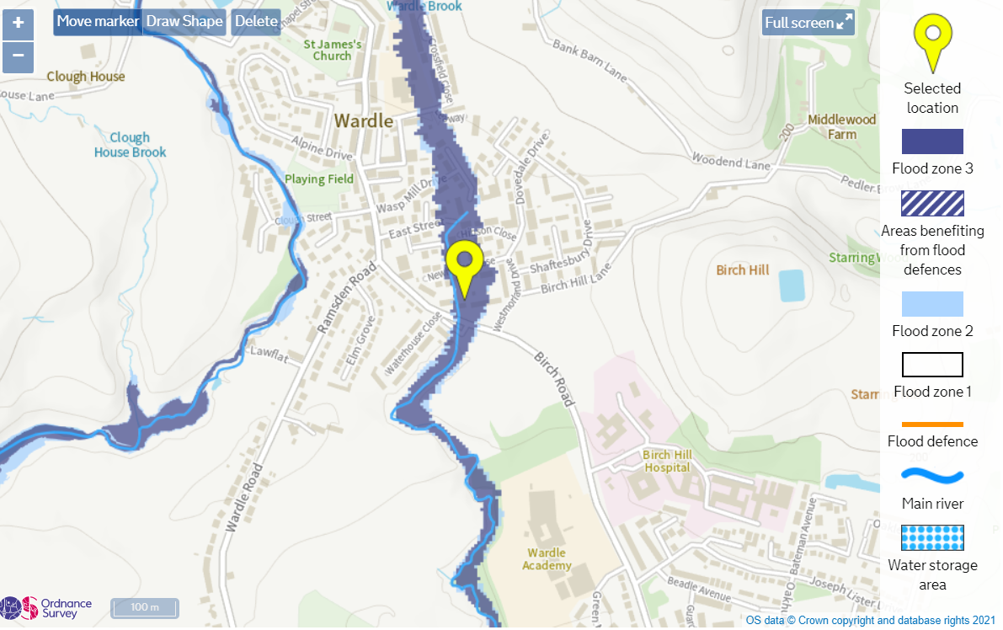
2.2: Hydrology and Flooding
The current Environment Agency flood map shows the property to lie in Flood Zone 3.
Environment Agency Product 4 data was requested for Wardle Brook but the brook has not been modelled by the Agency whilst Buckley Brook to the west is the nearest watercourse that has been modelled. Wardle Brook flood zone mapping is therefore based on J Flow software and LIDAR aeroplane surveying ground levels. Appendix 4 shows the mapping and data as requested for another site located slightly north of the property.
LIDAR aeroplane surveying produces a grid of ground levels usually on a 5m grid or more recently on a 2m grid. Either way, river or brook channels are not picked up accurately and tree areas usually give higher levels than the existing ground beneath. The J Flow software also assumes that smaller stream catchments will only accommodate 1 in 2 year flows. The mapping is however useful as where there is no accurate modelling it provides a good and useful initial guide that identifies where further accurate work is needed where necessary.

3.0: Proposed Development
3.1: Development Proposals
410 Birch Road is an existing semi-detached two storey property, with the principle front elevation facing south at a slight easterly angle. A driveway is situated to the front of the house, leading down the side of the property, with gardens to the front and rear.
The proposal is for a rear extension with extension of the roof to create a 2-storey rear (North) elevation, together with an entrance porch to the front (South) elevation at 410 Birch Road, Wardle, Rochdale, OL129LX.
The rear extension is proposed to have 2-storeys.
The ground floor of the the rear extension is proposed to extend out circa 4500mm from the rear elevation of the existing house. This is intended to provide open plan living, dining and kitchen space, with improved storage and laundry space.
The 1st floor of the new rear extension is proposed to extend out circa 2400mm from the rear elevation of the existing house, above the proposed ground floor extension. This is intended to provide and additional bedroom space and enable a new additional bathroom to be integrated into the house.
The floor levels within the proposed extension are proposed to match the existing floor levels within the existing property. The existing internal ground floor level is circa 0.7m above the ground level of the driveway to the side of property.
3.2: Flood Risk
The existing ground floor levels to the property are circa 0.7m higher than the ground level adjacent the property at driveway level.
The ground level adjacent the property at driveway level is circa 188.0m AOD. The nearest surface water drain manholes to the property lie to the front and rear (i.e. north and south). The manhole to to the rear (North) of the property is circa 188.0m AOD, and matches the level of the ground to the side of the property. Whilst the manhole to the front (South) of the property is circa 187.0m AOD, being circa 1.0m lower than the ground level to the side of the property (refer to Appendix 2, Appendix 7 & Appendix 10 for details).
The culverted watercourse (Wardle Brook) culvert channel bed level lies approximately 2.8m below the cover level of the manholes referenced to the north and south of the property.
Wardle Brook has an FEH Web catchment area of 0.56km2 (refer to Appendix 5 for details). It lies south of and below Watergrove Reservoir (refer to Appendix 7 for details) which is a public water supply reservoir maintained by United Utilities to a 1 in 10,000 year standard under the Reservoirs Act and accordingly is inspected regularly by a Reservoirs Panel Engineer.
In the case of this specific proposed development, the Gov.UK ‘Advice for Minor Extensions’ must be followed as the side extension of the property is classified as ‘more vulnerable’ development.
The history of the property is that is has not been known to flood in at least the last twenty years. There is no local flood warning service for Wardle which points towards no serious flood incidents in the past.
The proposed extension and existing property is therefore very unlikely to be at risk of flooding in a 1 in 1000 year Wardle Brook flood as the ground floor level of the extended / existing property is very likely to sit above the Wardle Brook flows.
Nevertheless, it is considered to be prudent to provide basis flood resilience features to the extension such as the provision of seals to any UPVC door sets and no ventilation airbricks being provided to the new external walls at low level.
3.3: Foul and Surface Water Drainage
Drainage will comprise separate systems with foul connections to the existing property foul drainage system – the rear elevation to the property has and existing rainwater pipe and the associated existing drainage system to the rear of the terrace block is understood to be combined. The new extensions are proposed to drain foul and rain water as per the existing property, to existing drain connection points.
3.4: Effect on Culverted Watercourse (Wardle Brook)
The extension proposed extending to the front and rear only of the property would not extend beyond the existing building line to the side of the existing house. And would not encroach over the adjacent the culverted watercourse (Wardle Brook) routed below ground to the side of the property bordering the property line between 410 and 408 Birch Road (refer to Appendix 9 for details).
The existing culverted watercourse is understood to be comprised of 1050 x 1050mm square section with the top of the section at a depth of circa 1800mm below ground level and the base being circa 2800mm below ground level.
Careful consideration and planning will be given to the design of the extension structure and foundations to ensure the works to construct the proposed extension can be undertaken to mitigate any impact to the function, operation or integrity of the existing culvert. With the existing culverted watercourse (Wardle Brook) remaining unaffected by the proposed extension works.

APPENDIX 1
SITE LOCATION PLANS
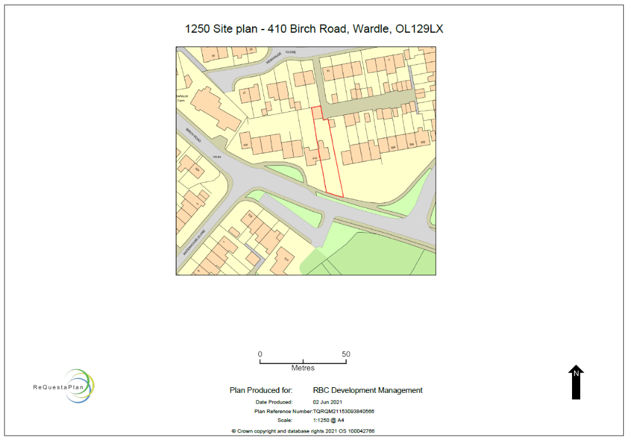
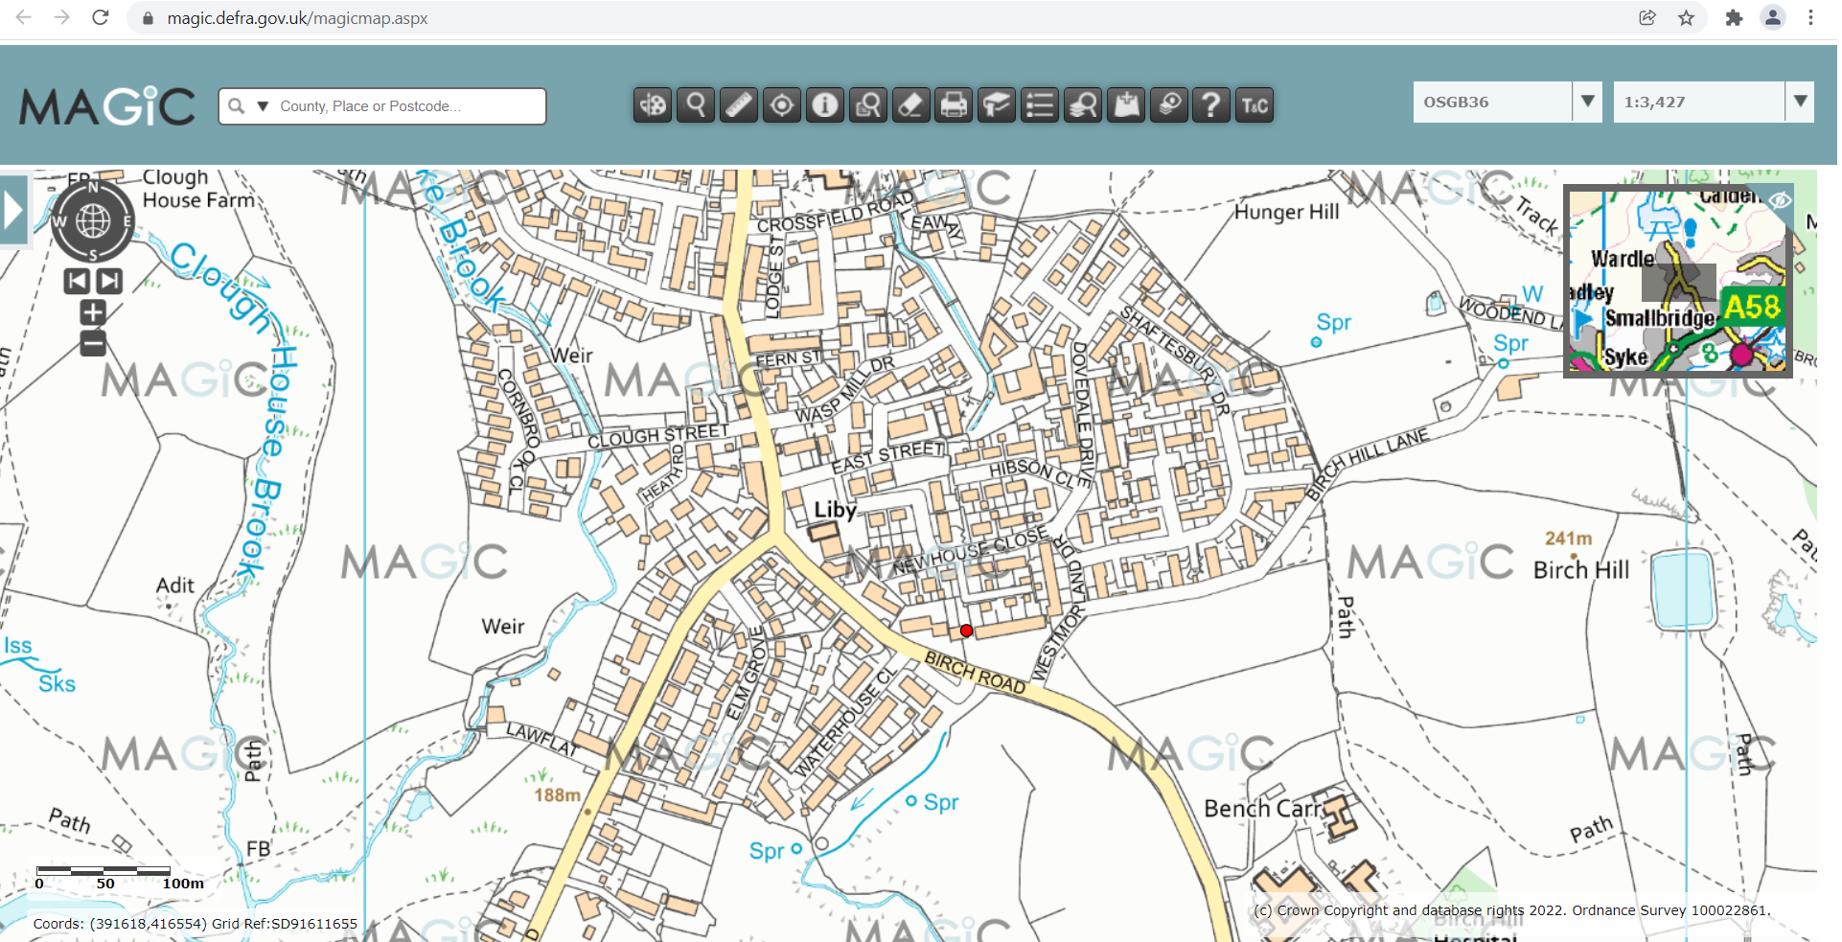
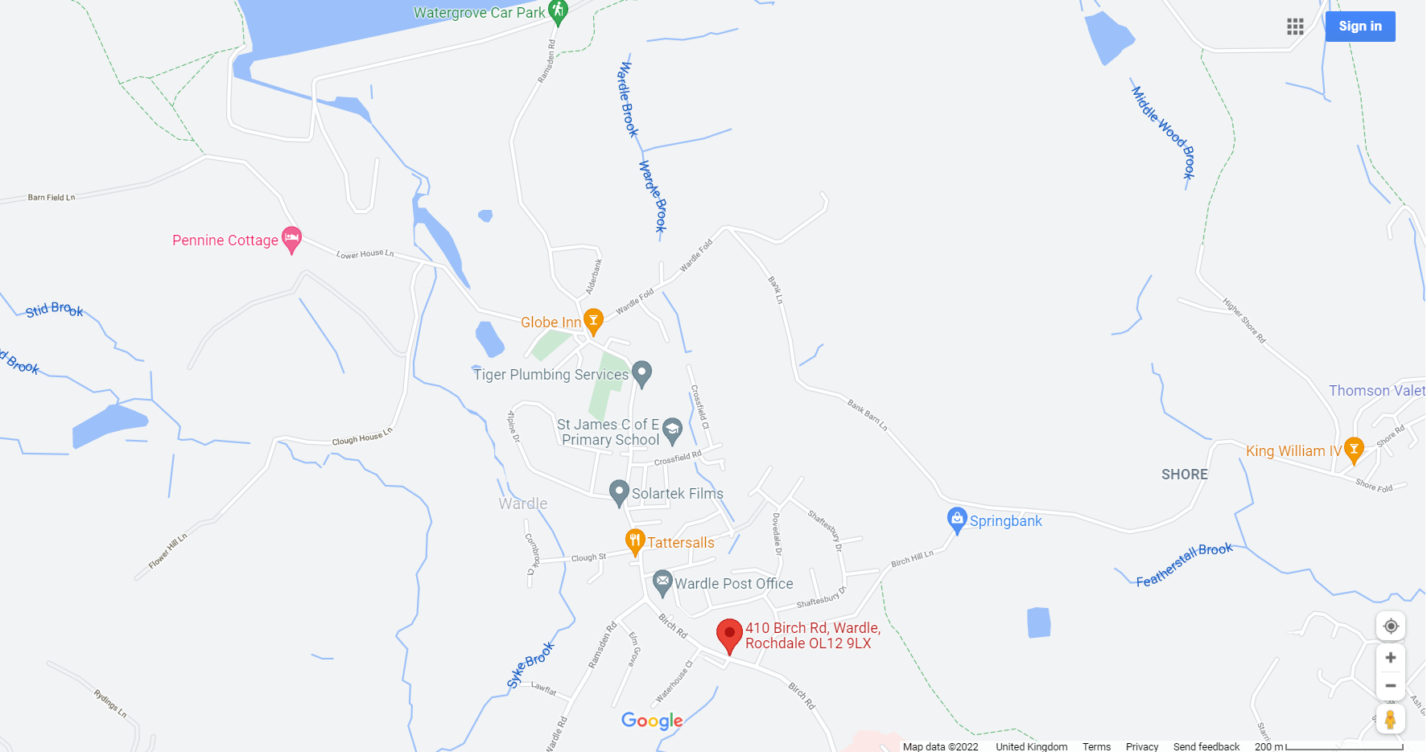

APPENDIX 2
SITE LOCATION TOPOGRAPHICAL LEVELS
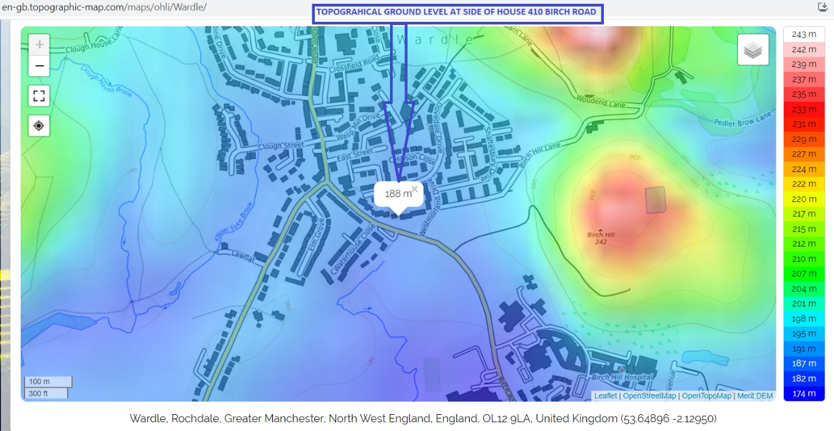
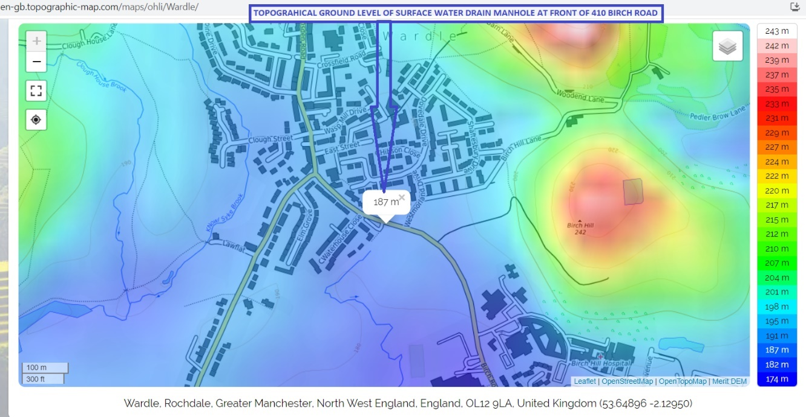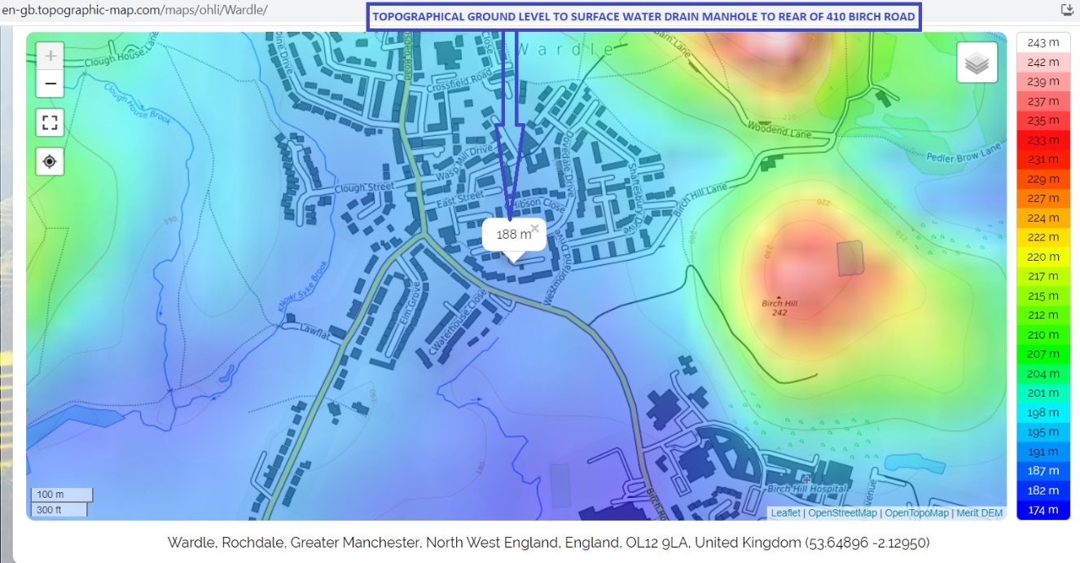

APPENDIX 3
ENVIRONMENT AGENCY FLOOD MAPPING
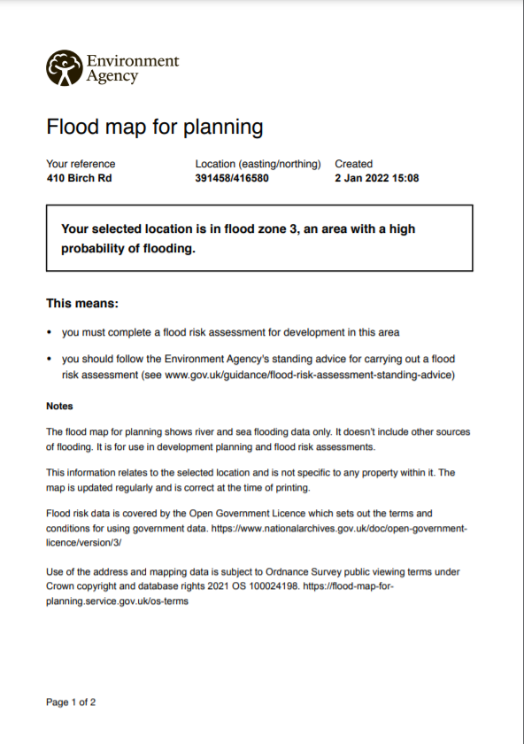
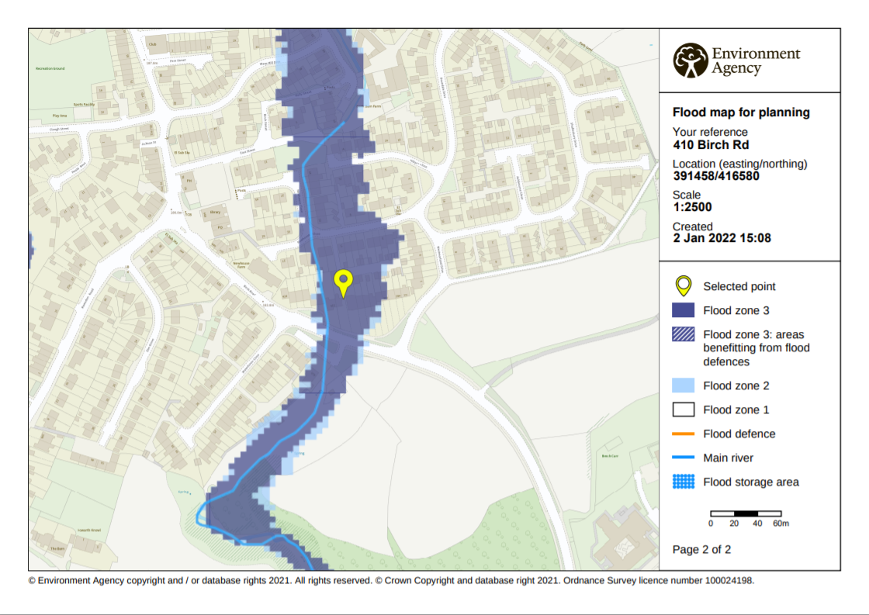

APPENDIX 4
ENVIRONMENT AGENCY APPROXIMATE SURFACE WATER MAPPING
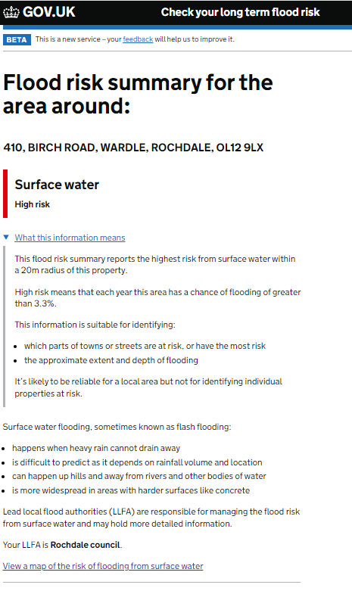
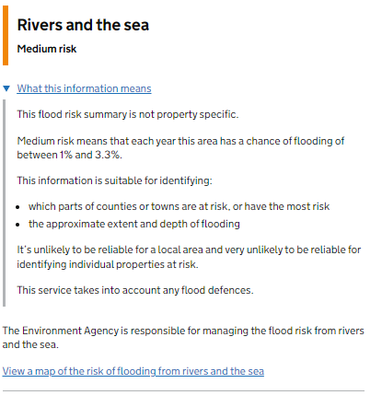
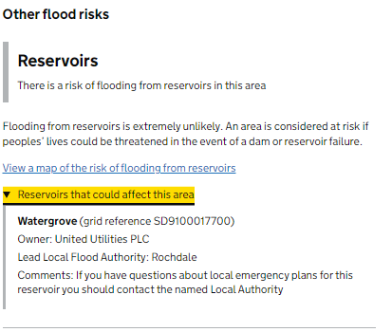
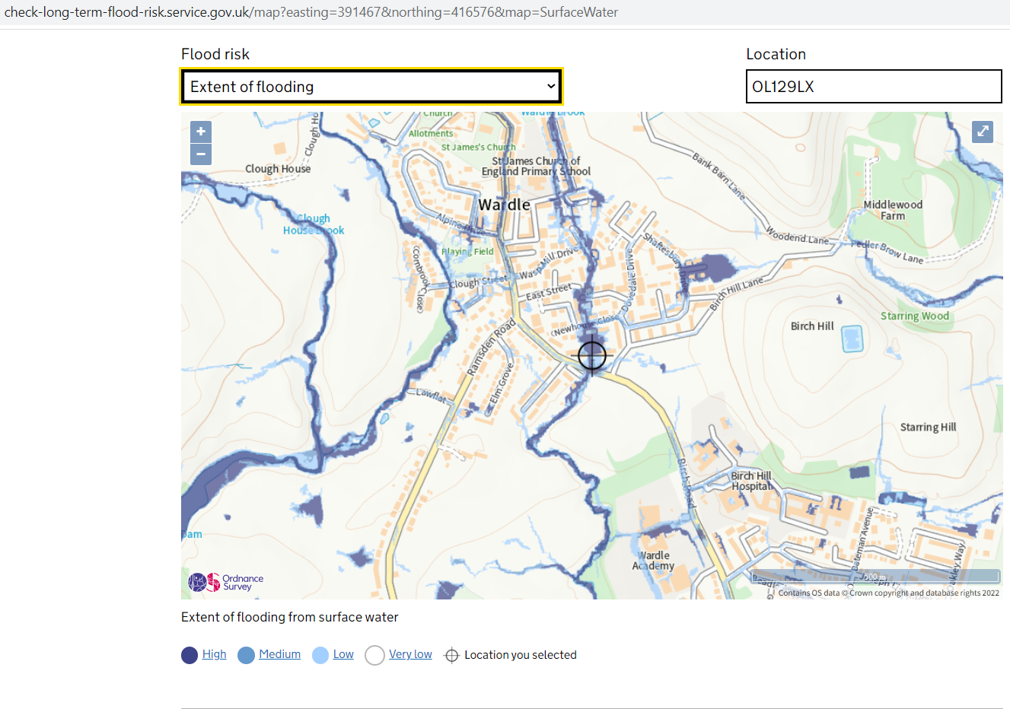
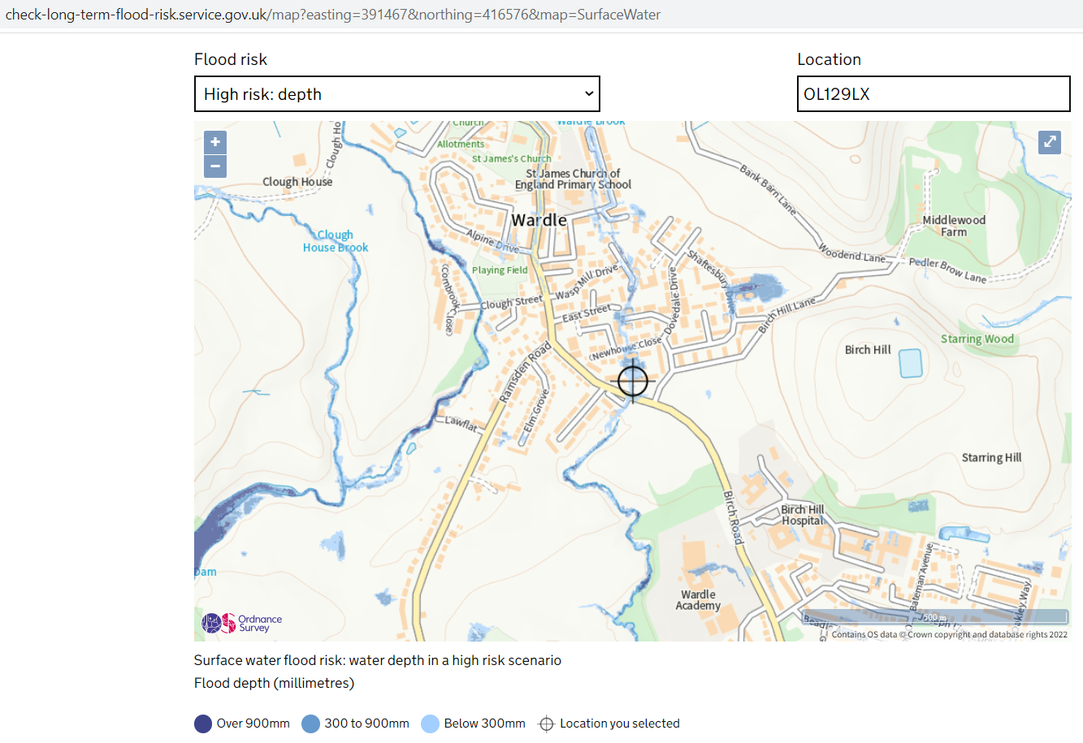

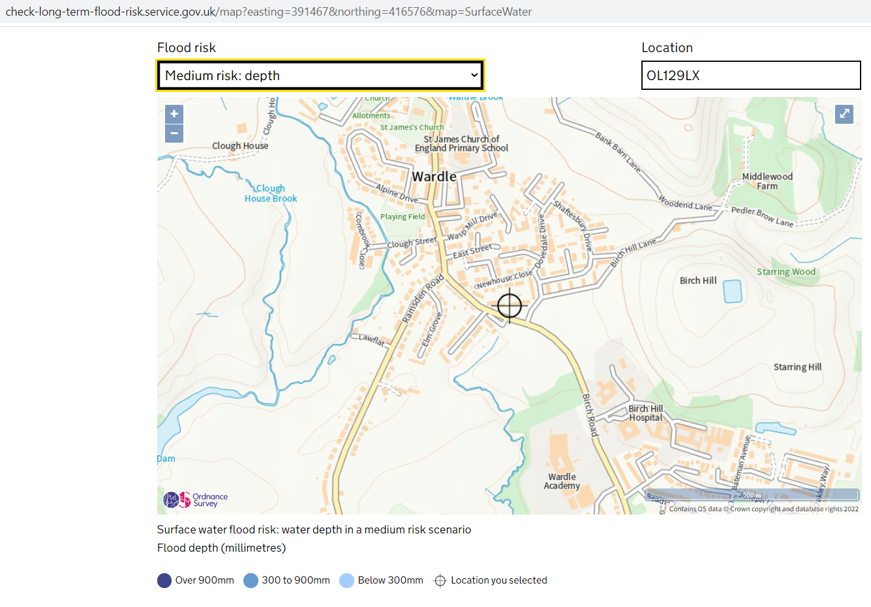
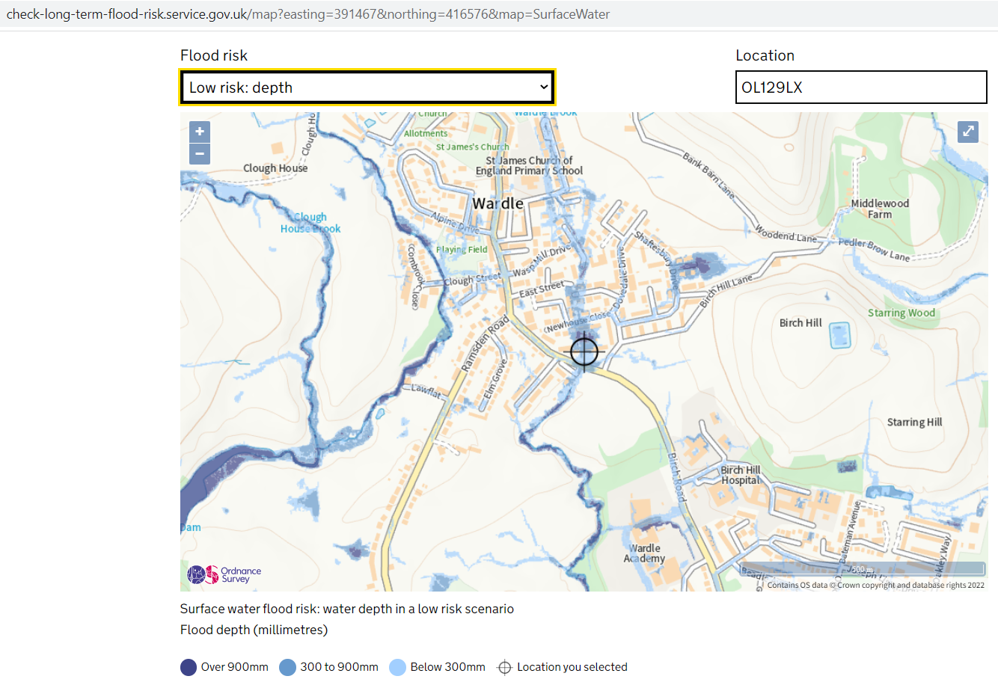
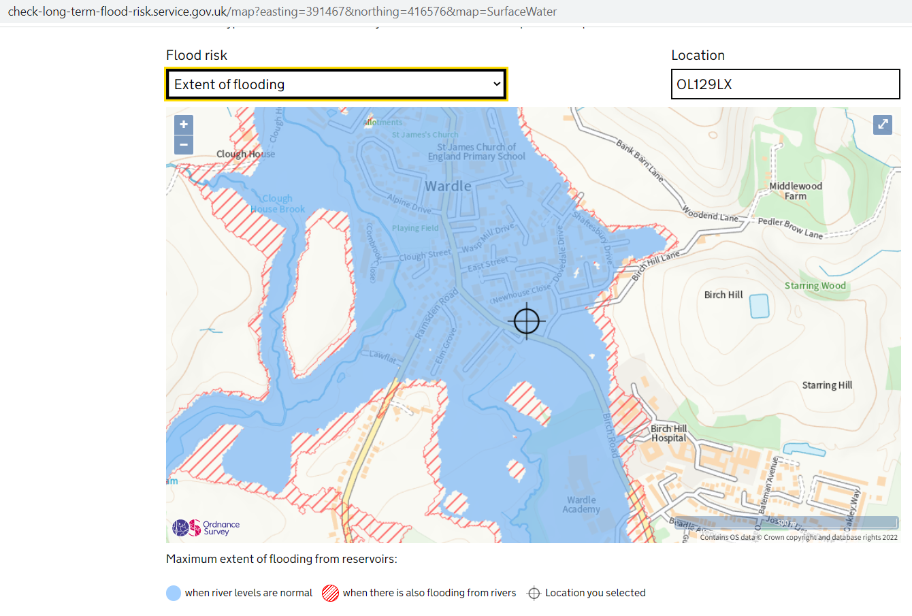

APPENDIX 5
ENVIRONMENT AGENCY FLOOD DATA
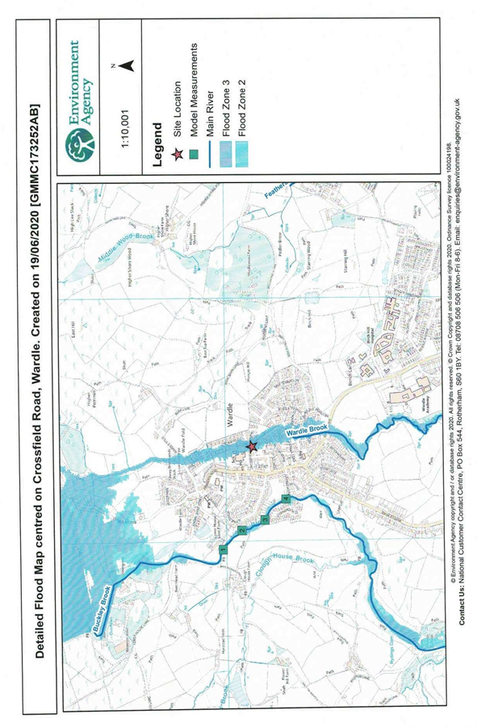


APPENDIX 6
WARDLE BROOK CATCHMENT
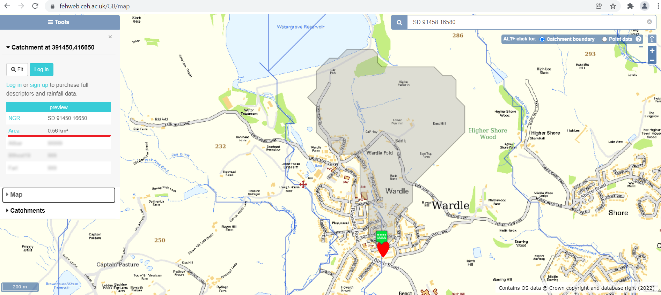

APPENDIX 7
UNITED UTILITIES DRAINAGE RECORDS
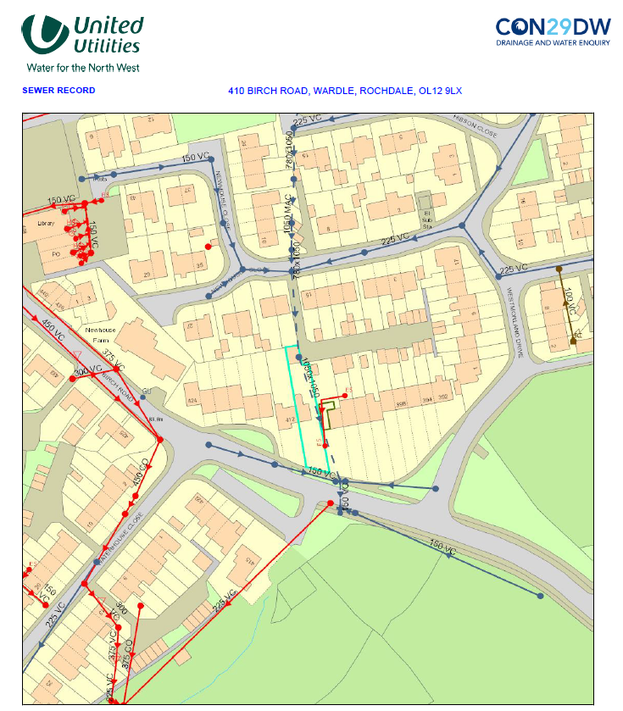

APPENDIX 8
UNITED UTILITIES WATERGROVE RESERVOIR MAP
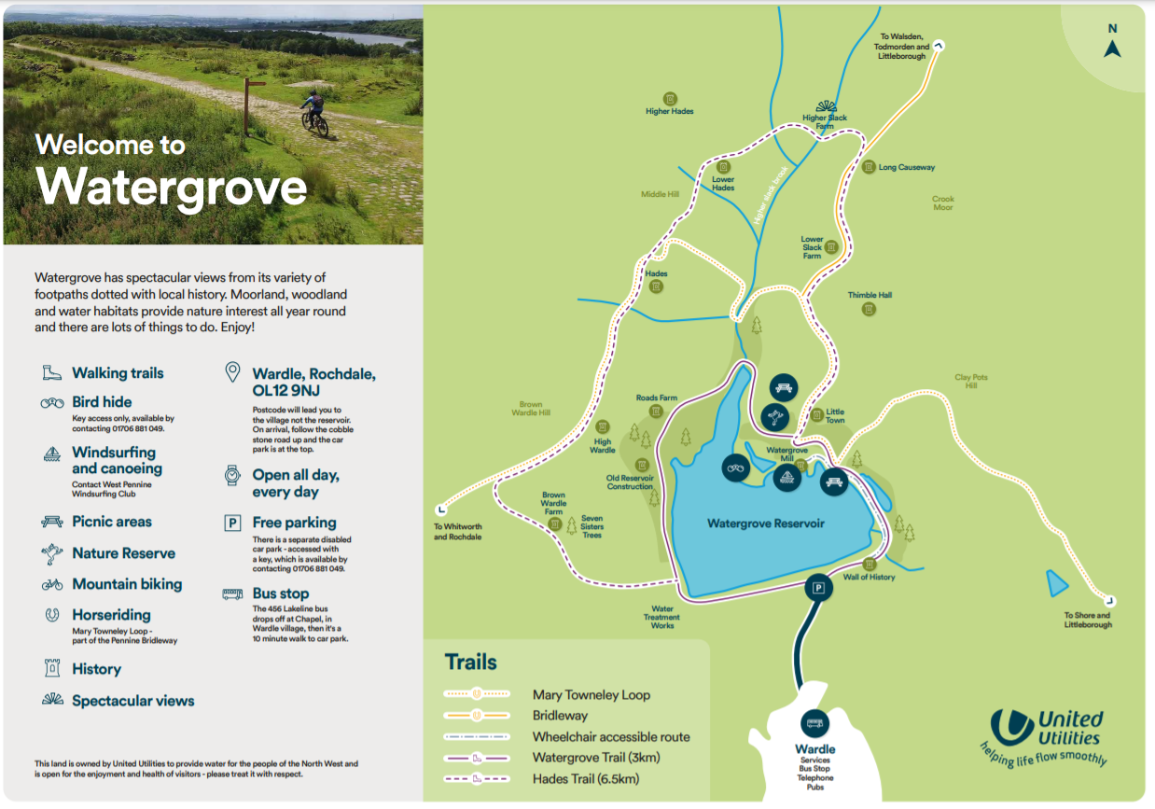

APPENDIX 9
GOV.UK FLOOD RISK ASSESSMENT STANDING ADVICE
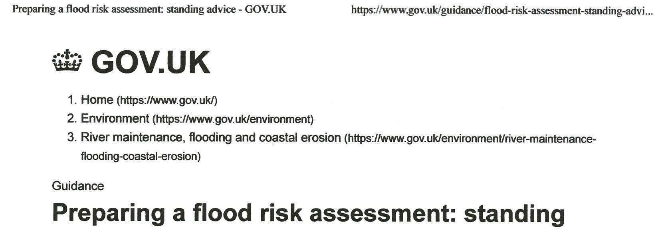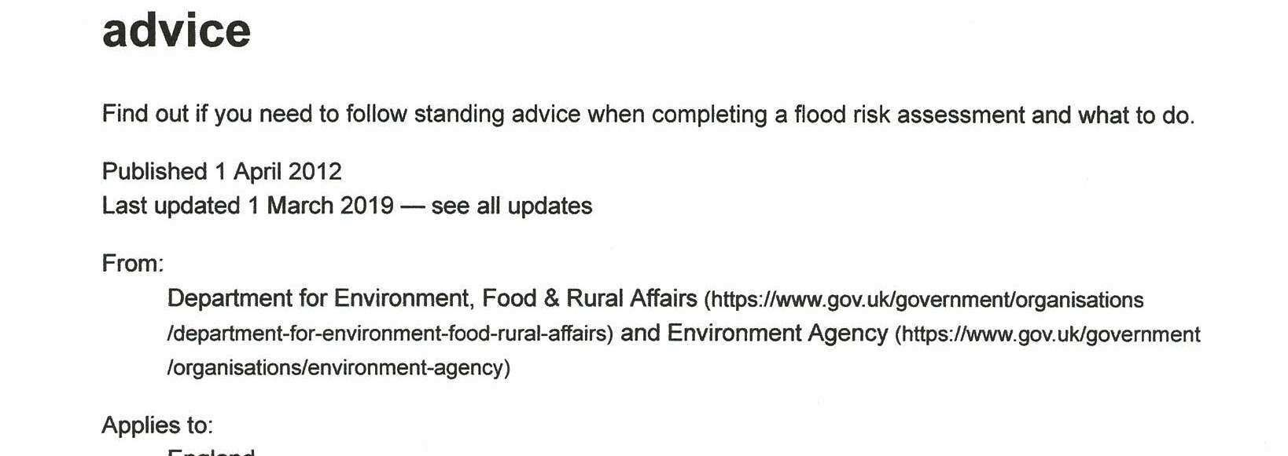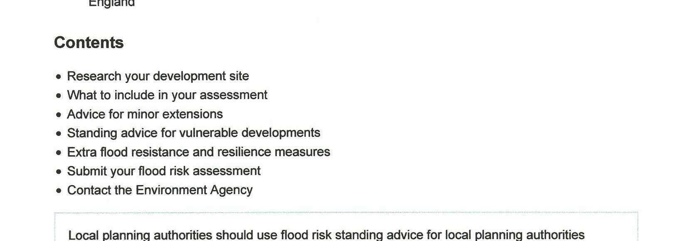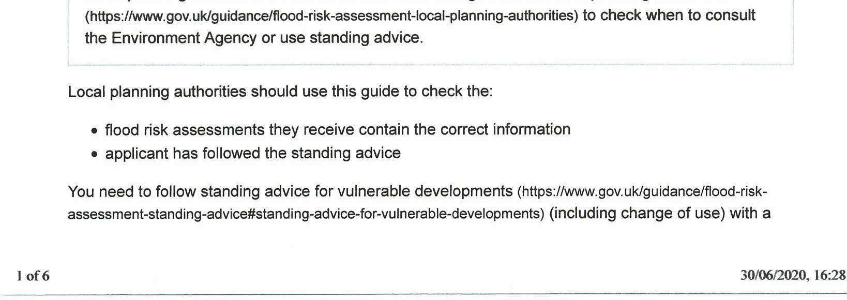
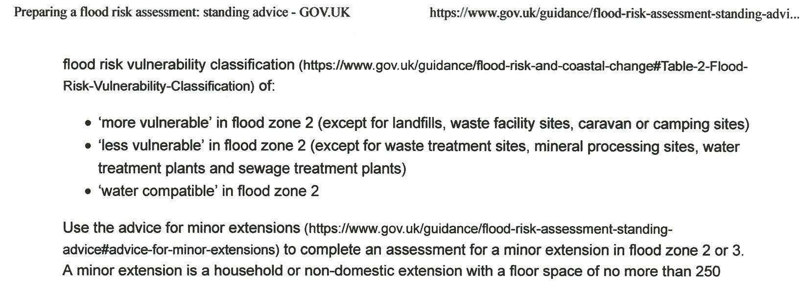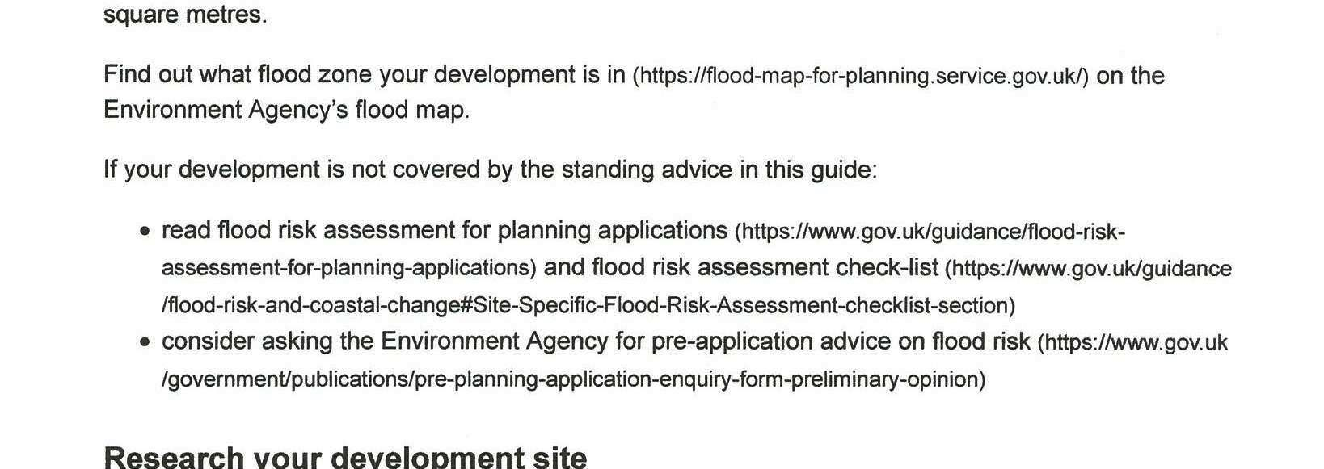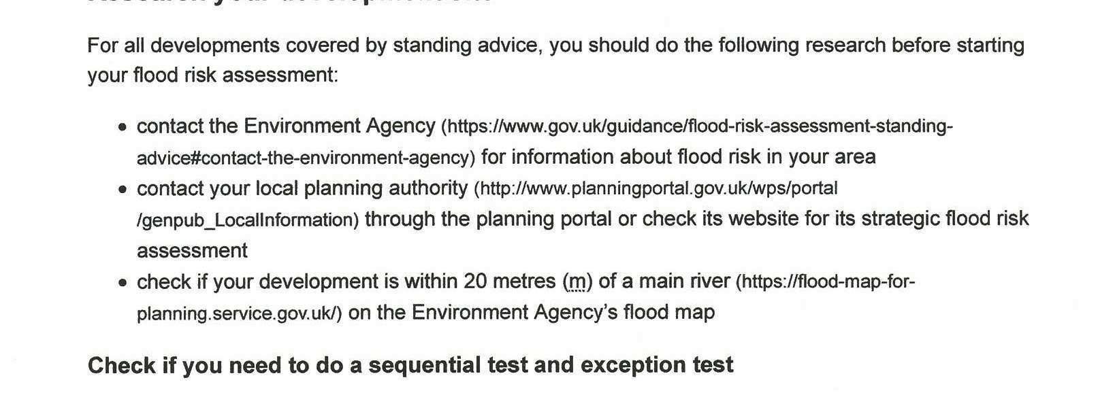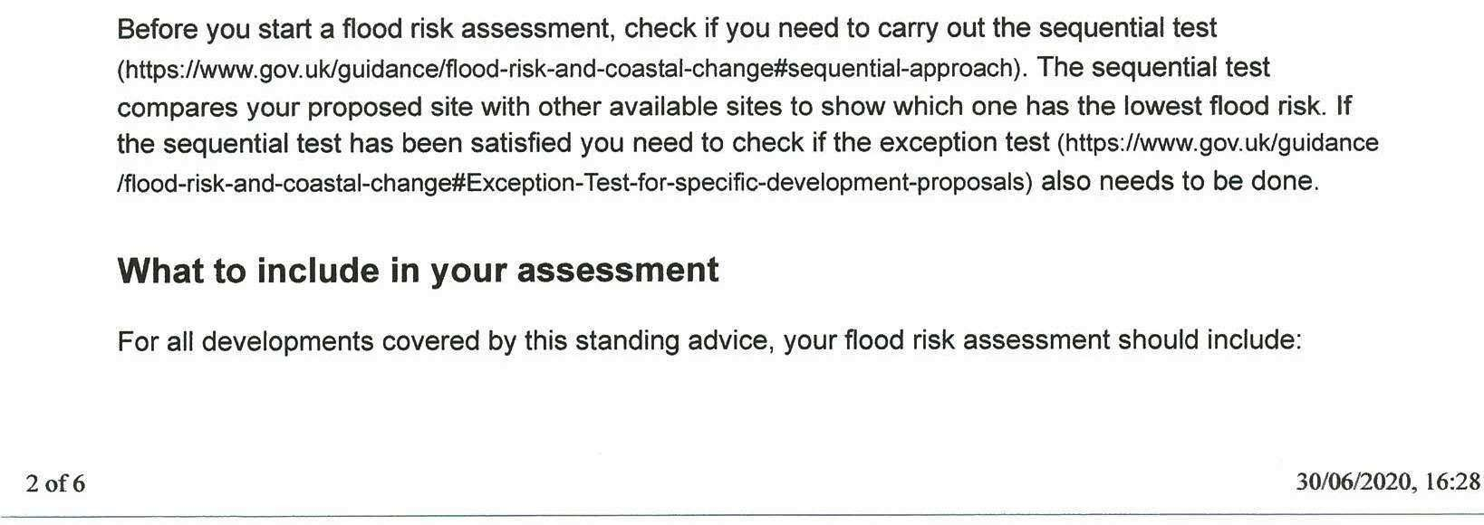
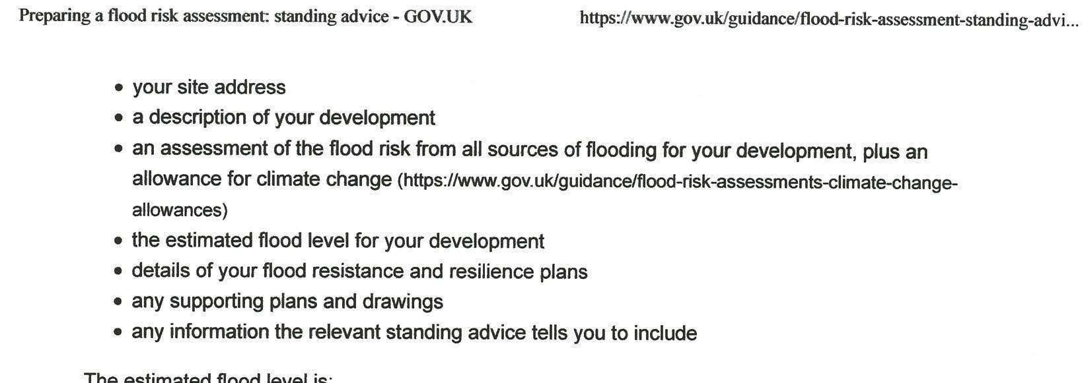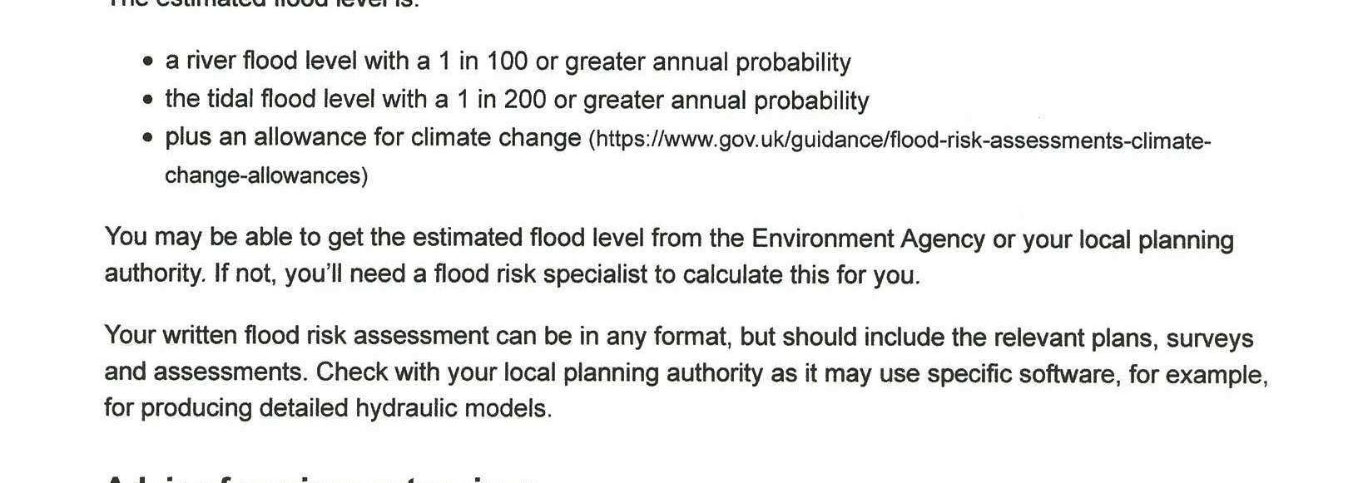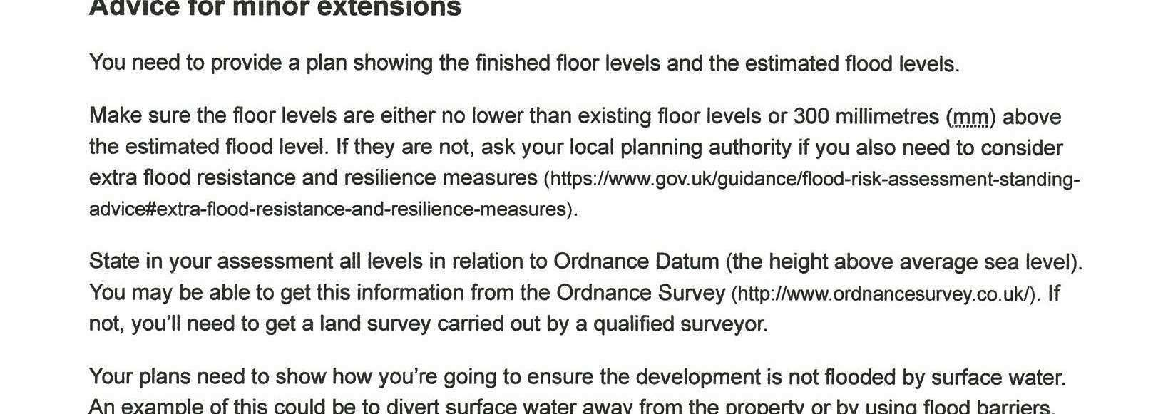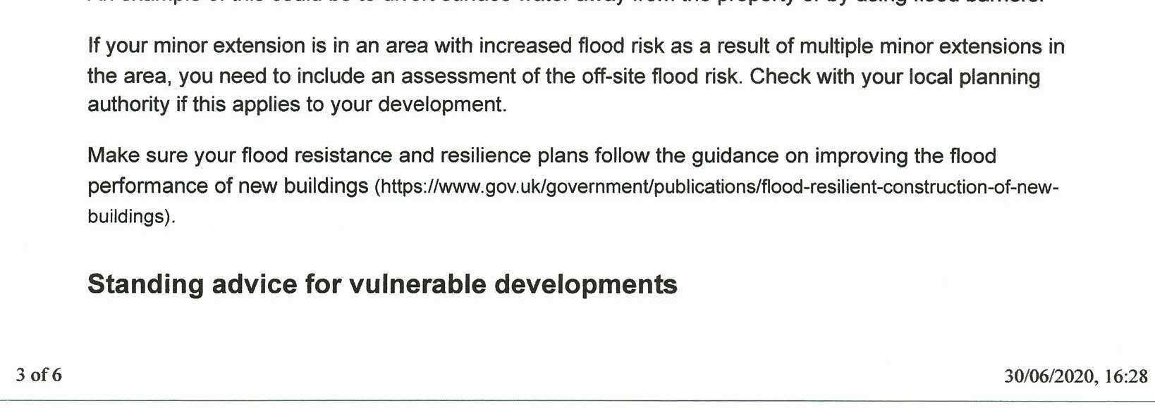
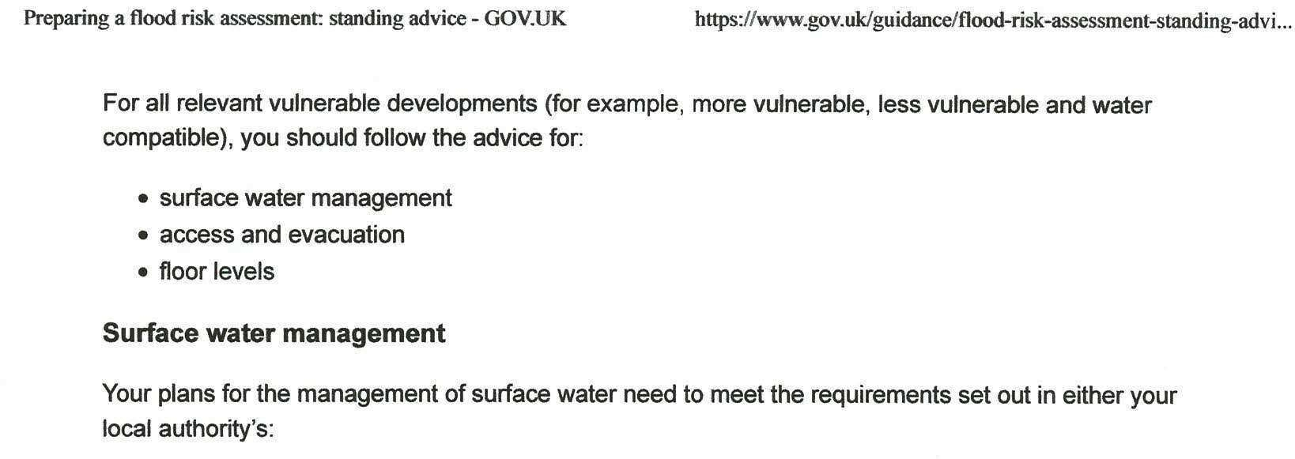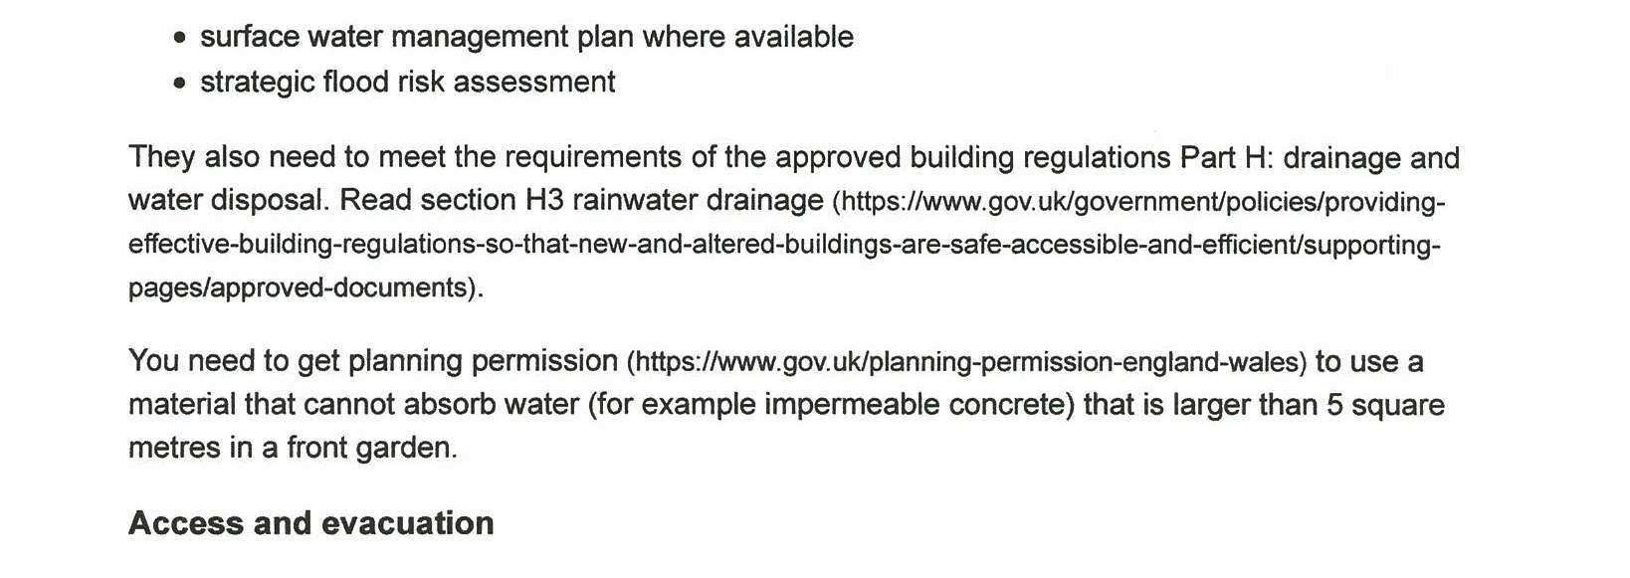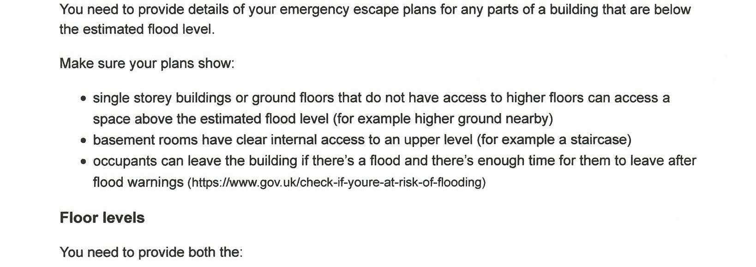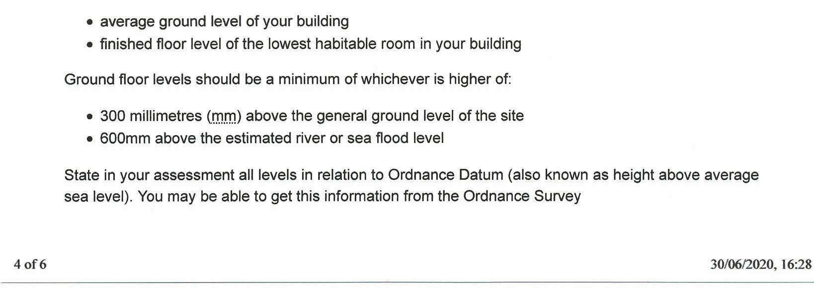
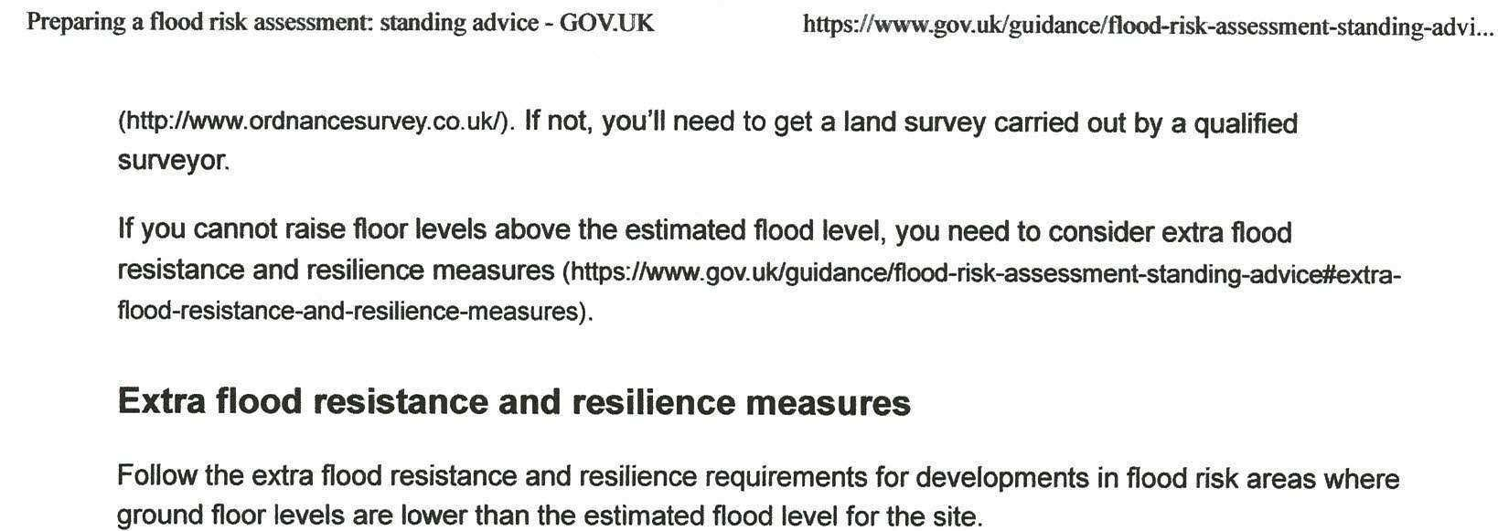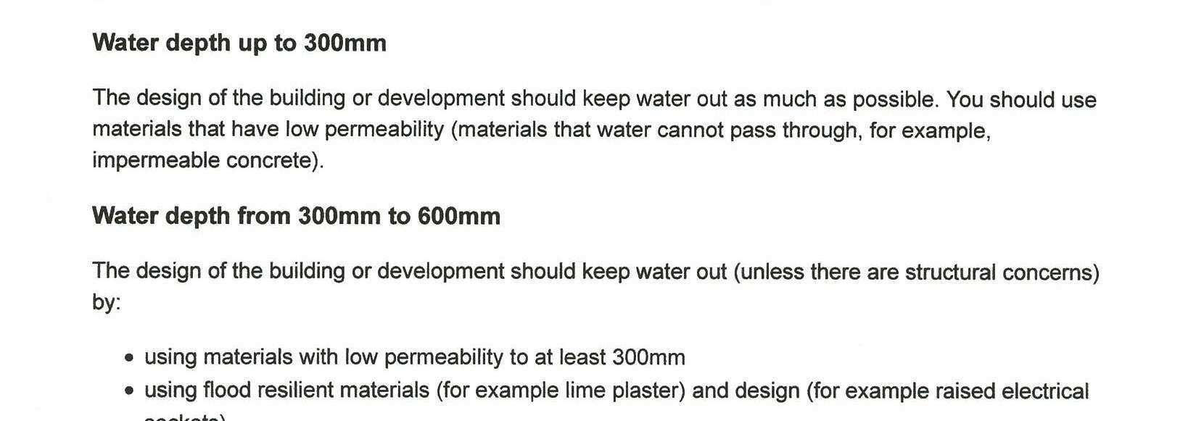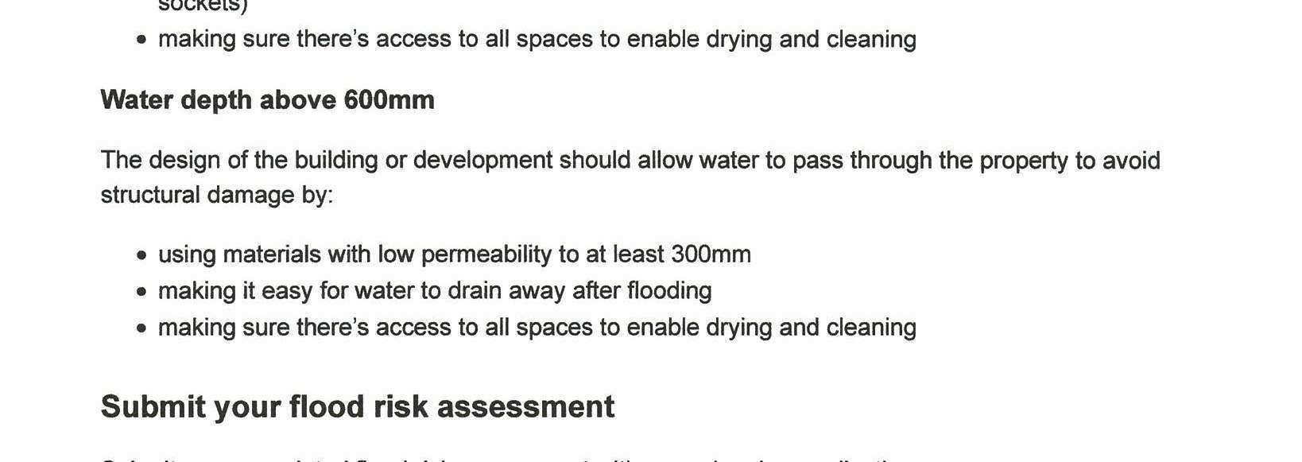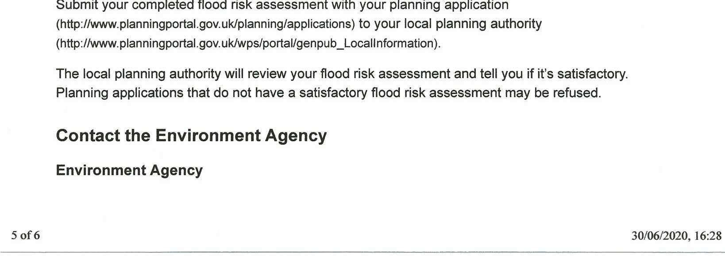
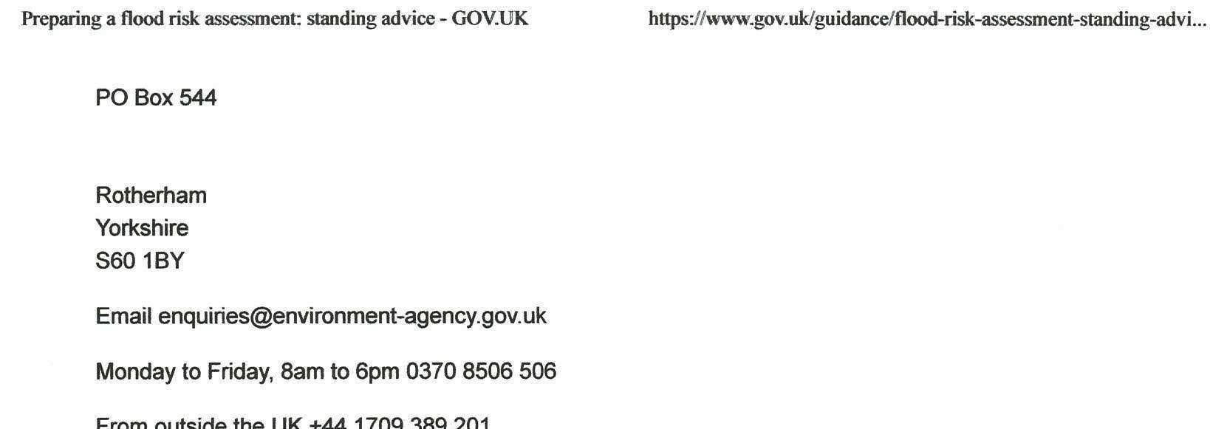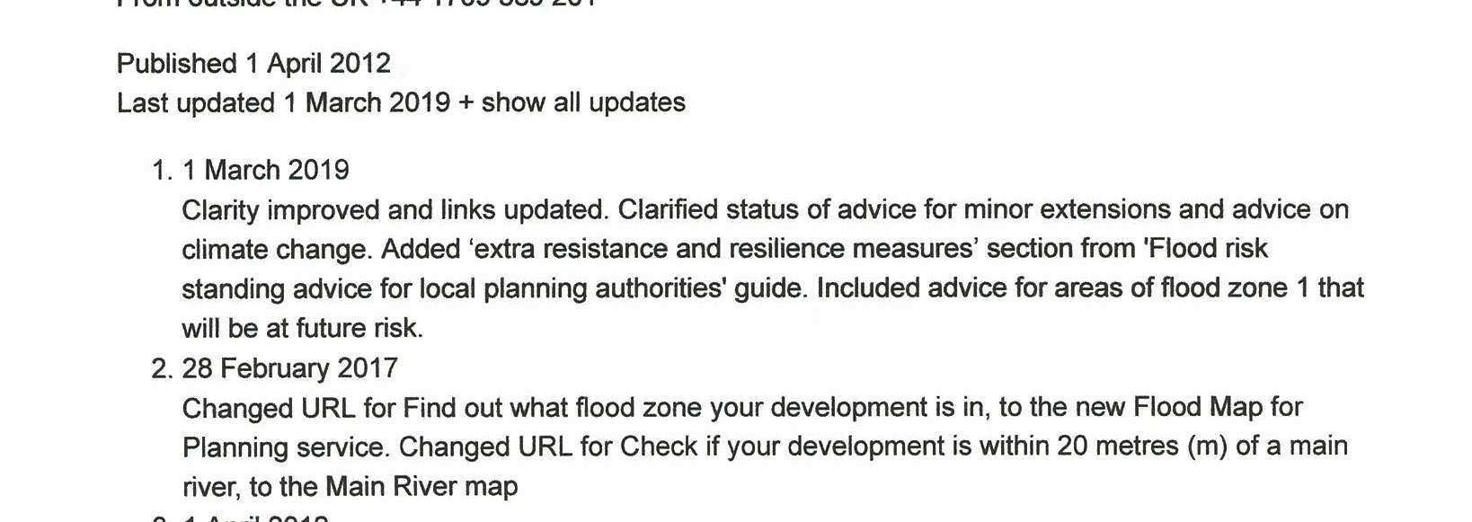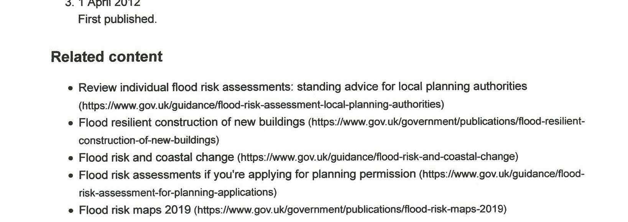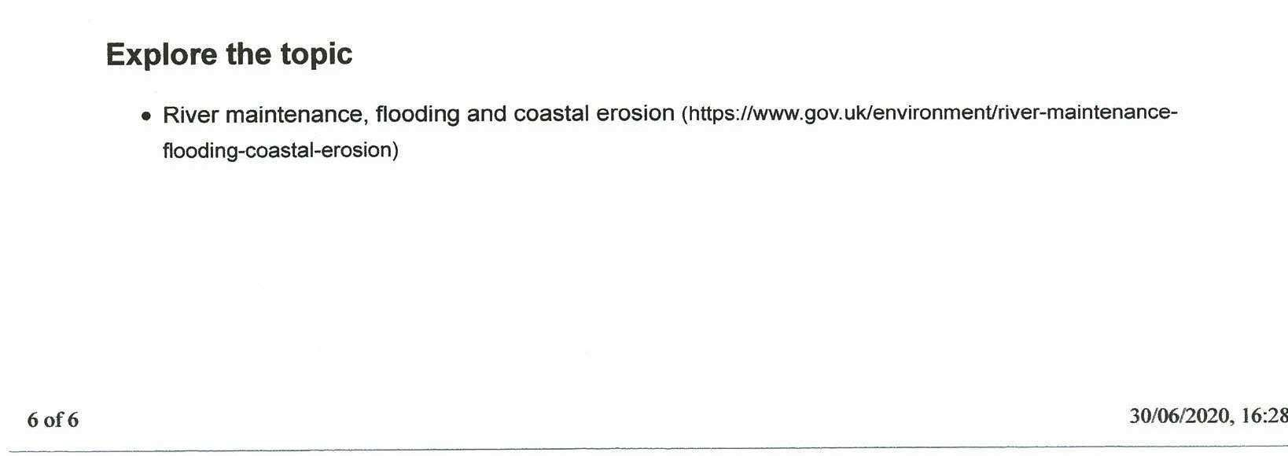

APPENDIX 10
ILLUSTRATED CULVERT AND PROPOSED EXTENSION PLAN
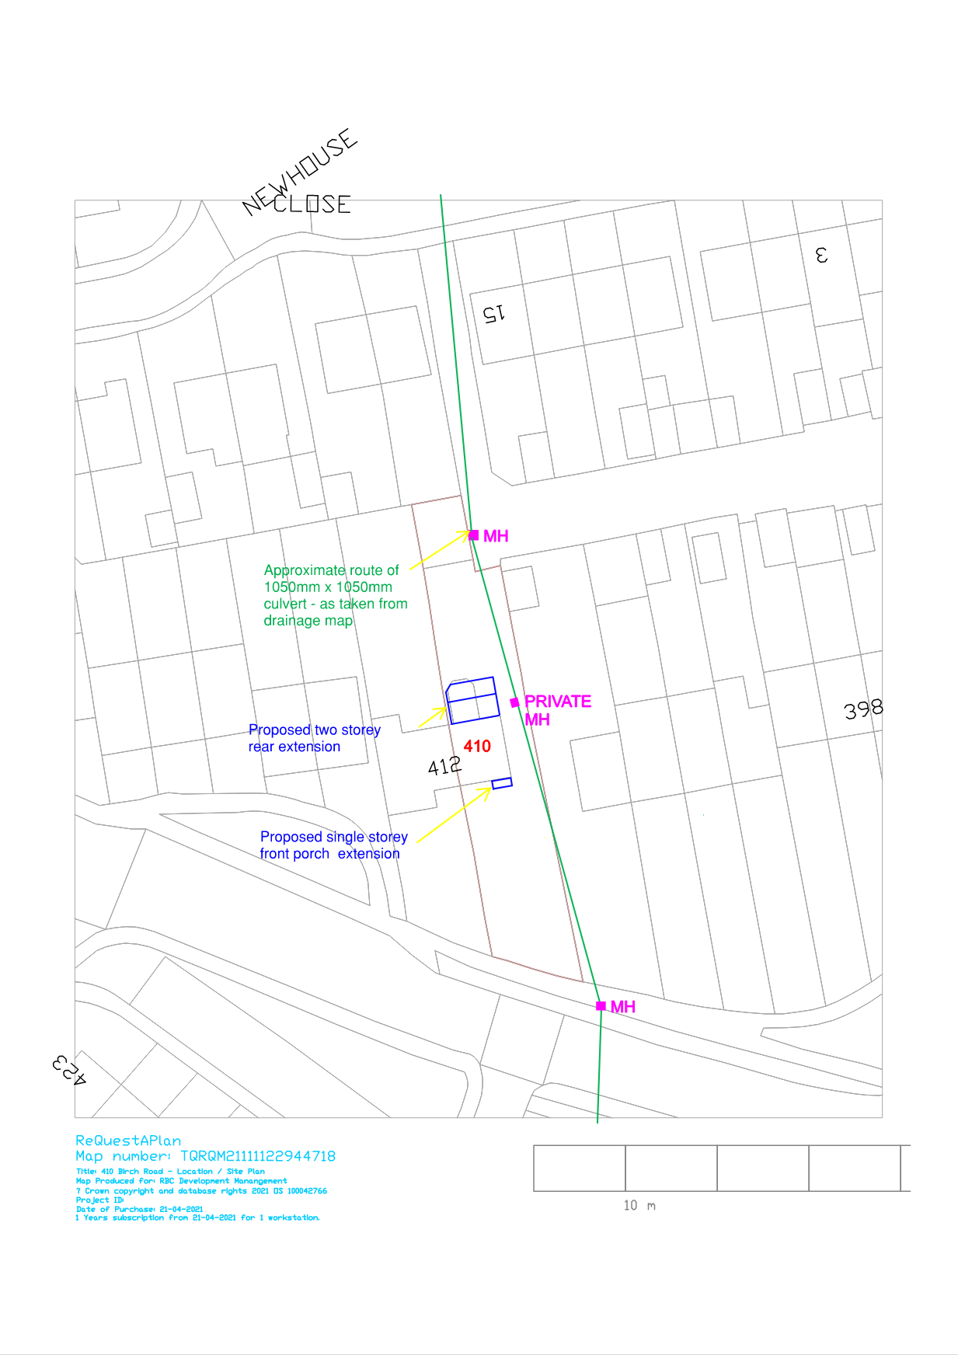

APPENDIX 11
EXISTING PROPERTY ELEVATION IMAGES AND PROPOSED EXTENSION PLANS

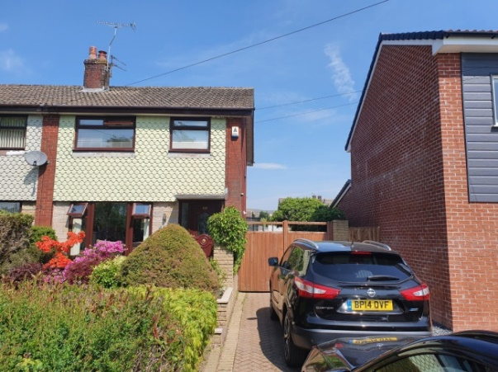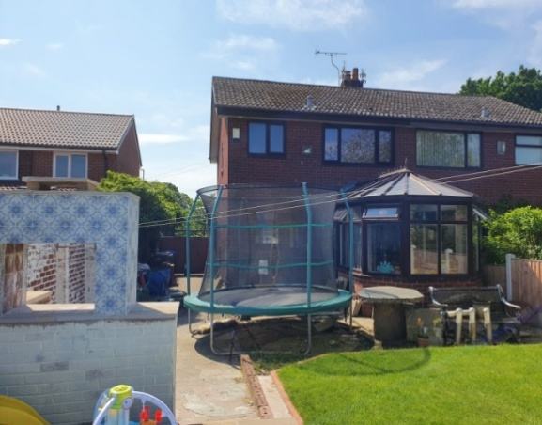

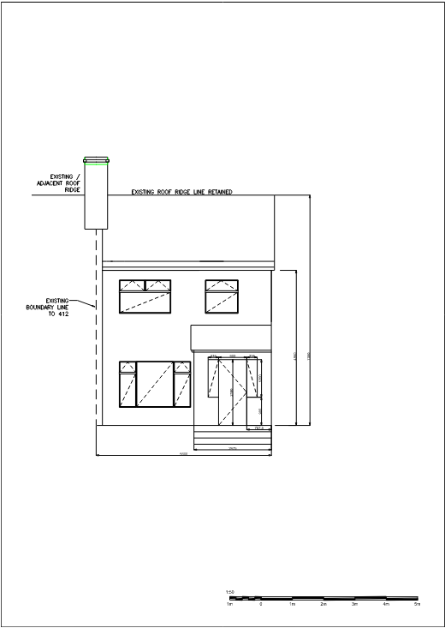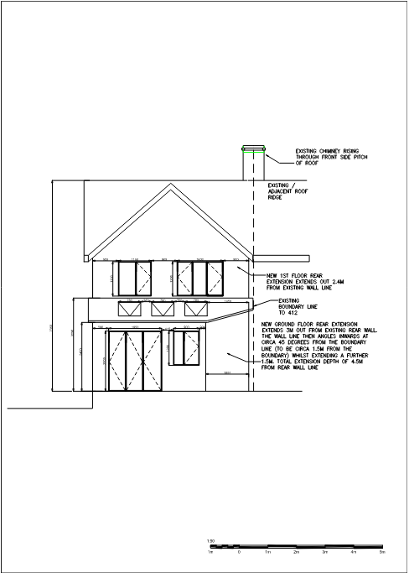
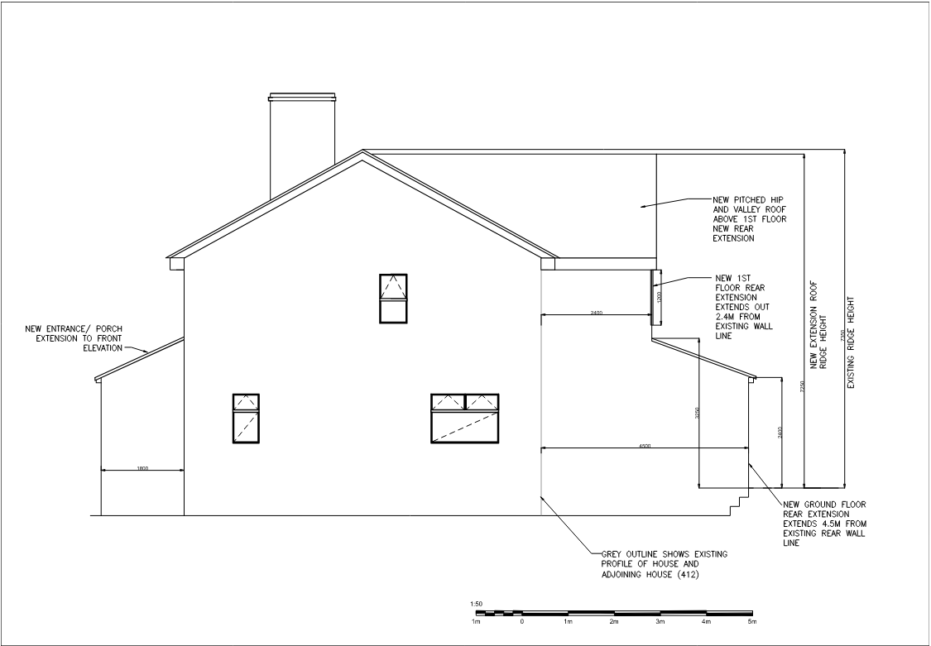
GROUND FLOOR FIRST FLOOR
