
A. & H. Construction
& Developments PLC
Building and Civil Engineering Contractors

Construction Environmental Management Plan
Rhodes Business Park
Silburn Way
Middleton
Rochdale
M24 4NE

PLANNING CONSENT REF: 23/01213/FUL

The information contained within this Construction, Environmental Management Plan, is to address item 12 of PLANNING CONSENT REF: 23/01213/FUL:
will be conveyed to the project team, including contractors so that they have the necessary information required to complete the works safely, without harm to themselves or others who may be affected by our works.
Construction Environmental Management Plan
No development, site clearance or earth moving shall take place, or material or machinery brought on site until a method statement via a Construction Environmental
Management Plan (CEMP) to protect the River Irk from further accidental spillages, runoff, dust and debris has been supplied to and agreed in writing by the Local Planning Authority.
The approved CEMP shall be adhered to throughout the construction period and for future operations in accordance with the approved details. The development shall not be carried out otherwise than in accordance with the approved CEMP.
Reason: To minimise detrimental effects to the neighbouring amenities, the amenities of the area in general, detriment to the natural environment through the risks of pollution and dangers to highway safety, during the construction phase in accordance with Policies DM1, P3, T2, G8 and G9 of the adopted Rochdale Core Strategy and the National Planning Policy Framework.

Index Page
1. Description of Project 5
a) Project description including start and finish dates 5
b) Location: 5
c) Assessment of existing conditions 5
d) Hours of operation 6
e) Surrounding Areas and Boundaries 6
f) Security and Segregation 6
g) Control of operations on site (Permits): 7
h) Health and Safety Management of the works: 7
i) Traffic routes: 8
j) Deliveries, Collections, Vehicle loading, Securing loads and Vehicle unloading 8
k) Noise: 9
l) Vibration: 9
m) Lighting: 10
n) Dust: 10
o) Mud: 11
p) Waste Management: 11
q) Emissions to air: 11
r) Water Course 12
Appendix 1. Site Plan 13
Appendix 2. CEMP Review register 18

Date completed: | Completed by: | Issued to: | Revision: | Amendment:
15/07/25 | M.McQuillan  EHS Manager | Richard Booth  Quartz

Description of Project

Project description including start and finish dates
Design and construction of 1no. speculative general industry/storage & distribution/commercial unit (Use Class B2/B8/E(g) incorporating first floor Cat A ancillary offices, providing a total of 21,409ft² (1,989m²) GIA together with associated external site works including hard standings, landscaping, 27No. car parking bays, drainage, all work in connection with the provision of utilities to the development and any other work implied in the information provided, including without limitation, any S38, S106, S278 or similar works outside the curtilage of the site.
The unit is designed to achieve BREEAM 2018 minimum rating of ‘Very Good’ and EPC rating A.

Location:
Rhodes Business Park
Silburn Way
Middleton
Rochdale
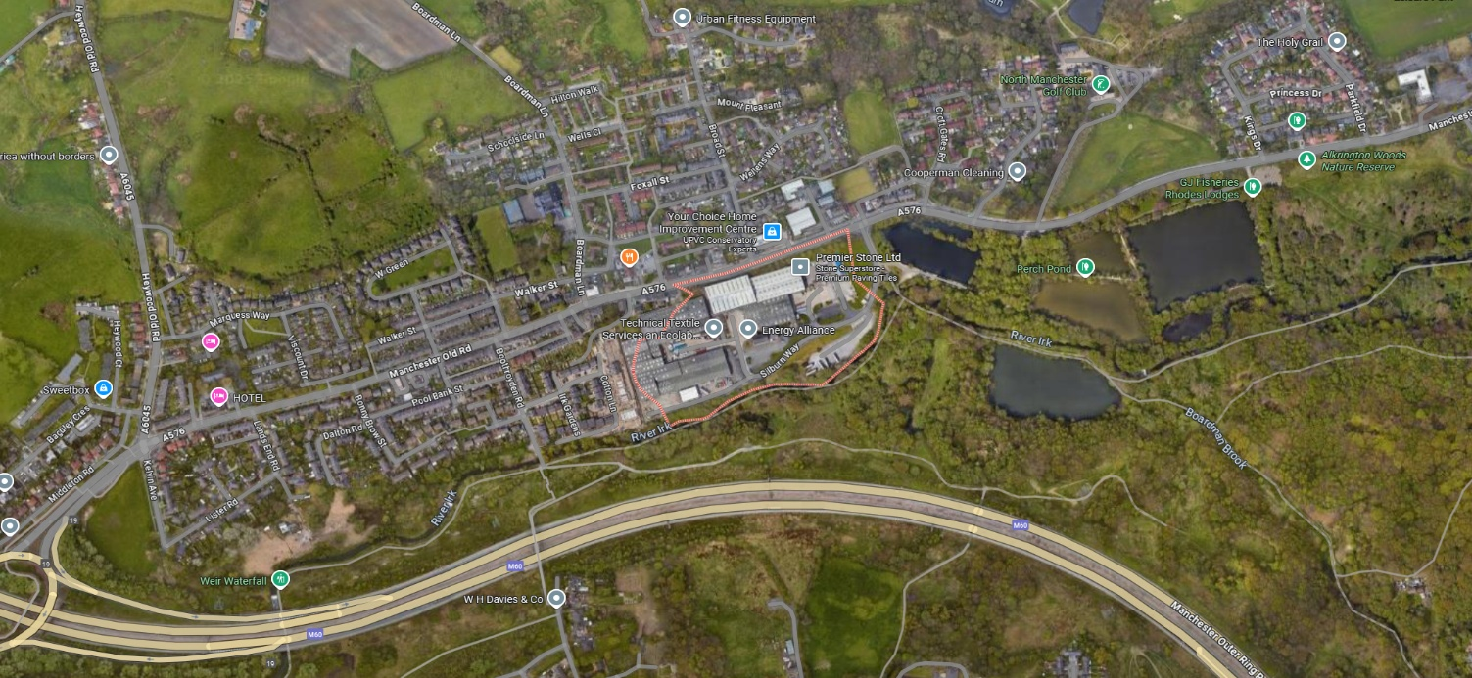
M24 4NE

Assessment of existing conditions
A ‘Dilapidation Survey’ of the existing access roads and footpaths in close proximity to the site, shall be undertaken by the site management team ahead of commencing works on site.
The survey will include photographic and written evidence of the findings. The report will be issued to the project team for review and comment.
We will ensure that the existing highway infrastructure is protected using barriers, signs and by instructing the delivery and collection vehicles to proceed with caution and where necessary, guide them on to site by means of a banksman.

Hours of operation
Working hours are generally limited to the normal working hours defined in the National Working Rules for the Building Industry as produced by the National Joint Council for the Building Industry and as modified for the area in which the works are located.
We shall comply with BS 5228:2009+A1:2014 Code of Practice for Noise and Vibration Control on Construction and Open Sites, BS 6472-1992 Guide to the Evaluation of human exposure to vibration in buildings and BS 7385-2:1993 Evaluation and measurement for vibration in buildings.
In Rochdale, construction work is generally restricted to specific hours to minimize noise disturbance.
The allowed hours are typically:
• Monday to Friday from 8am to 6pm
• Saturdays from 8am to 1pm
• Construction work is not permitted on Sundays or bank holidays.
If construction work needs to occur outside of these hours, we would need to apply for a special permit from the local council.
Rochdale Borough Council handles noise complaints and can investigate instances of construction noise outside of the permitted hours. They can also take enforcement action if the noise is deemed a statutory nuisance.
This information will be clearly conveyed to all contractors and suppliers via pre order meetings, when placing orders and during the site audit. This will be closely monitored by the site management team to ensure compliance.

Surrounding Areas and Boundaries
We note that the site is a multi-let industrial estate, occupied by nine light industrial warehouse units originally constructed in the 1970’s/80’s and redeveloped/refurbished in 2004.
The site extends to 1.33 Acres (0.54Ha) and is currently utilised as a lorry trailer parking area with surrounding soft landscaping.
Ahead of undertaking any work, a letter drop will be undertaken to the surrounding businesses, providing information on the work taking place, as well as the relevant site contacts.

Security and Segregation
The site will be enclosed with heras fencing and separate access gates will be installed for pedestrians and vehicles. The gates will be clearly marked with site safety and directional signage.
The fencing will be installed to prevent unauthorised access and show demarcation of the site. The fence shall be inspected on a daily basis by the site management team to ensure it remains secure at all times.
Clear Site safety and directional signage will be displayed on the site perimeter fences and areas of high risk. The signs will show the defined access routes, give clear safety instructions and guidance and define the site working areas.
All construction vehicles shall adhere to the site speed limits at all times and flashing beacons will be operational at all times and reversing beepers used where reversing takes place. The site speed limit shall be conversant with the site conditions. Maximum speed limits on site will be 9mph.
Drivers must adjust their driving to suit the site conditions and ensure that, where pedestrians have to cross traffic routes, pedestrians will be given priority at all times.
A traffic plan has been established and will be displayed in the welfare area and communicated to all personnel through the induction.

Control of operations on site (Permits):
A. & H. Construction & Developments PLC permit system will be implemented, and these will be issued by A. & H. Construction and Developments PLC Site Management team, as required for the works activities taking place.
These will be issued in advance of the works commencing, with the control measures conveyed to the permit controller i.e., Person receiving the permit. These will include;
Excavations/Breaking ground | Works involving Hot Works | Lone Working
Works on/near existing services | Crane operating | Use of Work at Height Equipment
Isolation of or working near services | Works in confined spaces | Use of Step Ladders
Works on HV electrical equipment | Use of Nail Guns | Work in Highways
The permits issued will be recorded on the permit register and will be signed as received by the person controlling the operations i.e., the site supervisor. It will then be signed off and closed out when the task is complete.
Spot checks will be carried out to ensure the permits are being adhered too and work will be stopped where they are not.
The supervisor will then be required to ensure that the correct permit is in place. All permits will be adhered to at all times or the works will be stopped and action taken to address the failure to comply with the permit.

Health and Safety Management of the works:
A. & H. Construction & Developments PLC will ensure, all work is planned, managed and carried out, such that the health, safety and welfare of all workers, client personnel and members of the public are safeguarded, at all times, so that we meet the client’s health and safety goal.
There will be strong day to day site management, clear co-ordination of the works, as well as training, instruction, information and clear communication for all.
All persons on site including visitors, will operate in accordance with A.&H. Construction & Developments Plc procedures, site specific rules, as well as any requirements lay down by the client or project management team, including information contained within contract documents, as well as information and instructions given at site induction.
Daily visual safety inspections shall be carried out by the Project Manager and a weekly written Environmental Health & Safety audit will be completed by the Project Manager, as well as by the supervisor of each contractor engaged.
This will highlight any day-to-day site issues or concerns and will ensure, that all parties take responsibility for site Health and Safety. The Contracts Manager will also undertake Environmental Health & Safety audits, as part of their duties.
Where actions are required to address any areas of concerns or observations, this will be detailed within the report and discussed as the project team.
Regular site safety audits shall be carried out by the EHS Department, with all findings recorded and communicated with the Site Management team.
These will be undertaken on a monthly basis, as a minimum. Any areas of concern will have the appropriate action taken to address the concern. These will be discussed with the site project team and persons responsible for the area of concern.

Traffic routes:
Access is via Silburn Way through a security checkpoint. Site directional sign will be erected on the route to the site, to direct the operatives to the works area. Traffic directional signage will be in place prior to works commencing, showing the direct routes to site and will be adapted to suit the changes, as they occur.
All construction vehicles shall not exceed the site set speed limit of 9mph or 5mph at pedestrian crossing points. . All speed restrictions on approach road are to be observed at all times.
Site Safety and directional signage will also be displayed stating Construction Works, No Access, No Entry etc. Chapter 8 barriers, pedestrian barriers shall also be utilised on site to create segregated areas between vehicles and pedestrians.
The parking of all site vehicles will be within the confines of the site boundary, in designated contractors/visitor parking. Vehicles will not park within the construction area, unless to load or off load.
The site plan will show the route to site, along with the defined parking areas and areas for loading/unloading. Clear Site safety and directional signage, will be displayed on the site perimeter fences and areas of high risk.
The signs will show the defined access routes to the site and welfare areas, give clear safety instructions and guidance, and define the site working areas between A.& H. Construction & Developments PLC and the existing businesses.
We will look to install one-way routes, as well as turning areas to prevent the need for vehicle's such as HGV’s to reverse. If drivers cannot see behind their vehicle, they must leave their cab and check behind the vehicle before reversing.
Where reversing is required for HGVs, the vehicles will be guided by a competent person, at all times. Reversing alarms can also be used and these should be kept in working order. The audible alarms should be loud and distinct enough that they do not become part of the background noise and flashing warning lights can also be used.
The site traffic information will be issued to the contractors on their orders and we will implement restrictions on delivery/plant movement times for large/bulk material deliveries to the site.
All deliveries and collections must be planned and agreed in advance with the site management team, to ensure there aren’t multiple deliveries arriving at the same time. Unplanned deliveries may be turned away, where the site cannot accommodate them.
We will ensure that manoeuvring space within the site is accommodated, to prevent reversing and to minimise manoeuvring off site. Large vehicles / Bulky loads will be guided to the works area by a competent operative, wearing clean hi viz vest/coats, so they are clearly visible to the driver.

Deliveries, Collections, Vehicle loading, Securing loads and Vehicle unloading
All contractors will be notified, that they must ensure their deliveries and collections are coordinated and booked in with the site manager in advance. The contractors engaged will be given the site managers contact details, as part of the order and notified that, they are required to book their deliveries.
This will prevent multiple unplanned deliveries arriving on the same day. The site manager will confirm to the contractor that the delivery is agreed. The contractors must have a supervisor on site to meet and arrange the offloading of the vehicle.
Unplanned loads will be turned away and the contractor responsible will be informed. They must then again, notify the haulier that they must not send any deliveries without authorisation.
The site manager must be informed that this had been done. Repetitive breaches will lead to the haulier being banned from site. They must ensure that the companies they engage understand that they will be required to comply with the highway code at all times.
They will also need to ensure that, they understand the importance the importance of looking out for pedestrians and cyclists who cannot always be seen when operating HGV’s. This includes; 32 Tonne tipper trucks or Multi-axle Lorries of 30 tonne and upwards.
Loading of vehicles will be via forklifts, crane, hiabs, loading Lorries, i.e. “muck away” or imported material. All methods will be detailed and controlled by Method Statements prepared by sub-contractors responsible for a given delivery but will be segregated from pedestrian areas at all times.
All vehicles are to be checked prior to leaving the construction area in order to confirm the security of all loads. If and when necessary, loads will be secured using ropes, straps, netting or tarpaulins supplied and fitted by the delivery driver.
Site safety and directional signage, will be positioned on the main site entrance and hoarding to provide, directions to delivery drivers, site operatives and visitors to site.

Noise:
A noise impact assessment will be undertaken before the development work commences in accordance with recommendations in BS 5228 -1:2009 ‘Code of practice for noise and vibration control on construction and open sites. The assessment will confirm the existing noise levels and the potential noise levels that will be created during the construction works.
The sources of construction noise are temporary and vary both in location and their duration as the different elements of the site are constructed, and arise primarily through the operation of large items of plant and equipment such as bulldozers, diesel generators, vibration compaction plates, concrete mixer trucks, rollers etc.
Noise also arises due to the temporary increase in construction traffic near the site. The level of noise varies depending on the different elements of the site being constructed. All noisy activities, which can be heard beyond the boundary, will be planned and managed, to minimise the impact to the surrounding business and residents.
The levels are as determined at a fixed point closest to the façade of a habitable room of the nearest sensitive dwelling. These will be recorded, and reviewed by the site management team.
Plant with reduced noise levels will be used, throughout the project and all plant will be maintained in good order Plant will be turned off when not in use. Radios will not be allowed, including personal radios
Set working hours will be implemented for noisy activities, such as drilling, fixing. We will inform nearby residents and businesses about potential noisy activities and undertake them during appropriate times.
As the works progress, Noise assessments will be undertaken by the Project Manager, using a handheld noise meter a RS PRO Digital Sound Level Meter 8kHz,
Where noise levels are above the recommended noise levels from construction activities, the works will cease until further mitigating measures are implemented. i.e. use of noise screens, set working hours outside of surrounding business or residents sensitive works or times.
Compressors will be fitted with properly lined and sealed acoustic covers which will be kept closed whenever in use. Pneumatic percussive tools will be fitted with mufflers or silencers of the type recommenced by the manufacturers;
Equipment and vehicles to be shut down when not in use. Semi-static equipment is to be sited and oriented as far as is reasonably practicable away from noise sensitive receptors and will have localised screening if deemed necessary and where practicable, mains electricity to be used instead of generators.

Vibration:
The site team will monitor vibration trigger levels during the works where works may have an effect on any structure. This includes use of compaction rollers, HGV’s, tracked plant.
We will select tools and machinery with lower vibration ratings, fitted with dampeners and ensure regular maintenance to minimise excessive vibrations.
All drivers of any plant or HGVs creating vibration, will be instructed to slow down heavy equipment, particularly when working near sensitive structures or residents. Drop heights of materials from lorries and other plant will be kept to a minimum.
Fixed and semi-fixed ancillary plant such as generators, compressors and pumps liable to create noise/vibration whilst in operation will, as far as reasonably practicable, be located away from sensitive receptors.
We shall inform nearby residents and businesses about potential vibrations and schedule high-vibration activities during appropriate times.
We will look at digging slit trenches along boundaries, where vibration could transfer, as this can effectively reduce the impact of construction-induced vibrations on residents.
Open trenches generally offering the best performance, though in-filled trenches can also be effective and more practical in certain situations.
Deeper trenches and those with softer backfill materials tend to offer better vibration reduction.
Set working times for vibratory equipment will be implemented, as required to minimise the effect to the surrounding businesses.
Throughout the work, we will liaise with any resident or business who may be impacted and where issues or concerns are raised, the work will cease until the matter ius resolved.
Any additional measures will be discussed with any business or resident affected, to show that measures are being introduced to address their concerns.

Lighting:
Temporary site lighting will be occasionally required for specific activities to ensure safe working conditions, during periods of limited natural light but will be carried out within the limits of the permissible working hours.
The type of lighting will be non-intrusive and specifically designed to negate or minimise any effect to local properties and any other environmental considerations.
Given the proposed size and scope of the development, it is most likely that the construction timetable will require elements of the works to be undertaken during periods of the year when natural daylight is limited.
The use of artificial lighting may therefore be required in order to facilitate the works, such as vehicle and plant headlights; construction and compound lighting; office complex lighting; and localised floodlights/mobile lighting units.
Where appropriate the following measures will be considered for implementation:
• Do not "over" light the work area, as this can cause obtrusive lighting and is a waste of energy
• Dim or switch off lights where it is safe to do so
• Position lights away from residential properties and facing downwards in towards the construction area to minimize spill into nearby areas.
• Keep the lights in good, clean order
• Replace any faulty bulbs
• using shielded and downward-directed temporary lighting,
• installing motion sensors or timers to limit usage,
• selecting lower-intensity lights with warm colour temperatures

Dust:
A dust assessment shall be undertaken in accordance with procedures and recommendations in the Institute of Air Quality Management (IAQM) Guidance on Assessment of Dust from Demolition and Construction and Guidance on Air Quality Monitoring in the vicinity of Demolition & Construction.
We shall have a “nominated representative” of our contract team who will be responsible for the dust monitoring surveys. An initial survey shall be undertaken to determine existing elements of dust or other nearby industries that are creating dust. This will be either undertaken directly by the site manager or assistant site manager.
An inspection for visible dust emissions in the vicinity of the site boundary (internal and external) will be conducted at least once on each working day.
We shall look for dust deposition onto a surface and dispersion on and off-site, such as car bonnets, street furniture, fixed items on site or other items that may show a dust deposit such as the welfare, windows, works vehicles. The level of dust will be recorded and the findings will be reviewed by the site management team.
We will also undertake further monitoring of the points inspected, to monitor any additional build and where additional dust is noted, the site management team will review the existing procedures, to see where improvements can be made. i.e. additional water suppression, extraction etc
We will also ensure that the contractors engaged on site, are also aware that any concerns relating to dust being created and managed, must be reported back to the site management team.
All vehicles carrying dusty materials will be securely covered before leaving the site, to prevent dust spilling on the road and being swept away by the wind.
Haul roads and associated vehicle waiting areas will be regularly inspected and kept clean of all dusty materials, or dampened down
General site traffic will be restricted to watered or treated haul roads

Mud:
Hard standing areas will be created for vehicles to off load and load, to minimise vehicles accessing on to areas of dirt/ mud. This will prevent mud/debris getting on to the vehicle wheels and body.
A wheel cleaning facility will be set up, to control and prevent mud being drawn out on to the road. This will consist of a jet wash, that will be used to remove dirt and debris from the wheels and bodies of the site vehicles, as required.
This will be done before they exit the works area and all materials that are washed off, will be contained on site for disposal.
All drivers will be responsible to ensure their vehicles are clean and hazard free, before leaving site. This will be checked and monitored by the gateman. Any vehicle that is not clean, will not be allowed to exit the site.
Road sweepers will be called off as required by the Project Manager to clean the access roads. These will be readily available to address any mud as soon as it arises.
Monitoring of the weather conditions against the site-based activities will help the manager plan for operations that may create mud, i.e., Groundworks. Manual clearing of mud will also be carried out as required by means of broom, shovels etc.

Waste Management:
The waste hierarchy will be followed through this project and waste will be minimised, recycled or reused where possible.
Waste will be separated and segregated on site where space allows and will be removed by a licensed waste contractor.
All waste removed will be logged with the correct waste criteria and the licensed waste contractor will be given any information on contaminated materials, so they can ensure they are disposed of in the correct manner at the licensed waste facility.
Contractors removing their own waste, must hold a waste transfer licence and a copy will be held on site. Waste will be removed from site where possible, during quiet times.
Contractors will be responsible for managing their waste and this will be controlled through, cleaning up of their works area on a day-to-day basis. This will be managed by the Project Manager.
Waste will not be allowed to accumulate within the works and will be contained in a controlled manner until disposal within the waste skips.
Failure to manage the waste will lead to their works being stopped until the matter is resolved.
A record of all waste removed from site will be held by the site management team to ensure that the waste is managed and removed in a controlled manner and to allow the calculation of waste removed from site.

Emissions to air:
All Non-Road Mobile Vehicles used on site will be in good working order, serviced regularly and monitored to ensure that they remain in good working order. Any vehicles that are noted in poor order will not be allowed to be operated on site.
In addition to the plant itself, the conditions of the site will be monitored to ensure that the air quality is not affected by the construction activities, themselves.
Measures will be implemented to control dust and fumes. Plant and equipment used on site will be in good working order. They will be regularly serviced, to ensure the emissions are kept to a minimum.
Any plant and equipment that is noted as faulty, will be taken out of service until repaired or replaced. Dust will be controlled through dampening down using towable bowsers or water sprinklers.
HGV’s will use cover sheets during transporting of aggregate, or soils which may dry out. All vehicles attending site will need to be maintained to a high standard.

Water Course
To prevent water run off occurring during our work which could impact on the river Irk or highways, we will plan ahead for intense and also prolonged wet weather and consider all relevant pollution mitigation measures including;
- Monitoring the weather forecast, ahead of any site strip, excavations
- Installing temporary drainage, to draw water to a designated holding area
- Minimising the amount of time stripped ground and soil stockpiles are exposed.
- Use of Cut Off ditches
- Use of water pumps to draw water to a designated holding area
- Using sand bags and expanding water defense barriers
- Only remove vegetation from the area that needs to be exposed in the near future
We will create run-off lagoons, as required and allow suspended solids to settle before disposal off site.
Settled solids will be removed regularly and appropriately disposed of. Run-off is to be collected in an impermeable sump. Contaminated water tankered off site for authorised disposal.
Where run off water is contaminated with silt or other pollutants, such as oil this water, this will not be pumped or allowed to flow (directly or indirectly) into the water environment, without any treatment.
Plant and wheel washing will be carried out in a designated area of hard standing at least 10 metres from any watercourse or surface water drain
Refueling of plant or equipment shall be carried away from water courses or drainage points and on a hard standing with drip drays underneath.
Sand bags will be placed around areas such as gullies and drains to protect them and prevent any ingress should a spill occur.
Spills will be cleaned up immediately with a spill kit and the waste material disposed of accordingly via a licensed waste contractor.
Any spills that may affect the local water course will be reported to the local EA and water trust, for advice and control.
All fuel and generators will be stored on a suitable drip tray with a capacity equal to 110% of the capacity of the fuel tank that supplies the equipment. We will empty drip trays regularly, to make sure that they can contain any spills.
The required control measures will be constantly reviewed by the site management team, who will ensure the correct mitigation measures are being implemented, at all times.
Contractors will prevent contamination effecting the ground water table and nearby water courses and to work in strict accordance with the EA Pollution Prevention Guidance Notes.
Spills will be cleaned up immediately with a spill kit and the waste material disposed of accordingly via a licensed waste contractor.
The Environment Agency and client will be advised, where any significant spills occur which could affect the local drainage systems.

Appendix 1. Site Plan
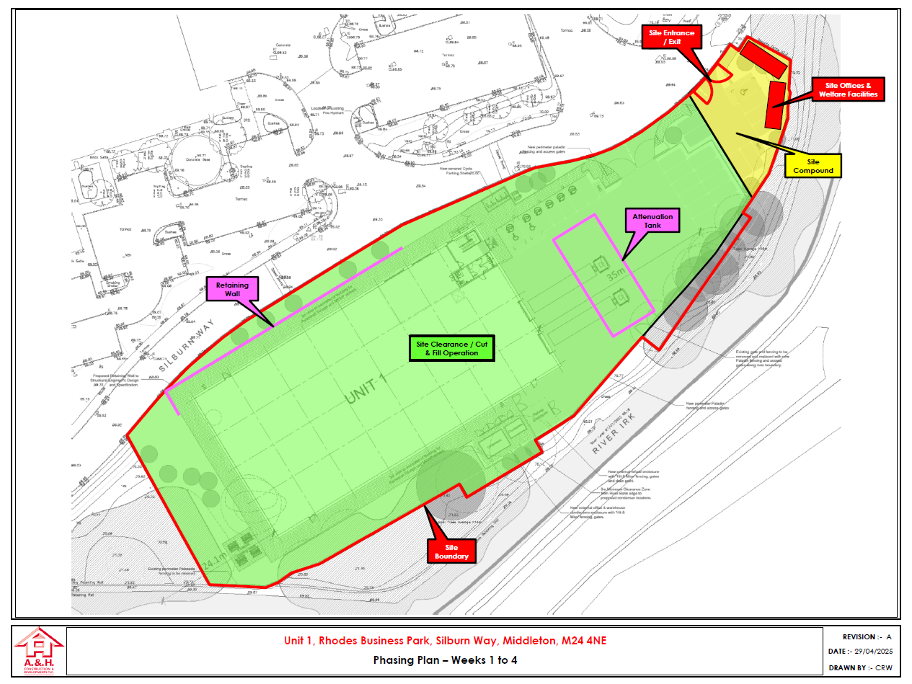

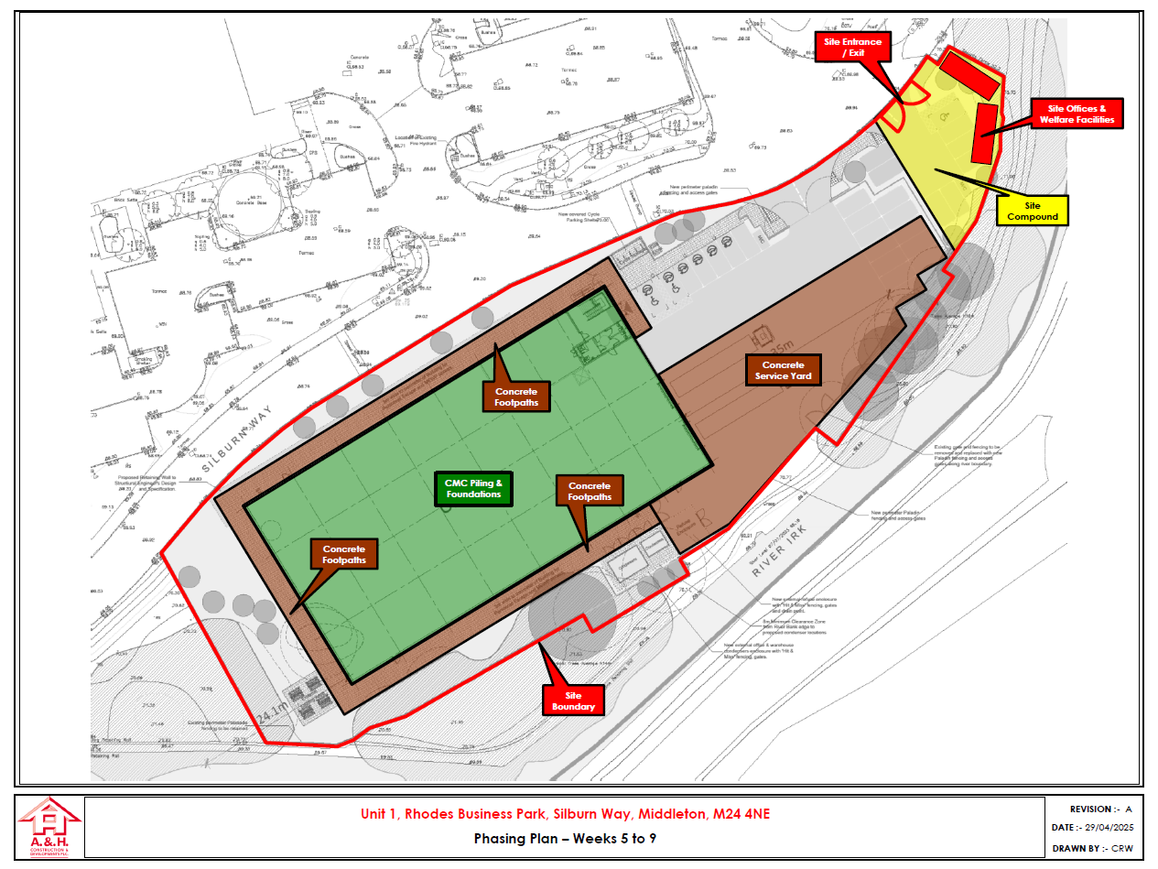

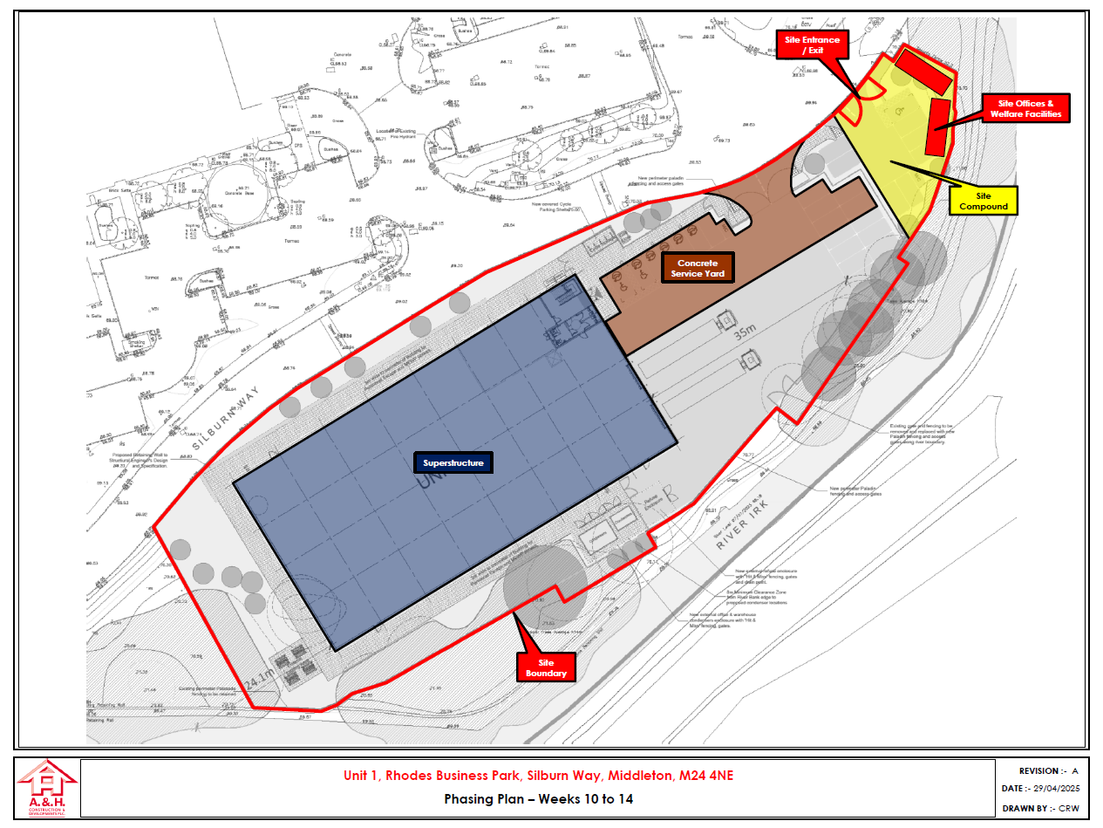

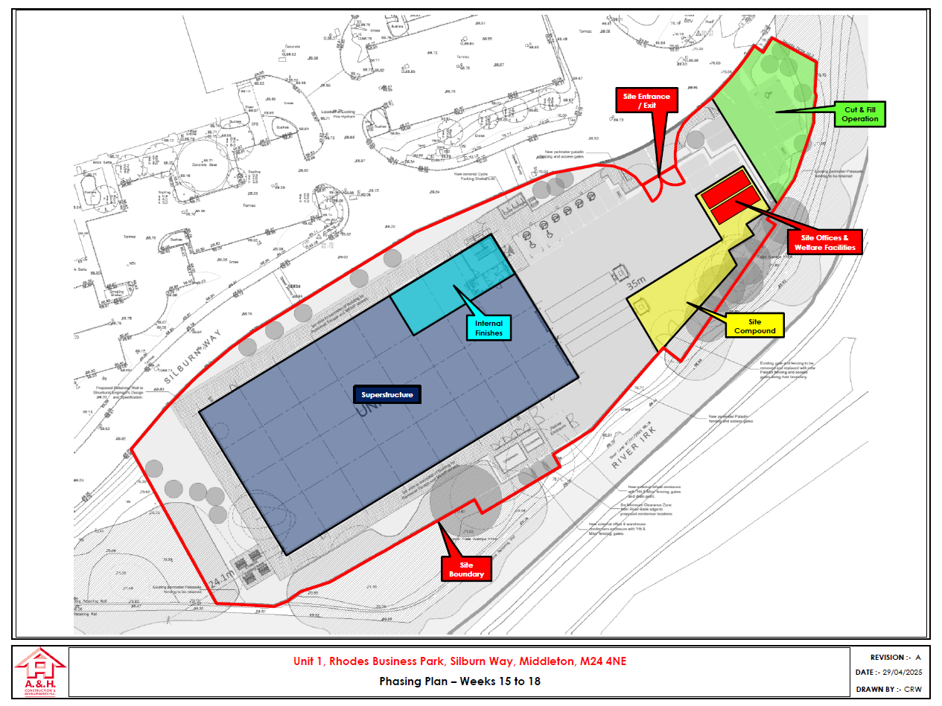

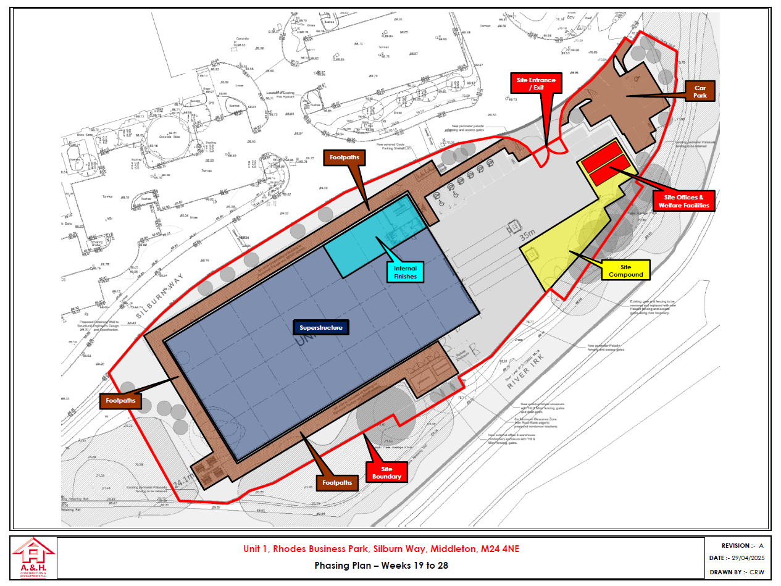

Appendix 2. CEMP Review register

The CPP must be reviewed on a monthly basis or after any significant changes. Any amendments made, required must be advised to a member of the EHS team for the CPP to be updated.
CPP Review date: | Reviewed by: | Amendment Required:  YES/ NO / NA | Detail of amendment &  Pg / Item number: | Signature:

