

Top O’th Meadow Farm
Meadowhead Lane
Norden, Rochdale
OL11 5UL
Tel: 01706 658771

14th August 2025

Report for
John Hughes
244 Harbour Lane
Rochdale
OL16 4EL

As requested, please see the completed tree report, as discussed this offers no guarantees as trees are living organisms and can fail at any time. We would also like to advise that no indemnity or insurance cover is offered. This report is in “my opinion” only and covers only the trees that have been inspected.

Trees in question are subject to a Tree preservation order – Unknown

Local authority; Rochdale

Location
In the garden of 244 Harbour Lane.

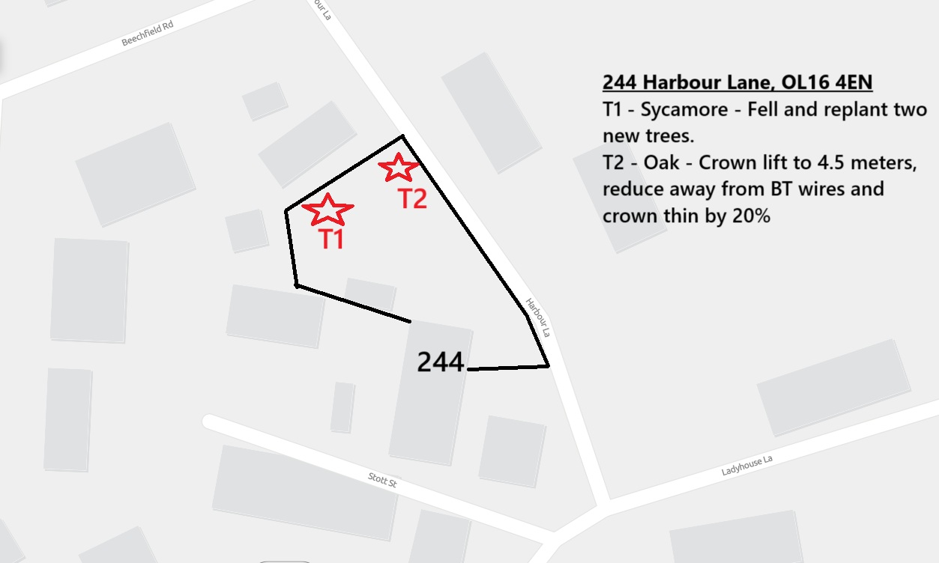

Work provided

Site visit, arboricultural inspection, photography, report, and quotation.
All trees have been thoroughly inspected and only the tree with any defects or concerns have been noted.

Trees included

T1 Sycamore
T2 Oak

Issues found

T1,Sycamore, stem cavity present at 0.5 meters, hollow sound when knocked with a nylon hammer. Upper canopy looks to be declining in comparison to other Sycamore trees within the same area.
T2, Oak, low intrusive canopy. Little light manages to pass through the dense canopy. Minor secondary branches rubbing on BT wire.

Recommendations

T1 – Sycamore, fell and replant two new trees.
T2 – Oak, crown lift to 4.5 meters, reduce from BT wires and crown thin up to 20%

The decision to fell the protected T1 Sycamore tree to ground level arises from concerns related to its structural integrity and its potential risk to surrounding properties. The presence of a stem cavity in the tree, which emits a hollow sound when tapped with a nylon hammer, indicates internal decay or a significant reduction in the tree's structural stability. Such compromised trees pose safety hazards, particularly when situated near residences or buildings, as they are susceptible to failure under environmental stressors like wind or heavy precipitation.

Given the tree's proximity to several properties, it represents a tangible threat to structures and inhabitants in the area, warranting action. It is essential to prioritise public safety by mitigating these risks promptly.

The felling process follows due diligence wherein a formal agreement with the local authority recognises the necessity of removing T1 to ensure protection and safety within the community. To uphold environmental responsibility, the proposal includes replanting two new trees, thereby contributing to biodiversity and the aesthetic value of the landscape long-term. This approach balances immediate safety needs with sustainable ecological considerations.

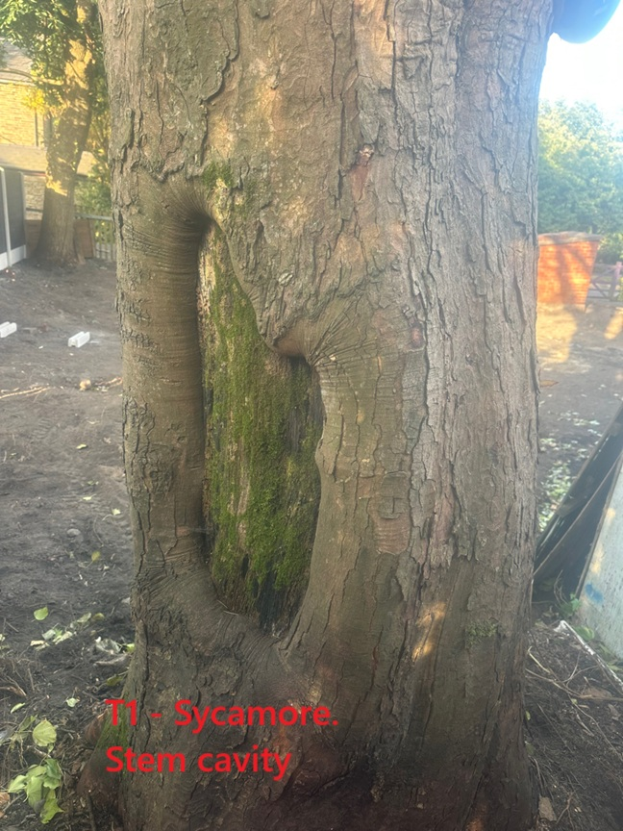
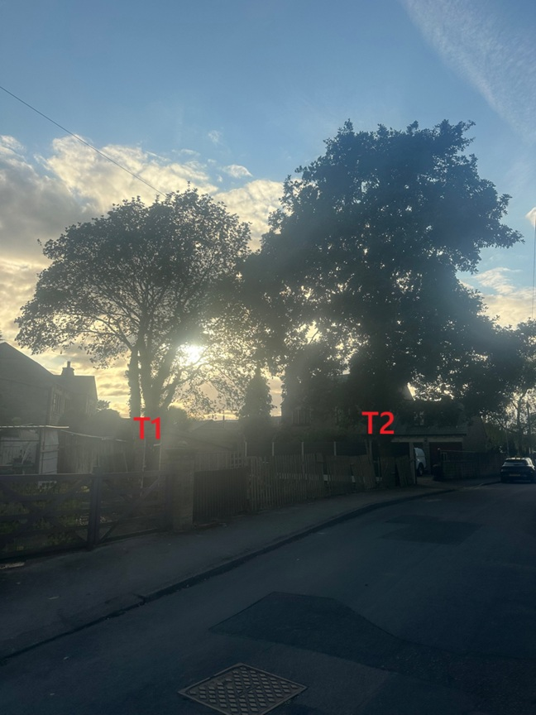
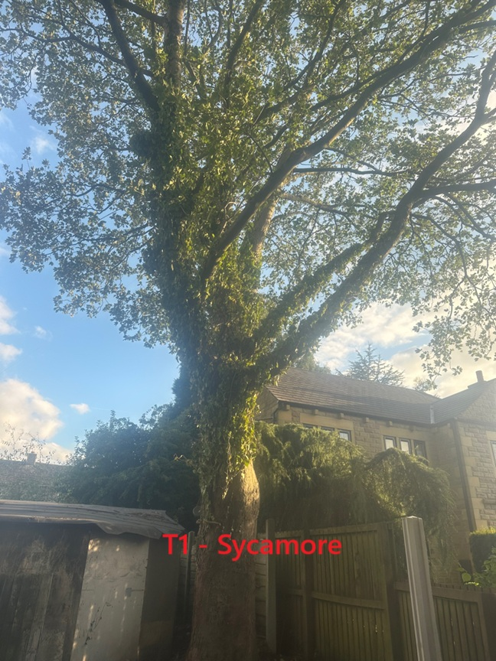
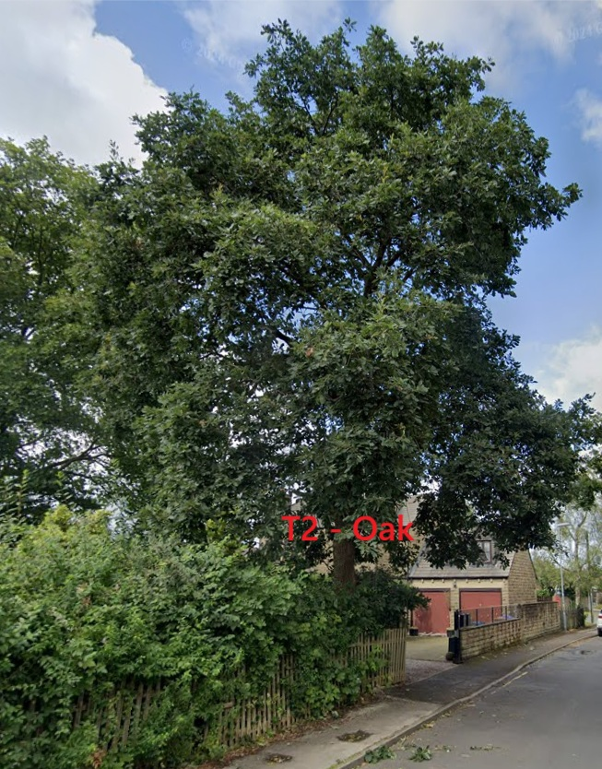
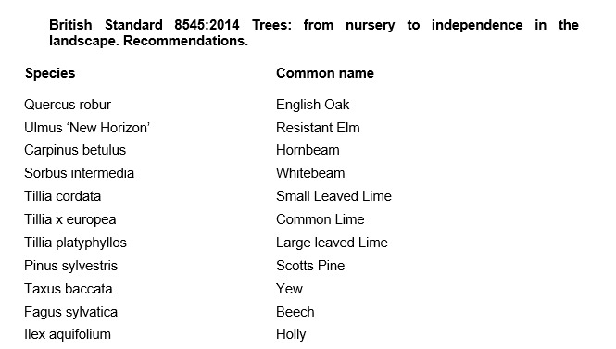

Aftercare

To ensure success when planting trees, providing good aftercare is as important as good planting practice. The first two to three years after planting are critical for a tree’s establishment. Planted well and cared for correctly, it should flourish and become a valuable feature in your garden. It is an investment of time and money, and it would be a shame to lose the benefit of a fine tree through post-planting neglect. The first challenge is moving the plant from the nursery to its new home: this can cause stress to any tree. Give it attention for the first few years to ensure re-establishment and survival in its new location. Watering, weeding, staking, mulching and formative pruning are important for successful establishment, but none are onerous or time consuming. Tree aftercare the guidelines on these pages apply primarily to ornamental trees: fruit trees are established in the same way, but pruned and managed differently to maximise fruit production. Newly planted trees ideally need regular watering in dry spells for three to five years to ensure good root growth. After planting a tree, pruning may be necessary to enhance the natural shape or improve its structure and strength. In the first few years, identify and correct problems with the main framework of the tree – prune early, as this helps avoid future complications. With a young tree, one of the most common tasks is to remove lower branches that begin to interfere with other gardening activities, create shade or block views. Look out, too, for pests such as aphids and diseases such as canker – they can reduce the vigour of your tree and make establishment slower. If you keep your tree vigorous and healthy, it is less likely to succumb to pests and disease

For the first two to three years, irrigate newly planted trees weekly during dry spells in spring and summer. Too much water, and roots will not extend in the search for moisture – but underirrigation results in slow establishment and symptoms of stress, such as canopy dieback and bark splits on the trunk. Water directly at the base of the tree and, particularly if the ground is dry, apply slowly to stop it running off. Make sure water has penetrated the soil; on our well-drained soil, we apply two to three full watering cans of water per week to new plantings.

From initial planting, mulch annually in spring or autumn to suppress weedy competitors and help retain soil moisture. ✤ Organic or inorganic materials can be used; composted wood chippings, leaf mould and well-rotted manure. ✤ Organic materials should be part composted: six-month-old wood chip is ideal. ✤ Mulch should be 7–10cm (3–4in) deep; avoid piling it round the trunk as this can soften the bark.

New trees should be staked until their roots provide good anchorage – this can take several years. If loose, the tree will rock in the wind and its root ball will move, which hinders plant establishment and could even result in death. ✤ Check ties are secure and a padded cushion is between the tree and stake. Rubbing against a stake can create a scar, which leaves the tree open to disease. ✤ Check regularly: ties left too tight cause serious bark damage. Fast-growing trees may need ties loosening every year.

Formative pruning trees
Formative pruning is the process of shaping a tree when it is young. Every variety has a different natural growth habit, but unpruned trees will for the most part produce a crown cluttered with branches. The aim is to develop an open, balanced network of strong, unshaded branches and at a height that allows for good management such as grazing livestock and machinery. This is achieved by creating a good height trunk and pruning young growth back to encourage the tree to grow in the right direction and develop thick branches.


Kind regards,
Mr. Ryan Slack
General Manager and Director
SEG Award, Cert Arb L2 (ABC)

