
Highways and Engineering Service - Economy and Environment

Drainage Consultation on Application – 25/00683/DOC- Mount Green Filling Station
LLFA Consultation Response on behalf of Head of Highways and Engineering.
Date of Response: 14th July 2025.
Location & Proposed Development
Mount Green Filling Station, Halifax Road, Wardle, Rochdale, OL16 2SQ
Submission of details to comply with conditions 14 (Highway Dilapidation) and
15 (Drainage) of planning permission 23/01033/FUL
23/01033/FUL : Residential development comprising of 17 supported living apartments including associated office space, entrance hall offering a break out, communal space for residents and visitors with servicing , landscaping, off street car parking and bin storage
Documents Reviewed
25/00683/DOC:
- Drainage General Arrangement - J8426/D01
- Drainage & Hardstanding Build Up Details - J8426/EX02
- SuDS Maintenance Plan – Rev A (June 2025, Bell Munro Consulting)
- Covering Letter – 03/07/2025 (Ref: J8426030725)
- Hydraulic Calculations - J8426
- Rain Garden and Drainage Feature Layout (Drawing ref: J8426/D01 Rev C)
- UU Consultee Comments 31/07/2025
23/01033/FUL:
- Existing Topographical Survey – POSWD-RYZ-ZZ-00-DR-A-0101
- Proposed Site Plan - POSWD-RYZ-ZZ-00-DR-A-0100
- Flood Risk Assessment - 80754R1
- SUDS Pro-Forma
- Sustainable Drainage Assessment - 80754.01R1

Drainage & Flood Officer Comments

- The development proposes drainage infrastructure such as, permeable paving, attenuation storage and a rain garden, with a surface water outfall to the combined sewer via a pumped discharge. This is not acceptable in principle.

- The aim should be to discharge surface run off as high up the following hierarchy of drainage options as reasonably practicable: The ordered drainage techniques to be assessed with the aim to reduce or omit lower techniques:
- Control at Source (Infiltration / Recycling)
- On Site Treatment (Basins, Swales, Rain gardens, Tree pits)
- Local Treatment (Adoptable Ponds, Basins, Swales etc)
- Regional Treatment (ditto usually to a larger scale)
- Discharge to Watercourses / Bodies
- Discharge to SW Sewers
- Discharge to Combined Sewers

- The Drainage General Arrangement drawing includes a note stating that infiltration has been dismissed due to the presence of clay strata beneath made ground. However, there is no evidence that site-specific investigations have been carried out to confirm the feasibility of infiltration across the site. In addition, the GA shows areas of permeable paving which appears to be inconsistent with the poor infiltration comments.

- The initial application appears to incorporate more green landscaping than the DOC Drainage GA. These which may accommodate further green SuDS. In addition, the SuDS Report discussed rainwater harvesting. If the only option is found to be discharge to a combined sewer, then recycling water to mitigate regular, weather independent, potable usage such as WC flushing should be considered.

- Discharge to a watercourse has been discounted due to being too far and requiring 3rd party involvement. However, a culvert is only approx 5m from the redline boundary and could potentially be routed within the public highway. In addition, discussions with UU regarding s104 adoption may be feasible.
Furthermore, discharge to the culvert may be feasible by gravity which would avoid any pumping requirements.

- The culvert is shown as 100mm dia on UU records which is incorrect. RBC have updated survey information regarding the culvert which can be made available on request.

- It is noted that UU consultee comments also raise similar comments.

- There are no sustainable drainage proposals for the access road. Is Wuerdle Street adopted or being offered for adoption.

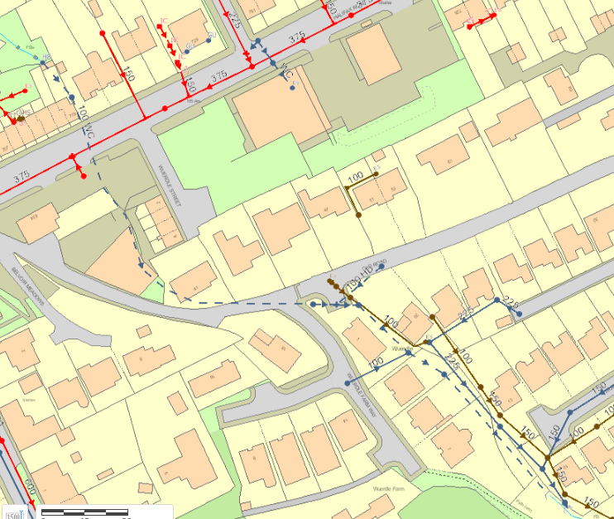

Drainage & Flood Officer Summary:

- The proposal to discharge surface water into a combined sewer is not acceptable in principle.
- A comprehensive investigation and assessment of more sustainable options for infiltration, recycling and discharge to a watercourse is required.
- Further incorporation of green SuDS may be feasible and should be investigated to minimise the volume of buried storage and runoff volumes.

Consultation by Keith Mealey
Drainage & Flooding Officer
keith.mealey@rochdale.gov.uk

