Planning Statement
Ref:AG.050825.C
Application for a determination under Class A, Part 6 of Schedule 2 of the Town and Country Planning (General Permitted Development) (England) Order 2015 (as amended).
Proposed agricultural storage building, Long Clough Farm, Clough Road, Littleborough OL15 9PA

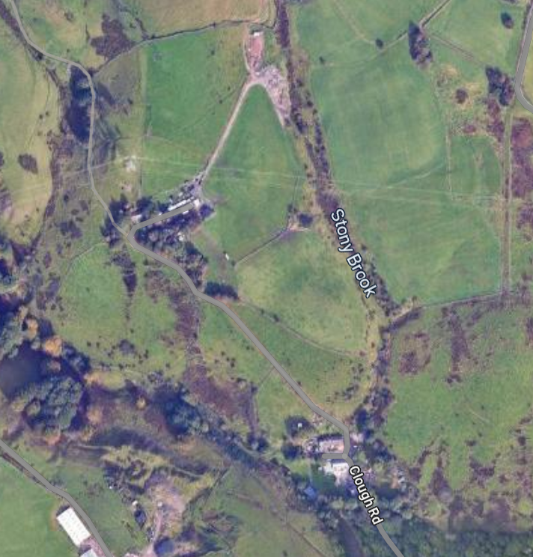

 | P
D | A

August 2025

Prepared by Hartley Planning and Development Associates Ltd
Proposed development
The proposed development is for an agricultural storage building for farm equipment and hay on land at the above farm.
The landholding at the farm extends to some 6.5ha, excluding other associated agricultural land in the area.

The proposed building would be sited on disturbed ground on the land holding accessed along an existing farm track. It would be sufficiently separated from the listed farm house so as not to adversely affect the latter’s setting.
It would be 20 metres by 12 metres, with a height to the ridge of 6 metres. External walls would be 2 metre high concrete panels with Yorkshire boarding above (stained in a natural colour). The roof would be corrugated mineral fibre boarding.
The proposed building is reasonably necessary for the purposes of agriculture on the farm.
The prior notice application accords with the requirements of part 6 of the GPDO (2015) (as amended) : -
 | Requirements of Part 6 of the GPDO | Application to land at Grane Road
1 | Works for the erection of a building on agricultural land of 5 hectares or more | The holding is 6.5 ha
2. | the development is not to be carried out on a separate parcel of land forming part of the unit which is less than 1 hectare in area | N/A
3 | Size not to exceed 1000m2 | The size is 240 m2
4. | Height not to exceed 12m | The height to the ridge would be 6 metres
5 | No part to be within 25 m of the metalled part of a trunk or classified road | The proposed barn is not within 25m of a trunk or classified road.
6 | No part of any building for the accommodation of livestock or for the storage of slurry or sewage sludge shall be within 400 metres of the curtilage of a protected building.  Paragraph D1 states that "protected building" means any permanent building which is normally occupied by people or would be so occupied, if it were in use for purposes for which it is apt; but does not include—  (i) a building within the agricultural unit; or  (ii) a dwelling or other building on another agricultural unit which is used for or in connection with agriculture | The barn is not to be used for such purposes  It is for agricultural storage

Conclusion
Thus, application is made in accordance with the terms of the GPDO which states that ‘the developer must, before beginning the development, apply to the local planning authority for a determination as to whether the prior approval of the authority will be required as to the siting, design and external appearance of the building, the siting and means of construction of the private way, the siting of the excavation or deposit or the siting and appearance of the tank, as the case may be. (My highlighting)

