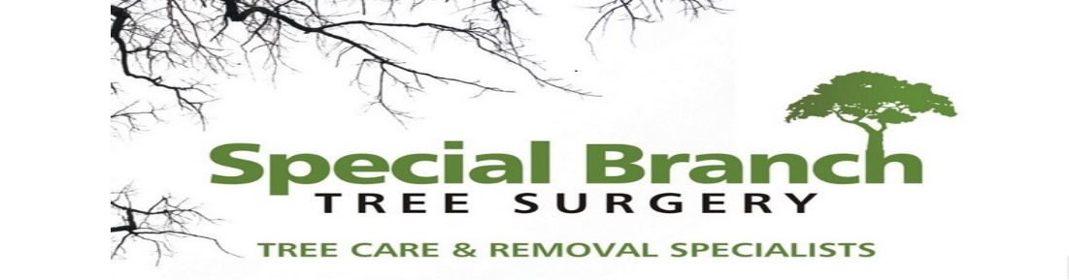

Top O’th Meadow Farm
Meadowhead Lane
Norden, Rochdale
OL11 5UL
Tel: 01706 658771

20th May 2025

Report for
Callum Sellars
Carr Wood Cottage
School Lane, Rochdale
OL11 5UT

As requested, please see the completed tree report, as discussed this offers no guarantees as trees are living organisms and can fail at any time. We would also like to advise that no indemnity or insurance cover is offered. This report is in “my opinion” only and covers only the trees that have been inspected.

Trees in question are subject to a Tree preservation order – Unkown

Local authority; Rochdale

Location
Garden of Carr Wood Cottage.

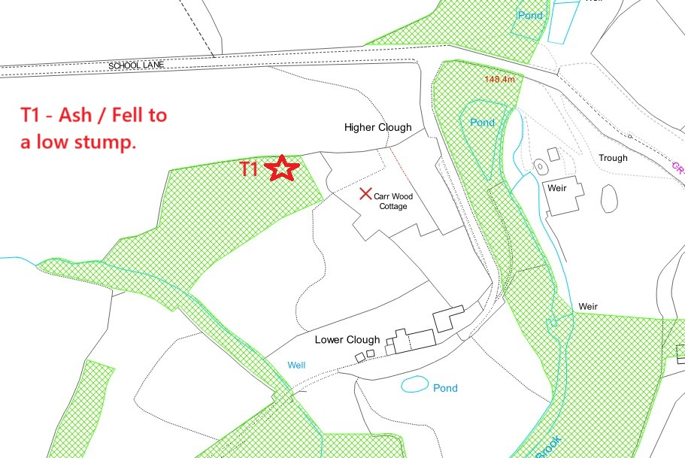

Work provided

Site visit, arboricultural inspection, photography, report, and quotation.
All trees have been thoroughly inspected and only the tree with any defects or concerns have been noted.

Trees included

T1 Ash.

Issues found

T1 – Ash. Ash Die Back present in a more moderate stage

Recommendations

T1 – Ash. Fell to a low stump.

1. Disease Impact and Progression: Ash Dieback manifests through symptoms such as crown dieback, leaf loss, and ultimately tree death. Moderate levels of infection indicate that T1 is already experiencing detrimental effects from the disease. As the disease progresses, it compromises the structural integrity of the tree, making it increasingly susceptible to breakage during storms or high winds.
2. Safety Concerns: The primary reason for removing a diseased tree like T1 is public safety. Affected trees pose a risk of falling branches or complete collapse, especially in urban areas where they are near pathways, roads, or structures. In 2020, a study published in the *Journal of Arboriculture* noted that approximately 30% of trees infected with Ash Dieback exhibited severe structural weaknesses within three years of initial symptoms appearing.
3. Ecosystem Considerations: The removal of infected trees can also play a role in managing the spread of Ash Dieback. By eliminating moderately infected trees like T1, we reduce the fungal inoculum in the environment, potentially slowing down disease transmission to nearby healthy Ash trees. This proactive approach aligns with best practices outlined by forestry management guidelines which advocate for the removal of diseased specimens to protect remaining healthy populations.
4. Long-Term Management Strategy: The decision to remove T1 should be part of a broader management strategy that includes planting disease-resistant species or diversifying the tree population in affected areas. Research indicates that promoting biodiversity can enhance ecosystem resilience against future pest and disease outbreaks.

The client has already planted five new trees at the front of the property and has an ongoing landscape project which will be including planting new trees throughout the grounds of the property.

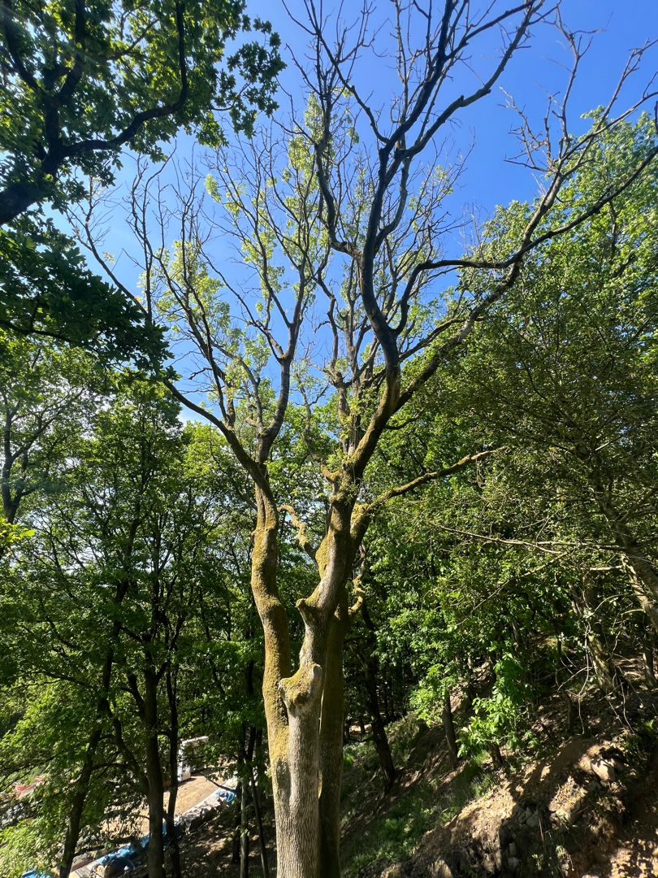
Kind regards,
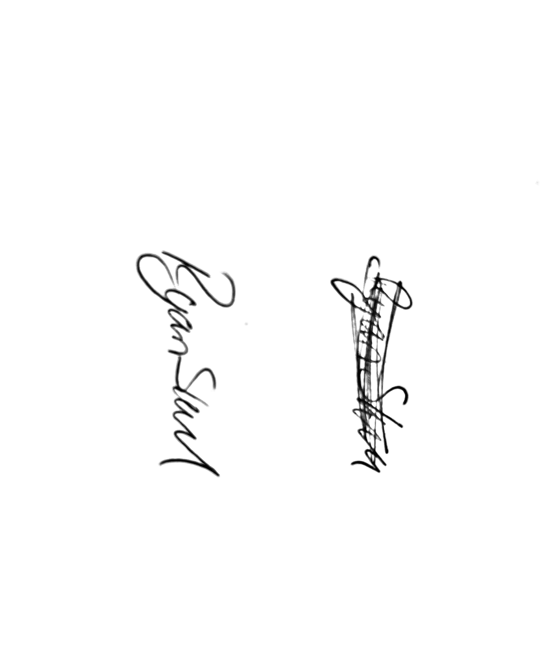
Mr. Ryan Slack
General Manager and Director
SEG Award, Cert Arb L2 (ABC)

