SPECIAL BRANCH
`

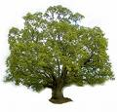
Tree Surgeons Ltd
Top O’th Meadow Farm
Meadowhead Lane
Norden, Rochdale
OL11 5UL
Tel: 01706 658771

Mini Tree Report Date: 3rd August 2025

Anne Puxley
11 Durness Place
Heywood
OL10 3ST
As requested, please see my mini tree report, as previously mentioned this offers no guarantees as trees are living organisms and can fail at any time. We would also like to point out no indemnity or insurance cover is offered. This report is in “my opinion” only and covers only the trees that have been inspected.

Trees in question subject to Tree Preservation Order Ref TPO 250

Greater Manchester tree preservation orders
Local authority: Rochdale

Location
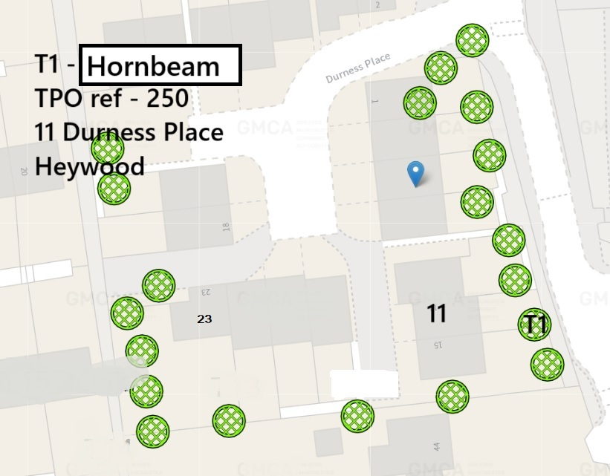

Work done

Site visit, arboricultural inspection, photography and report.

Trees in question

1 tree shown in the plan as T1 (Hornbeam) , in the rear garden of 11 Durness Place. This tree appears to be in reasonably good health, with no sign of previous pruning works visible.

Problem

- The tree is causing excessive shading garden
- The crown spread of small branches are causing a nuisance, mingling with other trees and encroaching on the property.
- Untidy appearance.

Recommendation

T1 – Crown lift to 4.5 meters, crown thin by 20-25%. Reduce branches growing towards the property by 1-2 meters.

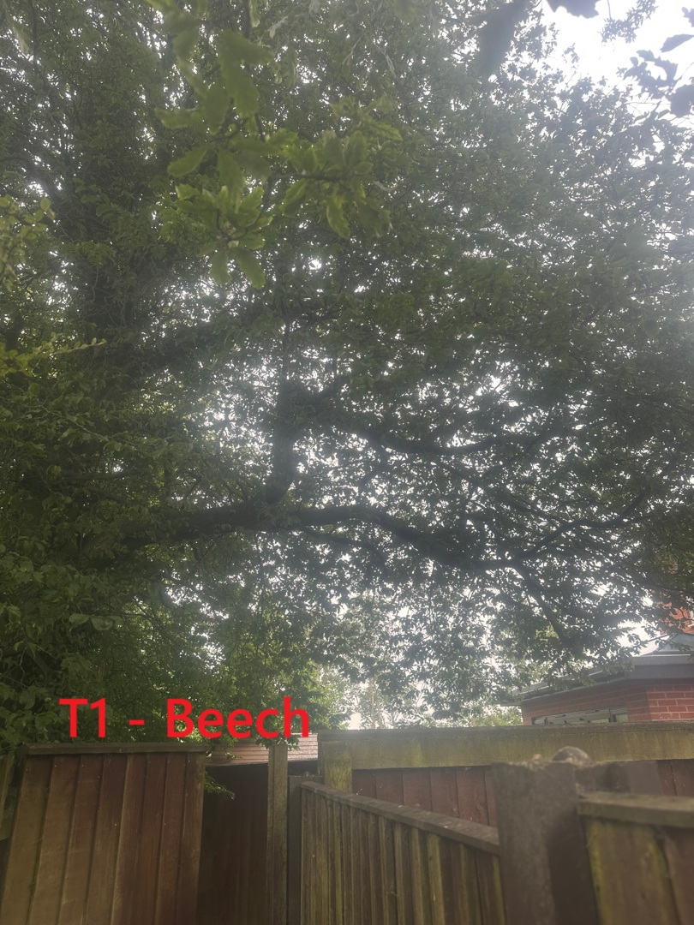
Hornbeam
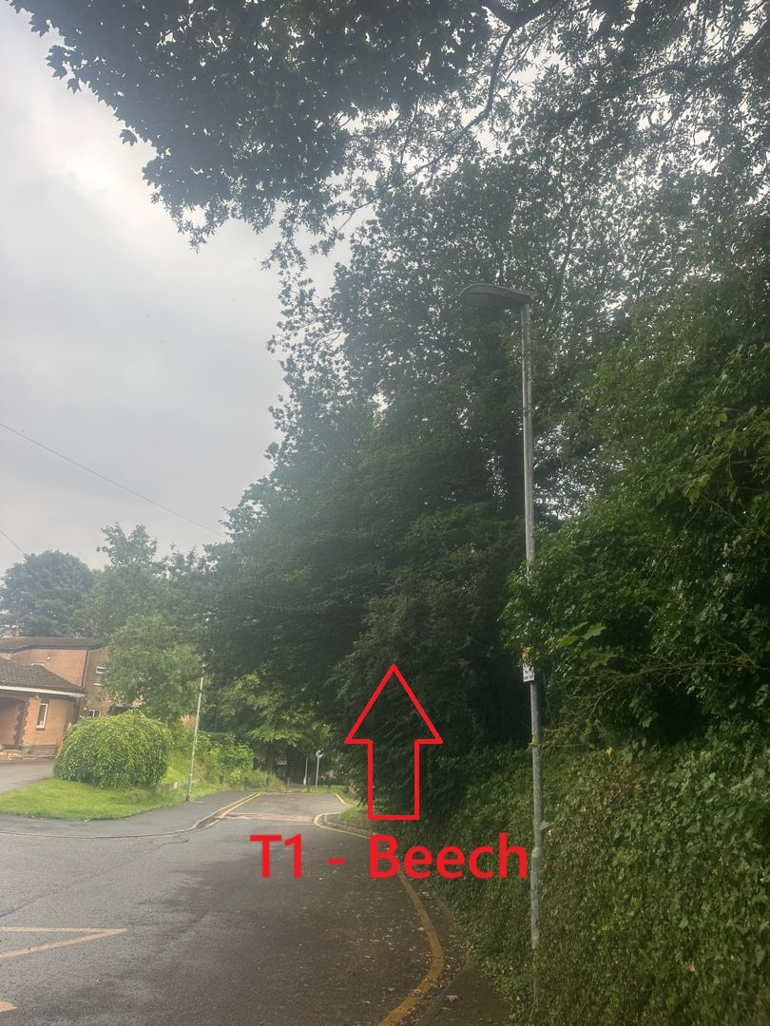
Hornbeam
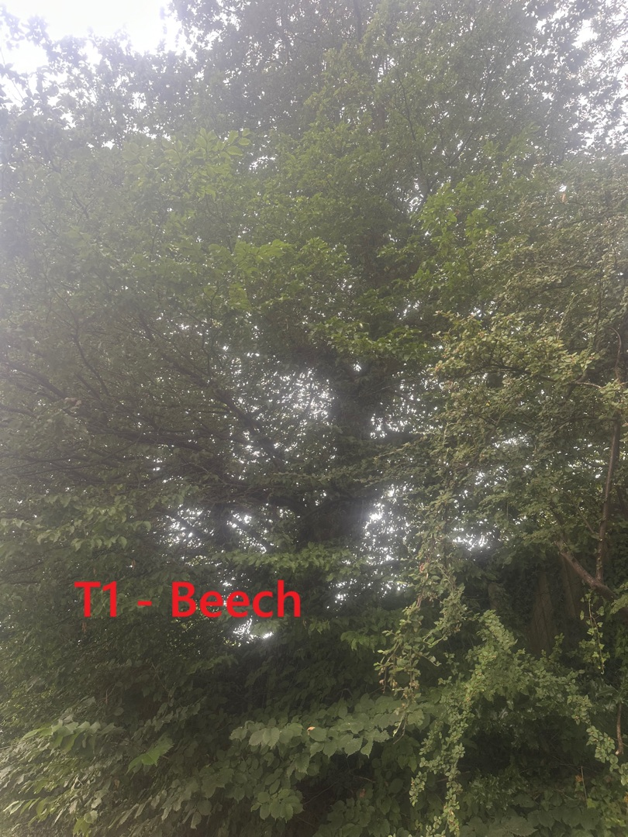
Hornbeam

R. Slack
Mr R. Slack cert Arb L2 (ABC)

