Common Walls: International Mural Festival Drawing Number: CW(SK)001
Hogarths Mural Design Proposal, by mural artist Onor www.onurpainting.com/wall
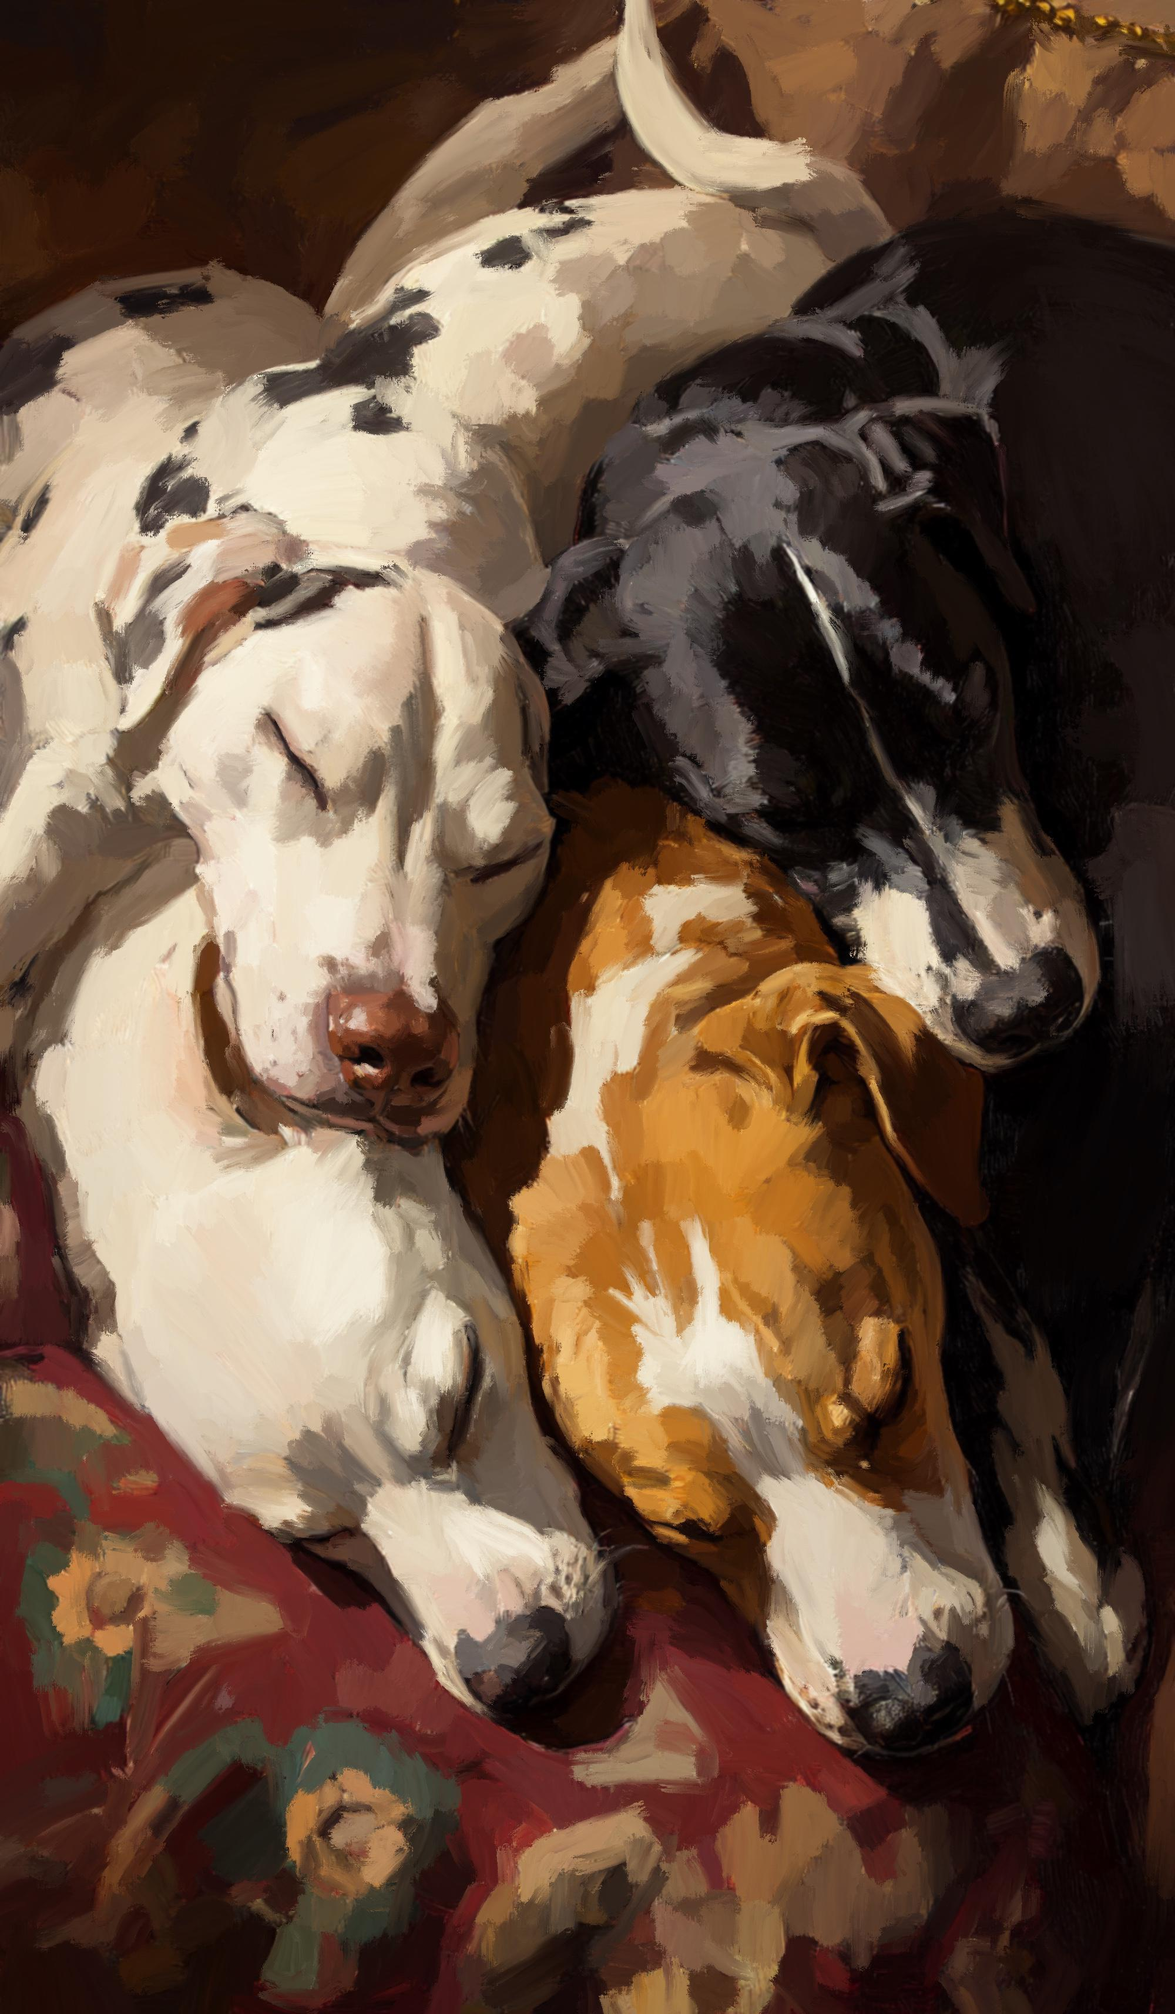
Common Walls: International Mural Festival Drawing Number: CW(SK)001
Hogarths Mural Design Proposal superimposed on building
