DESIGN AND ACCESS
STATEMENT



R T DESIGN
Architectural and Surveying Services

25 Seymour Drive, Bradshaw, Bolton, BL2 3HB

PROPOSED RAISING OF THE
RIDGE AND NEW ROOF AT
2 WALTON STREET, MIDDLETON.

1.0 INTRODUCTION:

This statement is being provided in support of a full planning application for the relacement of the existing roof with a raised ridge height to a house in multiple occupation at 2 Walton Street, Middleton, M24 2GB. It is also proposed to change the internal layout of the HMO from a 3 bedroom HMO to a 4 bedroom HMO, all with en-suite facilities.

DESIGN

Use - The current property has a very low pitched roof that is in a poor condition, with water damage to the first floor due to the leaking roof. This in part could be due to the fact that the roof pitch is too low for the fitted roof tiles to be viable. The current tiles appear to be a Marley Ludlow Major, which according to the Marley roof tile specification should have a minimum roof pitch of 25degrees. The current roof have a roof pitch which is approximately 19 degrees, which during bad weather would cause the tiles to lift in heavy wind allow the rain to get under the tiles.

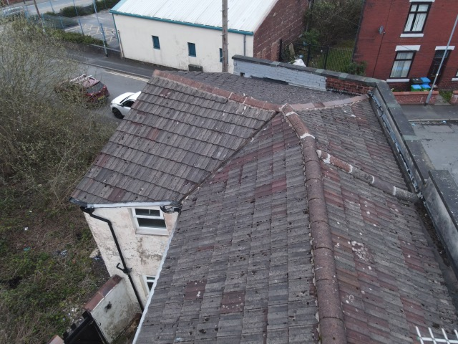

The property is also used as a 3 bedroom HMO with a lounge, kitchen, dining room, 3 bedrooms and a bathroom.

Amount – It is proposed that, due to the damage to the roof, it is to be totally replaced, with the ridge height increased, to mprove the roof pitch and also remove the low parapet walls to the front elevation which would remove the internal valley gutter, again reducing the risk of water damage.

The proposed alterations have been discussed with the owners of the adjacent property at 4 Walton Street, which has the same pitch roof, but the owners have decided to keep with the existing roof. Having been informed of the changes, which would also include the raising of the party wall to accommodate the increased ridge height, they have had extensive discussions with the applicant and are fully supportive of the proposals.

Layout – Due to the increased height of the ridge, the party wall between 2 and 4 Walton street would need to be built up to form a parapet wall between the two roofs which would then have a stepped flashing dressed into the party wall to suit the different heights of the two roofs.

The internal layout of the house will be as shown on the layouts which will provide a better standard of accommodation for the tenants. The changes will also be in line with the requirements of the Rochdale Borough Council Strategic Housing Services HMO Standards guidlelines.

Scale – The new roof will be built up off the existing external walls of the property with the increased roof pitch taken the proposed ridge height 550mm higher than the current ridge height.

Landscaping – The existing small yard will be retained in its’ current format.

Appearance – The existing rendered walls will be repaired and upgraded as required. The new roof will be fitted with Marley Modern tiles which are suitable for the proposed roof pitch. If the existing Marley Ludlow Major tiles were to be used the roof pitch would need to be increased to accommodate the required pitch.

Inclusive access
Access to and within the proposed area will be required to comply with
Building Regulations Part M, covering all aspects of disabled access and use of facilities.

External lighting by all access routes and doorways will be provided by means of passive
detectors to afford better access for the visually impaired.

