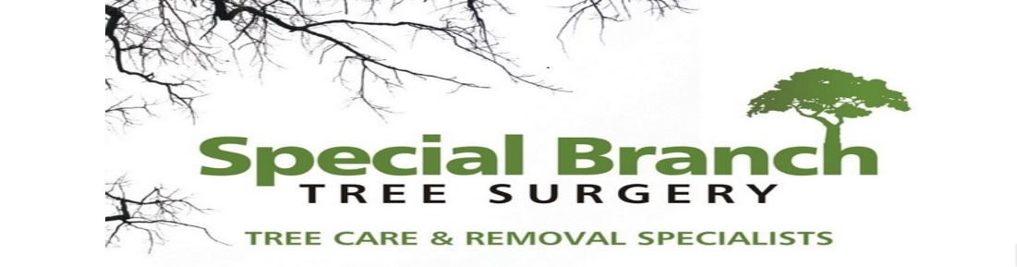

Top O’th Meadow Farm
Meadowhead Lane
Norden, Rochdale
OL11 5UL
Tel: 01706 658771

3rd August 2025

Report for
Janine Hunter
9 Burwell Close
Rochdale
OL12 6DQ

As requested, please see the completed tree report, as discussed this offers no guarantees as trees are living organisms and can fail at any time. We would also like to advise that no indemnity or insurance cover is offered. This report is in “my opinion” only and covers only the trees that have been inspected.

Trees in question are subject to a Tree preservation order – Unknown

Local authority; Rochdale

Location
Directly behind the rear garden of 9 Burwell Close.

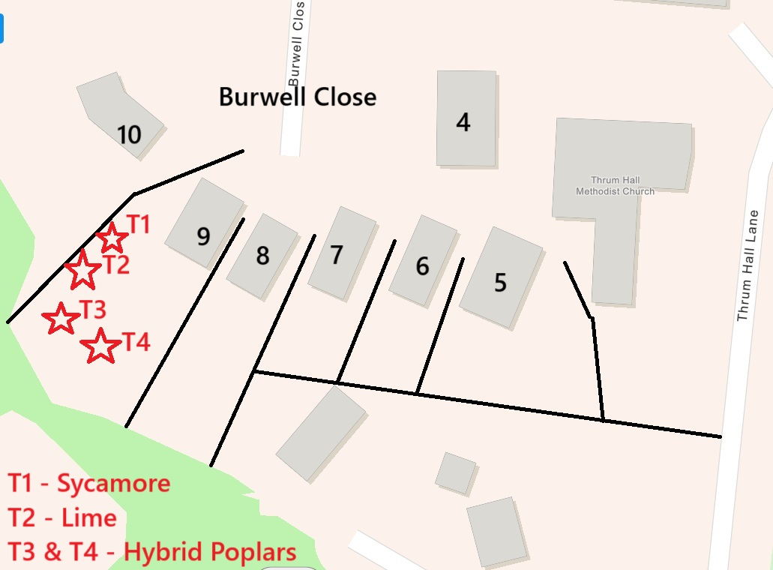

Work provided

Site visit, arboricultural inspection, photography, report, and quotation.
All trees have been thoroughly inspected and only the tree with any defects or concerns have been noted.

Trees included

T1 Sycamore
T2 Lime
T3 Hybrid Poplar
T4 – Hybrid Poplar

Issues found

T1, T2, T3 & T4. Mature tree’s. Casting a lot of shade and the canopy covers a substantial area.

Recommendations

T1, T2, T3 & T4 – Crown lift current canopy to gain another 1.5 meter clearance.

Crown lifting, particularly for T1 - Sycamore, T2 - Lime, and T3&T4 - Hybrid Poplars, provides several ecological and practical benefits while adhering to conservation standards. These tree species often exhibit dense lower branches that can impede light passage and airflow, potentially affecting the health of the understory vegetation and contributing to damp conditions that may encourage decay or disease. By lifting the crown, the improved clearance fosters a better microclimate, promoting biodiversity and enhancing overall ecosystem resilience.
Furthermore, crown lifting enhances the aesthetic appeal and accessibility of the area, improving sightlines for both pedestrians and vehicles. This incremental space created beneath the canopy can be crucial for facilitating maintenance activities and ensuring public safety, especially in areas frequented by people.
Importantly, the mention of adherence to British standards assures that the works will be conducted with meticulous care and precision, safeguarding the vitality and structural integrity of these valued trees. Conducting these operations following best practices ensures that intervention in these protected specimens is both responsible and sustainable, maintaining the ecological balance and visual harmony of the landscape.

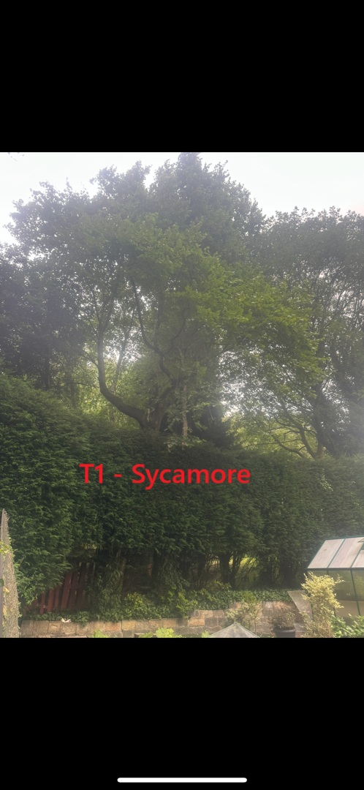
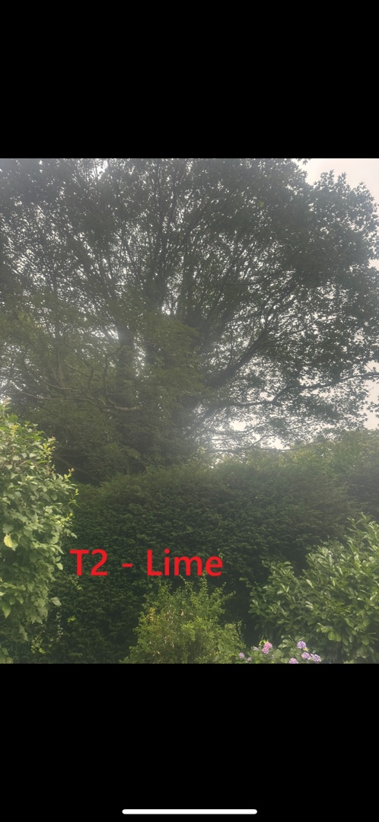
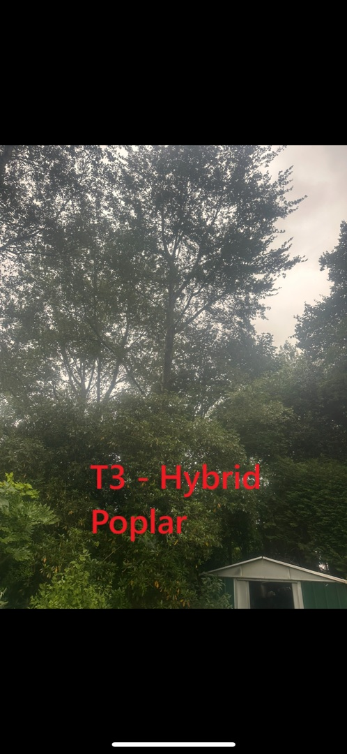

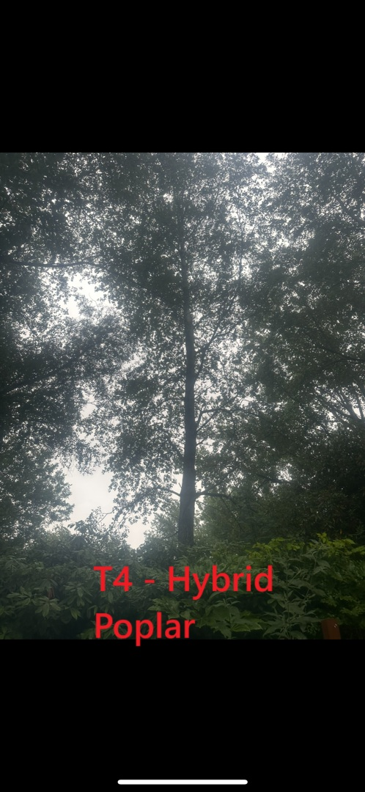

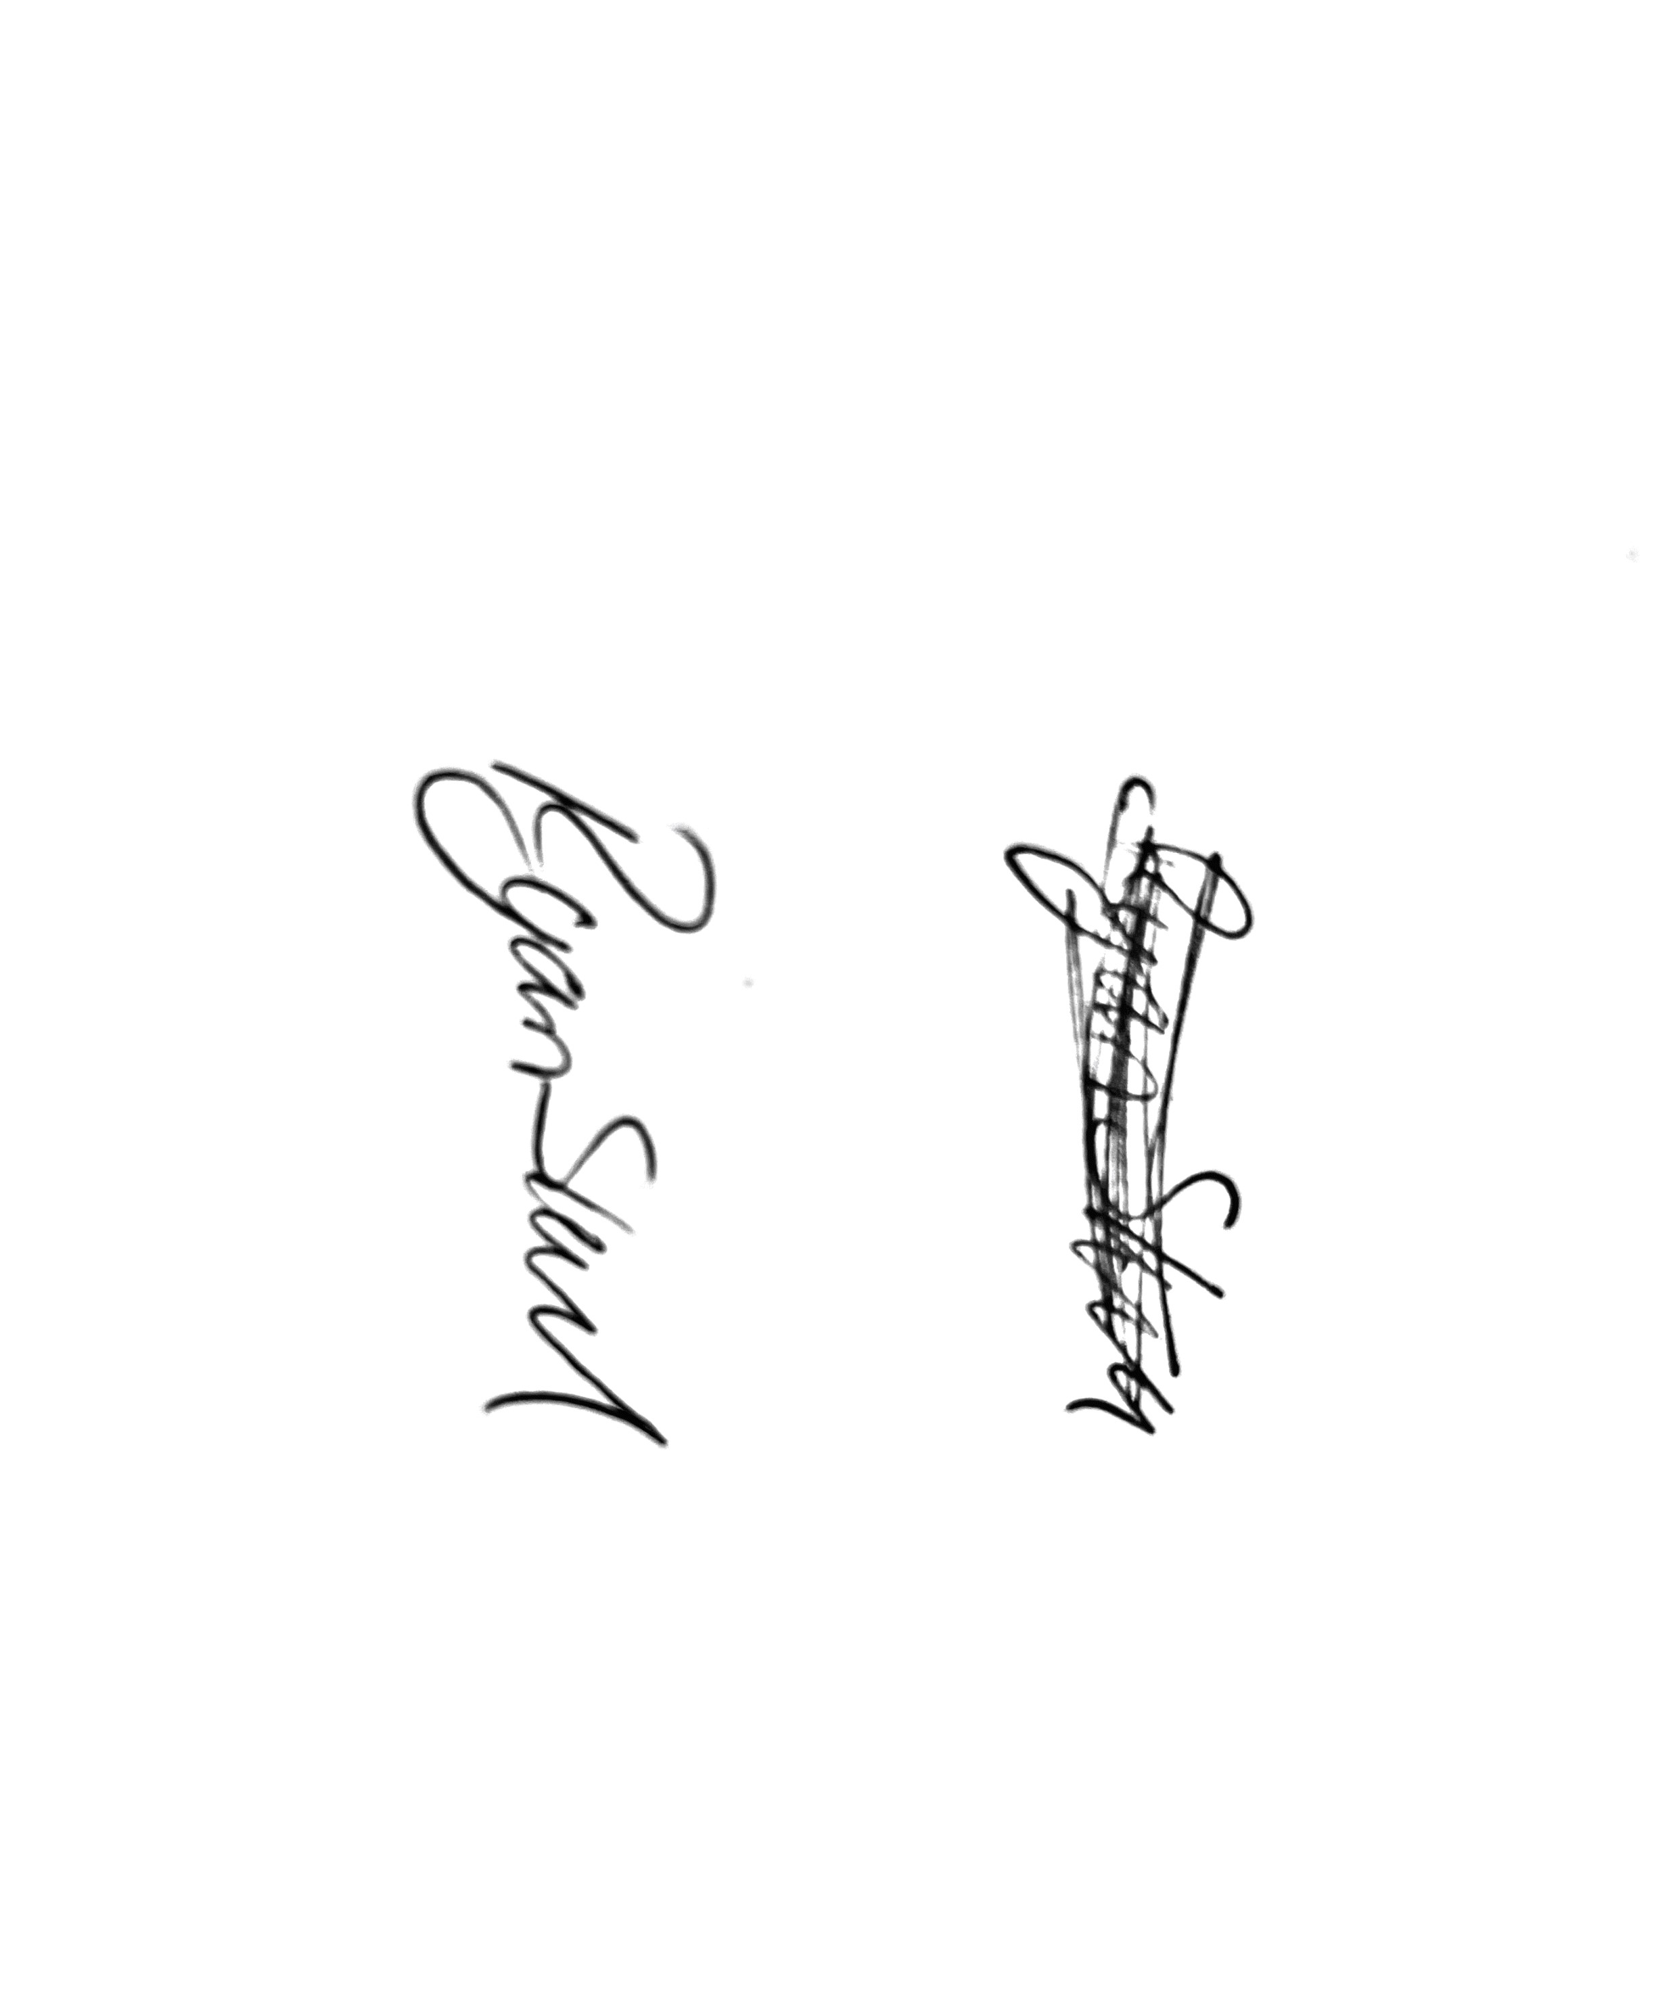
Kind regards,
Mr. Ryan Slack
General Manager and Director
SEG Award, Cert Arb L2 (ABC)

