EV Charger details
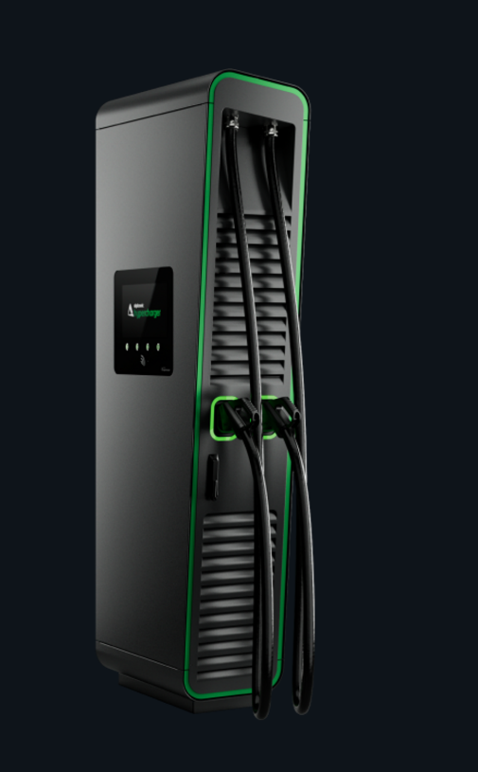

https://www.alpitronic.it/en/hypercharger/hyc-200/

