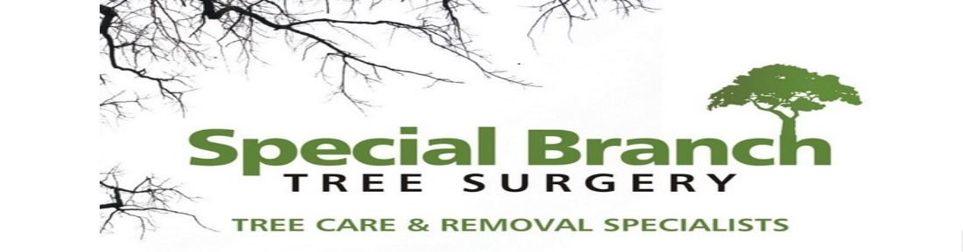

Top O’th Meadow Farm
Meadowhead Lane
Norden, Rochdale
OL11 5UL
Tel: 01706 658771

25th June 2025

Report for
Lesley Whitehead
27 Hargate Avenue
Norden, Rochdale
OL12 7GL

As requested, please see the completed tree report, as discussed this offers no guarantees as trees are living organisms and can fail at any time. We would also like to advise that no indemnity or insurance cover is offered. This report is in “my opinion” only and covers only the trees that have been inspected.

Trees in question are subject to a Tree preservation order – TPO099

Local authority; Rochdale

Location
Rear garden of 27 Hargate Ave.

TPO Ref: TPO099 T5 - Ash

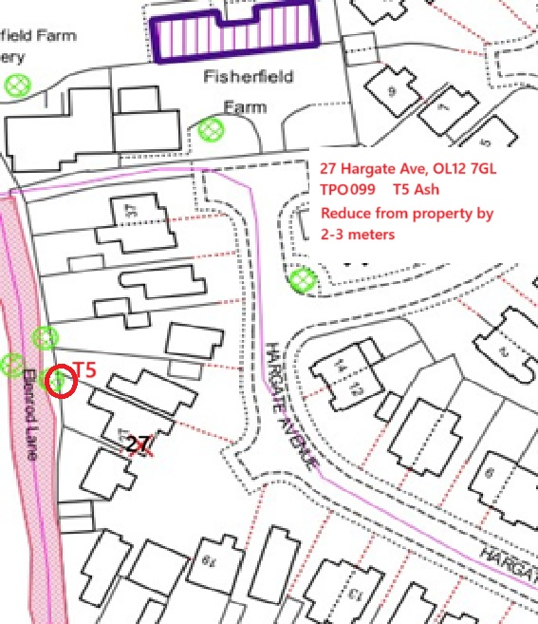

Work provided

Site visit, arboricultural inspection, photography, report, and quotation.
All trees have been thoroughly inspected and only the tree with any defects or concerns have been noted.

Trees included

T5 – Ash

Issues found

T5 – Ash, branches overhanging the garden casting shade and growing over the property.

Recommendations

T5 – Ash, reduce from property by 2-3 meters.

Pruning a T5 Ash tree (Fraxinus excelsior) that is growing too close to a property line is a common practice aimed at maintaining both the health of the tree and the enjoyment of outdoor spaces. Here are several key points to consider regarding this specific situation:

The primary concern here is the excessive shade being cast over the garden area due to the tree's growth. This can hinder photosynthesis in garden plants, leading to stunted growth and reduced flowering.
Additionally, branches extending over property lines can pose safety risks during storms or high winds. Pruning helps maintain an aesthetically pleasing landscape by keeping trees well-managed and appropriately sized.

The recommendation to prune back by 2-3 meters specifically targets the branches growing towards the property. This targeted approach minimises disruption to the overall structure of the tree while effectively reducing shading.
Pruning should ideally be performed during the late winter or early spring when trees are dormant, reducing stress on the tree. Proper techniques include making clean cuts just above a node or lateral branch to promote healthy regrowth.

Pruning within this specified range is unlikely to cause significant stress to the T5 Ash. In fact, judicious pruning can enhance air circulation and light penetration, which may promote healthier foliage.
Ash trees are resilient and can recover quickly from pruning. By removing only the branches that extend towards your property, we allow the tree to maintain its natural shape and structure.

The canopy will remain largely intact, preserving its role in providing habitat for wildlife and contributing to local biodiversity.
A well-pruned tree can enhance landscape aesthetics rather than detract from it. This careful management ensures that both the tree and surrounding garden remain visually appealing.

It’s worth noting that regular maintenance, including pruning, is essential for any urban tree to thrive in proximity to human habitats. While pruning may temporarily alter the appearance of the T5 Ash, it is crucial for balancing ecological health with human enjoyment of outdoor spaces.

Furthermore, consulting with an arborist before proceeding with pruning can provide additional insights tailored to local conditions and specific tree health assessments. This professional guidance ensures that best practices are followed in maintaining both tree health and property enjoyment.

In conclusion, pruning back the T5 Ash by 2-3 meters on the side growing towards your property will effectively reduce excessive shade without compromising its health or amenity value. This approach supports both your gardening interests and the long-term vitality of the tree itself.

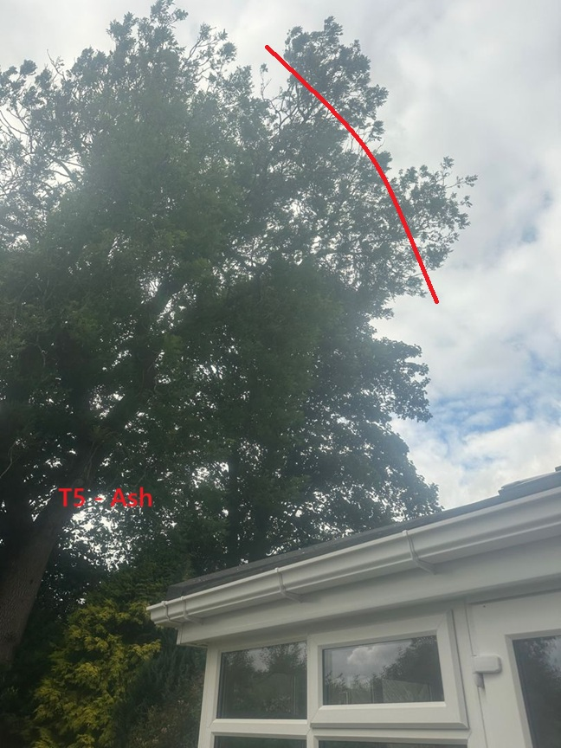

Kind regards,
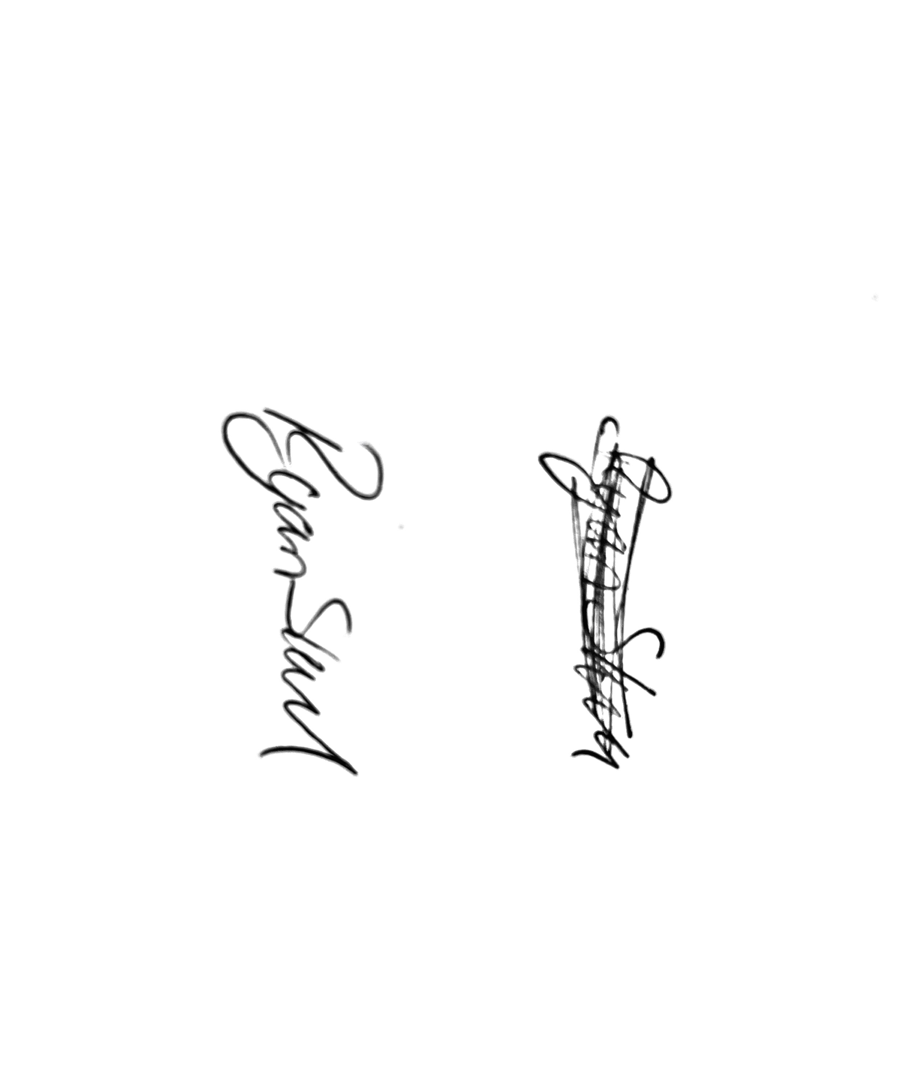
Mr. Ryan Slack
General Manager and Director
SEG Award, Cert Arb L2 (ABC)

