Schedule 2, Part 3, Class R of the General Permitted Development Order, 2021 (as amended) (GPDO)

Prior Notice application for the change of use of an agricultural building to a flexible commercial use. Harwood Fields Farm, Castle Hill Road, Bircle, Rochdale BL9 6UL

Planning Statement

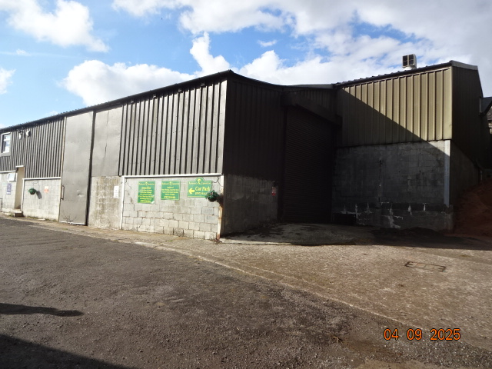

H | P
D | A

November 2025

Prepared by Hartley Planning and Development Associates Ltd
Proposed development
The proposed development is to use 445m2 of an agricultural building for retail purposes in accordance with the terms of Schedule 2, Part 3,Class R of the GPDO

In 2024, approximately 128m2 of space in a building previously used for agricultural purposes at the farm has been used for retail purposes. The LPA were informed of this at the time as required by the GPDO, and details of the use are submitted with the current application.

The applicants now which to cease the use of the above space for commercial purposes under Class E of the Use Classes Order and to relocate such commercial uses to a separate building, using 445m2 for this purpose.

We are content to accept a condition that the present use of the premises for commercial purposes within Class E of the Use Classes Order shall ease no later than the first opening of the alternative premises for such Class E uses.

The prior notice application meets the requirements of the GPDO 2015 (as amended): -

Requirements of the GPDO | Comments with regard to the application building
Class R
agricultural buildings to a flexible commercial use
R. Permitted development  Development consisting of a change of use of a building and any land within its curtilage from a use as an agricultural building to a flexible use falling within one of the following provisions of the Use Classes Order—  (a) Class B8 (storage or distribution) of Schedule 1;  (b) Class C1 (hotels) of Schedule 1; or  (c) Class E (commercial, business or service) of Schedule 2. | The proposed commercial uses would include Class E sales related to the farm enterprise including a small café aimed at visitors to it and for the sale, as previously, for goods associated with the existing adjoining premises.
Development not permitted

Development is not permitted by Class R if—
(a) the building was not used solely for an  agricultural use as part of an established  agricultural unit—  (i) on 3rd July 2012;  (ii) in the case of a building which was in use before that date but was not in use  on that date, when it was last in use, or  (iii) in the case of a building which was brought into use after 3rd July 2012, for a  period of at least 10 years before the date development under Class R begins; | The agricultural building has been in existence for many decades, and has been used for agricultural purposes before, during and since 3 July 2012
(b) the cumulative floor space of buildings which have changed use under Class R within  an established agricultural unit exceeds 1,000 square metres;( area increased to this under the Town and Country Planning (General Permitted Development etc.) (England) (Amendment) Order 2024) | The proposed floor area would be 445m2
(c) the site is, or forms part of, a military explosives storage area; | N/A
(d) the site is, or forms part of, a safety hazard area; or  (e) the building is a listed building or a scheduled monument. | N/A
R.2.  Development is permitted by Class R subject to the following conditions—  (a) a site which has changed use under Class R may, subject to paragraph R.3,subsequently change use to another use falling within one of the use classes comprising the flexible use; | Noted
(b) for the purposes of the Use Classes Order and this Order, after a site has changed use  under Class R the site is to be treated as having a sui generis use; | Noted
(c) after a site has changed use under Class R, the planning permissions granted by Class  E of Part 7 of this Schedule apply to the building, subject to the following modifications—  (i) “curtilage” has the meaning given in paragraph X (interpretation) of this Part;  (ii) any reference to “office building” is to be read as a reference to the building  which has changed use under Class R. | Noted
R.3.—  (1) Before changing the use of the site under Class R, and before any subsequent change of use to another use falling within one of the use classes comprising the flexible use, the developer must—  (a) where the cumulative floor space of the building or buildings which have changed use  under Class R within an established agricultural unit does not exceed 150 square metres, provide the following information to the local planning authority—  (i) the date the site will begin to be used for any of the flexible uses;  (ii) the nature of the use or uses; and  (iii) a plan indicating the site and which buildings have changed use; | N/A
(b) where the cumulative floor space of the  building or buildings which have changed use  under Class R within an established agricultural unit exceeds 150 square metres, apply to the local planning authority for a determination as to whether the prior approval of the authority will be required as to—  (i) transport and highways impacts of the development;  (ii) noise impacts of the development;  (iii) contamination risks on the site; and  (iv) flooding risks on the site,  and the provisions of paragraph W (prior approval) apply in relation to that application. | See below
(2) Subject to sub-paragraph (3), development under Class R of the type described in paragraph R.3(1)(b) must begin within a period of 3 years starting with the prior approval date. | Noted
(3) Where, in relation to a particular development under Class R of the type described in paragraph R.3(1)(b), planning permission is granted on an application in respect of associated operational  development before the end of the period referred to in sub-paragraph (2), then development under Class R must begin within the period of 3 years starting with the date that planning permission is  granted. | Noted
(4) For the purposes of sub-paragraph (3), “associated operational development” means building or other operations in relation to the same building or land which are reasonably necessary to use the building or land for the use proposed under Class R. | Noted

Transport and highways impacts of the development;

There is already good access to and from the premises via Castle Hill Lane. By its limited area, the retail /café element in unlikely to become a destination in its own right, but is rather likely to be used by people already coming to the farm , associated with its activities, especially its equestrian uses

Noise impacts of the development;

The proposed commercial uses would be surrounded by existing buildings in the same ownership and control. By its limited area, there is no reason to believe that noise, either from the proposed or the existing surrounding uses, would have any adverse impact, one upon the other. That has proved to be the case for the existing, similar commercial uses operated since 2024 elsewhere on the farm

Contamination risks in relation to the building

The proposed use is not, like a dwelling, in the most vulnerable category in terms of risk . Moreover, the proposed use is currently operating in another building but within the same complex of buildings.
The previous and existing use of the building is for agricultural storage.
There is no reason to believe that there are any abnormal risks from contamination.

Flood risks in relation to the building.

The proposed development is shown to be in the lowest risk category on the Environment Agency’s map (Zone 1)

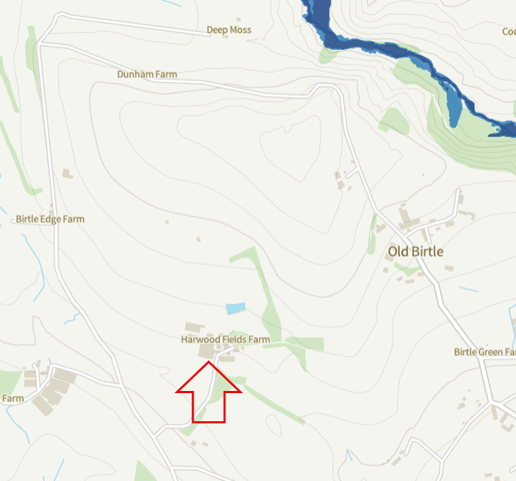

Condition

We are content to accept a condition that the present use of the premises for commercial purposes within Class E of the Use Classes Order shall cease no later than the first opening of the alternative premises for such Class E uses.

Suggested condition
T
The development hereby permitted shall not commence until all parts of the existing use shown on the submitted location plan reference SR.040324.A and relating to Class E of the Use Classes Order 1987 (as amended) has ceased.

