
Highways and Engineering Service - Economy and Environment

Drainage Consultation on Application – 25_00920_DOC Station Sq Rochdale - Drainage Comments
LLFA Consultation Response on behalf of Head of Highways and Engineering
Date of Response: 18th November 2025
Location & Proposed Development
Rochdale Station Square, OL11 1DR
Submission of details to comply with Condition 8 (drainage) on planning permission 22/01551/FUL
Documents Reviewed
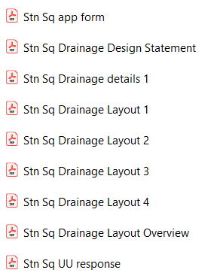
Drainage & Flood Officer Comments
The above documents have been submitted after significant liaison with the LLFA. The submissions are consistent with the liaison discussions, and it is considered the condition can be discharged
Consultation by Keith Mealey
Drainage & Flooding Officer
keith.mealey@rochdale.gov.uk

