
Highways and Engineering Service - Economy and Environment

Drainage Consultation on Application – 25/00929/FUL -

Rochdale Cricket, Lacrosse & Squash Club
LLFA Consultation Response on behalf of Head of Highways and Engineering.
Date of Response: 20th November 2025
Location & Proposed Development
ROCHDALE CRICKET, LACROSSE & SQUASH CLUB
Construction of 6 padel tennis courts (4 covered, 2 uncovered) and new clubhouse building with changing facilities, café and raised terrace area. Creation of new parking spaces and associated boundary treatments
Documents Reviewed
- Drainage Strategy Report - rep-tjba-rochdale padel club-DSR-090625 - Jun 2025
- Existing Site Plan - 25009-006-A - August 2025
- Existing Location Plan - 25009-005-A - August 2025
- Proposed Club House Floor Plans - 25009-008-A - August 2025
- Proposed Club House Elevations - 25009-011-A - August 2025
- Proposed Site Plan - 25009-007-B - August 2025
- Flood Maps
- UU Safe Dig Records

Drainage & Flood Officer Comments
- The proposed development site covers approximately 0.24 hectares and is not located within Flood Zone 2 or Flood Zone 3. However, the Flood Map for Planning indicates that a small area within the site boundary is at risk of surface water flooding. The site does not fall within Heywood or Littleborough, which are the two designated Critical Drainage Areas within the borough. A Drainage Strategy Report has been provided.
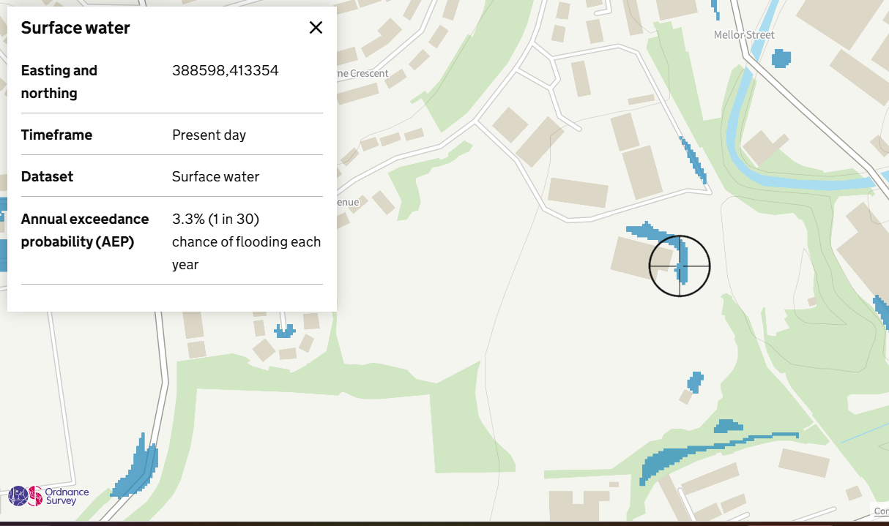

- The aim should be to discharge surface run off as high up the following hierarchy of drainage options as reasonably practicable: The ordered drainage techniques to be assessed with the aim to reduce or omit lower techniques:
- Control at Source (Infiltration / Recycling)
- On Site Treatment (Basins, Swales, Rain gardens, Tree pits)
- Local Treatment (Adoptable Ponds, Basins, Swales etc)
- Regional Treatment (ditto usually to a larger scale)
- Discharge to Watercourses / Bodies
- Discharge to SW Sewers
- Discharge to Combined Sewers
- The Drainage Strategy Report indicates that infiltration and permeable paving will be used across the site; however, no site-based infiltration testing has been undertaken to determine feasibility. Should infiltration be found unfeasible, the report proposes discharge to the Red Brook culvert located approximately 25 m south of the site boundary.

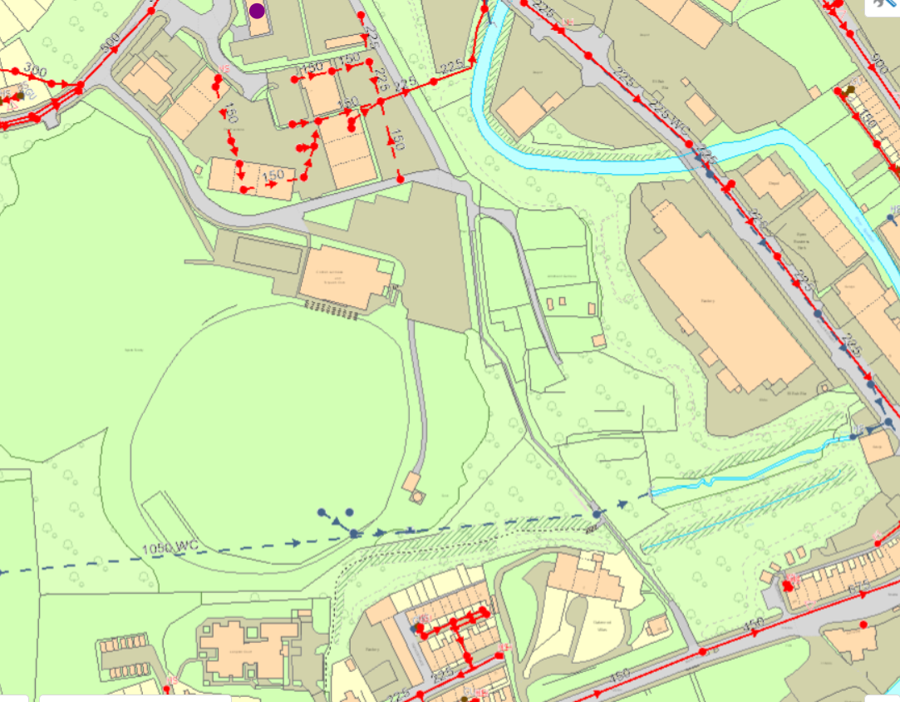

- The design has been based on the 1-in-100-year storm event with a 25% allowance for climate change. Typically, a 45% allowance is required in line with Rochdale LLFA standards.

- The proposals are to discharge foul water from the development to the existing foul sewer network serving the adjacent clubhouse.

- A Maintenance and Management plan for all drainage systems and components is required.

- No detailed drainage layout drawings or finished floor levels have been provided.
Drainage & Flood Officer Summary:

- The drainage proposals are acceptable in principle subject to the above points being addressed during subsequent design stages.

Consultation by Keith Mealey
Drainage & Flooding Officer
keith.mealey@rochdale.gov.uk

