
Highways and Engineering Service - Economy and Environment

Drainage Consultation on Application – 25/01081/DOC - Unicorn Aerobic Fitness Centres
LLFA Consultation Response on behalf of Head of Highways and Engineering
Date of Response: 2nd December 2025
Location & Proposed Development
Unicorn Aerobic Fitness Centres Cheetham Street Middleton M24 4DG
Submission of details to comply with condition 3 - Drainage design: Sustainable surface water drainage scheme and a foul water drainage scheme detail; condition 4 - Boundary Treatment Details and condition 5 - Hard Landscaping Details of planning permission 24/01037/FUL.
Documents Reviewed
FUL:
- Sustainable Drainage Strategy, dated 23/09/24
- LLFA Review for 24/01037/FUL
DOC
- Drain services inspection report - 01/02025
- Drainage Strategy Plan - 2982-BCL-00-XX-DR-001-P03
- Micro Drainage Report
- Proposed Exploratory Hole Location Plan - GRO-25231-P01
- Soil Percolation Testing
- SuDS Management & Maintenance Plan for Private Drainage -
2982-BCL-00-XXRP-D-001-P02
Drainage & Flood Officer Comments
- Initial review comments originally provided in response to planning application 24/01037/FUL identified that the primary drainage strategy to use infiltration was considered acceptable in principle, subject to site-based testing and detailed design. However, the secondary strategy to discharge to combined sewers if infiltration was found not to be feasible, was not acceptable in principle. Records indicated the presence of culverted watercourses or public surface water sewers within 100m of the site, and any proposed discharge to these would require comprehensive investigation.

- The aim should be to discharge surface run off as high up the following hierarchy of drainage options as reasonably practicable: The ordered drainage techniques to be assessed with the aim to reduce or omit lower techniques:
- Control at Source (Infiltration / Recycling)
- On Site Treatment (Basins, Swales, Rain gardens, Tree pits)
- Local Treatment (Adoptable Ponds, Basins, Swales etc)
- Regional Treatment (ditto usually to a larger scale)
- Discharge to Watercourses / Bodies
- Discharge to SW Sewers
- Discharge to Combined Sewers

- The new drainage layout submitted as part of the discharge of conditions application indicates that surface water from the northern roof elevation will be collected via three rainwater downpipes discharging into a proposed combined drain running west to east along the northern site boundary. This sewer connects to a proposed manhole (CW05), which will tie into the existing combined sewer network on Cheetham Road.

Surface water from the southern part of the site will be managed via rainwater downpipes, permeable paving serving the parking areas, and Polypipe Permavoid diffuser units located around the car park. These will convey runoff to an attenuation tank, which discharges through a flow control unit restricting outflow to 5 L/s. The controlled discharge then enters a proposed combined dain, flowing to the proposed manhole (CW11) before ultimately connecting to the existing combined sewer network on Cheetham Road.

- The drainage layout described above is not acceptable in principle.
- Infiltration testing has been completed, and reasonable rates were obtained which are greater than those assumed at FUL
- Trial holes indicate sandy soils and no water strikes.
- However, the strategy on the layout drawing discounts soakaways due to spatial constraints. The site is the same footprint as at Full application and space was not used as an excuse at that stage and is not acceptable now. The tank footprint is similar to the 6mx6m estimate for a soakaway at FUL. In addition, there appears to be reasonable space for a soakaway in a similar location to the tank (see sketch).

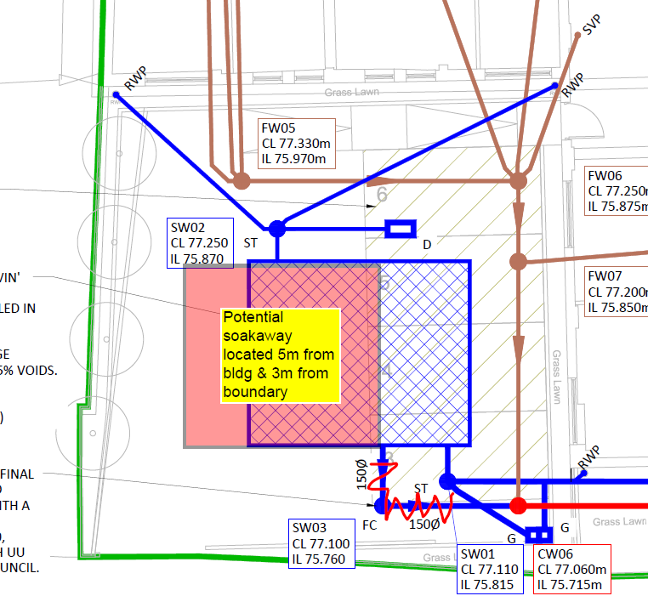
- In addition, the initial review clearly advised that if infiltration was not viable then discharge to a watercourse which is considered to be within reasonable proximity for a development of this scale (see sketch), would need to be assessed There is no evidence that this investigation has been undertaken.

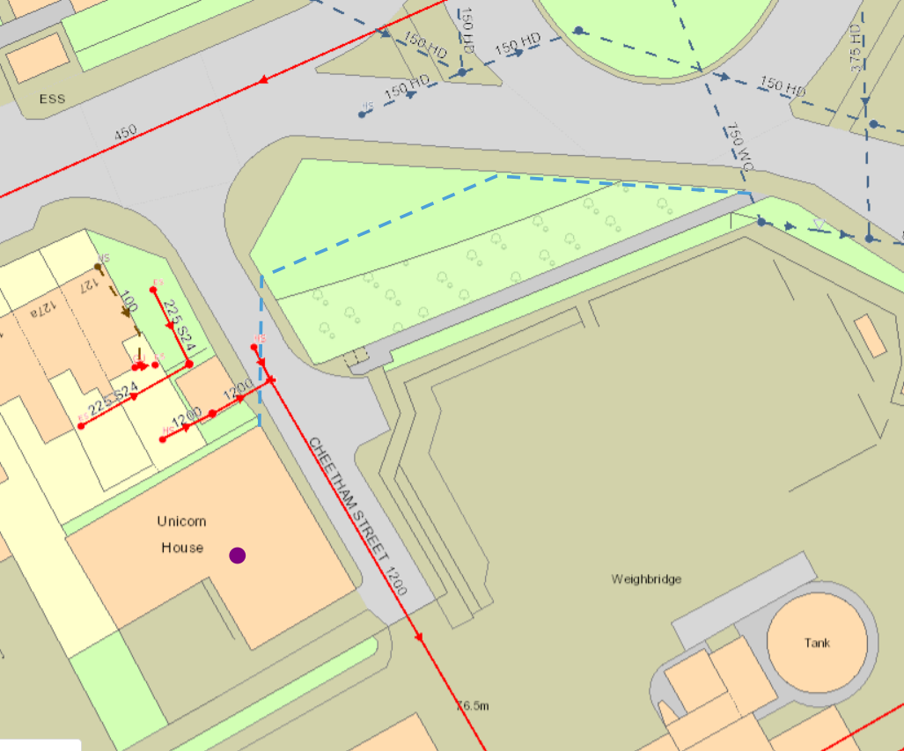

- The proposal to discharge the northern roof unrestricted to a combined sewer is also not acceptable. The maximum discharge from the site from all sources is limited to 5l/s. Separate foul and surface water drainage systems should be provided, private combined drainage is not acceptable

- It is not clear how the diffuser unit is intended to operate. Diffusers are normally to distribute the received flow. It is not clear from the drawings if the diffuser unit is receiving and then diffusing flows from the rwps.
Drainage & Flood Officer Summary:
- The revised DOC strategy is not acceptable in principle.
- The DOC strategy has not addressed comments from the initial FUL review.
- Results suggest infiltration is viable and should be further assessed.
- Records indicate culverted a watercourse within reasonable proximity and discharge would need to be comprehensively investigated.
- The site drainage requires full separation and clarity of flows routes / treatment.
- The above points should be addressed before the condition can be discharged.

Consultation by Keith Mealey
Drainage & Flooding Officer
keith.mealey@rochdale.gov.uk

