
Highways and Engineering Service - Economy and Environment

Drainage Consultation on Application – 25/00339/FUL – Sparth House, 185 Manchester Road, Rochdale, OL11 3QY
LLFA Consultation Response on behalf of Head of Highways and Engineering
Date of Response: 26th November 2025
Location & Proposed Development
Sparth House, 185 Manchester Road, Rochdale, OL11 3QY
Erection of 74-bed care home development, including creation of new access, car parking, landscaping and other associated works following demolition of Sparth House
Documents Reviewed
- Surface Water and Foul Water Drainage Strategy Incorporating an Assessment of Flood Risk, prepared by Reid Jones Partnership, Ref: 11610, Rev P2 Oct 2025.
- Proposed Drainage GA 11610_400_P4
Previous Review 23/07/25Documents Reviewed
- Surface Water and Foul Water Drainage Strategy Incorporating an Assessment of Flood Risk, prepared by Reid Jones Partnership, Ref: 11610, July 2025.
- General Arrangement Plan UG-2266-LAN-GA-DRW-101 rev P04
Drainage & Flood Officer Comments
- The updated strategy has assessed infiltration and discharge to a water course and discounted them as options.

- However, the SuDS manual identifies 1x10⁻⁶ m/s as a minimum and parts of the site are greater than this value. Even if a full infiltration solution is not feasible shallow diffuse infiltration may still be viable. It is noted that the existing site has significant vegetated / green areas which do not appear to have water logging issues. The proposed development should aim to mimic existing natural drainage regimes as much as possible.

- The SuDS hierarchy description within the strategy is inaccurate. The first stage of the SuDS hierarchy as previously advised is to consider infiltration / recycling, (a recent update of the hierarchy now lists recycling ahead of infiltration). However, recycling has not been discussed. This is considered to be more significant when discharge is to a combined sewer. Therefore, if discharge to combined sewer is found to be only viable solution, then options for harvesting and recycling water for weather independent usage such as WC flushing may need to be considered in order to mitigate overall volumes.

- The report indicates the local water course has been surveyed but no data has been provided. It advises that the watercourse is not suitable to receive the site runoff. However, the supporting argument for this conclusion are not provided. The photos suggest quite a significant channel (see below) and it is unclear why a quite nominal 2.1l/s discharge from the site would be an issue.
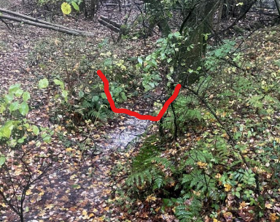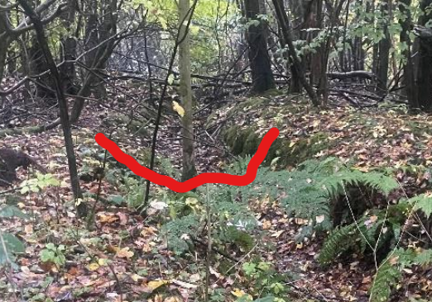

- The layout and revised strategy still do not incorporate any green surface-based SuDS control features such as swales, raingardens / hydro-planters, tree pits etc. Traditional buried storage solutions are not considered to be the most sustainable approach.

Drainage & Flood Officer Summary:
It is considered that the points from the previous review are not adequately addressed. To reiterate:
- The proposal is not acceptable in principle. Before discharge to a combined sewer can be accepted the applicant must provide evidence that
  - infiltration in any form is not feasible.
  - no alternative outfall such as a watercourse is achievable.
  - In addition, the use of SuDS source control features should be explored to support water quality, amenity, and biodiversity objectives.
- If discharge to combined sewer is found to be only viable solution, then options for harvesting and recycling water for weather independent usage such as WC flushing may need to be considered.
- Confirmation from United Utilities of acceptance of surface water discharge to the combined sewer.
- Consideration of on-site SuDS measures (e.g. permeable paving or landscaped treatment areas).
- Submission of a detailed maintenance and management plan for all drainage infrastructure.

Consultation by Keith Mealey
Drainage & Flooding Officer
keith.mealey@rochdale.gov.uk

