
Bowlee Primary School
Prior Approval Supporting Information

Date completed; 13th Oct 2025 Amended: 13th Oct 2025

Site Address: | Windemere Road, Middleton, M24 4LA
Solar PV Installation Overview | 138.86 kWp installation consisting of 262 x 530W PV Modules
Permitted Development Information | Solar PV modules must not protrude more than 0.2m beyond the plane of the roof slope when installed on a pitched roof  Solar PV modules must not protrude more than 1 meter above the highest part of the roof when installed on a flat roof  The solar PV equipment must not be installed within 1 meter of the external edge of the roof  Further information can be found at https://www.legislation.gov.uk/uksi/2015/596/schedule/2/part/14/crossheading/class-j-installation-or-alteration-etc-of-solar-equipment-on-nondomestic-premises
Roof type | Pitched Roof Design
Mounting System type | Clenergy Standing Seam (additional information below)
Site / Design Images and Information
Project Overview | 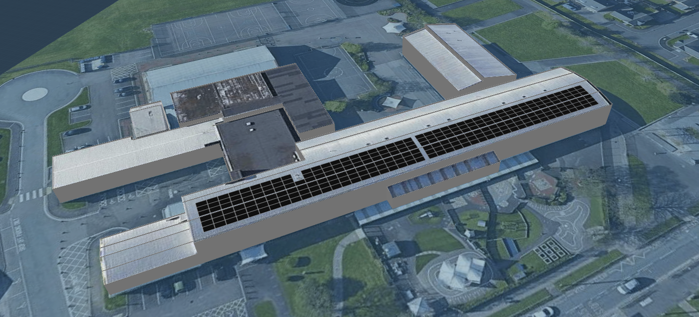
Site Location | 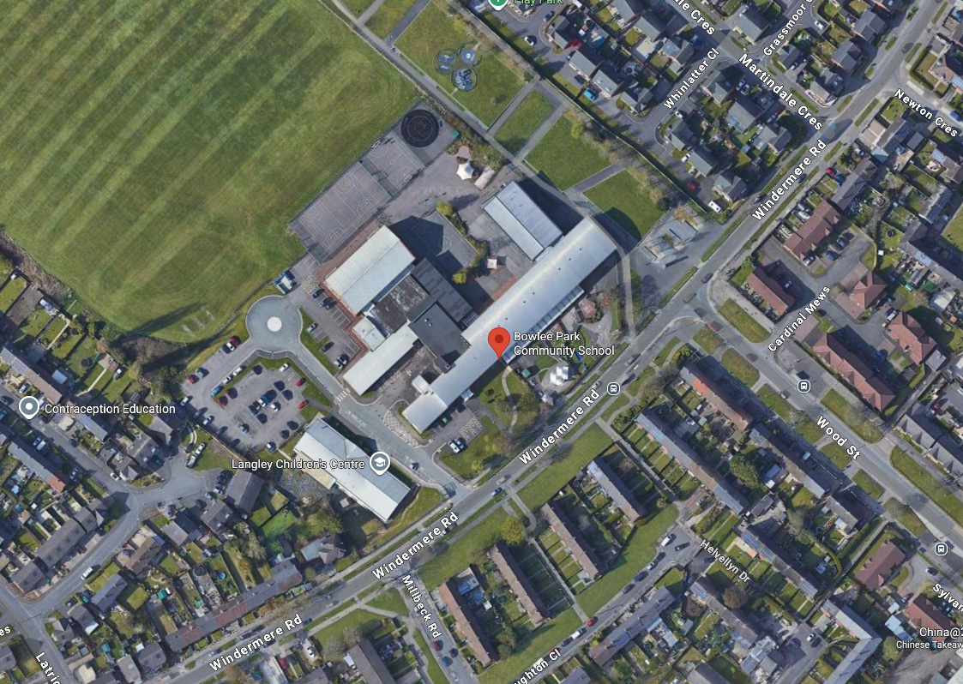
Site Modelling | 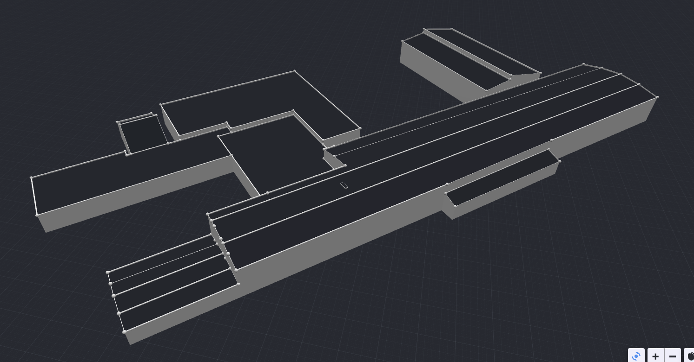
Roof Plan (Including dimensions) | 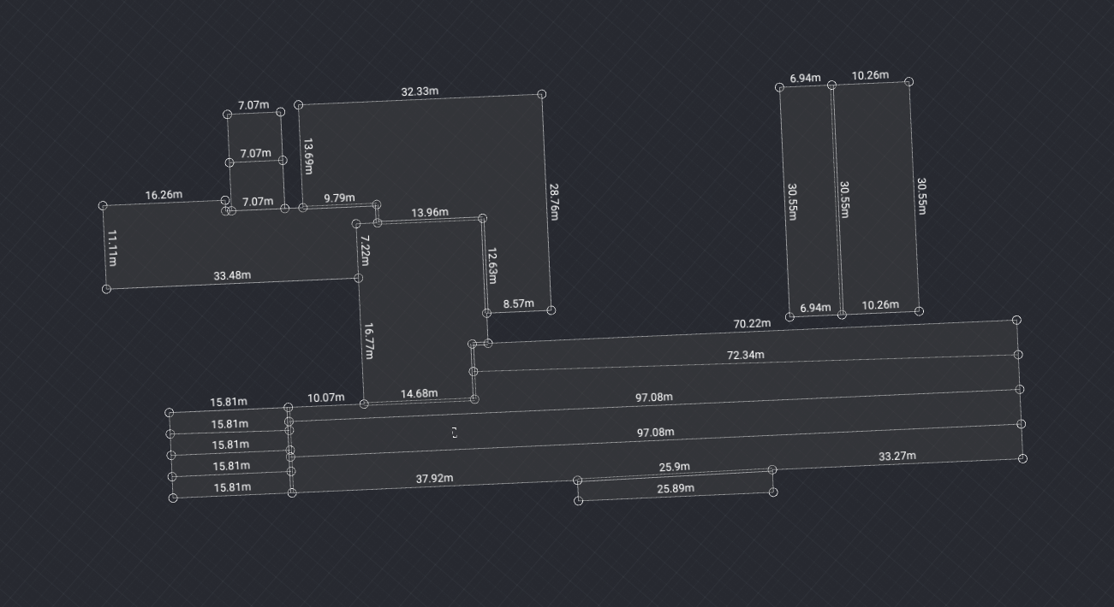
Roof Elevation Identification Plan | 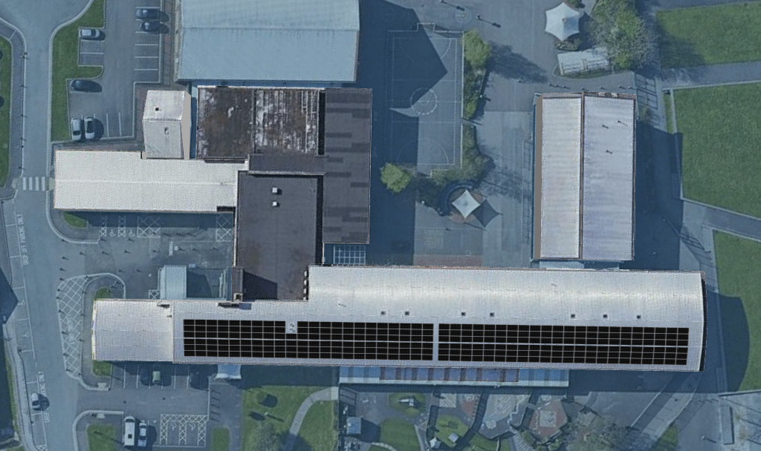  1
Module installation plan (including 1m perimeter)  Elevation 1  Additional images shown in appendix A | 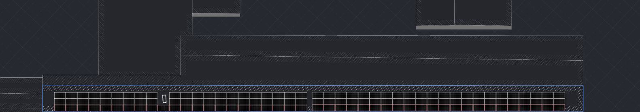  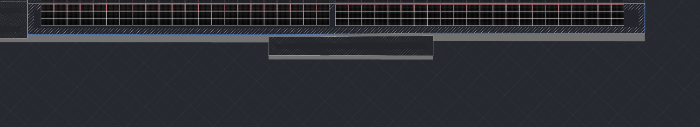
Module Dimensions | Length - 2063 mm / Width - 1134 mm / Frame Depth - 30mm  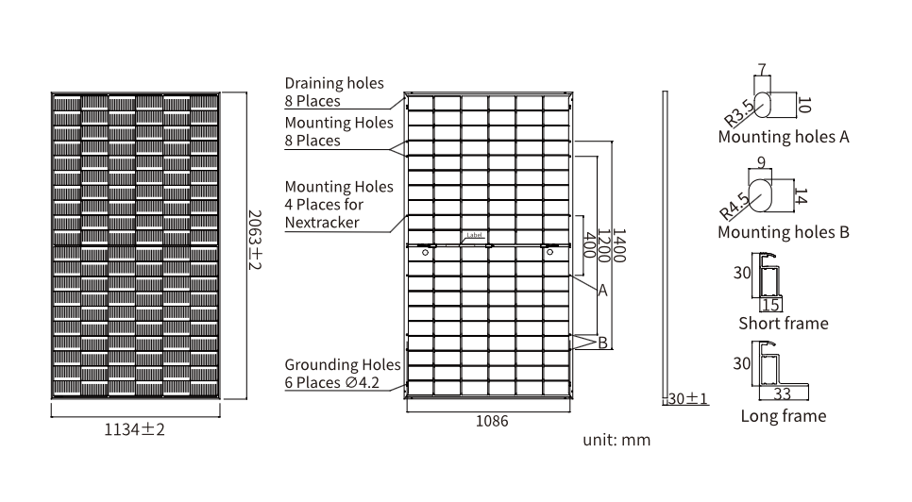
Mounting Dimensions | 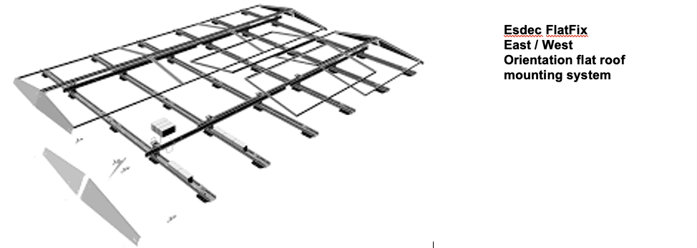  Finished protrusion height of solar panels above existing roof plane - <0.5m  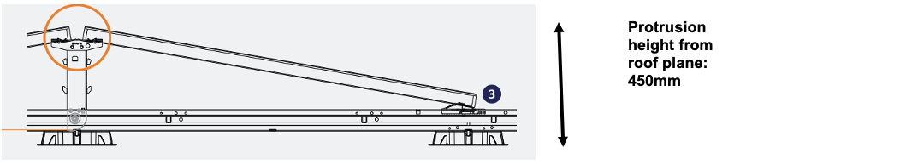

System Declaration

I confirm that the above information is true and accurate and that to the best of my knowledge the project specification outlined above satisfies the requirements of the Town and Country Planning (General Permitted Development) (England) Order 2015 (Update 21/12/2023) Class J – Installation or alteration of solar equipment on non-domestic premises.

Signed



Ben Nuttall
System Designer
NPS Energy Ltd
Completion of report

Appendix A

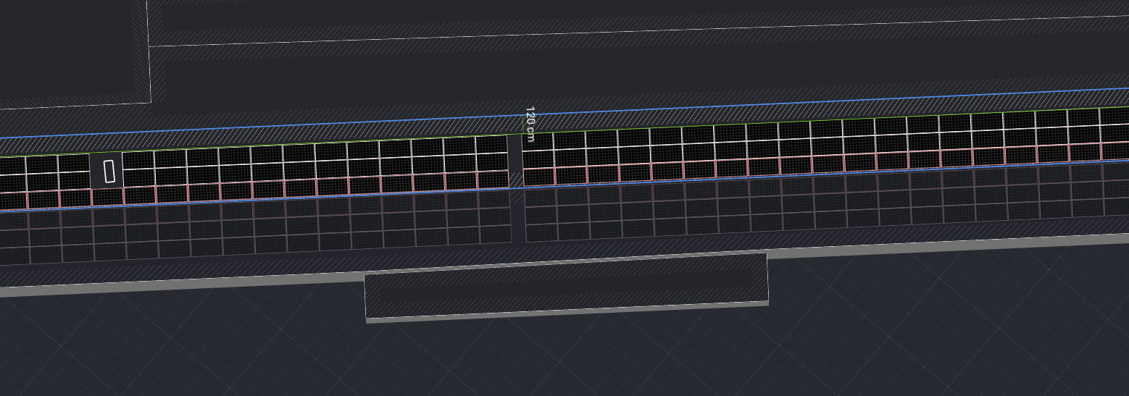 This image shows the panels are 120cm from external edge A.
C
A

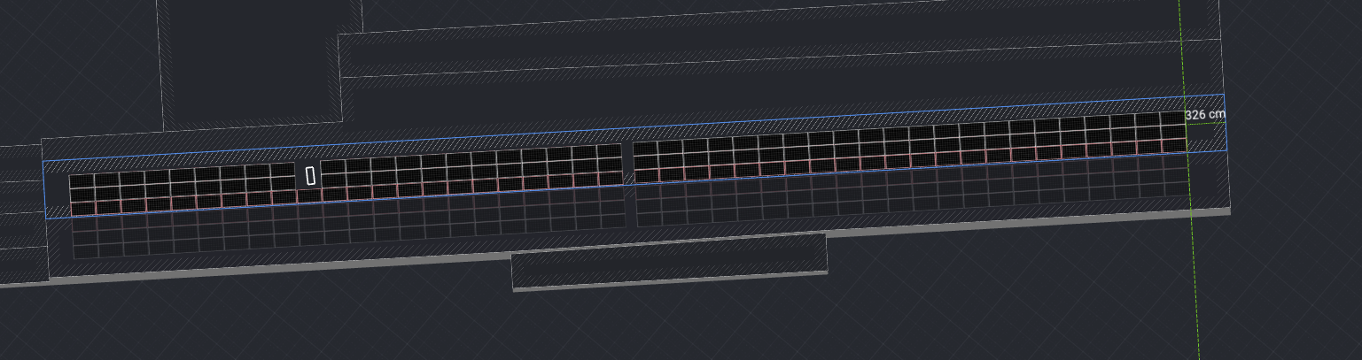 This image shows the panels are 326cm from external edge B.
D
C
B
A

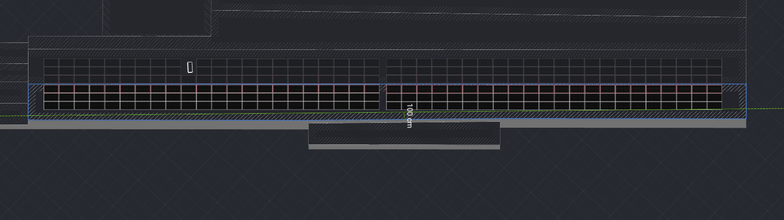 This image shows that the panels are 100cm from external edge C.
C
D
B
A

A
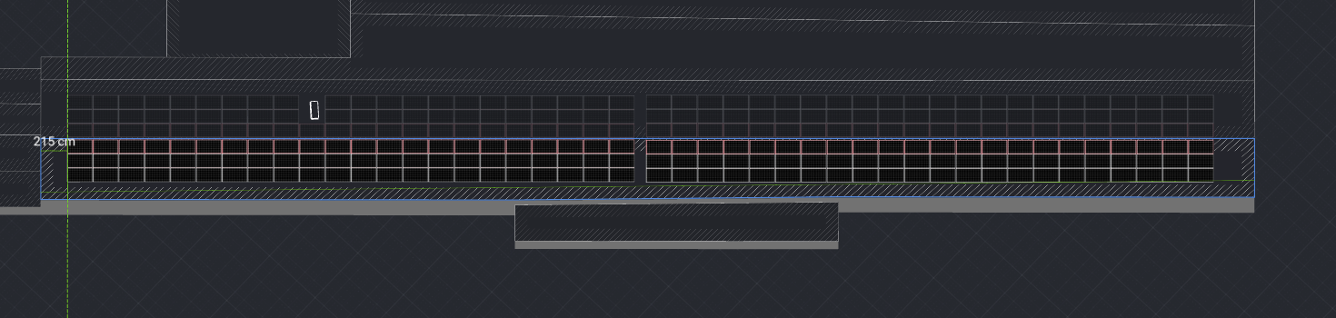 This image shows that the panels are 215cm from external edge D.
D
C
B

