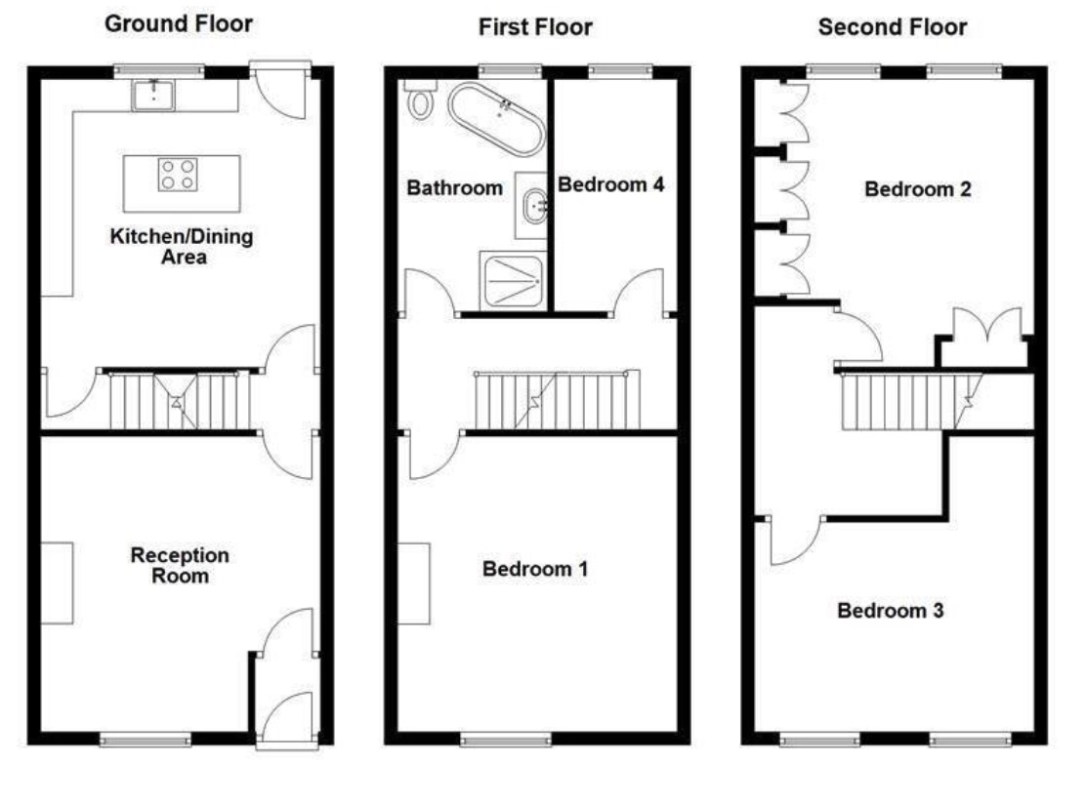

Floor plan 34 Rooley Moor Road.

Windows/Doors (in metres)

Ground Floor | Window 1 | Window 2 | Window 3 | Window 4 | Window 5 | Door
Kitchen | 1.067x0.60 | 1.067x0.62 | 1.067x0.60 | N/A | N/A | 1.89x0.97
Reception Room | 1.48x1.28 | N/A | N/A | N/A | N/A
First Floor
Bathroom | 1.068x0.627 | 1.068x0.636 | N/A | N/A | N/A | N/A
Bedroom 4 | 1.09x0.65 | 1.09x061 | N/A | N/A | N/A | N/A
Bedroom 1 | 1.447x1.341 | N/A | N/A | N/A | N/A | N/A
Second Floor
Bedroom 2 | 1.024x0.64 | 1.024x0.63 | 1.024x0.593 | 1.024x0.635 | 1.024x0.60 | N/A
Bedroom 3 | 1.078x0.607 | 1.078x0.646 | 1.078x0.644 | 1.078x0.619 | N/A | N/A

Ground Floor

Kitchen Windows
Window 1 (Right)
1.067x0.60

Window 2 (Centre)
1.067x0.62

Window 3 (Left)
1.07x0.60
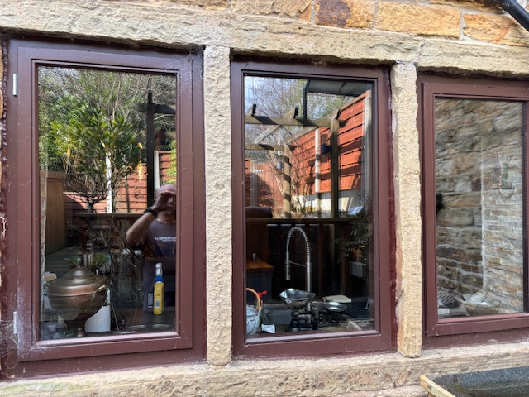

Kitchen Door
Back Stable Door
1.890x0.970
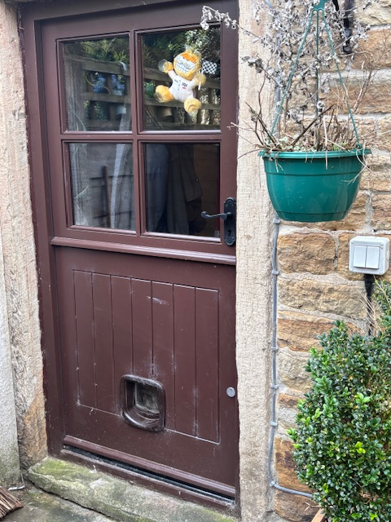

Bathroom & Bedroom 4 Windows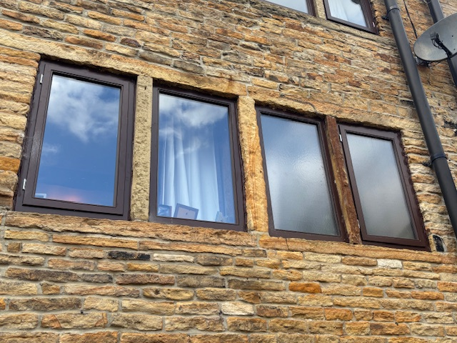
Bathroom
Window 1 (Right)
1.068x0.650

Window 2 (Left)
1.067x0.640

Bedroom 4
Window 1 (Right)

1.092x0.650
Window 2 (Left)
1.092x0.61

Bedroom 1 Window
Bedroom 1

1.476x1.285

(No Central Mullion)
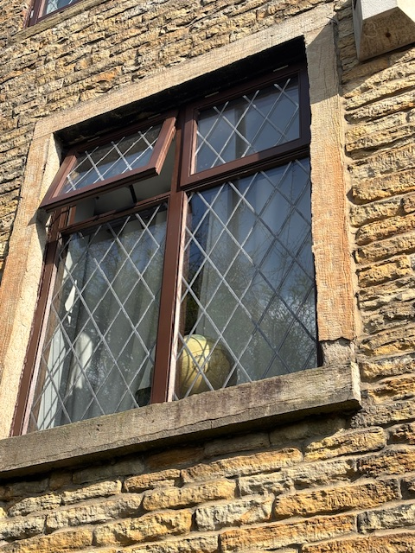

Bedroom 3
Window 1
1.078x0.607

Window 2
1.078x0.646

Window 3
1.078x0.644

Window 4
1.078x0.619

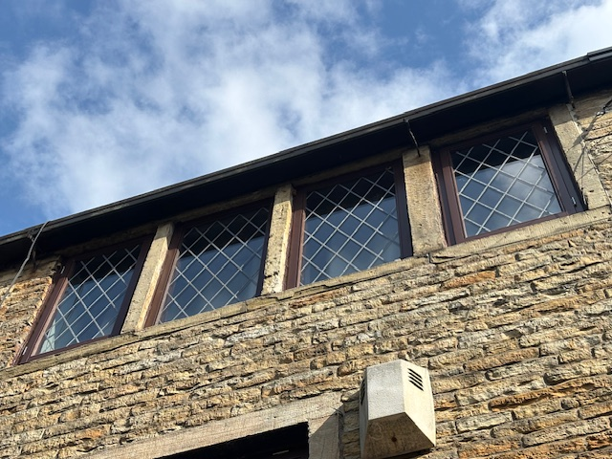

Bedroom 4
Window 1
1.0078x0.636

Window 2
1.067x0.627

Window 3
1.078x0.593

Window 4
1.078x0.635

Window 5
1.078x0.600
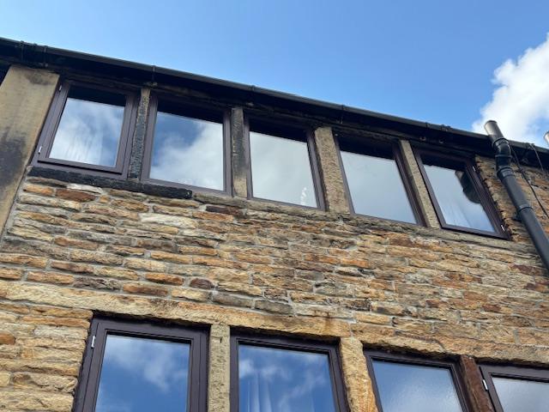

Front Door (Size TBC)

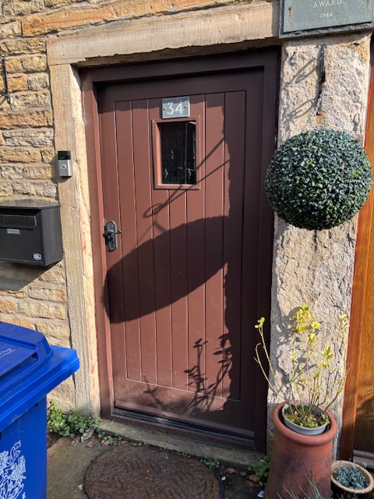

Product Specification

All windows were replaced with Sapele Hardwood and colour-matched to the existing windows. A drawing of large scale cross section has been provided below. All front windows have been replaced with faux leaded as per the originals.. Glazing is 14mm (4/6/4) to comply with the regulations for traditional/heritage DG. Coloured sealant was used rather than cement for pointing purposes.

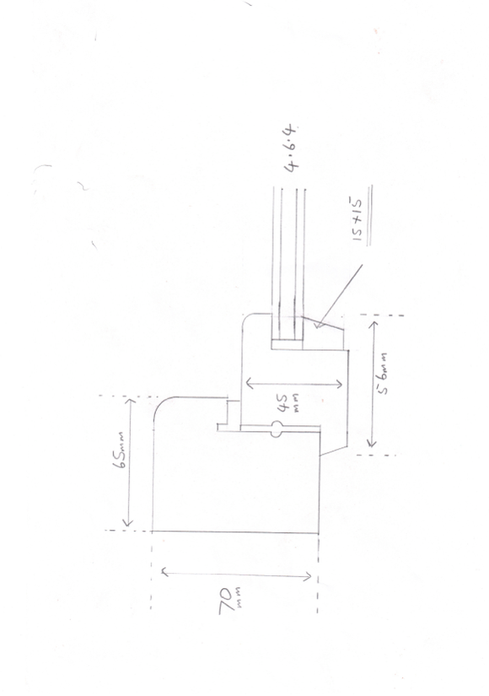

Old windows. I have attached copies of the old (1986) windows and UPVC door for reference.
