Proposed agricultural storage building, Moorside Farm, Nick Road Lane, Wardle
OL12 9PW

Planning Statement

Ref: MDH. 230226

H | P
D | A

March 2026

Prepared by Hartley Planning and Development Associates Ltd

Proposed development
The proposed development is for an agricultural storage building for farm equipment and hay on land at the above farm.

The appellants have very recently bought the farm, having moved from a farm relatively close by at Fold Head Farm in Whitworth which has some 17 acres (7 ha) and where planning approval was applied for and granted to them for an agricultural building by Rossendale Borough Council in July 2023. (Reference 2023/0129). The building has been constructed,

They have brought some of their animals with them to Moorside Farm.

The landholding at the farm extends to some 11ha, comprising 7ha at Moorside Farm plus 4ha of land South of Acre Street, Whitworth, the latter being some 0.9 miles away in a straight line: -

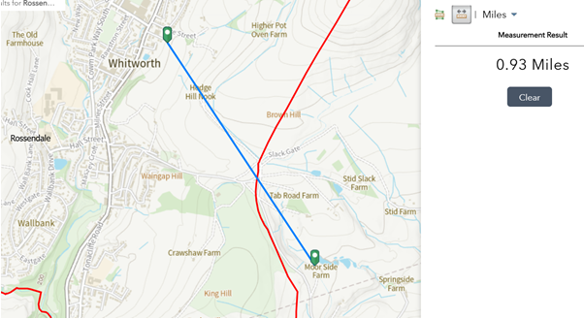

The proposed building would be sited adjoining the farmhouse.

It would be 27.5 metres by 15 metres (412.5m2), with a height to the ridge of 5.1 metres. External walls would be 2-metre-high concrete panels with Yorkshire boarding above (stained in a natural colour). The roof would be corrugated mineral fibre boarding.

The application site is within the Green Belt

Recent Planning History

Application 25/00996/AGR for the same development was recently submitted under Class A, Part 6 of Schedule 2 of the Town and Country Planning (General Permitted Development) (England) Order 2015 (as amended).

It was refused by the local planning authority on 27b October 2025 for the following reason: -
‘The application is not supported by evidence which is sufficiently precise or unambiguous in order to demonstrate that the proposed barn, on the balance of probabilities, would be reasonably necessary for agriculture and therefore fails to comply with the requirements of Class A of Part 6, Schedule 2 of The Town and Country Planning (General Permitted Development) (England) Order 2015 (as amended)’.

The subsequent appeal reference APP/P4225/W/25/3375119 was refused on 9 February 2026 with the Inspector concluding that ‘I am therefore unable to conclude that the site is agricultural land and therefore whether the development is reasonably necessary for the purposes of agriculture and can only fairly conclude that the proposal does not benefit from the Class A of Part 6 rights’.

The main issues
The main issues are (i) whether the proposal would be inappropriate development in the Green Belt; (ii) the agricultural use of the land ; (iii) the effect of the development upon the character and appearance of the area; (iv) the need for the proposed development , and (v) whether any harm by reason of inappropriateness, and any other harm, is clearly outweighed by other considerations so as to amount to very special circumstances required to justify the proposal.

Whether inappropriate development
Policy G4 of the Rochdale Core Strategy 2016 (CS) states that ‘Development will be restricted to those limited types of development which are deemed not to be inappropriate by national planning policies unless very special circumstances can be demonstrated’.

Policy JP-G9 of the Greater Manchester Places for Everyone 2024 (PfE) has little to say about development in the Green Belt other than referring to the 5 purposes of the Green Belt as outlined in national policy, and also that ‘ the beneficial use of the Green Belt will be enhanced where this can be achieved without harm to its openness, permanence or ability to serve its five purposes’. There is no reference to those exceptions which might be not inappropriate in the Green Belt, and as stated in national policy.

Paragraph 153 of the National Planning Policy Framework 2025 (the Framework) states that inappropriate development is, by definition, harmful to the Green Belt and should not be approved except in very special circumstances. However, paragraph 154 lists certain categories of development which form an exception to the general policy of restraint. Part (a) of that paragraph relates to ‘buildings for agriculture and forestry’.

The exception does not require an assessment of the impact in terms of openness or upon the purpose of the Green Belt.

As the proposed development is not inappropriate in the Green Belt, there is no necessity to consider ‘very special circumstances’

Therefore, the proposed development would not be inappropriate in the Green Belt.

Character and appearance

The proposed development would be of a size and appearance which is commonly seen in a Pennine rural area.

Moreover, it would not be isolated in its environment, being clustered with the existing farm building

When determining the earlier ‘prior notice’ appeal the inspector noted that ‘the proposed building would be constructed using materials typical of modern agricultural buildings, including lower-level concrete panels, Yorkshire boarding, timber sliding doors and a corrugated mineral-fibre roof. Its intended purpose is to provide covered storage for hay produced on the holding and secure accommodation for machinery such as a tractor, trailer, baler, grass-turning equipment, digger, dumper, quad bike and fencing machinery’

The proposed external materials, including Yorkshire boarding, are those commonly found in the area for agricultural buildings. It would assimilate with the rural scene.
While there are footpaths in the general area, the proposed building would not be incongruous in this rural area, being the sort of building commonly seen in Pennine locations and would not adversely affect its character or appearance.

For these reasons, the proposed development would assimilate with its rural character and appearance.

The agricultural use of the land

The earlier appeal decision related to a prior notice application and centred on the premise that there was insufficient evidence to conclude that land was in agricultural use, and therefore that the proposed building could not be said to be reasonably necessary for the purposes of agriculture.

However, while the GPDO defines agriculture as ‘land which, before development permitted by this Part is carried out, is land in use for agriculture and which is so used for the purposes of a trade or business, and excludes any dwellinghouse or garden’, this is a specific definition for the purposes of the GPDO alone (Classes A-C of Part 3 as state in paragraph D.1) and is not applicable to the current full application.

So far as the current application is concerned, the land has been bought recently by the applicants and had been used for agricultural purposes prior to its acquisition. The applicants already owned and still own approximately 7ha of agricultural land in Whitworth and where they have taken a hay crop from it while in their possession.

Even if there land had not been used for agriculture on acquisition and had been used for , for some other purpose at that time, planning permission is not required to change the use of land to an agricultural use.

Section 55 of the Town & Country Planning Act 1990 establishes the meaning of development in planning terms. In section 55(2) the Act also establishes certain operations and land uses tdo not constitute development. It states (inter alia):
‘55(2) The following operations or uses of land shall not be taken for the purposes of this Act to involve development of the land—
(e) the use of any land for the purposes of agriculture or forestry (including afforestation) and the use for any of those purposes of any building occupied together with land so used’.

The land is currently being grazed by farm animals. When the applicants moved to Moorside Farm, they brought with them from their previous farm 8 sheep, It would have been 23 sheep but 15 were sold immediately before the move. The aim is to build up the sheep flock. While the proposal is to use the building for storage purposes only, it seems prudent to allow for the possibility, subject to any further planning consents which may be necessary, to use part of the building also for lambing in the future

In addition, at the time of the appeal submission, there were 12 cows on the land, being grazed on behalf of an adjoining farmer.

All of the above clearly indicate that the land is being used for agriculture, as defined in paragraph 336 of the Town and Country Planning Act 1990 (as amended) :-

“Agriculture” includes horticulture, fruit growing, seed growing, dairy farming, the breeding and keeping of livestock (including any creature kept for the production of food, wool, skins or fur, or for the purpose of its use in the farming of land), the use of land as grazing land, meadow land, osier land, market gardens and nursery grounds, and the use of land for woodlands where that use is ancillary to the farming of land for other agricultural purposes, and “agricultural” shall be construed accordingly’.

In addition, the applicants have an an agricultural holding number (213250303).

Need

There are no other modern agricultural buildings on the land. Existing stone buildings are no longer suitable for animal welfare reasons for the keeping of livestock.

In any event, numerous appeal decisions indicate that the establishment of ‘need’ is not a requirement of the Framework (See submitted, highlighted appeal decisions) : -
- Appeal Ref: APP/Z2315/W/17/3170899: Deerplay Inn, Burnley Road, Clough Bottom, Cliviger OL13 8RD
- Appeal Ref: APP/T4210/W/16/3151468: Twine Valley Farm, Off Church Road, Shuttleworth
- Appeal Ref: APP/T4210/W/16/3151468: Twine Valley Farm, Off Church Road, Shuttleworth

But even if ‘need’ were to be considered to be a planning consideration, the proposed building cannot be considered to be overly large for its purpose. The following calculations are those which accompanied the earlier ‘’prior notice’ application: -

‘The agricultural unit extends to some 17 acres. I am advised by local farmers that an acre should produce 100 traditionally sized oblong square bales per acre and with two cuts per year(These are figures I’ve used on numerous similar; - space requirements for storage barns).

So, 17 acres can be expected to produce 3400 bales per year
A standard bale of hay measures some 3’6”(1.07m) by 20”(0.51m) by 14”(0.36m) giving each a volume of 0.2m3.

Therefore, 3400 bales would need an area inside the barn of 680m3, or roughly half of it . (ie the available space within the barn is 15m by 27.5m by an eaves height of 3m =1237m3 . The area for hay storage needs 15m wide by 3m high by 15m length).
The above calculations do not take into account space in the apex above eaves height, but space would be needed to be left both above the stored bales and around the sides, both for access and for fire prevention. The space above eaves height acts as a proxy for this.
On this basis, 15 metres of the length of the proposed barn would be required for the storage of hay.

That leaves an area of the barn measuring some 15 metres wide by 12.5 metres for all the agricultural equipment which I have previously listed, including amongst others: a tractor and trailer, a bailing machine, a grass turning machine, a digger, a dumper , a quad bike and a fence poster’.
In its officer report the LPA considers that the above information regarding hay storage needs ‘is not substantive enough to provide absolute certainty this is the proposed use’. However, the test is not one of absolute necessity but is based on reasonable necessity.

The above figures do not take into account the further 7ha owned by the appellant relatively close by in Whitworth and which will boost the potential for the hay crop. One crop of this alone, at 100 small bales per acre, would add a further 1,000 bales per year. The farm and in Whitworth is approximately 0.9 miles away in a straight line: -

The figure used in the above calculation of 100 small hay bales per acre is supported by others, as stated in ‘Horse and Hounds’ and submitted with the appeal. The dimensions used for the volume of such a hay bale are comparable to those described on Google and also submitted with the appeal.

We appreciate that not all the 17 acres on the agricultural unit might provide the amount of hay as calculated above, but the figures do not take into account the additional 9ha acres owned by the appellants nearby in Whitworth.

The above calculations indicate that approximately 55% of the proposed building would be used for the storage of hay, leaving the rest for the storage of agricultural equipment, which the LPA was advised would include ‘ amongst others a tractor and trailer, a bailing machine, a grass turning machine, a digger, a dumper , a quad bike and a fence poster’.
The climate in this location in the Pennines is challenging and equipment left out in the open quickly deteriorates
On the basis of the above, the use of the proposed building would approximate to the following layout:-

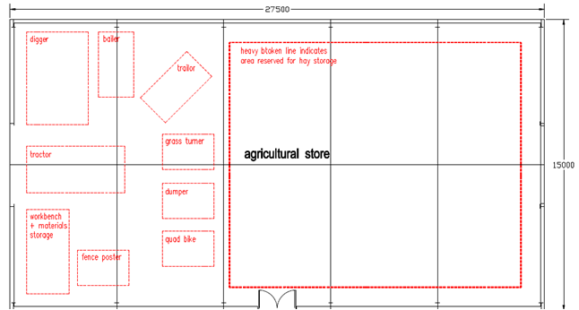
Scale: approx 1:200

Three bays of the building would be used for hay and two bays for the storage of agricultural equipment. The latter is hardly adequate given the need for manoeuvring space and to get individual items in and out.
The above indicates that the proposed building is hardly big enough’.

The appellants have an agricultural holding number (213250303) and which has been transferred to Moorside Farm

Other Matters

Bio Diversity Net Gain (BNG)

The application is accompanied by a BNG statutory matric and other associated documents which indicate a BNG figure of 11.2%.

Summary

Policy G4 of the Core Strategy states that proposals for development in the Green Belt will be judged against the contents of the Framework.

The Framework considers that the construction of agricultural buildings are not inappropriate in the Green Belt.

While the Framework, attested by various Planning Inspectors, require no affirmation of need for an agricultural building, or for its size, there is indeed such a need as we have indicated.

There would be no adverse or significant impact upon the character and appearance of the area.

Consequent to the above there is no need to show very special circumstances in this case.

Therefore, for the above reasons, we believe that the application should be supported.

