Full application for a detached dwelling at the existing cabin known as Summit Cabin, adj. Salley Street, Calderbrook Road. Littleborough OL15 9NG
Part Retrospective

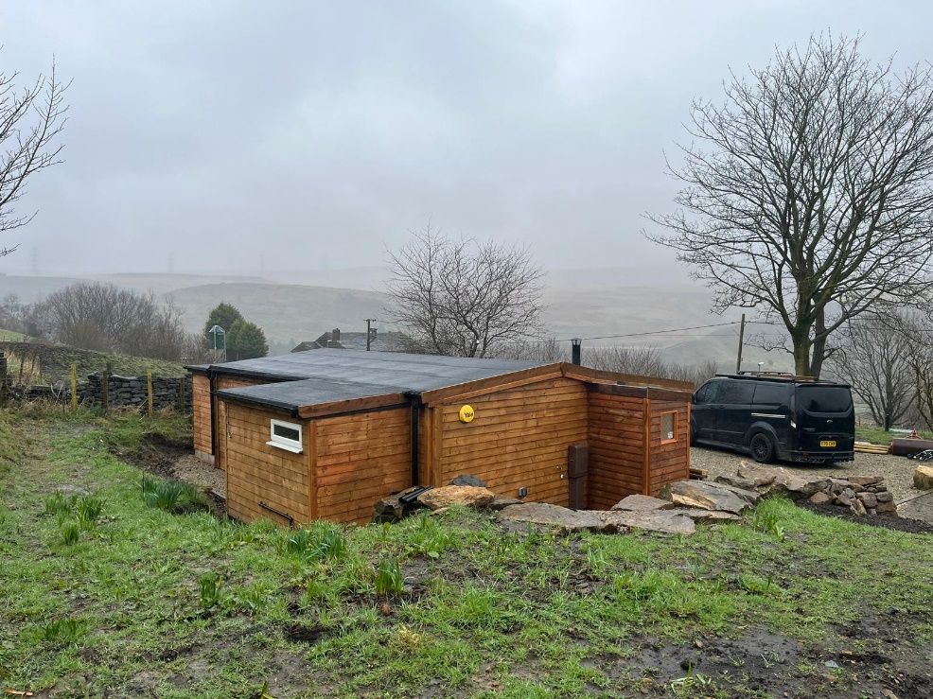

H | P
D | A

December 2025
Amended April 2026
Ref:DC.140326.A

Prepared by Hartley Planning and Development Associates Ltd

The application site, known as Summit Cabin, is located between Calderbrook Road and Higher Calderbrook Road. The building already exists and has been the subject of a recent appeal for its presence and use as a holiday let .
Therefore, application is made retrospectively for development already constructed plus for its use as a detached one bedroom dwelling. .
Access is via a long established track leading from Calderbrook Road
The site is in the Green Belt
Recent history
Application reference 24/00692/FUL, for the erection of a detached building for use as holiday let accommodation, the installation of an underground septic tank and associated landscaping works was dismissed on appeal dated 4 September 2025.
The appeal was part retrospective as the cabin had already been constructed.
The appeal was dismissed on the grounds that the proposed development could not be considered to meet one of the exceptions to Green Belt policy and would be harmful to openness.

The current application is submitted in the light of the Inspector’s decision and for a proposed development which we consider does meet such an exception to Green Belt policy.

It is also submitted on the basis that the cabin is lawful through the passage of time, where construction began before April 2024 and where the building has been substantially competed for more than 4 years. In such circumstances its use accords with paragraph 154 (h) (iv) of the National Planning Policy Framework 2024 (as amended) ( the Framework)

The Main Issues

The Main issues are (i) whether the proposal is inappropriate development in the Green Belt having regard to the Framework and any relevant development plan policies; (ii) the effect on the openness of the Green Belt and (iii) whether any harm by reason of inappropriateness, and any other harm, is clearly outweighed by other considerations, so as to amount to the very special circumstances required to justify the proposal.

Whether inappropriate Development
The proposed development would not be inappropriate in the Green Belt for two main reasons – firstly grey belt and secondly the lawfulness of the building
Policy JP-G9 of the Greater Manchester Places for Everyone 2024 (PfE) states: -
‘The beneficial use of the Green Belt will be enhanced where this can be achieved without harm to its openness, permanence or ability to serve its five purposes. In particular, the enhancement of its green infrastructure functions will be encouraged, such as improved public access and habitat restoration, helping to deliver environmental and social benefits for our residents and providing the high-quality green spaces that will support economic growth’.
Paragraph 142 of the National Planning Policy Framework(2025) (the Framework) states that the fundamental aim of Green Belt policy is to prevent urban sprawl by keeping land permanently open. The essential characteristics of Green Belts are their openness and their permanence.
The Framework, at paragraph 154, sets out the categories of development which may be regarded as not inappropriate in the Green Belt, subject to certain conditions.
Grey Belt
One such exception is outlined in paragraphs 155 as follows and which refers to ‘grey belt’ land: -
‘155. The development of homes, commercial and other development in the Green Belt should also not be regarded as inappropriate where:
a. The development would utilise grey belt land and would not fundamentally undermine the purposes (taken together) of the remaining Green Belt across the area of the plan;
b. There is a demonstrable unmet need for the type of development proposed;
c. The development would be in a sustainable location, with particular reference to paragraphs 110 and 115 of this Framework; and
d. Where applicable the development proposed meets the ‘Golden Rules’ requirements set out in paragraphs 156-157 below’.
Paragraph 156 of the Framework imposes ‘golden rules for ‘major’ development on grey belt land. Major development is defined in the Framework, for housing, as 10 or more houses or where the site is greater than 0.5 ha. Such requirements do not apply in the case of the current application where the appeal site is less than 0.5 ha.
Grey Belt Land is defined in Annex 2 to the Framework as follows: -
‘Grey belt: For the purposes of plan-making and decision-making, ‘grey belt’ is defined as land in the Green Belt comprising previously developed land and/or any other land that, in either case, does not strongly contribute to any of purposes (a), (b), or (d) in paragraph 143. ‘Grey belt’ excludes land where the application of the policies relating to the areas or assets in footnote 7 (other than Green Belt) would provide a strong reason for refusing or restricting development.
NB. Footnote 7, which defines areas which are excluded from the definition of grey belt land, do not apply in this case. Such areas include habitats sites (and those sites listed in paragraph 194) and/or designated as Sites of Special Scientific Interest; Local Green Space, a National Landscape, a National Park (or within the Broads Authority) or defined as Heritage Coast; irreplaceable habitats; designated heritage assets (and other heritage assets of archaeological interest referred to in footnote 75); and areas at risk of flooding or coastal change.
The application site in relation to the definition of ‘grey belt’ land
The following plan shows the position of the application site within the Green Belt: -
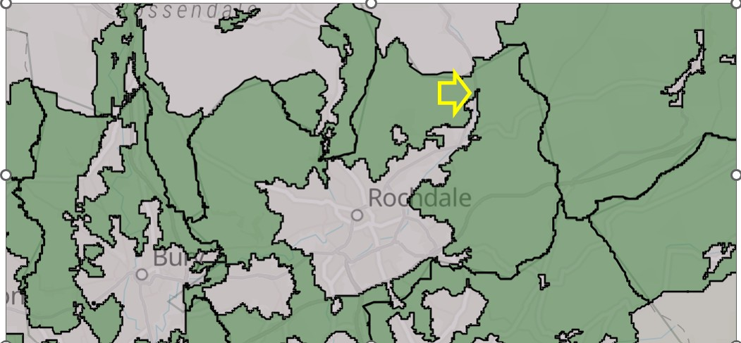

In order to meet the definition, the site must not ‘strongly contribute to any of the purposes (a), (b), or (d) of the Green Belt as defined in paragraph 143 of the Framework.(My highlighting)
These purposes are stated as follows in the Framework: -
‘a) to check the unrestricted sprawl of large built-up areas
b) to prevent neighbouring towns merging into one another
d) to preserve the setting and special character of historic towns’.
Planning Policy Guidance (PPG) (Paragraph: 005 Reference ID: 64-005-20250225) contains advice on how these matters might be assessed.
‘Purpose A – to check the unrestricted sprawl of large built up areas
This purpose relates to the sprawl of large built-up areas. Villages should not be considered large built-up areas.
Contribution | Illustrative features
Strong | Assessment areas that contribute strongly are likely to be free of existing development, and lack physical feature(s) in reasonable proximity that could restrict and contain development.  They are also likely to include all of the following features:  - be adjacent or near to a large built up area  - if developed, result in an incongruous pattern of development (such as an extended “finger” of development into the Green Belt)
Moderate | Assessment areas that contribute moderately are likely to be adjacent or near to a large built up area, but include one or more features that weaken the land’s contribution to this purpose a, such as (but not limited to):  - having physical feature(s) in reasonable proximity that could restrict and contain development  - be partially enclosed by existing development, such that new development would not result in an incongruous pattern of development  - contain existing development  - being subject to other urbanising influences
Weak or None | Assessment areas that make only a weak or no contribution are likely to include those that:  - are not adjacent to or near to a large built up area  - are adjacent to or near to a large built up area, but containing or being largely enclosed by significant existing development’

In this case, the appeal site is not adjacent to or near to a large built-up area.
For this reason, the appeal site makes only a weak contribution to the checking of the unrestricted sprawl of a large built-up area.
This is the conclusion of the LPA also, when it states in its officer report relating to the earlier proposal for the building and its use as a holiday let that ‘ the development applied for however is not significant enough in size to contribute towards what could be considered to constitute a sprawl of a large built-up area and it would not conflict with this purpose’.
‘Purpose B – to prevent neighbouring towns merging into one another
This purpose relates to the merging of towns, not villages.
Contribution | Illustrative Features
Strong | Assessment areas that contribute strongly are likely to be free of existing development and include all of the following features:  - forming a substantial part of a gap between towns  - the development of which would be likely to result in the loss of visual separation of towns
Moderate | Assessment areas that contribute moderately are likely to be located in a gap between towns, but include one or more features that weaken their contribution to this purpose, such as (but not limited to):  - forming a small part of the gap between towns  - being able to be developed without the loss of visual separation between towns. This could be (but is not limited to) due to the presence or the close proximity of structures, natural landscape elements or topography that preserve visual separation
Weak or None | Assessment areas that contribute weakly are likely to include those that:  - do not form part of a gap between towns, or  - form part of a gap between towns, but only a very small part of this gap, without making a contribution to visual separation’

The Green Belt plan above shows that the appeal site lies on the very edge of the Green Belt boundary. Land immediately to the west rises steeply and the contours alone constrain further development and act to prevent the coalescence of Littleborough with Ramsbottom and Greenmount to the North of Bury. By its limited area and constrained by existing development to the North, it adds nothing to the prevention of coalescence with Todmorden to the North.
Therefore, it makes at best only a weak contribution to visual separation.
This is also the conclusion of the LPA when it states in its officer report to which reference is made above that ‘ The development and application site involved with this application serves no purpose in preventing neighbouring towns merging and as such it would not conflict with this purpose’.
Purpose D – to preserve the setting and special character of historic towns
This purpose relates to historic towns, not villages. Where there are no historic towns in the plan area, it may not be necessary to provide detailed assessments against this purpose.
In this instance, the appeal site makes no such contribution.
The LPA, in its officer report to which reference has been made, concurs and states that ‘ the application site does not abut an identified historic settlement and does not have a physical or visual relationship to the setting or significance of an historic town. The proposed development would not conflict with this purpose’.
Conclusion upon the purposes of the Green Belt (a, b and d) and the classification of the application site as grey belt.
The application site makes only a weak contribution to the checking of an unrestricted sprawl of a large built-up area. It makes only a weak contribution to the prevention of the merging of Littleborough with towns around it including Ramsbottom and Todmorden, and it makes no contribution to the preservation of the setting and special character of a historic town. The LPA concurs.
Therefore, we conclude that the application site is grey belt land, and as such it meets one of the exceptions to Green Belt policy as stated in paragraph 155 (a) of the Framework: -
‘155. The development of homes, commercial and other development in the Green Belt should also not be regarded as inappropriate where all the following apply:
a. The development would utilise grey belt land and would not fundamentally undermine the purposes (taken together) of the remaining Green Belt across the area of the plan;
b. There is a demonstrable unmet need for the type of development proposed;
c. The development would be in a sustainable location, with particular reference to paragraphs 110 and 115 of this Framework and
d. Where applicable the development proposed meets the ‘Golden Rules’ requirements set out in paragraphs 156-157 (Not applicable in this case because the size of the proposed development falls below the level where this condition becomes relevant)
When determining the earlier appeal, the Planning Inspector came to no conclusion as to whether the appeal site constitutes grey belt land as he considered, on the evidence submitted, that one of the two other requirements – that of a demonstrable need – wase not met for a holiday let.
This, and the other requirement relating to sustainability, are addressed below.
Demonstrable unmet need for the type of development proposed
The Framework includes a definition of unmet need with regard to housing developments. Its footnote 56 defines it as follows: -
  - ‘In the case of applications involving the provision of housing, means the lack of a five year supply of deliverable housing sites, including the relevant buffer where applicable, or where the Housing Delivery Tests was below 75% of the housing requirement over the previous three years ‘

- Thus, there is an unmet need if the Council cannot demonstrate a minimum 5-year
- deliverable supply of housing land, or else if the number of completed dwellings is deemed to be insufficient according to the Housing Delivery Test which applies to it.

Moreover, paragraph 78 of the Framework states that ‘Local planning authorities should identify and update annually a supply of specific deliverable sites sufficient to provide a minimum of five years’ worth of housing against their housing requirement set out in adopted strategic policies.

It would seem that the LPA has failed to do this, with its latest monitoring report applying to 2022-23. It states that this has been updated in 2025, but it is not at all clear as to the nature of any such update. The figures on housing supply still only refer to no later than 2022-23

Moreover, while the monitoring report indicates that its housing target is 520 additional homes per year for the period 2012-2028, its new target from 2025 is now 918 net completions per year, announced by Government in 2024. There is no evidence to indicate that the Council can demonstrate such a level of required housing supply.

The Greater Manchester Development Plan Monitoring report (December 2024) indicates that net completions in Rochdale in 2023-24 was 681 dwellings. However, this falls short of the new housing target by a considerable way. The report would seem to indicate that the average completion rate for the previous three years to December 2024 was 568 dwellings.

Even before the increase in its housing target, the Council has been aware of the housing crisis in its area, declaring a housing crisis in 2022-3 in an attempt to address it. In such circumstances, even the earlier housing target did not set an upper limit.

Following its declaration of a housing crisis, the Council has published an Interim Housing Strategy for 2025-27. It refers to the poor quality of much if the housing stock in the Borough and to the acute need for rented accommodation, including the great need to resolve the unsatisfactory policy of having to house families in bed and breakfast accommodation. As the Government has recently stated, one extra dwelling is one more to help to meet a family in need.

The LPA considers that it can rely on the availability of a 5 year supply of demonstrable housing land in the Grater Manchester Development Plan 2024 (‘Planning for Everyone( (PfE) but the Government sets targets for individual Councils for housing delivery purposes..

In its email to us of the 9 March 2026 the LPA wrote that with regard to our Grey Belt submission: -
‘As you know, Paragraph 155 of the NPPF sets out that “The development of homes, commercial and other development in the Green Belt should also not be regarded as inappropriate where all the following apply:

a. The development would utilise grey belt land and would not fundamentally undermine the purposes (taken together) of the remaining Green Belt across the area of the plan;
b. There is a demonstrable unmet need for the type of development proposed56;
c. The development would be in a sustainable location, with particular reference to paragraphs 110 and 115 of this Framework;
d. Where applicable the development proposed meets the ‘Golden Rules’ requirements set out in paragraphs 156-157”.

In terms of our assessment against this, I agree that the development does not strongly contribute to any of purposes (a), (b), or (d) of paragraph 143 of the Framework. However, having regard to footnote 56 of the NPPF which sets out the circumstances where it can be considered that there is a demonstrable unmet need for the type of development proposed in respect of housing, the Council is able to demonstrate a 5-year supply of deliverable housing sites (as set out within the recent adopted Places for Everyone Joint Development Plan) and within the Housing Delivery Tests which are above 75% of the housing requirement over the previous three years, with Rochdale measuring 169% delivery versus the requirement in 2021, 142% in 2022 and 138% in 2023. As such it is clear that the proposals would not be serving a demonstrable unmet need, and the proposal is inappropriate development within the Green Belt’.

However, the above figures do not demonstrate the position since 2023 and where an annual housing supply and delivery assessment is required. Without this, the default position is that a 5-year supply of deliverable housing lans cannot be demonstrated, nor the required delivery of completed dwellings.

But in addition , the Places for Everyone Joint Development Plan for Greater Manchester includes housing targets for individual Councils, as follows: -

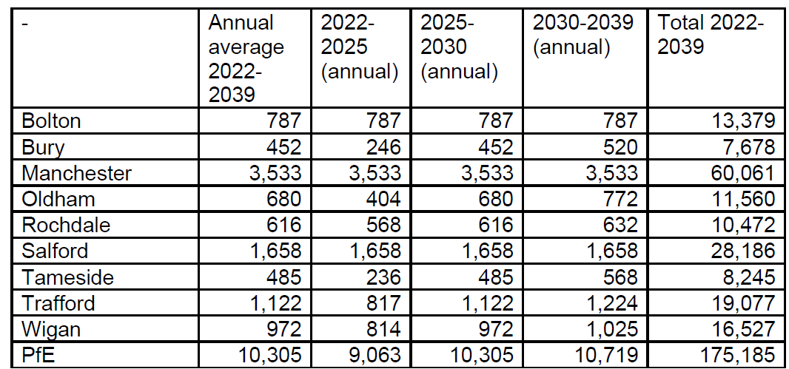

The LPA gives no assurances that it is able to meet such requirements. Moreover, since the adoption of the plan, housing targets have been substantially increased by Government ,with a figure believed now to be for Rochdale of some 918 dwellings per annum.

Therefore, on the available evidence, we do not consider that the Council can demonstrate that it can meet, or is meeting, its housing target and therefore, that the ‘need’ as required for grey belt development exists.

Sustainability

The site is within 10 minutes’ walk of two separate bus routes (see submitted route plans), and which provide good access to Littleborough town centre and railway station within a further 10 minutes travel time. Moreover, when the routes are considered together, they provide a regular service from early in the morning to relatively late at night. Details of the bus timetables are submitted with the application.

Thus, public transport provides an accessible alternative to the private car for travelling to services and facilities.

In addition, the adverse effects of private vehicles in terms of carbon emissions and any impact upon climate change reduces annually with the move to electric vehicles as well as reductions due to home working and home deliveries.

We are all, no doubt aware of the definition of sustainability in the Framework, with its three components – economic, social and environmental. The provision of an adequate supply of houses, where the proposed development would play a part, has a clear and advantages in terms of the economic and social objectives.

So far as the environmental component of sustainability is concerned, the Inspector when determining the earlier appeal, considered this in terms of the impact upon the proposed development in relation the setting of the nearby non-statutory heritage assets, and also to its wider environmental impact, concluding as follows: -

‘21. Paragraph 216 of the Framework requires that the effect of a proposal on the significance of a non-designated heritage asset should be taken into account in determining the application and states that a balanced judgement will be required having regard to the scale of any harm and the significance of the heritage asset.
22. The terraced buildings at Salley Street have been identified as non-designated heritage assets and their significance derives from the historic use as weaver cottages. The cabin lies some distance from the terrace and is set back from the road. If viewed from the Pennine Bridleway, which is higher than and to the rear of the cabin, the rear of the terraces are visible. However, the landscaping around the site will mature and allow the cabin to be less prominent in the views. I therefore consider that the cabin has a neutral impact of the setting of the non-designated heritage assets’.

The LPA , in its email to us of 9 March 2026 concerning our Grey Belt assessment, simply says that it does not consider the site to be sustainably located. It does not say why it considers this to be the case, and it does not address the above reasoning that it is sustainably located.

Conclusion regarding development on grey belt land
The proposed development is not inappropriate in the Green Belt, being grey belt land and where the necessary requirements in terms of ‘need’ and ‘sustainability’ are met.(The other requirement referred to in the Framework to ‘golden rules’, is only applicable to major development).

The exception for grey belt development does not require an assessment to be made regarding the impact upon openness.

The Lawfulness of the building and paragraph 154(h) (iv) of the Framework
The building was substantially completed before 25 April 2024. It was completed over 4 years ago. .
Thus, it is lawful through the passage of time and where it is immune from enforcement where no action has been taken within 4 years of substantial completion of any breach of planning control consisting of operational development.
The time limits for taking enforcement action are set out in section 171B of the Town and Country Planning Act 1990 (see also The Planning Act 2008 (Commencement No. 8) and Levelling-up and Regeneration Act 2023 (Commencement No. 4 and Transitional Provisions) Regulations 2024 for transitional arrangements).
Moreover, Paragraph 154 (h) (iv) of the Framework permits the following

- ‘Other forms of development provided they preserve its openness and do not conflict with the purposes of including land within it. These are:

(iv) the re-use of buildings provided that the buildings are of permanent and substantial construction’;

The building is permanent and of substantial construction.

As it’s construction is lawful, it cannot be said to have an adverse effect upon openness or the purposed of the Green Belt.

Therefore , its use for a dwelling would meet the Framework test for its use as a dwelling

Very special circumstances
As the proposed development is not inappropriate, it is not necessary to consider very special circumstances
Other Matters
Biodiversity Net Gain (BNG)
The building already exists and application is made for it retrospectively. In that sense, retrospective applications are not included within the requirement of BNG.
The Government has announced that sites of less than 0.2ha, as in this case, are to be exempt from the BNG legislation.
Notwithstanding the above, we have submitted the GNG metric and calculations which were submitted with regard to the earlier application for a holiday let and where biodiversity conditions have not changed
Further, we accept that the National Planning Policy Framework requires some ecological enhancement and we would accept a condition that 1 no bat box and I no sparrow box (the latter to accommodate several sparrows) shall be provided prior to the first occupation of the property
Drainage
The same drainage plans as for the proposed holiday let are again proposed.
We consider that these are self-evident and appropriate.
However, even if a different view were to be taken, the Inspector, when determining the earlier appeal noted that
‘Disposal of Sewage
15. Policy EM/8 of the Rochdale Unitary Development Plan requires that development proposals should make satisfactory arrangements for the disposal of sewage. Building regulations approval has been obtained for the means of providing sewage disposal though the use of a biodisc. From the evidence before me and having regard to the nature and scale of the development, I can see no reason that submission, approval and implementation of an appropriate means of disposing of sewage could not be secured by means of a suitably worded planning condition.
16. Therefore, subject to a suitably worded condition, the proposal makes adequate provision for the disposal of sewage, and I find no conflict with Policy EM/8 and Policy G8 of the Rochdale Core Strategy (2016)’.

APP/P4225/W/24/3356528

