AMPLE POWER LIMITED

Construction Environmental Management Plan

FOR

CONTRACT NAME |  | Balleyvesey WPT Middleton
CONTRACT ADDRESS |  | Bentley Avenue  Stakehill Industrial Estate  Manchester  M24 2GP
CONTRACT NUMBER |  | C1090
CONTRACT DOCUMENT REF |  |  |  | REVISION |  | 1
DATE PRODUCED |  | 12/01/2026

Contents
Introduction and Project Overview 3
Site Layout Plan 3
Waste Management 4
Dust Control Measures 4
Noise Control Measures 4
Ecological Considerations 4
Protection of Existing Drains and Gullies 5
Review Process 5

REVISION NUMBER | 1 | DATE |  | 12/01/2026
Initial Plan
APPROVED BY
PROJECT MANAGER | Daniel Kingsbury |  | DATE | 14/01/2026

RECORD OF REVIEW*
DATE | REVIEWED BY – NAME & ROLE | REVISION REQUIRED Y/N | SIGN
15/01/26 | Steven Challis – HSE Manager | Yes | Steve Challis
Review of Construction Environmental Management Plan to be undertaken on at least 3 Monthly Basis or after significant operational change.

CONSTRUCTION ENVIRONMENTAL MANAGEMENT PLAN READ AND UNDERSTOOD BY
NAME | POSITION | DATE | SIGNATURE | REVISION NUMBER
14/01/2026 | Project Manager – Daniel Kingsbury | Yes |  | 01

`

Introduction and Project Overview

This Construction Environmental Management Plan (CEMP) sets out comprehensive environmental control measures for the proposed extension and annex demolition works. The purpose of this CEMP is to ensure that all construction activities are undertaken responsibly, safely, and in compliance with relevant legislation, guidance, and best practices. The project involves the careful demolition of existing structures, construction of new extensions, reconfiguration of workshop spaces, internal modifications, drainage alterations, and external works as illustrated within the provided architectural drawings. The CEMP addresses all anticipated environmental risks, including but not limited to waste generation, dust emissions, noise impacts, traffic movements, ecological factors, surface water contamination, protection of existing drains and gullies, and site-wide emergency procedures. The plan is intended for use by contractors, site operatives, subcontractors, and stakeholders involved in the construction process.
The plan includes detailed operational strategies and mitigation procedures to minimize environmental impact while ensuring continuous compliance throughout all phases of construction. This introduction also details the roles and responsibilities of the project management team, the Principal Contractor, and environmental supervisors. All individuals on site must adhere to the measures set out in this CEMP and attend regular briefings to ensure awareness of environmental requirements.

Site Layout Plan

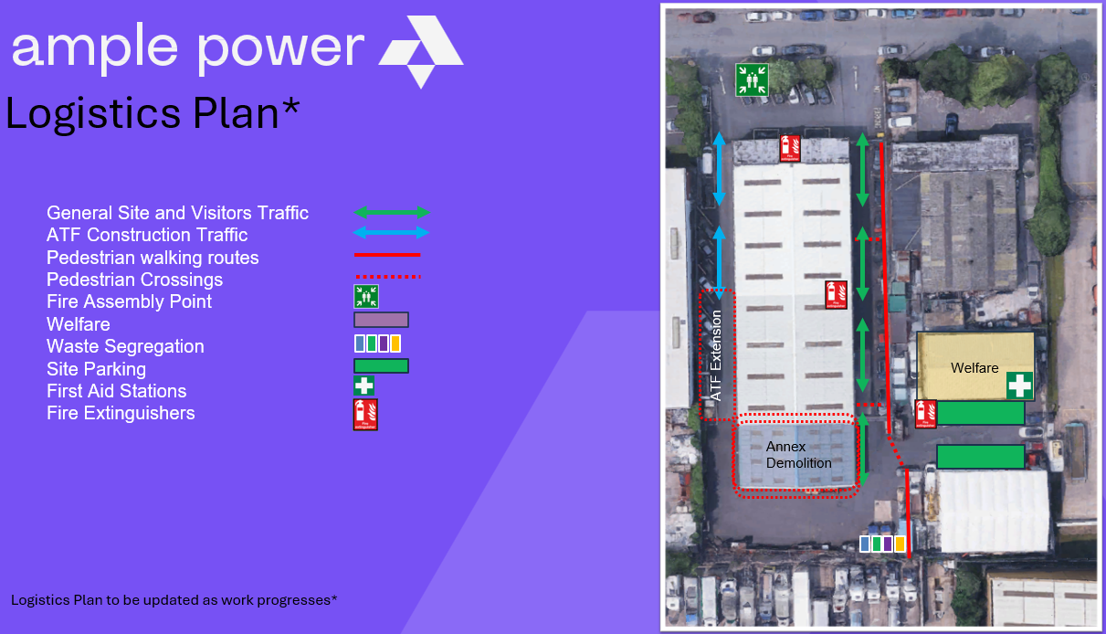

The logistics plan is designed to ensure safe and efficient movement within the site while minimizing conflicts between simultaneous construction activities.
Site access will be controlled via a single designated entrance (shown with green arrows above) to prevent unauthorized entry for all general site traffic. A second entrance (shown in blue arrows above) will be utilized for ATF construction traffic only. Signage will be placed prominently to guide both vehicles and pedestrians. Deliveries will be scheduled to avoid peak hours, and a banksman will assist larger vehicles when reversing or maneuvering on site.
Material storage zones will be located away from drains and gullies to mitigate accidental contamination. All hazardous materials will be stored within bunded containment areas. The site compound includes clearly marked fire assembly points and emergency exit routes which must remain unobstructed at all times.
The layout will be updated periodically as the project evolves, especially during phases involving demolition, excavation, or structural alterations. All operatives will be issued with the latest copy of the plan during induction or toolbox talks.

Waste Management

All waste generated will be handled in accordance with the waste hierarchy: prevention, reduction, reuse, recycling, recovery, and disposal as a last resort. Skips will be located in designated areas shown on the site layout plan. Separate skips will be provided for mixed construction waste, metals, timber, inert waste, and hazardous materials as required. WAC testing will be undertaken on all arisings prior to disposal off site.
All operatives will receive training on the correct disposal procedures. Waste transfer notes will be maintained for all collections, and only licensed waste carriers will be used. Demolition materials such as steel, brick, concrete, and timber will be segregated at source wherever possible.

Refer to ‘Site Waste Management Plan’ for further details

Dust Control Measures

Dust will be controlled to prevent nuisance to nearby receptors. Measures include damping down during demolition, cutting, grinding, and vehicle movements on unmade ground. Water bowsers or hose reels will be used for dust suppression where required. Stockpiles of materials will be kept damp or covered, and no bonfires will be permitted.
Where enclosed areas are being worked on, dust extraction units will be used. Wheel washing or brushing will be implemented if necessary to prevent dust and debris being transported onto public highways. Monitoring will be undertaken visually by site supervisors and additional controls applied where conditions such as high winds increase dust generation.

Noise Control Measures

Noise associated with construction has the potential to affect staff and neighbours. Measures include limiting noisy activities to predefined working hours, using modern low-noise equipment, maintaining plant regularly, and positioning noisy tools or generators away from sensitive areas. Acoustic barriers or screens will be deployed where prolonged noisy activity occurs.
Subcontractors will follow a noise-awareness training programme to reduce unnecessary impacts such as shouting, metal-on-metal impacts, and the running of idling engines. Periodic noise monitoring will be undertaken where required.

Ecological Considerations

Although the site is industrial in nature, ecological considerations still apply. A Preliminary Roost Assessment (PRA) and bat emergence survey will be completed in order to:

• Identify potential bat roosting features within structures at the site.
• Assess the potential value of those features for bats following best practice guidelines.
• Assess the potential of the surrounding habitats for foraging and commuting bats.
• Identify potential for and signs of nesting birds within the site.
• Identify whether the site is in use by roosting bats and ascertain the details of any roosts
present.
Should nesting birds, bats, or other protected species be encountered, works will stop and a qualified ecologist consulted.
Surface water protection is also an ecological concern. All fuel, oils, and chemicals will be stored in bunded areas to prevent leaks. Spill kits will be available throughout the site. Measures to prevent contamination of soils and watercourses will be enforced strictly.

Protection of Existing Drains and Gullies

Before works begin, mesh covers, silt socks, and protective plates will be installed on all drains and gullies within the work area. These must be inspected daily. No materials or waste will be stored near drainage points. Should contamination occur, the area will be isolated immediately and cleaned using appropriate absorbent materials.

Review Process

This document is reviewed and updated at key milestones, including:
- Completion of demolition
- Start of groundworks
- Structural completion
- Start of fit-out
- Commissioning stage

The reviewer should assesses whether:
- Environmental risks have changed
- New mitigation measures are required
- Existing measures remain effective
- Any new legislation, guidance, or client requirements apply

Updated versions are reissued to all contractors and subcontractors, with changes explained during toolbox talks.

