SITE SPECIFIC SUPPLEMENTARY INFORMATION

- Site Details

Site Name: | Rochdale CLS | Site Address: | Rochdale Cricket, Lacrosse and Squash Club  Redbrook  Bridgefold Road  Rochdale  OL11 5BX
NGR: | E: 388630 N: 413337 | Site Address:
Site Ref Number: | ROD169 - 98997 | Site Type: Macro | NTQ Replacement

- Pre-Application Check List

Site Selection

Was an LPA mast register used to check for suitable sites by the operator or the LPA? |  | No
If no explain why:

After a phone call to the LPA it was felt that the industry database was a more up to date source of information.

Was the industry site database checked for suitable sites by the operator: | Yes
If no explain why:

N/A

Pre-application consultation with LPA

Date of written offer of pre-application consultation: | 23rd March 2026
Was there pre-application contact: |  | No
Date of pre-application contact: | N/A
Name of contact: | The Director of Planning
Summary of outcome/Main issues raised:

At the time of preparing this submission, and despite our attempt to engage in pre-application dialogue with the LPA, no comments had been received in respect to the proposals.

Ten Commitments Consultation

Rating of Site under Traffic Light Model: | Green
Prior to the submission of this application the applicant initiates pre-consultation discussions with the local planning authority. This provides an opportunity for the LPA to discuss development proposals and identify site specific issues.

Summary of outcome/Main issues raised:

No responses had been received at the time of submission.

School/College/Nursery

Location of site in relation to school/college/nursery:

Willows Private Day Nursery is in close proximity to the site.

Outline of consultation carried out with school/college:

Pre Planning Consultation Letter sent

Summary of outcome/Main issues raised:

No response

Civil Aviation Authority/Secretary of State for Defence/Aerodrome Operator consultation
Will the structure be within 3km of an aerodrome or airfield? |  | No
Has the Civil Aviation Authority/Secretary of State for Defence/Aerodrome Operator been notified? |  | No
Details of response:

N/A

Developer’s Notice

Copy of Developer’s Notice enclosed? | Yes
Date served: | 28th March 2025

- Proposed Development

The proposed site:
It is imperative to consider that this proposal is to replace an existing installation and is not a new additional installation. The need for this tower stems from MBNL having been issued with an NTQ (Notice to Quit) on their existing site and thus this new mast is urgently required to maintain coverage.

The existing NTQ site is installed on Tentercroft, one of four tower blocks due to be demolished due to the inadequacies of the construction, to meet modern standards and the costs of maintenance, improvement and refurbishment. The residential tenants have been served with a demolition notice which states that the intention is for the flats to be demolished likely end of 2026 or early 2027. The Housing Association are already actively moving tenants out of the blocks. They intend building new housing in the area and moving all of the residents out over the next couple of years.

The proposed site at Rochdale Cricket, Lacrosse and Squash Club, Redbrook, Bridgefold Road, Rochdale, OL11 5BX. The proposed site is situated on land bordering the corner of the car park. To the north is Willows Private Day Nursery and Jolly Giraffes, with a mix of commercial and residential properties beyond; to the east are established trees, allotments with commercial properties beyond. To the south is the cricket field perimeter with established trees and housing beyond, to the west are the open playing fields and cricket pitch, bordered by established trees with residential properties beyond.

The proposal is for the installation of a new 25.0m high Valmont Greenfield Monopole and associated antennas that will provide continued and improved coverage for EE, H3G LTE and ESN for this area of Rochdale when the existing rooftop site at Tentercroft is decommissioned. The proposed new facility will require the installation of a limited number of equipment cabinet housing radio equipment at ground level and in close proximity to the base of the tower.
The immediate area is a mix of residential, recreational and commercial properties, with a good number of established trees creating borders between the properties and facilities; they will help to screen the proposed monopole from neighbouring properties, helping to maintain the visual amenity.
As previously stated, this is not a new additional installation but is a replacement for an existing installation that is to be removed. The proposed installation is necessary for the continued and improved wireless connectivity and capacity for local businesses, residents and visitors to this busy area of Rochdale.

Figure1
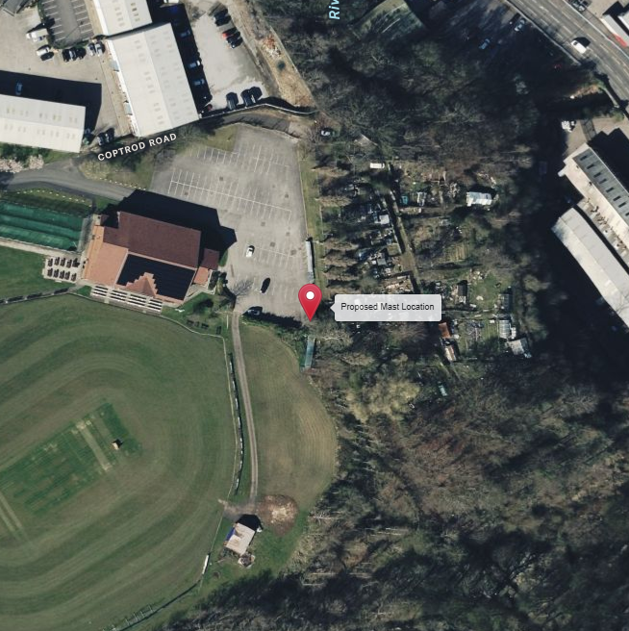
Figure 2
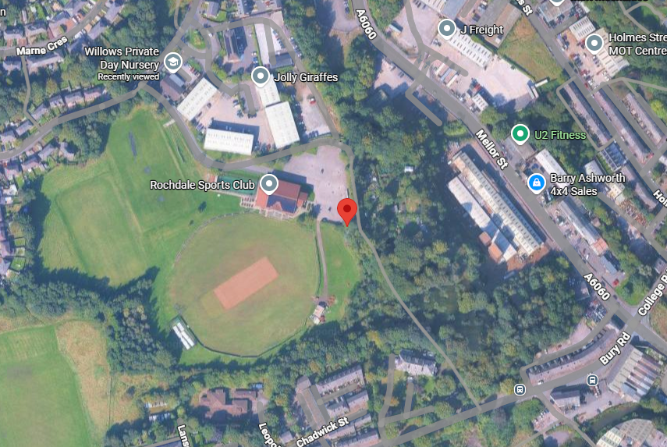

Site Ref: | ROD169 – 98997 | Site Address: | Rochdale Cricket, Lacrosse & Squash Club Ltd., Bridgefield Road, Rochdale, OL11 5BX

Local Planning Authority: Rochdale Metropolitan Borough Council (MBC)

Development Plan: Rochdale Core Strategy (2016) / Rochdale UDP Review 2001-2016 (2006)
Fig.1: LP Plan Extract (Reference Only):

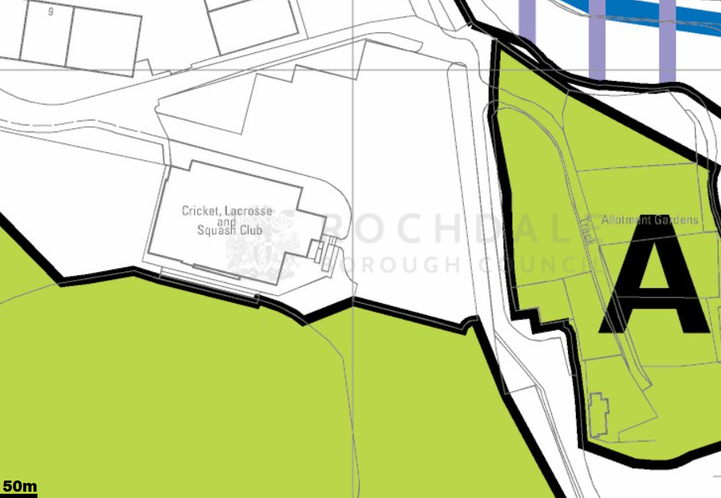

Site and its surrounds

Policy Relevant to the Development Site:

The site is designated as being within the settlement boundary, with urban uses to the north, east, south, and west. The site designation is not a material consideration.

Rochdale MBC does not have a specific telecoms policy. Therefore, the NPPF is of relevance. The National Planning Policy section of this supporting statement goes into detailed analysis of why this site is in compliance with the NPPF.

Policy Analysis:

The proposed development at this site is required to deliver the requisite level of electronic communication service on a single site that is to be adapted to accommodate multiple users (so enable future site sharing opportunities) yet seeks to minimise its visual impact or change to the character of this location (the site being as physically distant from lines of sight from residential uses as possible in this part of the Borough). The form and design of the proposed configuration would not appear out of context in this location (being seen as a telecommunications installation in a location where such infrastructure would be appropriate / not unusual), so according with wider Development Plan policy, and would ensure the integrity, character and setting of the area is fully maintained.

In addition to the above, Paragraph 119 of the NPPF (2024) states:

Advanced, high quality and reliable communications infrastructure is essential for
economic growth and social well-being. Planning policies and decisions should
support the expansion of electronic communications networks, including next
generation mobile technology (such as 5G) and full fibre broadband connections.
Policies should set out how high-quality digital infrastructure, providing access to
services from a range of providers, is expected to be delivered and upgraded over
time; and should prioritise full fibre connections to existing and new developments
(as these connections will, in almost all cases, provide the optimum solution).

The LPA should look to support this proposal as the equipment will bring “reliable communications” to the area.

Paragraph 122 states that

c) for a new mast or base station, evidence that the applicant has explored the
possibility of erecting antennas on an existing building, mast or other structure
and a statement that self-certifies that, when operational, International
Commission guidelines will be met.

The discounted options section of this planning statement fully illustrates that all other potential masts, roof tops and other locations have been investigated. The proposed site is the optimum location from a planning and coverage perspective.

The public benefits of a greatly enhanced communications network for businesses, residents and visitors alike in this location would qualify as a substantial benefit with near benign change or impact on amenity or on the character of the area (the site being well screened).

The enhanced digital service would very much accord with the objectives of the Development Plan.

The proposal fully accords with the requirements of the NPPF.

RADIO PLANNING AND PROPAGATION
When planning cellular telecommunications networks it is important for engineers to predict, with a high degree of confidence, the behaviour of cellular transmissions. This then enables the operator to calculate how many cell sites are needed to provide the level of coverage required by the services they offer under the terms of their licence.
The strength of radio signals detected at a receiving device naturally reduces the further away it is from the transmitter. In general the reduction (or decay) in signal power is affected by a number of variables. The main factors are

- frequency,
- distance (from transmitter),
- terrain (such as hills),
- clutter (such as buildings, foliage, vehicles, and water)
- and atmospheric conditions (such as rain).

A reduction in the strength of the radio signal increases the likelihood of dropped calls and reduced data rates for internet browsing, for example.
Clutter
Any physical object obstructing the propagation of radio signals causes a reduction in signal strength reaching a customer’s device. A common term for these objects is ‘clutter’. The more obvious examples are buildings and geographical terrain such as hills and trees.
Buildings cause a varying amount of signal reduction depending on their height, construction, thickness of walls, number of windows etc. Glass causes a lower reduction in signal than brick/concrete walls.
Customers will inadvertently be aware of this by finding that sometimes they need to go near windows, a higher floor of a building or even outside in order to achieve a stronger signal for their mobile devices.
Tree Clutter
The effects of trees on signal degradation should never be underestimated. Signal absorption and shadowing effects vary according to vegetation and density, and are caused by the main tree trunk, branches and leaves.
Cell sites located in or near trees will have signals significantly reduced. As a result a number of extra sites may need to be built locally in order to counter-effect this.
Signal variation throughout the seasons is also a practical concern. Leaves on trees in the spring and summer can cause shadowing and reduce radio voice quality and increase the number of dropped calls.
As a result the bottom of an antenna should be a) above the top level of the trees, b) allow greater height due to the antenna downtilt at build or for future requirements and c) allow some room for future growth of the trees.
In the case where the cell site utilises point-to-point microwave backhaul transmission the microwave dish should not be obscured at all.
Propagation Models
In essence these are mathematical formulae used to characterise radio wave propagation, in order to determine the received signal strength at a receiving device.
The most well-known propagation model used for mobile telecommunications is ‘Okamura-Hata’. More specific studies have been performed to investigate specific clutter and terrain such as dense-urban and urban environments. Resulting from these are propagation models for specific clutter types.
Coverage Planning Tools
Radio planning engineers plan cellular networks using highly sophisticated computer programs that incorporate the above propagation models. Armed with data on cell site location, cell site configuration, maps, terrain etc they are used to predict areas of coverage deficiency (so called ‘coverage holes’), new site requirements and configurations.

Network Changes
Over time the topography and clutter in an area is subject to change. For example, building developments, housing and tree growth can all change. As a consequence the signals received from local phone masts can degrade, as they are dependent on these factors. These reasons along with customer complaints, network consolidation (mast sharing) and new technologies (4G) require a re-evaluation of a network operator’s telecommunications infrastructure.
Mast sharing can result in some masts no longer being needed. As a result they are decommissioned and physically removed.
Technical surveys undertaken for reasons above may highlight that antenna height increases are required – this is more likely for sites with low antenna heights around 15m AGL, particularly street furniture sites. More details on these reasons below.
While thus far this document is generic to mobile telephony masts it should be noted that each mast has to be dealt with on a case-by-case basis.
Site Height increases
There are a number of reasons why an operator may request a height increase on existing structures. The main ones are described below.
Maintaining existing coverage
The antennas inside, for example, street furniture sites are generally of 2 physical build designs – ‘Single Stack’ and ‘Dual Stack’. The former describes when the set of antennas are all at the same height. The latter describes a site with 2 sets of antennas one above the other.
The ‘Dual Stack’ is by far the preferred option. This is due to a number of factors including greater flexibility & control for different technologies and providing optimum service performance to customers.
Network Consolidation between H3G LTE and EE and new 4G technologies facilitate a Single Stack structure being upgraded to a Dual Stack structure. In a straight swap scenario at equal height the new lower aperture antennas would be lower than they were originally - resulting in significantly reduced coverage. To ensure existing coverage is maintained the whole structure needs to be increased in height.
Clutter changes
A more extreme example is when the local clutter or tree lines have changed, or are such that the mobile signals are blocked, resulting in lower quality calls and downloads for mobile device users. To provide sufficient services to customers height increases on existing masts or additional new masts are required. The former is the preferred option in many cases.
ICNIRP Compliance
The addition of new technologies and mast sharing affects ICNIRP compliance – a higher minimum mast height is required in some cases.

Enclose map showing the cell centre and adjoining cells:
This can be emailed to the LPA upon request.

Type of Structure
Description:

PROPOSED MBNL 25.0m HIGH VALMONT GREENFIELD MONOPOLE MOUNTED ON 5.8m x 5.8m CONCRETE FOUNDATION AND EQUIPPED WITH 6No. APERTURES AND 4No. 600mm DISHES
PROPOSED GRAVEL TO COMPOUND
PROPOSED 9 No. SAFTEY BOLLARDS
PROPOSED MBNL MK 5B LINK A/C CABINET (TX) TO BE INSTALLED ON A ROOT FOUNDATION
PROPOSED EE 3No. BOBS. 3No. RRU & ROTARY ISOLATOR MOUNTED ON 450mm DROPPER SECTION FIXED TO GANTRY POLE
PROPOSED H3G RBS6130 CABINET TO BE INSTALLED ON ROOT FOUNDATION
PROPOSED 2.4M HIGH PALLISADE COMPOUND FENCE TO PERIMETER OF PROPOSED SITE WITH 3000mm WIDE ACCESS GATES
PROPOSED 300mm WIDE OVERHEAD CABLE TRAY GANTRY AND SUPPORT POLES
PROPOSED MBNL KOMODO CABINET C/W UCU MK2 TO BE INSTALLED ON ROOT FOUNDATION
PROPOSED EE D-AIRO CABINET TO BE INSTALLED ON ROOT FOUNDATION
PROPOSED MBNL FUTURE CABINET TO BE INSTALLED ON ROOT FOUNDATION
PROPOSED H3G 3NO. BOBS & ROTARY ISOLATOR MOUNTED ON 450mm DROPPER SECTION FIXED TO GANTRY POLE

Overall Height: 25.0m AGL
Height of existing building |  | N/A
Equipment Housing:
Length: |  | See drawings
Width: |  | See drawings
Height: |  | See drawings
Materials
Tower/mast etc – type of material and external colour: | See drawings
Equipment housing – type of material and external colour: | See drawings

Reasons for choice of design:
The proposed installation is an EE Ltd and H3G LTE 25.0m high Valmont Greenfield Monopole which will house both EE and H3G LTE. The sharing of base stations between multiple operators is one of the key strategic policy principles contained within the NPPF.

Central Government attaches great importance to the design of the built environment and outlines this within Section 12 (para. 131) of the 2024 National Planning Policy Framework. It states:

“Good design is a key aspect of sustainable development, creates better places in which to live and work and helps make development acceptable to communities.”.

In keeping with the National Planning Policy Framework guidelines of using high quality communications infrastructure the proposed monopole design and location has been selected endeavouring to minimise the visual impact on residential properties by utilising the available trees surrounding the pitches to help screen the mast from residential properties to the north, south and west; and benefitting from the screening provided by the trees in the allotments and the commercial properties to the east between it and Holmes Street.
Whilst it is accepted that this proposed installation is tall, physical objects such as the tall surrounding buildings and trees can obstruct radio signals causing a reduction in signal strength and coverage. The height of the proposed monopole is therefore necessary for this installation to enable the continued and improved coverage and capacity to be achieved and delivered to the residents and businesses in the Rochdale area.

- Technical Information

ICNIRP Declaration attached  ICNIRP public compliance is determined by mathematical calculation and implemented by careful location of antennas, access restrictions and/or barriers and signage as necessary. Members of the public cannot unknowingly enter areas close to the antennas where exposure may exceed the relevant guidelines.  When determining compliance the emissions from all mobile phone network operators on the site are taken into account. | Yes

- Technical Justification

Reason(s) why site required
The National Planning Policy Framework clearly states that authorities should not question the need for the service, nor seek to prevent competition between operators. Notwithstanding this fact, the Applicant considers it to be important to explain the technical justification for the site and how the facility fits into the overall network.

Notwithstanding this fact, the Applicant considers it to be important to explain the technical justification for the site and how the facility fits into the overall network.

The site is required to provide new 5G coverage for EE Ltd in order to improve coverage in the OL11 area of Rochdale. The cell search areas for 5G are extremely constrained with a typical cell radius of approximately 250m meaning that it would not be feasible to site the column outside of this locale.

The installation of this NTQ replacement telecommunications monopole within this area of Rochdale, is essential to ensure continued provision and to meet the growing demand for reliable and high-speed communication services. The proposed mast will also enhance mobile network coverage, ensuring that residents have continued and improved access to seamless and efficient communication services. This connectivity is not only crucial for personal communication but also plays a vital role in supporting businesses, education, and emergency services within the community.

- Site Selection Process – alternative sites considered and not chosen

Discounted Options
In accordance with the sequential approach outlined in the National Planning Policy Framework (NPPF) following search criteria have been utilised. Firstly, consideration is always given to sharing any existing telecommunication structures in the area, secondly consideration is then given to utilising any suitable existing structures or buildings and thirdly sites for freestanding ground-based installations are investigated.

This sequential approach is outlined below:

- Mast and Site Sharing
- Existing Buildings Structures
- Ground Bases Installations

In compliance with its licence and the sequential approach outlined in the NPPF all attempts to utilise any existing telecommunication structures where they represent the optimum environmental solution have been employed. The Ofcom Site Finder mast register is always examined prior to the submission of an application.

Site Type | Site Name and Address | NGR | Reason for not choosing
D1 | Falinge Park GF | 389275, 413929 | Public park discounted as it is very unlikely that a telecommunications site would be approved here
D2 | Falinge Road SW | 389181, 413976 | The pavement is not wide enough for the equipment. The equipment would block the cycle lane, so is therefore discounted
D3 | Sheriff Street SW | 389268, 413789 | Recent refusal. 21/01378/TELE. Site appears to be on the border of St Edmunds CA.
D4 | St Edmunds Church RT | 389137, 413840 | Grade II listed building within a CA. Very unlikely an installation would be approved here.
D5 | Chasley Road SW | 389040, 413875 | Site discounted due to the same principles as the recently refused location - on/within the CA.
D6 | Hebron Church | 389355, 413896 | A Greenfield installation would occupy over 50% of the car parking spaces, which is unfeasible for the Church.
D7 | Rochdale Infirmary | 389428, 414039 | Parking is at a premium at the Hospital, so there is no scope for a ground based installation. There are also no suitable rooftops which will provide the required height. The hospital is therefore discounted
D8 | Spotland Road | 389172, 413703 | Site directly outside shops with residential on the upper floors - would cause ICNIRP issues. There is also evidence of scarring on the pavement which would also kill the proposal.
D9 | Edmund Street | 389121, 413793 | Site discounted due to the same principles as the recently refused location - on/within the CA.
D10 | College Bank | 389261, 413498 | All the towers blocks are to be demolished so there is no scope to relocate onto an adjacent block.

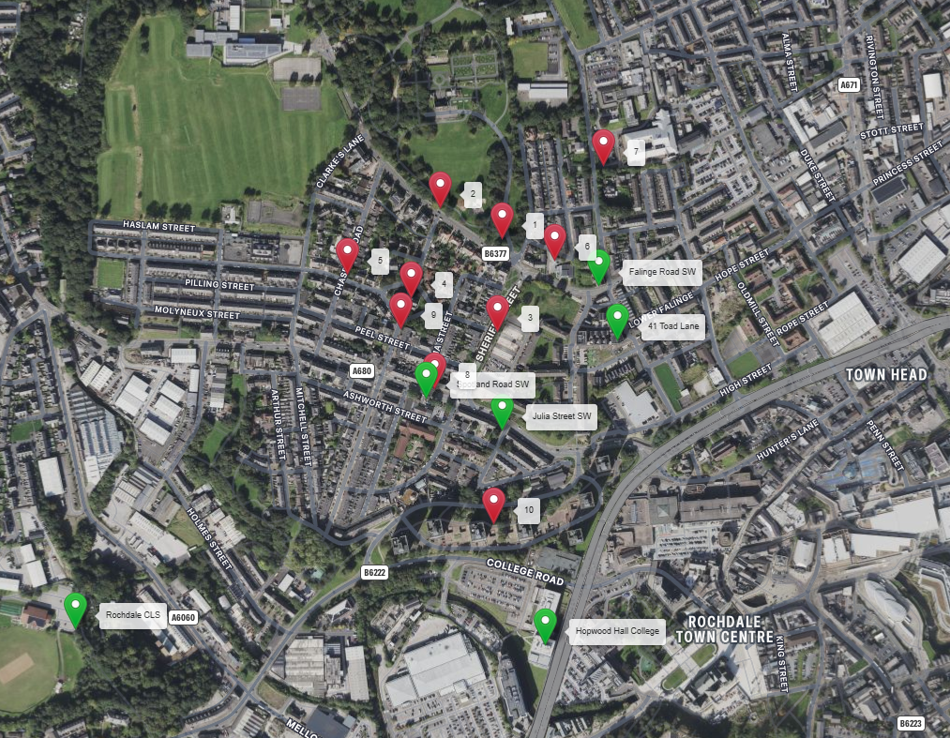

https://gridreferencefinder.com?gr=SD8862813342|Rochdale_s_CLS|2,SD8933913316|Hopwood_s_Hall_s_College|2,SD8927413640|Julia_s_Street_s_SW|2,SD8915913688|Spotland_s_Road_s_SW|2,SD8942113857|Falinge_s_Road_s_SW|2,SD8944913776|41_s_Toad_s_Lane|2,SD8927513929|1|1,SD8918113976|2|1,SD8926813789|3|1,SD8913713840|4|1,SD8904013875|5|1,SD8935513896|6|1,SD8942814039|7|1,SD8917213703|8|1,SD8912113793|9|1,SD8926113498|10|1&v=r&labels=1

If no alternative site options have been investigated, please explain why:

N/A

- Additional Relevant Information

Background to the Proposal
This specific proposal forms part of an integral requirement for EE Ltd, ESN and H3G LTE to expand their respective 5G telecommunications network across Rochdale specifically in this instance to enhance 5G coverage levels and network capacity within the OL11 area.

This partnership has resulted in the development and production of an array of “dual user” structures and cabinets, which have the ability to accommodate both operator’s antenna systems and radio equipment.

Mobile phone base stations operate on a low power, and accordingly base stations therefore need to be located in the areas they are required to serve. Increasingly, people are also using their mobiles in their homes, and this means we need to position base stations in, or close to, residential areas.

A further limiting factor is that the position has to be one that fits in with the existing network. Sites have to form a patchwork of coverage cells with each cell overlapping to a limited degree with the surrounding base stations to provide continuous network cover as users move from one cell to the other. However, if this overlap is too great unacceptable interference is created between the two cells.

DEVELOPMENT PLAN POLICY.

Development plan considerations have a special significance in law and re-iterated in Section 38 of the Planning and Compulsory Purchase Act 2004, it is stated that:

“If regard is to be had to the development plan for the purpose of any determination to be made under the planning Acts the determination must be made in accordance with the plan unless material considerations indicate otherwise.”

NATIONAL PLANNING POLICY

The Government remain committed to promoting telecommunications and place emphasis on the importance of telecommunications to the wider economy. The National Planning Policy Framework (NPPF December 2024) sets out the Government’s planning policies for England and how these are expected to be applied at the Local level. It provides a framework within which local people and their accountable Councils can produce their own distinctive local and neighbourhood plans, which reflect the needs and priorities of their communities.

The purpose of the planning system is to contribute to the achievement of sustainable development. There are three dimensions of sustainable development, each of which give rise to the need for the planning systems to perform a number of roles including: -

- economic objective – to help build a strong, responsive and competitive economy
- social objective – to support strong, vibrant and healthy communities
- environmental objective – to protect and enhance our natural, built and historic environment.

The NPPF contains at its core a presumption in favour of sustainable development which runs through both plan-making and decision-making processes. The NPPF recognises the vital importance of high-quality telecommunications and dedicates a whole chapter to this. Chapter 10 of the NPPF outlines the Governments support for high quality communications. The paragraphs below clearly outline the overarching support from Central Government for telecommunications and how Local Planning Authorities should embrace this vital infrastructure:

NPPF Paragraph 119 states:

“Advanced, high quality and reliable communications infrastructure is essential for economic growth and social well-being. Planning policies and decisions should support the expansion of electronic communications networks, including next generation mobile technology (such as 5G) and full fibre broadband connections. Policies should set out how high-quality digital infrastructure, providing access to services from a range of providers, is expected to be delivered and upgraded over time; and should prioritise full fibre connections to existing and new developments (as these connections will, in almost all cases, provide the optimum solution).”

It continues in Paragraph 120:

“The number of radio and electronic communications masts, and the sites for such installations, should be kept to a minimum consistent with the needs of consumers, the efficient operation of the network and providing reasonable capacity for future expansion. Use of existing masts, buildings and other structures for new electronic communications capability (including wireless) should be encouraged. Where new sites are required (such as for new 5G networks, or for connected transport and smart city applications), equipment should be sympathetically designed and camouflaged where appropriate.”

Operators always follow the sequential site selection process. Where an existing site can be shared or upgraded this will always be adhered to before a new proposal is put forward for consideration.

The support for telecoms and the need not to constrain Operators is laid out in Paragraph 123:

“Local planning authorities must determine applications on planning grounds only. They should not seek to prevent competition between different operators, question the need for an electronic communications system, or set health safeguards different from the International Commission guidelines for public exposure

Conclusion

We consider that the development is compliant with the council’s policy and that in accordance with Section 38 (6) of the Planning and Compulsory Purchase Act 2004 permission should be granted for the installation.

We consider the development complies with both central government and local planning policy guidance where the underlying aim is to provide an efficient and competitive telecommunication system for the benefit of the community while minimising visual impact.

Taking into account the factors of technical constraints, available sites and planning constraints we consider that this site and design clearly represents the optimum environmental solution.

On the basis of a recognised need to expand and promote telecommunications networks across the region, it is considered that the proposal fully accords with the requirements of the National Planning Policy Framework and Council’s Local Plan Policies.

Damian Hosker
Planning Manager
Email: d.hosker@whptelecoms.com

Contact Details

Name: (Agent) | Damian Hosker | Telephone: | 07771 527 070
Operator: | EE and H3G LTE | Fax no: | N/A
Address: | WHP Telecoms Ltd  1a Station Court Station Road  Guiseley  Leeds  LS20 8EY | Email Address: | d.hosker@whptelecoms.com
Signed: |  | Date: | 29th March 2026
Position: | Planning Manager | Company:  (on behalf of above operator) | WHP

