Proposed Cycle Stand:
2. No Sheffield Cycle Stands With Tapping Bars, supplied via Shelters4Less (www.shelters4less.co.uk), as shown below

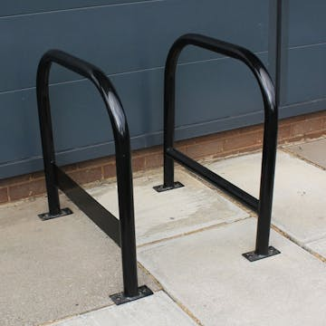

Product Ref: SR8868, Dimensions (H750 x W760mm), Triplex Powder Coated, Surface Mounted

Sheffield Cycle Stands With Tapping Bars | Shelters4Less

