

Nicola Baxter BSc (Hons), MSc (Hons)
Graduate Ecologist
nicbaxter@arbtech.co.uk
Arbtech Consulting Ltd
arbtech.co.uk

Biodiversity Net Gain Assessment

Site Address:
Standrings, Bagslate Moor Road, Rochdale, Greater Manchester, OL11 5XT

Client:
Jonathan Mulroy

Assessment Date:
14th November 2025

Project:
This report is prepared to inform a planning application with the Rochford District Council. The proposal is described as:
The construction of 1no. dwelling, with vehicular garaging, parking, new access and associated landscaping [Unsubmitted].

BNG assessment methodology and legislation can be found in the Arbtech Supplement: BNG Methodology and Legislation – 2025.
The results and recommendations contained within this report are valid for 18 months. An updated site visit and BNG assessment may be required if the report is to be used any longer than 18 months after completion.

Version Control
Status | Issue | Name | Date
Final | 1.0 | Nicola Baxter, BSc, MSc, Graduate Ecologist | 14/11/2025

Limitations and Copyright
Legal
Arbtech Consulting Limited has prepared this report for the sole use of the above-named client or their agents in accordance with our General Terms and Conditions, under which our services are performed. It is expressly stated that no other warranty, expressed or implied, is made as to the professional advice included in this report or any other services provided by us. This report may not be relied upon by any other party without the prior and express written agreement of Arbtech Consulting Limited. The conclusions and recommendations contained in this report are based upon information provided by third parties. Information obtained from third parties has not been independently verified by Arbtech Consulting Limited.
Arbtech cannot be held responsible for any project management failures, delays or unforeseen costs arising from failure to read and ensure understanding of the content with in, nor is Arbtech responsible for any adverse outcomes arising from failure to account for ecological advice given at any stage throughout the project collaboration.

© This report is the copyright of Arbtech Consulting Limited. Any unauthorised reproduction or usage by any person other than the addressee is strictly prohibited.

Site Location and Context
A baseline habitat map is provided in Appendix 1, a post development habitat map in Appendix 2, a proposed development plan in Appendix 3, headline BNG results in Appendix 4, and condition assessments in Appendix 5.
The survey site is centred on National Grid Reference SD 87053 13826 and has an area of approximately 0.217ha.

The site comprises one built structure (B1), within a vegetated garden with scattered trees and native hedgerows. It is situated within a private estate in the Metropolitan Borough of Rochdale, in Greater Manchester. There are scattered trees within the site and extending into the local garden landscape. Aerial imagery shows the local landscape to have an urban character, with several small copses and woodland swathes in close proximity to the site with golf clubs in the wider landscape. Water bodies can be found nearby, such as Caldershaw Brook located ~420m to the northeast. Such features likely enhance the area for a variety of species, including bats, amphibians and reptiles. The soils are described by Soilscapes LandIS database as slowly permeable seasonally wet acid loamy and clayey soils with impeded drainage, with a loamy and clayey texture. These soils are identified as having low fertility and support arable pastures and grasslands.

This report should be read in conjunction with the following documents:
- Statutory Baseline BNG Metric – Standrings, Bagslate Moor Road, OL11 5XT (Arbtech Consulting Ltd., 2025)
- Preliminary Ecological Appraisal (PEA) - Standrings, Bagslate Moor Road, OL11 5XT - v1(Arbtech Consulting Ltd., 2025)
- Tree Survey Report - Standrings, Bagslate Moor Road, OL11 5XT - v1 (Arbtech Consulting Ltd., 2025)
Executive Summary
- The site generates 4.38 area-based habitat units and 0.25 linear-based habitat units in its baseline. Note the habitat types are calculated separately and must independently achieve net gain; any excess of one cannot be used to offset any deficits of the other. To achieve a minimum +10% uplift for both, a minimum of 4.38 area-based habitat units and 0.28 linear-based habitat units are required.
- Trading rules are foreseen to be a concern: any removal of vegetated garden and individual trees must be made up for on a like-for-like or like-for-better basis. In other words, unless sufficient amounts of vegetated garden and individual tree habitats are proposed, the site will generate a trading error for the loss of these habitat types.
- No habitats can be created in BNG within any areas proposed to be private residential gardens. This includes any trees, green roofs, or wildflower meadows which may be proposed within such residential curtilages.
- Given the proposed development will be for the creation of a dwelling and associated vegetated garden, it is unlikely that net gain will be achieved within the site’s red line boundary. Off-site compensation will likely be required.
Introduction
BNG Informative
Habitat Degradation Statement | Date reflected by BNG calculations | 14th October 2025
Habitat Degradation Statement | The baseline biodiversity value of the site is derived from the site as observed during the PEA field survey (Arbtech Consulting Ltd., 2025). As evident in the screenshots of satellite imagery obtained from GoogleEarth dated 14th May 2019 (next satellite image dated 22nd April 2020) and 10th March 2025 (most recent satellite image), the site does not appear to have undergone any degradation. The habitats on site, and therefore biodiversity value of the site, is not considered to have undergone degradation since 30th January 2020.
Habitat Degradation Statement | 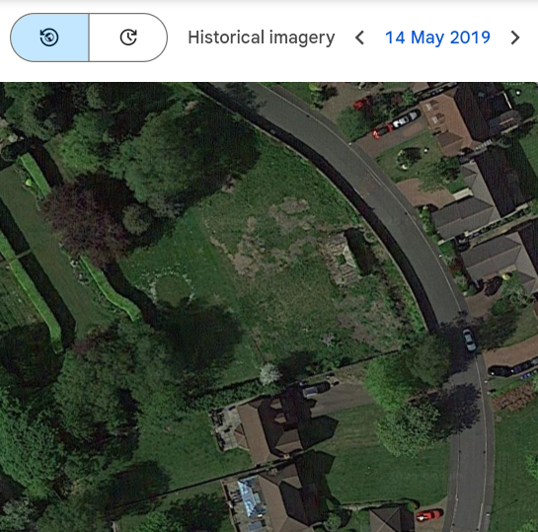 |  |  |  | 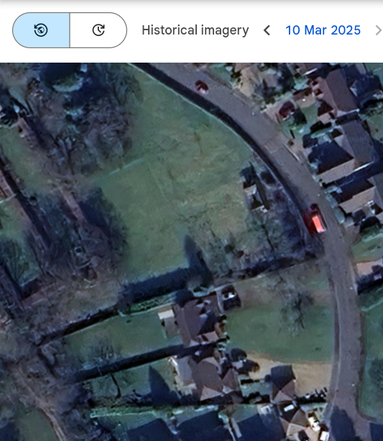
Irreplaceable Habitat Statement | No irreplaceable habitats as listed under the Biodiversity Gain Requirements (Irreplaceable Habitat) Regulations (2024) are currently present nor were present before 30th January 2020.
Metric Version & Publication Date | Statutory Biodiversity Metric Calculation Tool first published 29th November 2023 with last updates to metric tools and user guides on 3rd July 2025.
BNG Target Uplift | +10%
National Character Area (NCA) | 54 - Manchester Pennine Fringe
Strategic Significance | The Rochdale Metropolitan Borough Council is covered by the Greater Manchester Local Nature Recovery Strategy (LNRS) prepared and adopted by the Greater Manchester Combined Authority (GMCA).  Available at: https://www.gmconsult.org/environment-team-policy-and-strategy/lnrs/
Strategic Significance | Habitat |  | Baseline /  Post-Development | Justification
Strategic Significance | Baseline |  | All | Low: Default following the publication of the LNRS
Limitations
There were no specific limitations to the assessment.

Baseline
Baseline Biodiversity Value: On-Site
Area-Based Habitats (A-1)
Habitat | Area (ha) | Description | Condition Assessment | Strategic Significance
Developed land/sealed surface | 0.001ha  (0 units) | There is paving along the front of the disused outbuilding (B1) located to the east of the site. | Habitat condition pre-determined as ‘N/A’ as detailed within the Statutory Biodiversity Condition Assessment Supplement. | Low Strategic Significance
Buildings | 0.004ha  (0 units) | B1 is a disused single storey outbuilding within the garden, located near the eastern wall. |  | Low Strategic Significance
Vegetated garden | 0.205ha  (0.41units) | The site is dominated by vegetated garden. Comprising intensively managed lawns, introduced shrubs, individual trees, and a line of trees along the southwestern boundary. There is scattered scrub within the grassland. For species list please see the PEA/PRA. |  | Low Strategic Significance
Urban Tree | Poor:  0.0041ha  (0.02 units) | 26no. trees were considered in the baseline, 1no. of which achieved ‘poor’ condition by passing 2 or fewer criteria, 18no. of which achieve ‘moderate’ condition by passing 3 or 4 of 6 criteria, while the remaining 7no. achieve ‘good’ condition by passing 5 of 6 criteria. See PEA/PRA and AIA for more information. | Poor: passes 2 of 6 criteria.  1no. small (T21) | Low Strategic Significance
Urban Tree | Moderate:  0.1221ha  (0.98 units) |  | Moderate: passes 3 or 4 of 6 criteria.  14no. small (T1-T9, T10-T12, T18-T19)  4no. medium (T22-T23, T25-T26) | Low Strategic Significance
Urban Tree | Good:  0.2149ha  (2.58 units) |  | Good: passes 5 or 6 of 6 criteria.  4no. medium (T13, T15-T17)  2no. large (T14 & T20)  1no. very large (T24) | Low Strategic Significance

Baseline Biodiversity Value: On-Site
Linear-Based Habitats (B-1)
Habitat | Length (km) | Description | Condition Assessment | Strategic Significance
Native Hedgerow | 0.039km  (0.23 units) | There are beech hedgerows within the site extending outside the development area. The hedges are approx. 2m in height and 1.5m in width with no gaps at the base or over 10% the total length of the hedge. No cleavers, nettles or other examples or nutrient enrichment present. | Good: Does not fail both attributes in more than one functional group.  Assessed using the ‘Hedgerow’ habitat type condition sheet. | Low Strategic Significance
Non-native and ornamental hedgerow | 0.017km  (0.02 units) | Along the southern boundary wall is an overgrown Lawson’s cypress hedgerow. Height approx. 3m, no nests were found during the site visit. | Habitat condition pre-determined as ‘Poor’ as detailed within the Statutory Biodiversity Condition Assessment Supplement. | Low Strategic Significance

Baseline Biodiversity Value

 | Habitat Type | Biodiversity Units Generated
Area-Based | Sealed & Unsealed Surface | 0
Area-Based | Vegetated Garden | 0.41
Area-Based | 1no. Urban Trees (Poor Condition) | 0.02
Area-Based | 18no. Urban Trees (Moderate Condition) | 0.98
Area-Based | 7no. Urban Trees (Good Condition) | 2.58
Total |  | 4.38
Linear-Based | Native Hedges | 0.23
Linear-Based | Ornamental Hedges | 0.02
Total |  | 0.25

Results, Discussion, and Next Steps
BNG Informative
Results and Discussion | The site generates 4.38 area-based habitat units and 0.25 linear-based habitat units in its baseline. Note the habitat types are calculated separately and must independently achieve net gain; any excess of one cannot be used to offset any deficits of the other. To achieve a minimum +10% uplift for both, a minimum of 4.38 area-based habitat units and 0.28 linear-based habitat units are required.  A post-development BNG assessment must be undertaken to discern the net change of biodiversity value as a result of the proposed development.
General Recommendations | Trading rules are foreseen to be a concern: any removal of vegetated garden and individual trees must be made up for on a like-for-like or like-for-better basis. In other words, unless sufficient amounts of vegetated garden and individual tree habitats are proposed, the site will generate a trading error for the loss of these habitat types.  Recommendations include:  Retaining individual trees within the site.  - The site contains 26 individual trees. Scattered trees must be replaced with the same broad habitat type (trees) or a higher distinctiveness habitat type.  - Retained on-site habitat may require long-term management to maintain the baseline conditions outlined in this report, i.e. trees must be maintained in moderate condition or better.  Retaining native hedgerow with trees located within the site.  - It is strongly advised that efforts are made to retain as much of the existing native hedgerow as possible within the proposed development, as this comprises a large percentage of the existing hedgerow unit value of the site.  - Retained on-site habitats may require long-term management to maintain the baseline conditions outlined in this report, i.e. native hedgerows with trees must be maintained in moderate condition or better.  Retaining ornamental hedgerows  - Hedgerows provide highly valuable habitat for wildlife, and act as a great source of refugia, nesting and roosting, foraging, hunting and commuting opportunities for birds, mammals, invertebrates, reptiles and amphibians.  - Ornamental hedgerows comprise less than 20% of canopy cover from native or archaeophyte woody species. Archaeophyte species are those that have been recorded as naturalised in the wild before 1500CE. Climbing species such as Honeysuckle and Bramble are not included in the definition of woody species.  - It is recommended that a diverse range of species be planted, to provide structural complexity and sequential resources, such as leaves, flowers, fruits and nuts, at varying stages of the year.  - It is encouraged to provide a dense and diverse understorey growth between the ground and base of the hedgerow, to further support its use by wildlife.  - Species composition can include ornamental beech hedgerows, garden varieties of ornamental native species such as Yew, Box and Privet, and neophyte species. Neophyte species are those that have been introduced after 1500CE.  - Hedgerows must be managed to ensure the growth does not become top-heavy and at risk of collapse during adverse weather conditions. It is recommended that hedgerows are subject to maintenance one section at a time (outside of nesting bird season March-August) over a length of time, to allow for the natural regeneration of resources for wildlife.  No habitats can be created in BNG within any areas proposed to be private residential gardens. This includes any trees, green roofs, or wildflower meadows which may be proposed within such residential curtilages. Semi-natural habitats such as mixed scrub and trees should therefore be provisioned within communal areas under central management.  Given the proposed development will be for the creation of a dwelling and associated vegetated garden, it is unlikely that net gain will be achieved within the site’s red line boundary. Off-site compensation will likely be required, and can be done by:  - creating the required habitats off-site (i.e. outside the red line boundary) N.B. this will require a baseline ecological survey to determine the baseline value of the off-site parcel of land ideally within the curtilage of the LPA or within the same National Character Area (NCA), and the off-site land must be registered with the government;  - purchasing biodiversity units from existing habitat banks N.B. such habitat bank should ideally be within the curtilage of the LPA or within the same NCA; or  - purchasing statutory biodiversity credits from the government N.B. metric rules dictate if statutory credits are required, double the amount of credits will be required to compensate for a single unit deficit.  The mechanism for securing this off-setting will need to be proposed to and confirmed by the LPA and would be linked to the application through a planning obligation Section 106 (s106) agreement. The proposed habitat compensation should be of an appropriate distinctiveness to meet the trading rules of BNG.

Appendix 1: Baseline Habitat Plan
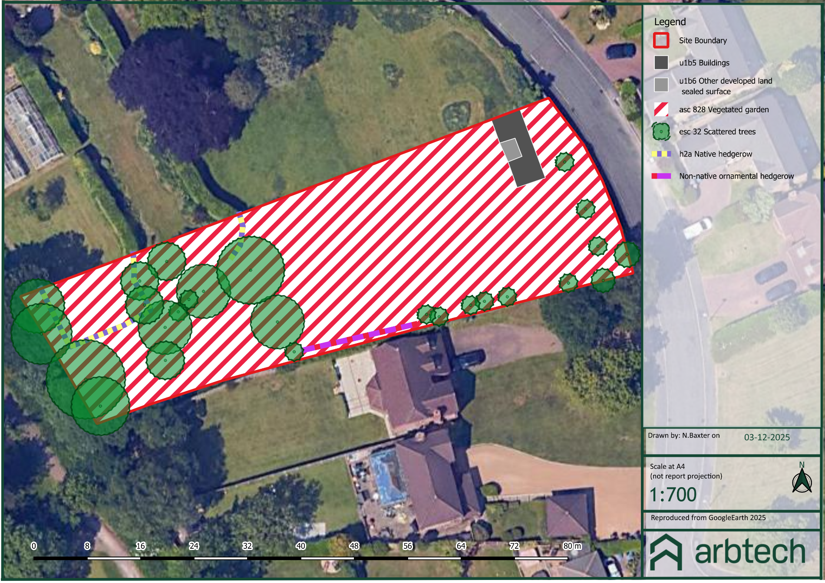
Appendix 2: Post-Development Habitat Plan
Not available at the time of writing.

Appendix 3: Proposed Development Plan
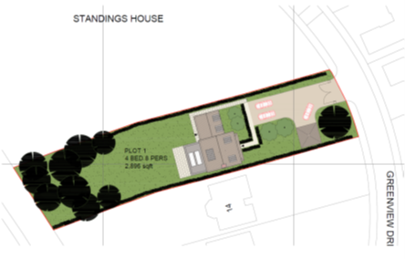
Appendix 4: Headline BNG Results

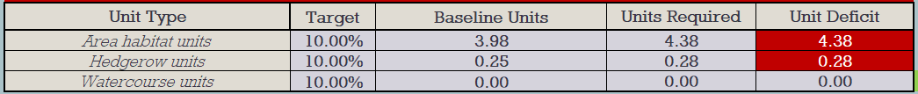
Appendix 5a: Baseline Habitat Condition Assessment Sheets
Urban Trees; assessed using ‘Individual Trees’ habitat type condition sheet:
Condition Assessment Criteria
A | The tree is a native species (or more than 70% within the block are native species).
B | The tree canopy is predominantly continuous, with gaps in canopy cover making up <10% of total area and no individual gap being >5 m wide (individual trees automatically pass this criterion).
C | The tree is mature (or more than 50% within the block are mature).
D | There is little or no evidence of an adverse impact on tree health by anthropogenic activities such as vandalism or herbicide use. There is no current regular pruning regime, so the trees retain >75% of expected canopy for their age range and height.
E | Natural Ecological niches for vertebrates and invertebrates are present, such as presence of deadwood, cavities, ivy or loose bark.
F | More than 20% of the tree canopy area is oversailing vegetation beneath.
Condition Assessment Result |  | Condition Assessment Score
Passes 5 or 6 of 6 criteria |  | Good (3)
Passes 3 or 4 of 6 criteria |  | Moderate (2)
Passes 0, 1 or 2 of 6 criteria |  | Poor (1)

Tree ID  Size | Criterion |  |  |  |  |  | # Passed  Condition
Tree ID  Size | A | B | C | D | E | F | # Passed  Condition
T01 - S | ✔ | ✔ |  | ✔ |  | ✔ | 4 - Moderate
T02 - S | ✔ | ✔ |  | ✔ |  | ✔ | 4 - Moderate
T05 - S | ✔ | ✔ |  | ✔ |  | ✔ | 4 - Moderate
T06 - S | ✔ | ✔ |  | ✔ |  | ✔ | 4 - Moderate
T07 - S | ✔ | ✔ |  | ✔ |  | ✔ | 4 - Moderate
T08 - S | ✔ | ✔ |  | ✔ |  | ✔ | 4 - Moderate
T09 - S | ✔ | ✔ |  | ✔ |  | ✔ | 4 - Moderate
T10 - S |  | ✔ |  | ✔ |  | ✔ | 3 - Moderate
T11 - S | ✔ | ✔ |  | ✔ |  | ✔ | 4 - Moderate
T12 - S | ✔ | ✔ |  | ✔ |  | ✔ | 4 - Moderate
T13 - M | ✔ | ✔ | ✔ | ✔ | ✔ | ✔ | 6 - Good
T14 - L | ✔ | ✔ | ✔ | ✔ | ✔ | ✔ | 6 - Good
T15 - M | ✔ | ✔ | ✔ | ✔ | ✔ |  | 5 - Good
T16 - M | ✔ | ✔ | ✔ |  | ✔ |  | 5 - Good
T17 - M | ✔ | ✔ | ✔ | ✔ | ✔ |  | 5 - Good
T18 - S | ✔ | ✔ |  | ✔ |  |  | 3 - Moderate
T19 - S | ✔ | ✔ |  | ✔ |  |  | 3 - Moderate
T20 - L | ✔ | ✔ | ✔ | ✔ | ✔ |  | 5 - Good
T21 - S |  | ✔ | ✔ | ✔ |  |  | 2 - Poor
T22 - M | ✔ | ✔ | ✔ | ✔ |  |  | 4 - Moderate
T23 - M | ✔ | ✔ | ✔ | ✔ |  |  | 4 - Moderate
T24 - VL | ✔ | ✔ | ✔ | ✔ | ✔ |  | 5 - Good
T25 - M | ✔ |  | ✔ | ✔ | ✔ |  | 4 - Moderate
T26 - M | ✔ |  | ✔ | ✔ |  |  | 3 - Moderate

Native Hedgerow (H1 & H2); assessed using ‘Hedgerow’ habitat type condition sheet:
Hedgerow favourable condition attributes
Attributes and functional groupings (A, B, C, & D) |  | Criteria (the minimum requirements for ‘favourable condition’ | Description |  | H1 | H2
A1. | Height | >1.5 m average along length | The average height of woody growth estimated from base of stem to the top of shoots, excluding any bank beneath the hedgerow, any gaps or isolated trees.  Newly laid or coppiced hedgerows are indicative of good management and pass this criterion for up to a maximum of four years (if undertaken according to good practice).  A newly planted hedgerow does not pass this criterion (unless it is > 1.5 m height). |  | Y | Y
A2. | Width | >1.5 m average along length | The average width of woody growth estimated at the widest point of the canopy, excluding gaps and isolated trees.  Outgrowths (e.g. blackthorn suckers) are only included in the width estimate when they >0.5 m in height.  Laid, coppiced, cut and newly planted hedgerows are indicative of good management and pass this criterion for up to a maximum of four years (if undertaken according to good practice). |  | Y | Y
B1. | Gap – hedge base | Gap between ground and base of canopy <0.5 m for >90% of length | This is the vertical ‘gappiness’ of the woody component of the hedgerow, and its distance from the ground to the lowest leafy growth.  Certain exceptions to this criterion are acceptable (see page 65 of the Hedgerow Survey Handbook). |  | Y | Y
B2. | Gap – hedge canopy continuity | Gaps make up <10% of total length and  No canopy gaps >5 m | This is the horizontal ‘gappiness’ of the woody component of the hedgerow. Gaps are complete breaks in the woody canopy (no matter how small).  Access points and gates contribute to the overall ‘gappiness’, but are not subject to the >5 m criterion (as Nthis is the typical size of a gate). |  | Y | Y
C1. | Undisturbed ground and perennial vegetation | >1 m width of undisturbed ground with perennial herbaceous vegetation for >90% of length:  - measured from outer edge of hedgerow, and  - is present on one side of the hedge (at least) | TNhis is the level of disturbance (excluding wildlife disYturbance) at the base of the hedge.  Undisturbed ground should be present for at least 90% of the hedgerow length, greater than 1m in width and must be present along at least one side of the hedge.  This criterion recognises the value of the hedge base as a boundary habitat with the capacity to support a wide range of species. Cultivation, heavily trodden footpaths, poached ground etc. can limit available habitat niches. |  | N | N
C2. | Undesirable perennial vegetation | Plant species indicative of nutrient enrichment of soils dominate <20% cover of the area of undisturbed ground | The indicator species used are nettles (Urtica spp.), cleavers (Galium aparine) and docks (Rumex spp.). Their presence, either singly or together, should not exceed the 20% cover threshold. |  | Y | Y
D1. | Invasive and neophyte species | >90% of the hedgerow and undisturbed ground is free of invasive non-native and recently introduced species | Recently introduced species refer to plant that have naturalised in the UK since AD 1500 (neophytes). Archaeophytes count as natives. |  | Y | Y
D2. | Current damage | >90% of the hedgerow or undisturbed ground is free of damage caused by human activities | This criterion addresses damaging activities that may have led to or lead to deterioration in other attributes.  This could include evidence of pollution, piles of manure or rubble, or inappropriate management practices (e.g. excessive hedge cutting). |  | Y | Y
Condition categories for hedgerows without trees
Category |  | Maximum number of attributes that can fail to meet ‘favourable condition’ criteria in Table TS1-2 | Weighting (score)
Good |  | No more than 2 failures in total  AND  No more than 1 failure in any functional group | 3
Moderate |  | No more than 4 failures in total  AND  Does not fail both attributes in more than one functional group (e.g., fails attributes A1, A2, B1, and C2 = moderate condition) | 2
Poor |  | Fails a total of more than 4 attributes  OR  Fails both attributes in more than one functional group (e.g. fails attributes A1, A2, B1, and B2 = poor condition) | 1
Score achieved: |  | Good

