Construction Management Plan

Land to the west of New Street, Littleborough
22/01039/FUL

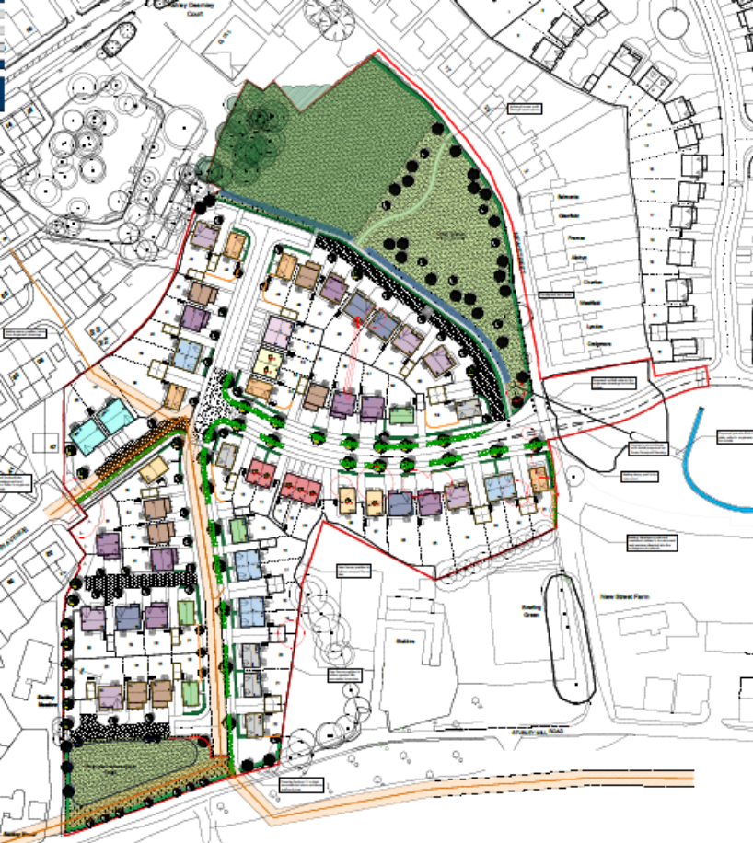
Revision :- C
Reference: New Street- 001
Date:- 10th September 2025

CONSTRUCTION MANAGEMENT PLAN
DATE:- | 10th September 2025
WORK ACTIVITY:- | CONSTRUCTION OF NEW HOUSING ESTATE AND ASSOCIATED INFRASTRUCTURE
SITE LOCATION | Land to the west of New Street, Littleborough
National Grid reference | E392610, N415790
Site Area | ~3.39ha
Site Description | Russell Homes intends to construct a low-rise residential development  comprising 62 dwellings with associated access, gardens, public open  space, attenuation basin, estate roads and ancillary infrastructure.  The site is located west of the current Russell Homes development,  accessed off New Road.
Previous Use | The site is currently open grassing land, previous uses have been identified in the Site Investigation report E3P 15-075.
Access | Access will be taken through the neighbouring development down Dearnley Ave.
Structures | There are no structures currently on site
Retain Structure | Non to be retained
Slopes | The site is variable in topography with undulating land. Generally, the site  topographically falls from 150 m AOD in the north to 140 m AOD in the south.  A steep slope is present in the northwest.
Surface Coverings | The site is surfaced by soft standing ground comprising short grassland and  self-seeding vegetation. An area of dense woodland is present in the far north  of the site. Sporadic semi-mature and mature trees are present in the central portion and along the site boundaries.  Reeds and rushes are present at the edge of the pond located on site.
Vegetation / Ecology | Refer to ecology /BNG statement
Hazardous Material Storage | No hazardous materials are store on site
Polychlorinated Biphenyls (PCB) | No equipment that may potentially contain PCBs was observed at the site
Waste Storage | No potentially hazardous waste streams are generated at the properties.
Drainage | There are a number of Foul / combined drains that run through and adjacent the site, refer to drainage strategy developed by Marston and Grundy. The existing United Utilities asset that run through the site and are to be retained. Works in the area are to be monitored and agreed with United Utilities. All easements are to be repected.
Schedule Of Accommodation | 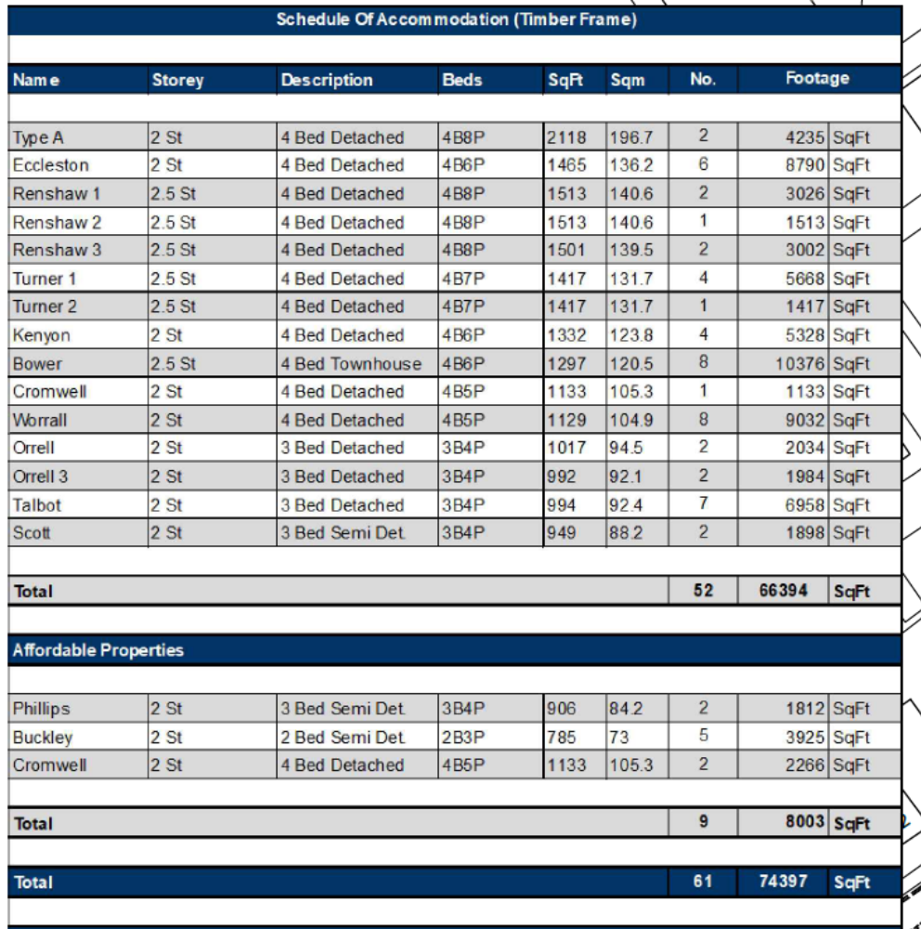
DURATION:- | 120 Weeks

Location plan

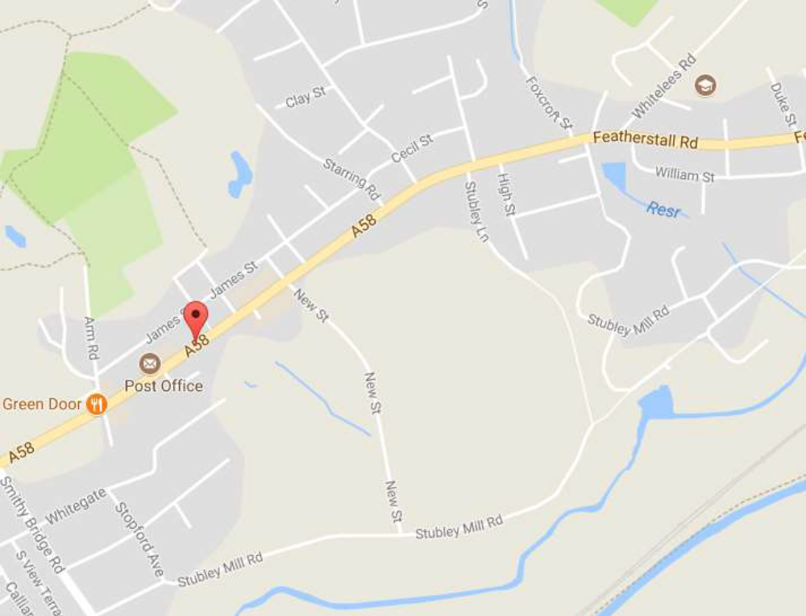

Location plan
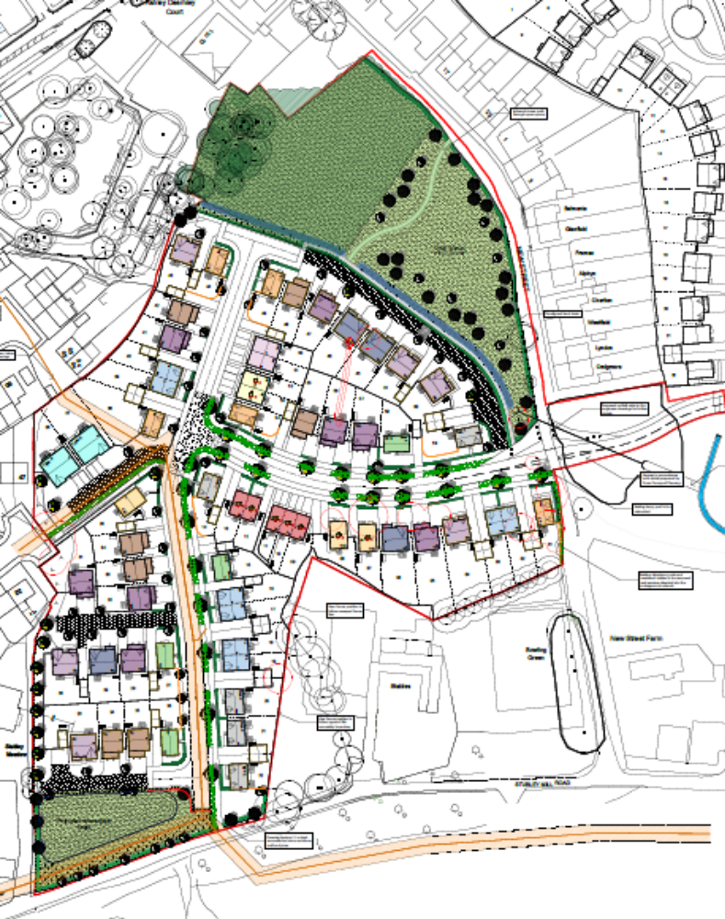

Site establishment

The Site consists of a 3.39 Ha parcel of land to be redeveloped into low rise residential.

The end use will be a total of 61 Units. The works will include all associated roads sewers and infrastructure. As well as a dedicated area of public open space.

Tree protection location

All tree protection will be installed as per the approved details see Mulberry report TRE/P3NL/Rev B

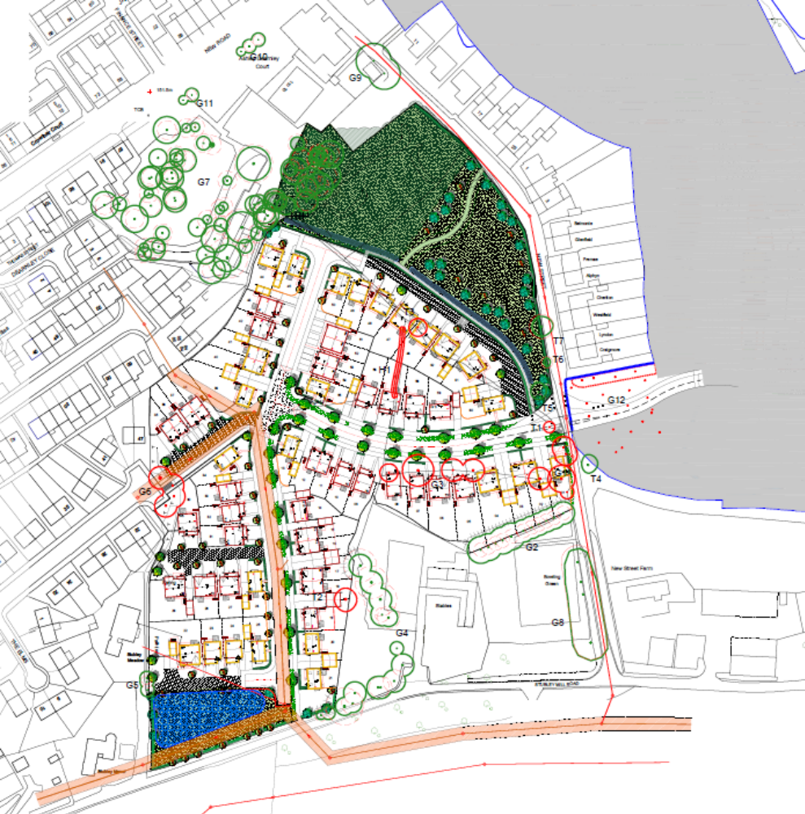

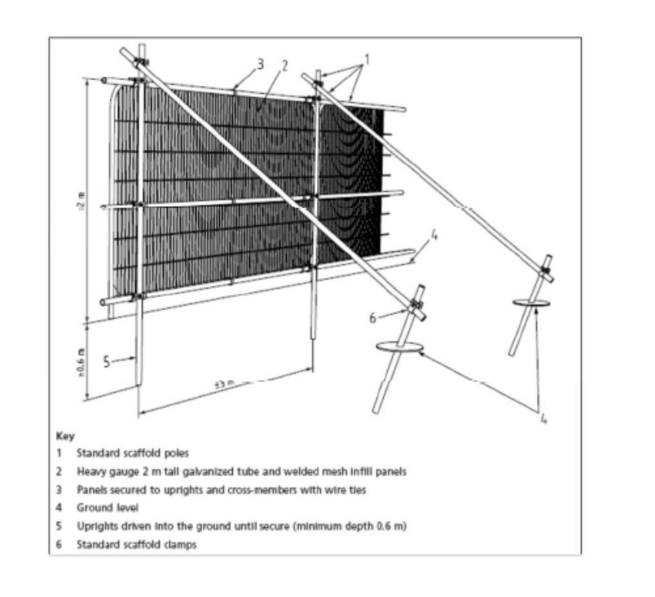

Site set up plan

A temporary access road will be provided, as per all construction sites. This will however be an ongoing matter as the site progresses.

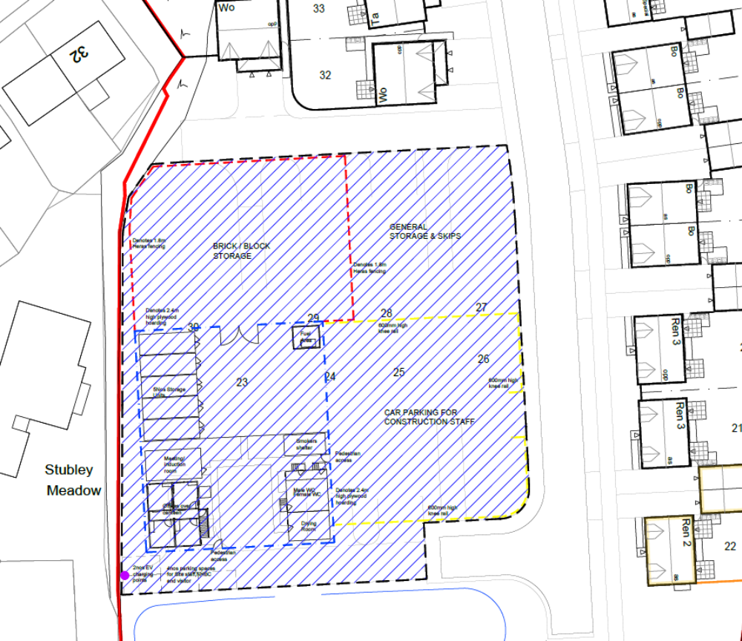

Plan indicating site set up, proposed welfare compound, proposed material compound and proposed waste handling compound. A temporary contractor compound maybe constructed at the start of enabling works the location of which may vary until the main compound is completed.

OPERATION TIMES

THE SITE WILL BE OPERATIONAL AT THE FOLLOWING TIMES:- (Information from planning approvals)

MONDAY TO FRIDAY | 07:30 to 18:00
SATURDAY | 08:00 to 14:30

No work activities will commence outside of these hours however it is noted that operatives may need to access and egress the site outside of these hours to prepare for work and after finishing work.

In the unlikely event that site deliveries arrive outside of these hours they may be brought on to site for Health and Safety reasons and to avoid unnecessary congestion to surrounding roads.

REMEDIATION

The geo environmental report identified a number of distinct areas which required remediation these are:-
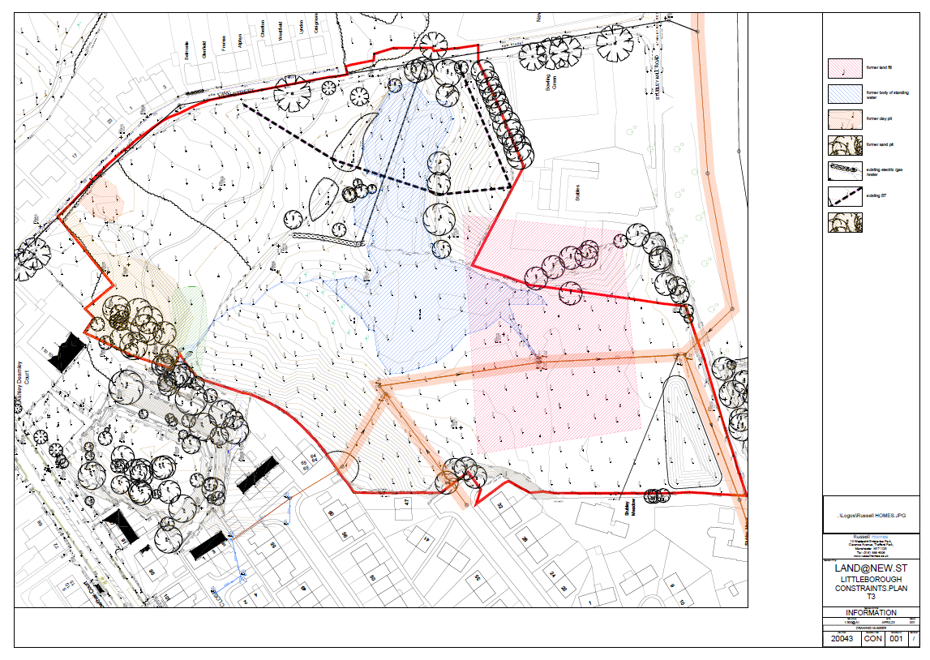

A full remediation strategy has been developed by E3P and has been formally submitted ref 15-075 to discharge the condition.

The implementation of the strategy will be undertaken to reduce the risk of health issues to both the occupants, the workforce and the surrounding public.

CONSTRUCTION AND DEMOLITION

The site will be managed from start to finish by an appointed management team consisting of the following: -

Civils Pre-Construction Site Manager | TBC
Housing Site Manager | TBC
Construction Manager | TBC
Commercial Manager | Stephen Wainwright
Quantity Surveyor | TBC
Technical Director | Matt Brennen
Design Manager | Neil Walker
Site Assistant | TBC
Health and safety advisory | TBC

The site managers will be the responsible people on site. They will monitor on a daily basis.

- All site boundary fencing.
- All adjacent roads on a daily basis.
- The scheduling of material deliveries spread out to avoid congestion where practicable.

The site will generally be constructed in the sequence identified on the program but may be subject to change depending on sales. Occupation of the sold properties will therefore follow a similar logic sequence.

Traffic Management

On site traffic for the civil works will be restricted to delivering and offloading in the material compound which will be adjacent to the site compound.

The material compound will be stoned up.
- Site traffic will be restricted to 5mph for all delivery vehicles
- A full time operative will be employed to manage all material deliveries to site he will:-
  - Monitor speed
  - Monitor wagons for any adverse environmental impact
  - Check wagons before leaving site to ensure wheels are clean
  - Check wagon sides to ensure there is no loose debris.
  - Clean the wagon wheels if required
  - Inform the site manager of any breaches that require immediate rectification

During initial enabling works site lay down areas will change and may be across several locations on site, this will be rationalised as the works progress and areas of the are remediated.

Placement of materials will be undertaken under the control of a site banksman as will the access and egress of delivery vehicles from site. Any requirements for the controlling of residue materials built up on the wheels of delivery vehicles will be assessed and mitigated as reasonably practical.

Roads will be monitored continually by the site manager and road sweeping measures will be implemented as required to ensure the surrounding areas are kept clean. Daytime temperatures will be monitored to ensure that any wet swept roads are gritted if sub-zero temperatures are anticipated.

(During initial enabling works this will be limited to during times of import only and the requirements for the management of surplus residue will be assessed daily. Measures such as a road sweeper, wheel wash and operative washing down wheels may be implemented when adjudged necessary).

On-site parking will be utilised to the point where it becomes no longer feasible within the zone identified on the site compound layout. It is likely that the site will be constructed in a continuous flow, there will therefore be no available on site parking towards the end of the development. When this becomes the case on-site parking will be kept to gable end zones where the disruption to the new home owners will be kept to a minimum.

Staff will use the temporary parking on site if necessary. No off-site parking is proposed.

Employees will be encouraged to use public transport where available and schemes are in place for bicycle purchase.

On Site Delivery route to the compound

Plant and materials will be loaded and unloaded In the material compound as shown on the below plan. The loading and unloading of plant an materials will be carried out with in the site operation hours only, all plant to be loaded and unload from the designated compound area.
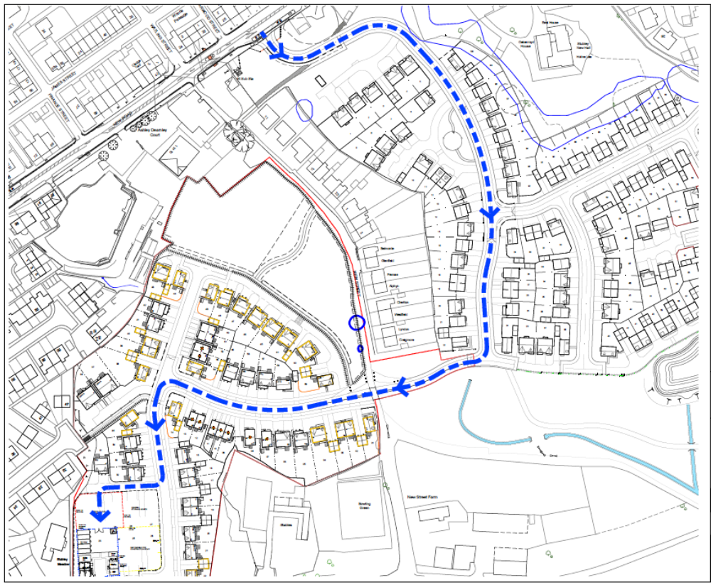

Off-site traffic route

Will generally be directed from the M62 through to the A58 – New Road.

We anticipate the off-site routes to be as follows:-

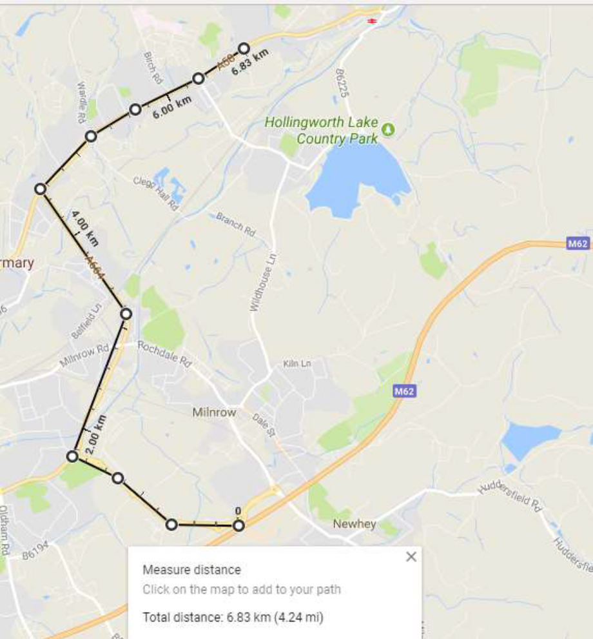

NOISE

It is inevitable that construction sites will make noise but the site is limited to low level housing operations, plant and equipment will be commensurate with this type of work. Small tools will be used akin to those identified on the “site Noise Safety” chart. In addition to this main plant such as telescopic handlers, excavators, dumpers, piling rig, crane and tarmac laying plant will all be utilised throughout the construction phase.

The workforce

Russells Ltd and its contractors will ensure that, where reasonably practicable, nobody on site is exposed to noise in excess of 80db (A). Where noise levels are suspected to be at or above 80db (A) the direct employer will be responsible for ensuring a suitable noise assessment is carried out. Suitable hearing protection must be made available to all affected personnel on request. Contractors undertaking work that continuously exceeds the noise level of 80db (A) hearing protection zones must be set up with clear warning signs positioned

Except where expressly permitted and agreed with the local authority, no operations which are audible above this range will be carried out outside of the working hours.

The surrounding area

There is no major demolition or breaking of structures which would involve heavy crushing plant so operations with the exception plied foundations are limited to low level construction operations where any elevated noise levels will be of short duration.

There are no properties adjacent to the site where construction activities are likely to cause problems however the following mitigation measures will be maintained at all times:-

- No work will be undertaken outside of the operational hours without the prior agreement of the local planning authority (with the exception of operatives accessing and egressing the site both before and after working hours and manned security as required during non-working hours).
- There will be no radios permitted on site, this will form part of the site induction:-
- Noise Monitoring will be carried out during activities known to be inherently noisy and mitigation will be provided if necessary.
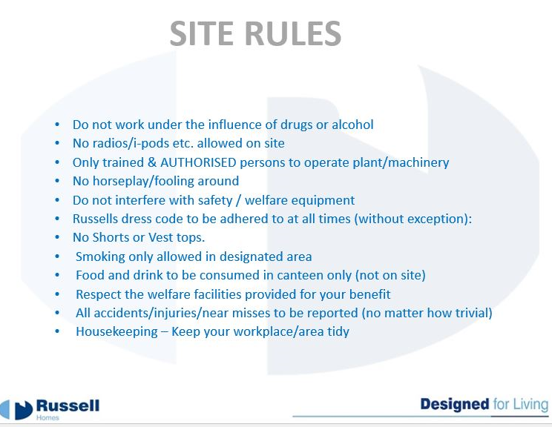

- These measures relating to the protection of the home owners will be in place prior to occupation of the respective property


DUST
The workforce

Dust and respiratory protection will form part of the site induction (as below) and all employees exposed to any dust will be fitted with face fit dust masks.
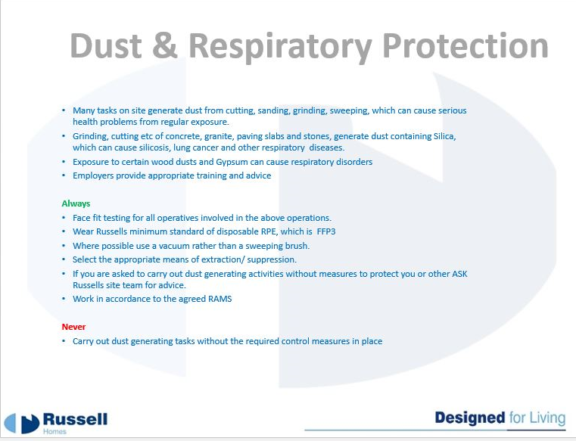
The surrounding areas

Mitigation measures will be implemented throughout the life of the construction project as follows:-

- All petrol operated cutting will be fitted with dust suppression to minimise the potential for airborne particles.



- The estate roads will be monitored on a daily basis by the site manager and swept as required using water dampened sweeping equipment to remove dust residue rather than supress it.
- The site manager will continually monitor for any increased levels of dust and water bowsers will be on site with spray valves to allow any emergency suppression.
- The Site Manager will review daily, there will be a labourer who will hose vehicles. The washer as detailed above.

Lighting
- The external lighting will be street lights only, the only lights will be those on vehicles and from welfare facilities. These will be shielded from residents to avoid light pollution. External site works cannot commence in the winter hours beyond sunlight hours to accord with Russell Homes Health and Safety policy.

Construction Methodology for Plot Construction
Introduction
Prior to the commencement of the Construction of the individual plots, the Principal Contractor for the Civil and Earthmoving operations with handover the Site fully finalized as completed below;
- Earthmoving including Cut and Fill to all plots and public open spaces
- Roads and Main Drainage fully Completed
- Roads and Shared drives completed up to base course levels
- Footpath, plot pads and drives filled with compacted stone to level
- Subbase completed to all garden areas with topsoil bunded for final spread
- New road entrance fully completed
- New incoming site service mains coordinated and installed
Prior to any works commencing Russell Homes will provide a Site Compound for Offices and Welfare, a designated Construction Parking area. A designated material storage area will also be provided.
For an initial Period until the Temporary Electrical feed can be provided; the welfare will run form an acoustic rated Generator within working hours.
Working Hours
Russell Homes will best adhere to the Working hours below unless approval is granted
MONDAY TO FRIDAY | 07:30 to 18:00
SATURDAY | 08:00 to 14:30

Programme of Works
It is anticipated the project will take 2.5 Years to fully complete, subject to sales.
The build route is programed to work inwards towards the site to ensure a constant separation between the newly occupied properties and the Construction Zone; the Construction Zone will be fully fenced at all times, with appropriate safety signage and a locked site access gate.
Traffic Management
The new Site entrance will be fully completed and Roads completed up to base course level prior to works commencing; in addition, Russell Homes will provide.
- A Construction Site Traffic Managements Plan for construction operations; this is developed in the site meeting room on a designated sign board. This is monitored and updated with site activities progressing on a weekly basis and forms part of our induction process.
- Adequate directional and speed restriction signage and further site-specific signage within the Construction Zone;
- Until the designated footpaths are completed pedestrian walkways are provided to separate the workforce and construction traffic.
- Roads are kept clean by road sweeps as required.
- All deliveries must report to the Site Compound for instruction and a designated Materials Storage area is provided for all deliveries to unload their goods

Building Control and Warranty
Construction operations will consult and coordinate the necessary stage inspections by the NHBC and requirements to discharge plot conditions.
Substructure operations
Precast driven plies are required to provide the required foundations for all the dwellings; prior to work commencing the piling contractor will complete a vibration impact report that will include any and extent of vibration monitoring required. This will be discussed and approved with the Environmental Health Officer prior to works commencing. The locations of existing properties are deemed to be at a distance as not to be affected by these operations, this will be verified in the report to be developed.
Prefabricated piles are delivered to site and installed by a piling rig
Precast beams and floors will be instead once the piling has been completed and tests results confirmed; these are delivered to site and installed with a small 30t crane. All crane operations are completed from the road and subject to an approved crane lift plan
Prior to the floors being completed; internal Drainage and Inflaming services will be coordinated and completed
The Plot Drainage and Services will be completed and Levels adjusted to provide the perimeter scaffold base.

Superstructure Operations
The designed Perimeter scaffold is installed prior to the Timber Frame installation; the prefabricated internal walls, floor cassettes and roof trusses are delivered to Site and installed in 1 week by using a suitably sized crane from the Road. All Crane operations are subject to a Crane lift plan and approval.
Upon completion of the Timber Structure the Roof is felted and tiled, the Windows are Installed internally and then the outer Brick skin is completed with all works being completed from the designed scaffold; a loading bay is provided to each level for the Site Forklift to safely load the materials required.

Finishes Operations
Once the new dwelling is watertight the internal works commence with operations as below
- First fix joinery
- First fix services
- Insulations
- Plastering
- 2nd fix joinery
- 2nd fix services
- Kitchen and tiling
- Painting
- Install service meters
- Final fix and commission
- Final snagging
- Build complete
- Customer demonstration
- Customer handover

External Works
Upon completion of the substructure and stripping of the scaffold external works commence with the below operations
- Incoming plot service connections
- Drive construction up to base course
- Perimeter flagging / retaining structures
- Top soil of gardens
- Footpath construction to base course
- Garden fencing
- Landscaping
- Drive final surface coat
- Shared access drives
- Final snag
- Build complete

Waste
Russell Homes work in accordance the waste management plan contained within our Environmental Management Plan; our aim is to minimize waste and recycle to a minimum of 90% across all sites;
A designated waste area is contained on site with larger skips and waste is transferred from the plots by using small tipping skips transported by the site forklift.

Public Complaints
Prior to works commencing our Customer Care department will notify all surrounding residents and provide their contract details for notification or any other information required. All calls, emails are logged onto a schedule, the required action is recorded prior to the complaint being closed out.

Build Route
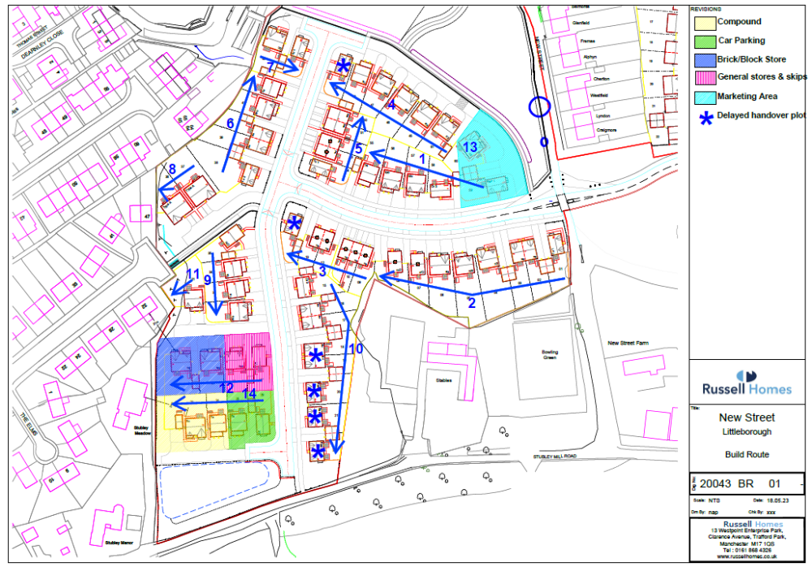

Russell Homes Sign Off

Health and safety
Name / position / date ……………………………………………………….
Construction
Name / position / date ……………………………………………………….
Technical
Name / position / date ……………………………………………………….

