Rear Door 35
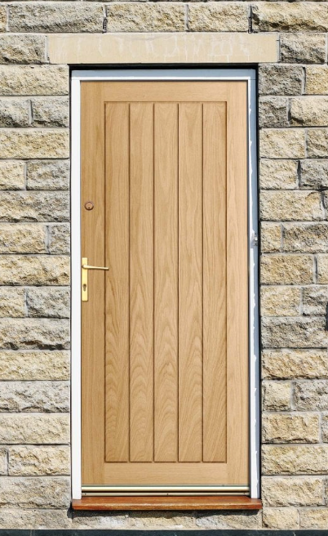
Full Specifications
Manufacturer product number
EXTOAKFAR30
Brand
Liberty Doors
Area for use
External / exterior use
Type
Standard Doors
Material
Oak
Finish
Unfinished
Colour
Brown
Lipping
15mm solid lipping
Core type
Solid timber core
Trimming allowance
10mm trimming from all edges
Manufacturer guarantee
Lifetime Guarantee
Sustainability
Responsibly sourced timber from sustainable forestry
Recommended hardware
3x External hinges. Weather Bar to comply with manufacturers guarantee
Rear Door 33
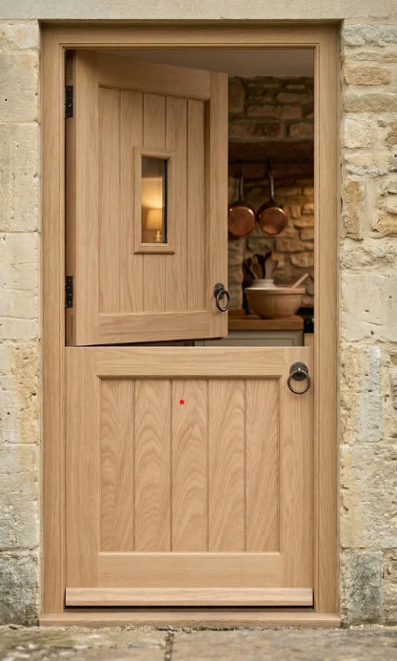
Full Specifications
Manufacturer product number
EXTOAKSTBCG30
Brand
Liberty Doors
Area for use
External / exterior use
Type
Stable Doors
Material
Oak
Finish
Unfinished
Colour Brown
Glazing type
14mm double clear toughened safety glass
Lipping 15mm solid lipping
Core type
Solid timber core
Trimming allowance
10mm trimming from all edges
Manufacturer guarantee
Lifetime Guarantee
Sustainability
Responsibly sourced timber from sustainable forestry
Recommended hardware
3x External hinges. 2x Weather bars to comply with manufacturers guarantee
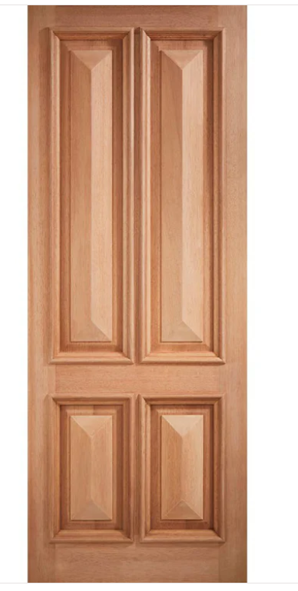
Front Door 33 & 35
4 Panel Exterior Hardwood Front Door
Brand
Liberty Doors
Area for use
External / exterior use
Material
Hardwood
Finish
Unfinished
Colour
Brown
Lipping
15mm solid lipping
Core type
Solid timber core
Trimming allowance
10mm trimming from all edges
Manufacturer guarantee
Lifetime Guarantee
Sustainability
Responsibly sourced timber from sustainable forestry
Recommended hardware
3x External hinges. Weather Bar to comply with manufacturers guarantee

