STRATEGIC HOUSING DIRECTORATE

From: | Strategic Housing Service | To: Nick Brookman
Name: | Michelle Kelly | Date: | 12/06/26
Application No: 25/01018/FUL

Location: Land at Waterfold Lane, Heap Bridge BL9 7JY

Site Location:

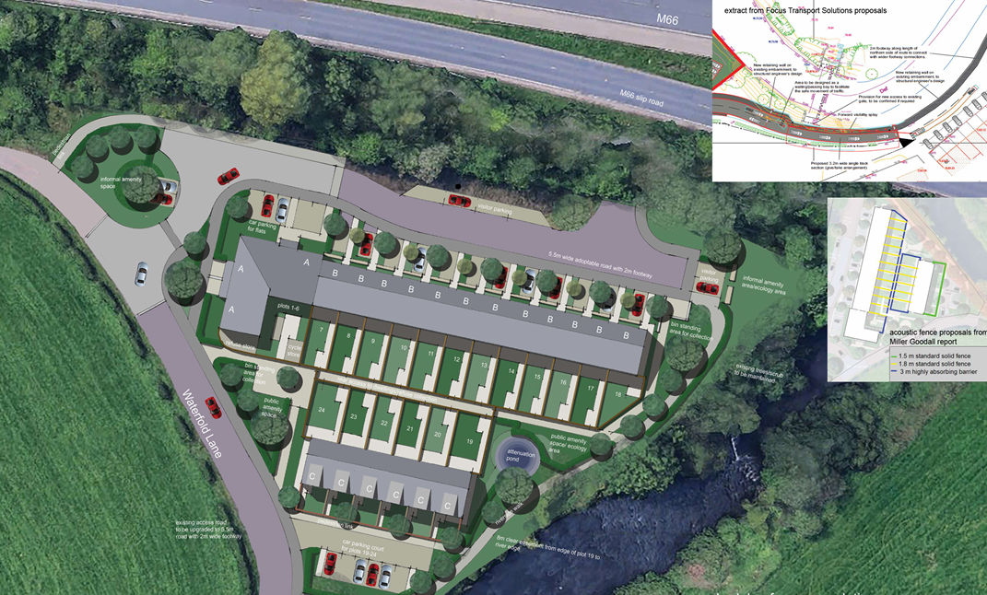

Thank you for consulting Strategic Housing.

The scheme proposes the erection of 24 dwellings consisting of 6no. 1-bed apartments and 18no. 3-bed houses.

The application confirms that all dwellings are to be for social rent. Strategic Housing strongly supports the delivery of a 100% social rent scheme, in accordance with national and local priorities.

Rochdale Council has declared a housing crisis and there is a critical need within the borough for 1-bedroom properties and 4/5-bedroom houses for social rent. As of June 2026, there are circa 3000 households on the Rochdale Housing Register in priority bands (A-C).

The table below details current demand of property size within the whole Rochdale Borough:

Total number of applicants in Priority Need (Bands A-C) (across all areas in Rochdale Borough) | 3,061
Applicants in priority need requiring a 1-bedroom property (across all areas in Rochdale Borough) | 1,157
Applicants in priority need requiring a 2-bedroom property (across all areas in Rochdale Borough) | 859
Applicants in priority need requiring a 3-bedroom property (across all areas in Rochdale Borough) | 680
Applicants requiring 4+ bedroom property (across all areas in Rochdale Borough) | 365

The table below details how many properties in the whole Rochdale Borough became available for let to applicants on the housing register in 2025/26 (April-March), and the average number of bids per property.

Whole Rochdale Borough - Lettings & Average Number of Bids
(1st April 2025 – 31st March 2026)
1 Bedroom | Properties available for let = 464  Average Bids Per Property = 169
2 Bedroom | Properties available for let = 205  Average Bids Per Property = 324
3 Bedroom | Properties available for let = 135  Average Bids Per Property = 432
4 Bedroom | Properties available for let = 2  Average Bids Per Property = 365
5 Bedroom | Properties available for let = 0
6 Bedroom | Properties available for let = 2  Average Bids Per Property = 369

The table below details how many properties in the Heywood township (where the site is situated) became available for let to applicants on the housing register in 2025/26, and the average number of bids per property.

Heywood - Lettings & Average Number of Bids
(1st April 2025 – 31st March 2026)
1 Bedroom | Properties available for let = 50  Average Bids Per Property = 169
2 Bedroom | Properties available for let = 43  Average Bids Per Property = 249
3 Bedroom | Properties available for let = 10  Average Bids Per Property = 535
4 Bedroom + | Properties available for let = 0

With regard to this application, Strategic Housing supports delivery of 1 bed apartments to meet acute local and indeed borough-wide demand as the data above confirms.

In the financial year 25/26, only four 4 bed or larger dwellings were advertised through Rochdale Council’s Choice Based Lettings system and none of these were in the Heywood area, emphasising the urgent need for 4 bedroom or larger properties for social rent. Strategic Housing requests that the developer review their proposal for this development to include some 4 bed or larger dwellings.

The application confirms all dwellings will meet Nationally Described Space Standards (NDSS) which Strategic Housing welcomes.

As at June 2026, 67 households are still awaiting fully wheelchair adapted accommodation with the average wait time currently at 529 days and some households waiting for 5 years + for a home that meets their needs. 40 households that are currently residing in council-provided temporary accommodation in Rochdale include at least one family member with a physical or mental disability (23 physical, 17 learning). The data emphasises the need for properties that are constructed to M4(3) standard in addition to M4(2).

The scheme states that all houses and the ground floor apartments are to meet M4(2) standards. As there is no lift in the plans, the three first floor apartments are not compliant with M4(2) standards. None of the homes are M4(3) standard and Strategic Housing would welcome a conversation to convert some of the 3 bed properties to M4(3) standard as there is a particular need for larger M4(3) properties to accommodate households that have disabilities requiring a fully adapted home.

Overall, Strategic Housing is supportive of the proposed scheme taking into account the points made above.

Strategic Housing
Rochdale Borough Council

