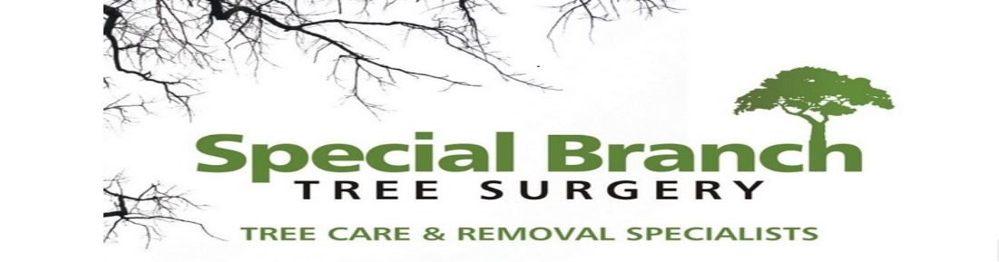

Top O’th Meadow Farm
Meadowhead Lane
Norden, Rochdale
OL11 5UL
Tel: 01706 658771

29th June 2026

Report for
Omar Ali
447 Edenfield Road
Rochdale, OL11 5YR

As requested, please see the completed tree report, as discussed this offers no guarantees as trees are living organisms and can fail at any time. We would also like to advise that no indemnity or insurance cover is offered. This report is in “my opinion” only and covers only the trees that have been inspected.

Trees in question are subject to a Tree preservation order – TPO284

Local authority; Rochdale.

Location
Front garden of 447 Edenfield Road.

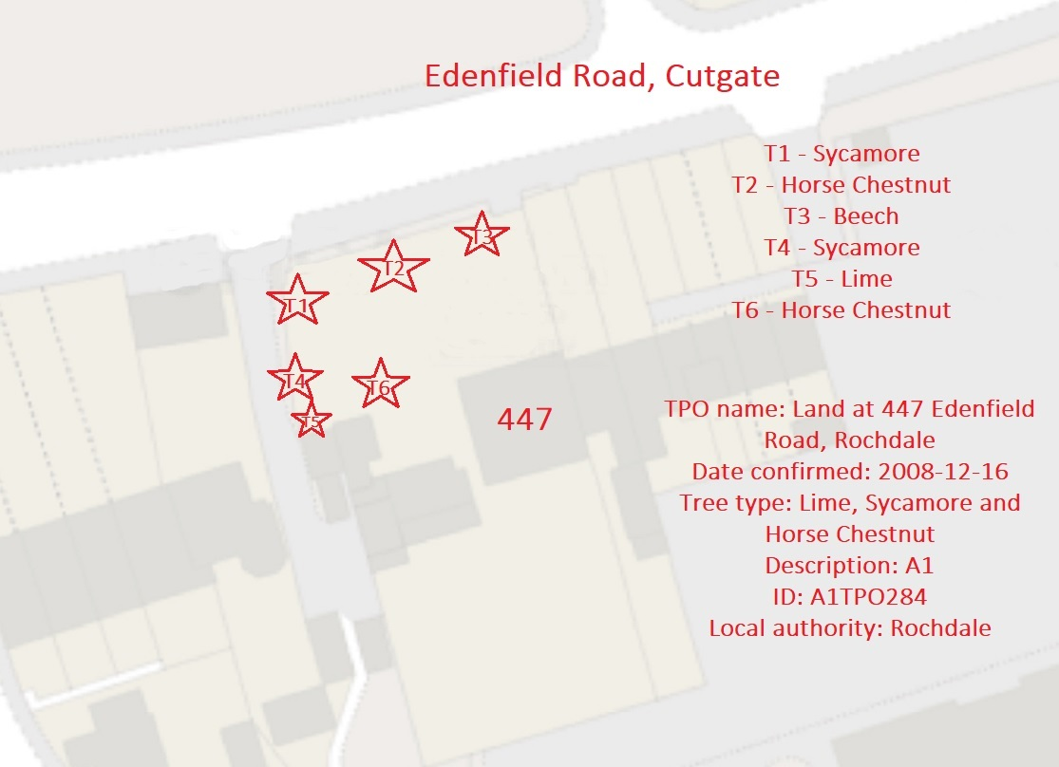

Work provided

Site visit, arboricultural inspection, photography, report, and quotation.
All trees have been thoroughly inspected and only the tree with any defects or concerns have been noted.

Proposed Works
The applicant is seeking consent to undertake routine arboricultural management works to the following protected trees:
- T2 – Horse Chestnut
- T3 – Copper Beech
- T5 – Lime
The proposed works consist of:
- T2 – Horse Chestnut: Crown lift to provide approximately 2.5 metres ground clearance over the adjacent footpath and 5.5 metres clearance over the adjoining highway.
- T3 – Copper Beech: Crown lift to provide approximately 2.5 metres ground clearance over the adjacent footpath and 5.5 metres clearance over the adjoining highway.
- T5 – Lime: Removal of epicormic growth from the main stem and lower scaffold branches.
All works are proposed to be undertaken in accordance with:
- BS3998:2010 – Tree Work Recommendations
- Current arboricultural best practice standards.
Reason for Works
The proposed works are required to provide the necessary statutory clearance over the adjacent highway and pedestrian footpath and to improve visibility of the traffic signals serving the nearby pedestrian crossing.
The existing canopy growth of T2 and T3 has encroached below the recommended clearance heights, while vegetation associated with the trees is restricting sightlines to the traffic lights. The removal of epicormic growth from T5 forms part of routine tree management and will assist in maintaining the tree's appearance while reducing unnecessary basal and stem growth.
The proposed works are considered proportionate and represent routine maintenance to ensure the safe and continued coexistence of the trees with the surrounding highway infrastructure.
Arboricultural Impact Assessment
The proposed works are limited in extent and represent standard arboricultural management practices. The crown lifting operations are confined to the removal of lower secondary branches only and are not expected to adversely affect the long-term health, vitality or structural integrity of either T2 or T3.
Similarly, the removal of epicormic growth from T5 is recognised as routine maintenance and will not have any detrimental effect on the tree's health or amenity value.
The works are not anticipated to materially alter the overall form, character or visual contribution of the trees within the local landscape and will retain their significant public amenity value while improving clearance and visibility for highway users.
Tree Ownership
The trees are situated within private ownership. This application has been submitted to obtain the necessary consent for the proposed works in accordance with the requirements of the Tree Preservation Order.
Conclusion
The proposed works to T2 (Horse Chestnut), T3 (Copper Beech) and T5 (Lime) are considered reasonable, proportionate and arboriculturally acceptable.
The works are limited to routine maintenance, providing statutory highway clearances and improving visibility of the pedestrian crossing traffic signals, whilst preserving the long-term health, structural integrity and visual amenity of the retained trees.
As all works will be undertaken in accordance with BS3998:2010 – Tree Work Recommendations and recognised arboricultural best practice, it is respectfully requested that consent is granted for the proposed works.
The proposed management represents a balanced approach to maintaining public safety and highway functionality whilst retaining the important landscape and amenity value of these protected trees.

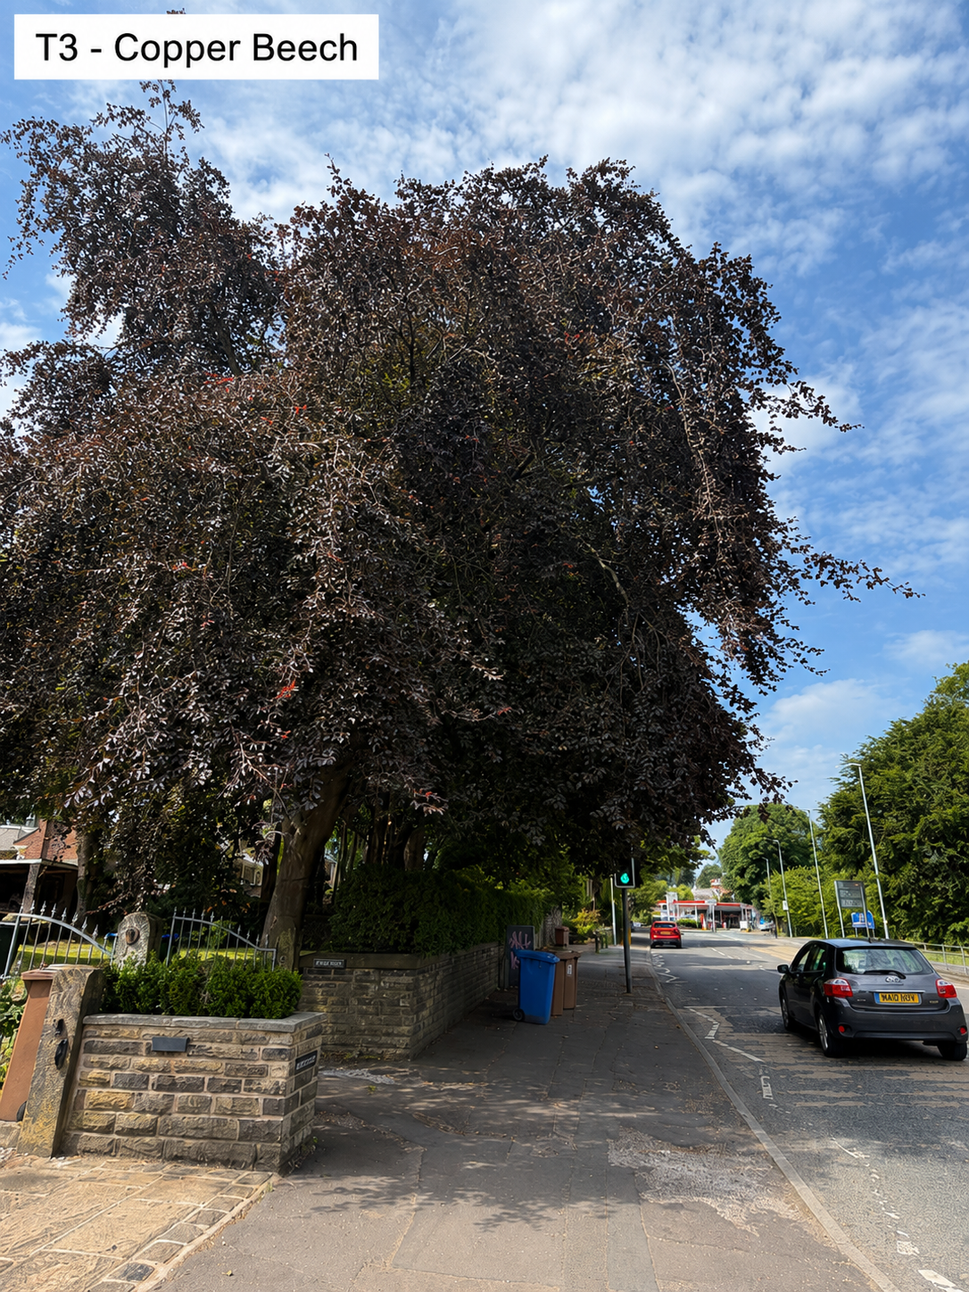
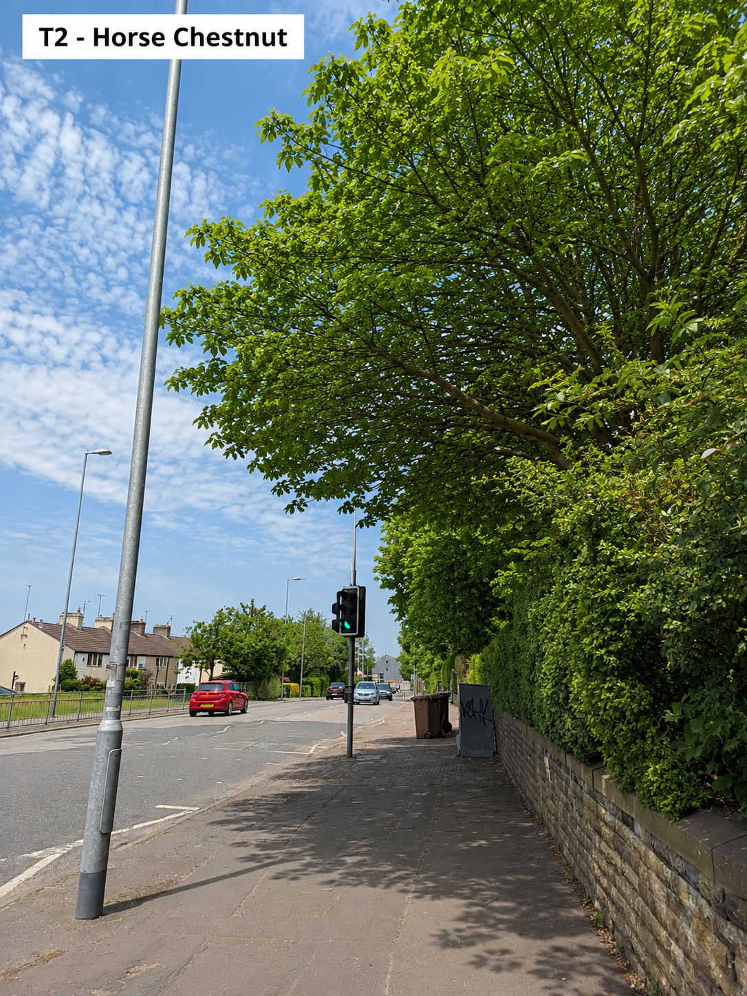

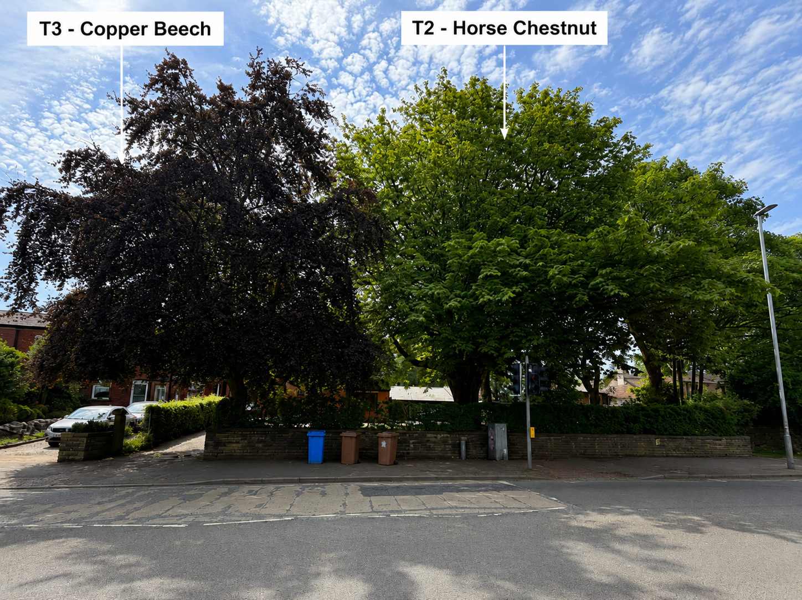
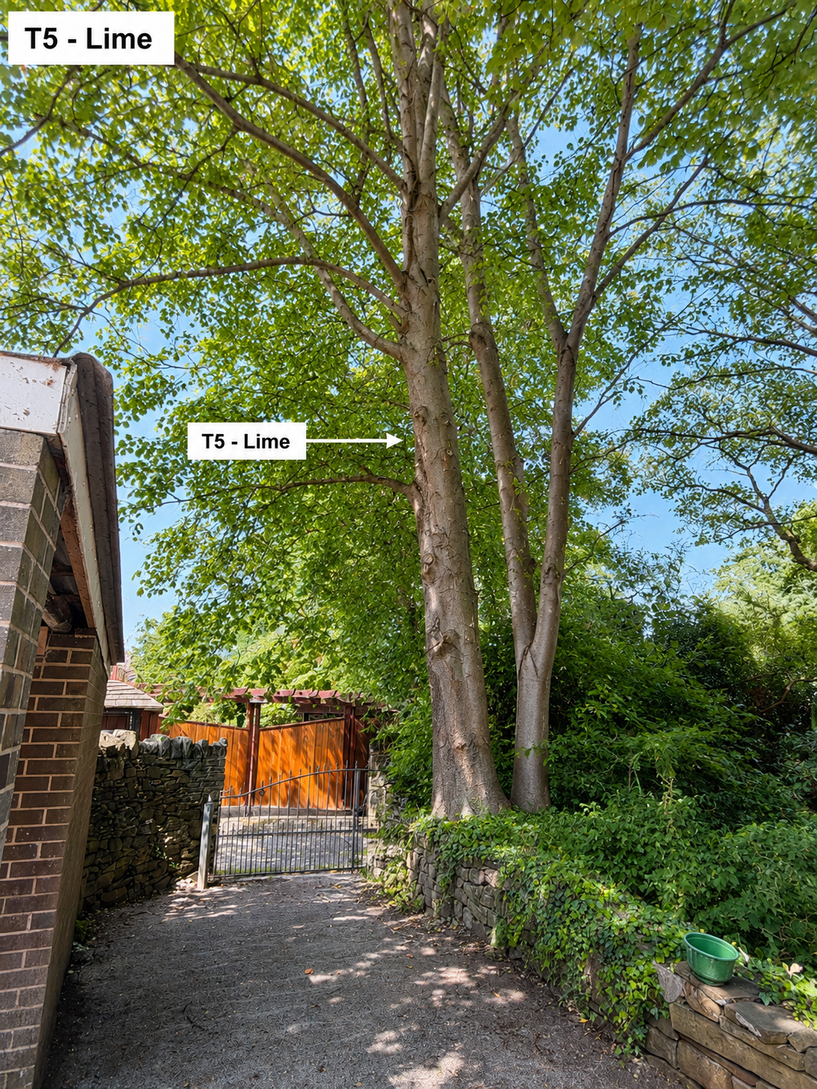

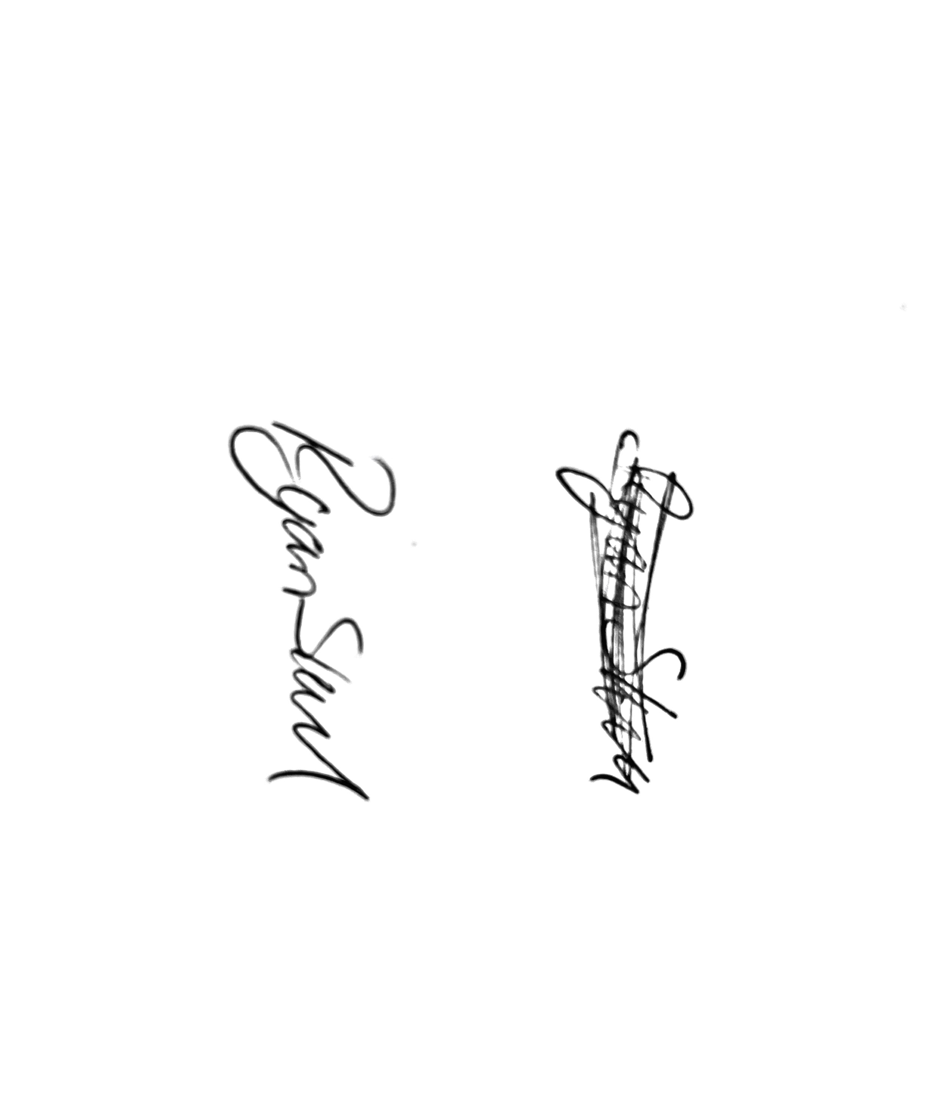
Kind regards,
Mr. Ryan Slack
General Manager and Director
SEG Award, Cert Arb L2 (ABC)

