STRATEGIC HOUSING DIRECTORATE

From: | Strategic Housing Service | To: Nick Brookman
Name: | Michelle Kelly | Date: | 29/06/26
Application No: PL/2026/0549

Location: Land on Drake Street, Rochdale OL16 1PJ

Site Location:

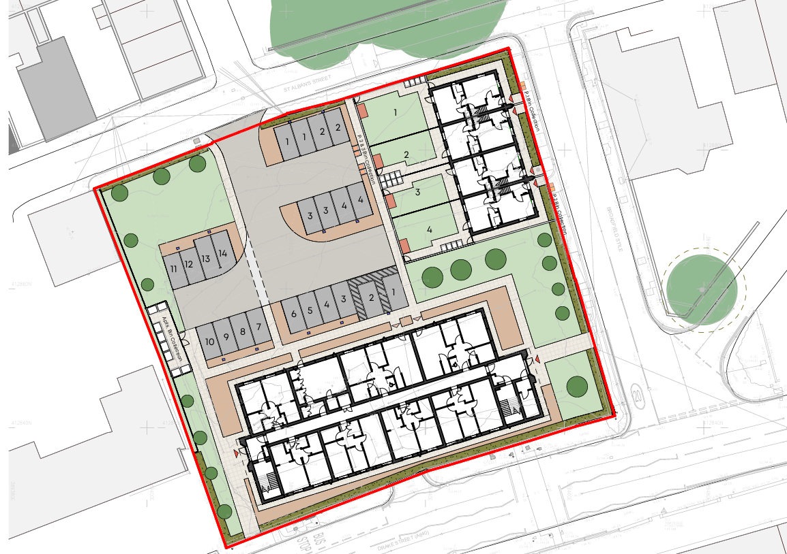

Thank you for consulting Strategic Housing.

The scheme proposes the erection of 27 dwellings consisting of 11no. 1-bed apartments, 12no 2-bed apartments and 4no. 4-bed houses.

The application confirms that all dwellings are to be for social rent. Strategic Housing strongly supports the delivery of a 100% social rent scheme, in accordance with national and local priorities.

Rochdale Council has declared a housing crisis and there is a critical need within the borough for 1-bedroom properties and 4/5-bedroom houses for social rent. As of June 2026, there are circa 3000 households on the Rochdale Housing Register in priority bands (A-C).

The table below details current demand of property size within the whole Rochdale Borough:

Total number of applicants in Priority Need (Bands A-C) (across all areas in Rochdale Borough) | 3,061
Applicants in priority need requiring a 1-bedroom property (across all areas in Rochdale Borough) | 1,157
Applicants in priority need requiring a 2-bedroom property (across all areas in Rochdale Borough) | 859
Applicants in priority need requiring a 3-bedroom property (across all areas in Rochdale Borough) | 680
Applicants requiring 4+ bedroom property (across all areas in Rochdale Borough) | 365

The table below details how many properties in the whole Rochdale Borough became available for let to applicants on the housing register in 2025/26 (April-March), and the average number of bids per property.

Whole Rochdale Borough - Lettings & Average Number of Bids
(1st April 2025 – 31st March 2026)
1 Bedroom | Properties available for let = 464  Average Bids Per Property = 169
2 Bedroom | Properties available for let = 205  Average Bids Per Property = 324
3 Bedroom | Properties available for let = 135  Average Bids Per Property = 432
4 Bedroom | Properties available for let = 2  Average Bids Per Property = 365
5 Bedroom | Properties available for let = 0
6 Bedroom | Properties available for let = 2  Average Bids Per Property = 369

With regard to this application, Strategic Housing supports delivery of 1 bed apartments and 4 bed houses to meet acute local and indeed borough-wide demand as the data above confirms.

In the financial year 25/26, only four 4-bed or larger dwellings were advertised through Rochdale Council’s Choice Based Lettings system and only one of those were in the Rochdale North area, emphasising the urgent need for 4 bedroom or larger properties for social rent. Strategic Housing welcomes the inclusion of 4 bed properties within this scheme.

The application confirms all dwellings will meet Nationally Described Space Standards (NDSS) which Strategic Housing welcomes.

As at June 2026, 67 households are still awaiting fully wheelchair adapted accommodation with the average wait time currently at 529 days and some households waiting for 5 years + for a home that meets their needs. 40 households that are currently residing in council-provided temporary accommodation in Rochdale include at least one family member with a physical or mental disability (23 physical, 17 learning). The data emphasises the need for properties that are constructed to M4(3) standard in addition to M4(2).

The scheme states that three 1-bed apartments and two 2-bed apartments are to meet M4(2) standards and two 2-bed apartments are to meet M4(3) standards. All of these properties are on the ground floor and, as there is no lift in the apartment block, the remaining apartments are not compliant with M4(2) standards. The 4 bed homes are not to M4(2) or M4(3) standards. The statistics demonstrate that there is a particular need for larger M4(2) and M4(3) properties, however, Strategic Housing appreciates that viability is a factor in this development.

Overall, Strategic Housing is supportive of the proposed scheme taking into account the points made above.

Strategic Housing
Rochdale Borough Council

