STRATEGIC HOUSING DIRECTORATE

From: | Strategic Housing Service | To: Michael Atkinson Smith
Name: | Michelle Kelly | Date: | 29/06/26
Application No: PL/2026/0421

Location: Land off Royle Road, Rochdale OL11 3ET

Site Location:
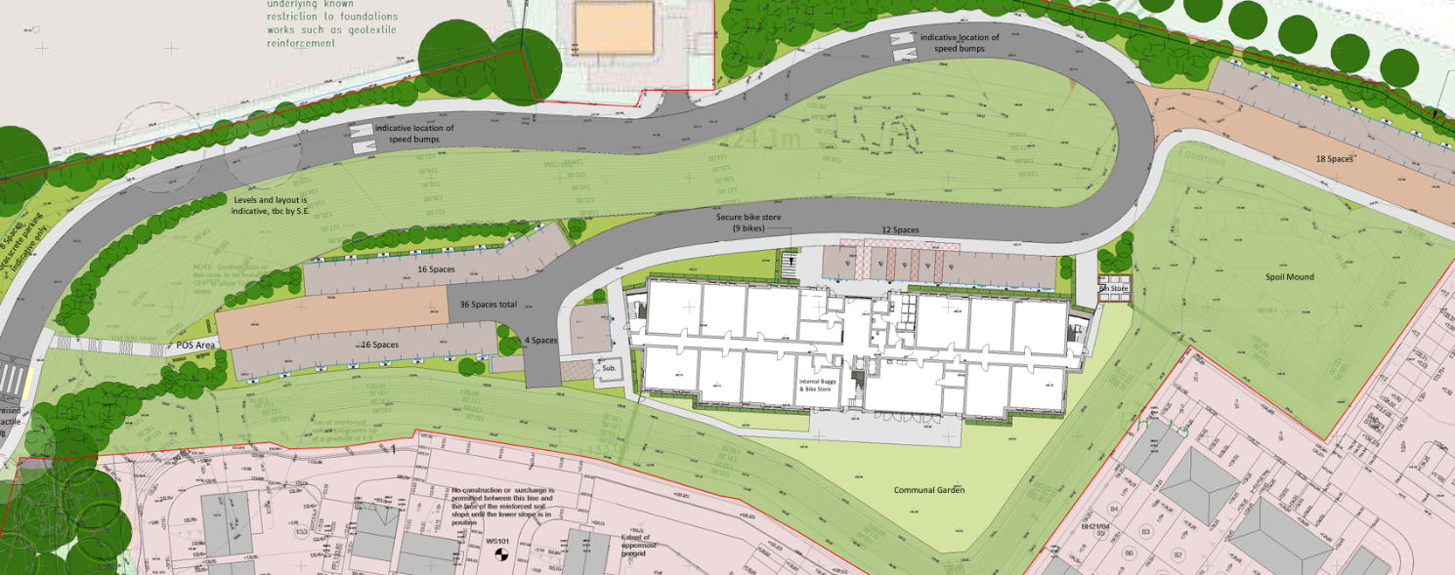

Thank you for consulting Strategic Housing.

The scheme proposes the erection of 75 dwellings consisting of 38no. 1-bed apartments and 37no 2-bed apartments built over five storeys with ‘extra care light’ facilities on site.

Rochdale Council has declared a housing crisis and there is a critical need within the borough properties for social rent. As of June 2026, there are circa 3000 households on the Rochdale Housing Register in priority bands (A-C).

The table below details current demand of property size within the whole Rochdale Borough:

Total number of applicants in Priority Need (Bands A-C) (across all areas in Rochdale Borough) | 3,061
Applicants in priority need requiring a 1-bedroom property (across all areas in Rochdale Borough) | 1,157
Applicants in priority need requiring a 2-bedroom property (across all areas in Rochdale Borough) | 859
Applicants in priority need requiring a 3-bedroom property (across all areas in Rochdale Borough) | 680
Applicants requiring 4+ bedroom property (across all areas in Rochdale Borough) | 365

The application currently does not currently include a clear affordable housing provision. The current requirement for developments of 10+ dwellings is for at least 20% of dwellings to be affordable or an off-site provision/contribution. Strategic Housing would welcome a discussion on how this criteria is to be met, with a preference for an on-site affordable provision included.

Strategic Housing notes that this scheme is aimed at the older population and appreciates that future predictions state that there will be a significant increase in the number of older people within the borough with a consequent higher need for specialist accommodation.

Within the above table, 751 applications with a priority need are from people aged 55+ and 485 of these applications have priority for an adapted/adaptable home to meet their needs.

Regarding this application, Strategic Housing therefore supports delivery of older persons accommodation to accommodate an aging population.

The application confirms all dwellings will meet Nationally Described Space Standards (NDSS).

The scheme states all of the 1-bed and two 2-bed apartments are designed to Building Regulations M4(2) with lifts included in the block for access to the higher floors. However Strategic Housing urges the applicant to refer to Housing LIN: ‘Design Principles for Extra Care Housing’. Strategic Housing is disappointed at the lack of apartments designed to Building Regulations M4(3) standard, to meet the needs of individuals requiring an adapted and wheelchair accessible home within an Extra Care setting.

Strategic Housing
Rochdale Borough Council

