
Highways and Engineering Service - Economy and Environment

Drainage Consultation on Application –OTH/2026/0130 - 29-31 Maclure Road
LLFA Consultation Response on behalf of Head of Highways and Engineering
Date of Response: 25th March 2026

BKPL Comments 27.03.26 in green.
Location & Proposed Development
Station Buildings, 29-31 Maclure Road, Rochdale, OL11 1DN
Submission of details to comply with conditions 8 (Compliance with CIS), 16 (Site Investigation and Remediation), 19 (Sustainable Building and Method Statement) and 22 (Below Ground Drainage) of planning permission 23/01310/FUL
Documents Reviewed
- 14834 Rochdale Corner Plot SuDS Maintenance Schedule - End User (Rev P01)
- 14834 Rochdale Corner Plot SuDS Maintenance Strategy - End User (Rev P02)
- 14834-BKP-V1-XX-DR-C-500-P04 Proposed Drainage GA
- 14834-BKP-V1-XX-DR-C-510-P04 Proposed Drainage Details Sheet 1 of 2
- 14834-BKP-V1-XX-DR-C-511-P03 Proposed Drainage Details Sheet 2 of 2
- BKP Drainage Comments
- Covering Letter - PC 8 16 19 22
- Remedial Specification - Ground Tech GRO-25277-6332
- UU Safedig records
- EA Flood Maps For planning
- UU Consultation Response 10/03/2026
- Drainage Strategy Report 14834-BKP-V1-XX-RP-C-011 P02 (for 23/01310/FUL)
- Proposed site Plan 8337-LRW-ZZ-00-DR-A-00-192_P02 (for 23/01310/FUL)
- Previous LLFA comments 12/03/2023 (for 23/01310/FUL)
Drainage & Flood Officer Comments

- The aim should be to discharge surface run off as high up the following hierarchy of drainage options as reasonably practicable: The ordered drainage techniques to be assessed with the aim to reduce or omit lower techniques:
- Control at Source (Recycling)
- Control at Source (Infiltration)
- On Site Treatment (Basins, Swales, Rain gardens, Tree pits)
- Local Treatment (Adoptable Ponds, Basins, Swales etc)
- Regional Treatment (ditto usually to a larger scale)
- Discharge to Watercourses / Bodies
- Discharge to Surface Water (SW) Sewers
- Discharge to Combined Sewers

Noted and agreed; review of SuDS hierarchy carried out and included in approved BKP Drainage Strategy Report 14834-BKP-V1-C-011-P02 (Section 4.4)

- No infiltration testing has been provided as part of the application. However, the Groundtech report notes that the site contains Made Ground with elevated concentrations of heavy metals (including lead, arsenic and mercury) and polycyclic aromatic hydrocarbons (PAHs). In addition, the site has a small footprint which is being fully built over. Therefore, it is unlikely that infiltration would be feasible even if favourable rates were obtained.

Review of potential for use of SW infiltration included in approved BKP Drainage Strategy Report 14834-BKP-V1-C-011-P02. Review based on previous NX Consulting ground investigation works (supplementary Grountech investigations had not been carried out at time of production of BKP report, however have been reviewed and indicate consistent ground conditions). Infiltration not considered feasible due to insufficient spaces available within site boundary and close proximity to adjacent properties as summarised in Section 4.4 of BKP report

- The drainage strategy rev P02 advised that there are no SW sewers in proximity to the site. However, UU records show that there are SW sewers in both Maclure Rd and Station Rd, although they then connect to combined sewers. Nevertheless, the proposed drainage should discharge to the SW sewers in the first instance. The BKP Drainage Comments reference P03 of the strategy but this could not be found on the portal.

Reference made to existing sewer systems within BKP Drainage Strategy Report 14834-BKP-V1-C-011-P02 (Section 4.1, shown in Figure 9 of BKP report as shown below)). As stated in Section 4.4, existing UU sewers directly adjacent to site are combined systems; UU SW sewers are present at approximately 30m to east of site (within Station Road) and 40m to north of site (within Maclure Road), however connection to these has not been considered feasible due to significant distance through third party land (including heavily services footpaths / highways as identified in subscan survey information.

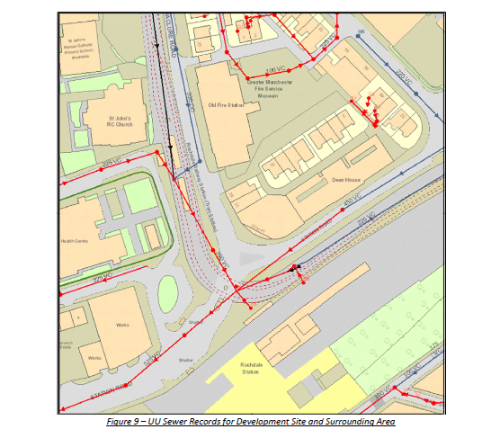
Updated BKP Drainage Strategy Report 14834-BKP-V1-C-011-P03 issued for submission to the planners on 06.03.24. Note drainage strategy (including strategy for surface water (including attenuation specifications, flow rates, outfall locations, etc) and foul run off have not changed since previous revision P02; updates related to changes to architectural layouts contained within BKP report for consistence with architectural updates at this time.

In addition, the status of the outfall route is uncertain and future separation of SW from combined sewers could be compromised by the current proposals.

Refer to BKP email 27.03.26; BPK drainage GA drawing updated to include details of outfall route to UU combined manhole 9701. Proposed system shown as separate ‘to point of discharge to the site’ as per Condition 22 requirement (ii)

Furthermore, some of the SW roof drainage is not routed via the flow control.

SW run-off from the existing Chicken Shaq building (included in the scheme as refurbishment of the existing property) is to remain as current site conditions and has therefore not been included in flow control from the site as noted in approved BKP report Section 4.4.

It is noted that UUs comments are consistent with the above points. Therefore, it is considered the SW drainage should be revisited.

SW strategy is as per BKP Drainage Strategy Report 14834-BKP-V1-C-011-P02, including compliance with Condition 22 requirements (flow rates, attenuation volumes, etc, as stated in Condition 22).

- No SuDS source control features have been proposed as part of the drainage strategy. Whilst there is limited space there may be potential for hydroplanters at RWPs or perhaps green roof / wall options for the new building.
SuDS features not considered feasible as part of BKP drainage strategy due to limited available space. Green / blue roof system was considered at early stage but discounted due to client team / architectural concerns. As such, no SuDS features were included in approved BKP Drainage Strategy Report 14834-BKP-V1-C-011-P02 or requested during planning stage.

- If it is considered that there is no scope for green SuDS, then recycling rainwater is now the top rung of the revised SuDS hierarchy (rather than joint top). Recycling is considered to be of benefit from a sustainability perspective rather than flood management. It is considered more sustainable to use recycled water rather than potable water for non-weather related usage (eg WC flushing). This in turn reduces some of the overall volume being discharged to combined sewer and ongoing treatment etc.
Use of recycling rainwater not included in approved BKP Drainage Strategy Report 14834-BKP-V1-C-011-P02 or requested during planning stage.

- The proposed attenuation tank is located beneath the main entrance area. If any works became required, then this would be extremely difficult to implement. A better location may be to locate the tank and access chambers beneath the cycle and bin storage areas indicated on the site plan. However, it is unclear if the site plan and Drainage GA are correlated because the pile caps and ground beams indicated on the Drainage GA look different to the wall locations on the site plan.
Attenuation tank included under the building due to limited space available on site (noting potential for undermining of existing adjacent building foundation is tank is located outside of the building within site boundary). Tank installation under the building slab is to include access chambers installed to both sides of the tank to allow maintenance jetting / cleaning of the tank. Tank to be suitably designed by specialist to accommodate both temporary and permanent loadings applied during construction / during building use to ensure tank is suitably durable.
Drainage & Flood Officer Summary:
- The outfall options for surface water discharge should be reviewed. – See notes above
- Mitigation options to reduce overall discharge volumes should be reviewed. – See notes above
- Future risks associated with the location of the attenuation tank should be reviewed. – See notes above
- The above points should be addressed before the condition is discharged. – See notes above
Consultation by Keith Mealey
Drainage & Flooding Officer
keith.mealey@rochdale.gov.uk

