
Highways and Engineering Service - Economy and Environment

Drainage Consultation on Application – PL/2026/0248

– Land Off, Holly Oak Gardens, Heywood, Rochdale, OL10 1HP
LLFA Consultation Response on behalf of Head of Highways and Engineering
Date of Response: 5th August 2026
Location & Proposed Development
Land Off, Holly Oak Gardens, Heywood, Rochdale, OL10 1HP
Residential development of 4no 3 bed dwellings
Documents Reviewed
- Holly Oak Gardens Drainage Strategy Report PREAPP-00044-2522-11-2024
- Holly Oak Gardens 411-001 Hard and Soft Landscaping Plan GA rev 01
- Existing Site plan
- 25.3573.SC2.2A Proposed Site Plan
- Site Location Plan
- EA Flood Maps for Planning
- UU Safe Dig Map
Drainage & Flood Officer Comments
- The aim should be to discharge surface run off as high up the following hierarchy of drainage options as reasonably practicable: The ordered drainage techniques to be assessed with the aim to reduce or omit lower techniques:
- Control at Source (Infiltration / Recycling)
- On Site Treatment (Basins, Swales, Rain gardens, Tree pits)
- Local Treatment (Adoptable Ponds, Basins, Swales etc)
- Regional Treatment (ditto usually to a larger scale)
- Discharge to Watercourses / Bodies
- Discharge to SW Sewers
- Discharge to Combined Sewers
- The proposal’s design feasibility should be based on a 1-in-100-year storm event with a 45% allowance for climate change, which is appropriate for peak rainfall. This climate allowance is appropriate for the ‘Irwell Management’ Catchment area for ‘More Vulnerable’ vulnerability class.

- No actual drainage layouts or proposals have been provided. The drainage strategy confirms infiltration will be assessed as the primary means if viable. However, it states there are no surface water outfall options within reasonable proximity and therefore if infiltration is proved to be unviable then discharge to a combined sewer will be proposed. It is noted that this is a greenfield site and does not appear to be a wetland / swamp. Therefore, the rain falling onto it must be going somewhere and the proposals should seek to mimic the current regimes.

- UU sewer records show a 900mm dia SW sewer heading towards the site. The potential downstream route may may coincide with the EA SW mapping (see extracts below). The downstream route for this sewer should be comprehensively investigated including site surveys if required to assess if it might offer a viable SW outfall for the development.

- It is noted that EA guidance for foul sewer connections to avoid small sewage discharges is 30m per dwelling. It is therefore considered that a similar approach for SW connections to a SW outfall should be adopted. Therefore, for a 4No unit development, potential outfall arrangements within approx 120m should be assessed. The head of extensive SW networks are located on Seymour Street and Cranmer Court which may be viable.

- Therefore, the drainage strategy comments that there are no SW outfalls in the vicinity is not supported and should be reviewed. If a connection to a SW outfall presents complex issues then perhaps s104 adoption strategy should be considered.

- If discharge to a combined sewer is found to be the only viable option, then mitigation of the total volumes being discharged should be considered in addition to peak flow attenuation. This could potentially be provided by rainwater recycling for all weather usage (e.g. WC flushing), green Surface based SuDS components (e.g. rain gardens, tree pits etc).

- The strategy does not incorporate any green SuDS source control which are required. In addition, these may assist in mitigating overall volumes of discharge.

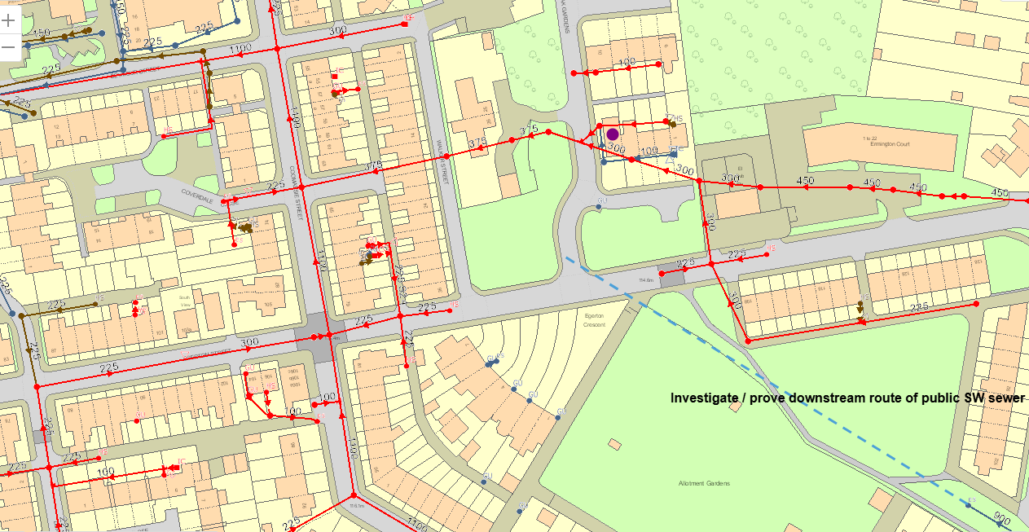

Does the SW sewer route through potential valley
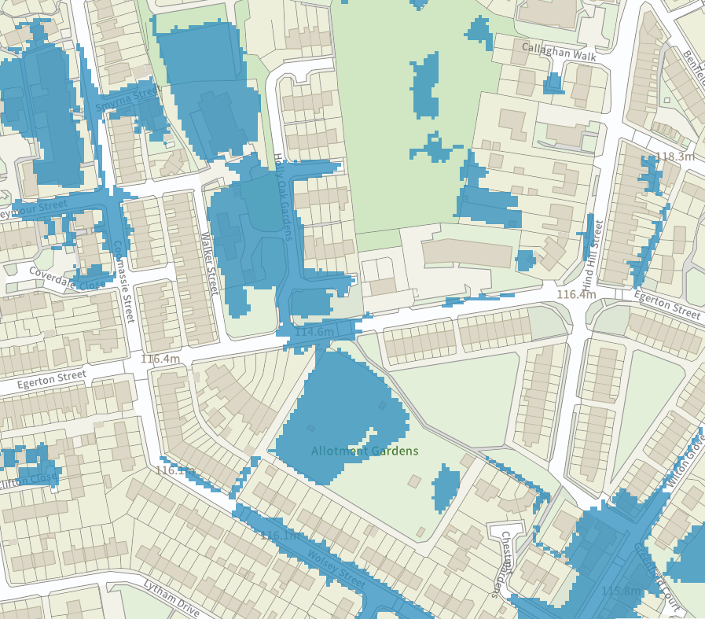

Drainage & Flood Officer Summary:
- Full drainage proposals, layouts etc should be provided.
- Investigation of infiltration potential for full and hybrid / partial options should be undertaken.
- Investigation of all potential SW outfalls should be undertaken.
- Options to mitigate overall volumes of discharge should be assessed.
- Green SuDS source control should be provided
- Resolving the above points could impact proposed layouts etc and therefore they should be addressed before approval and not left to conditions.

Consultation by Keith Mealey
Drainage & Flooding Officer
keith.mealey@rochdale.gov.uk

