APPLICATION FOR LISTED BUILDING CONSENT
HERITAGE STATEMENT OF SIGNIFICANCE

Location: Maw Rode Farm, Moor Road, Littleborough, OL15 9QH
Grade: II
Date Listed: 23rd April 1986
English Heritage Building ID: 1068525
OS Grid Coordinates: SD 94486 18379

Background Information:

SP Electricity North West are required to make amendments to the service of Maw Rode Farm, Moor Road, Littleborough, OL15 9QH. We need to rectify this part of the network as currently it does not meet the existing regulations. Maw Rode Farm is currently supplied overhead and as part of this works the overhead line and pole at the side of the driveway into Mawrode Farm will be removed. The proposed works comprise of installing a service cable under the driveway and then up the wall. The cable will be protected by a cable guard up to 1.8m up the wall. SPENWL will re use the existing entry point into the building.

English Heritage Description of Listed Building:

Extract taken from Historic England : ‘1/61 Barn adjacent to Mowrode - Farmhouse
- II Barn. 1708 on door lintel. Roughly dressed stone with graduated stone slate roof. Central opposed cart entries with shippon at lower end. Quoins. Blocked barn door with dressed surround and massive lintel. Shippon doors at front and rear have chamfered surrounds and elliptical-headed lintels. Muck passage in right gable end flanked by small windows. Rear obscured by later lean-to additions. C20 roof structure.

Listing NGR: SD 94486 18379 (Historic England, 2026)’

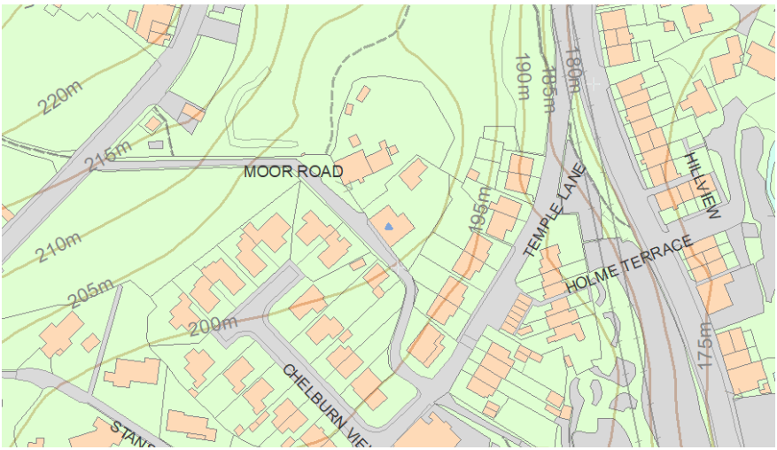

Impact of proposed works on Listed Building:

Consultation took place with the property owner prior to this application being made and a cable route was planned with the least visual impact in mind. The cable & required guarding (at low level) can be painted to match the existing finish colour of Mawrode Farm and will have no internal impact on any of the listed features mentioned above. SPENWL have designed the scheme so that the new cabling will have minimal impact on the property.

Figure 1 Maw Rode side profile of property where supply is to be attached (Authors Own, 2026)
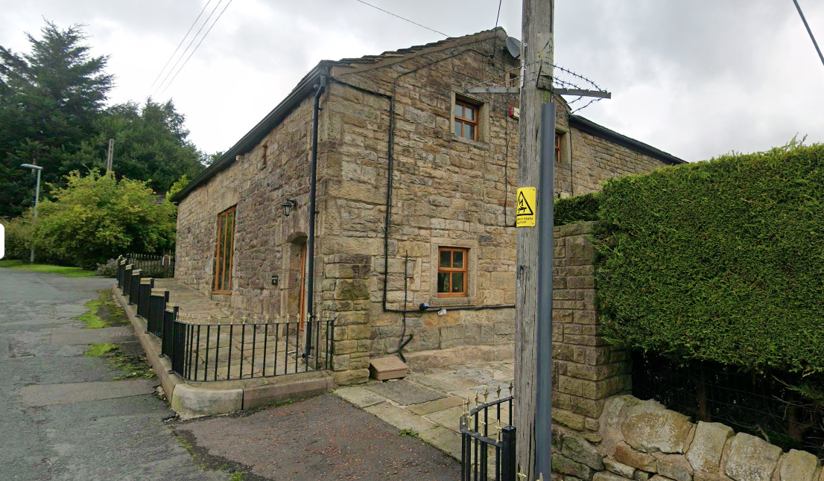

References:

https://historicengland.org.uk/listing/the-list/list-entry/1356723?section=official-list-entry

