STRATEGIC HOUSING DIRECTORATE

From: | Strategic Housing Service | To: Bob Melling
Name: | Michelle Kelly | Date: | 27/08/2026
Application No: PL/2026/0746

Location: Former Oakenrod Primary School Site OL11 4EE

Site Location: South Side of Bury Road

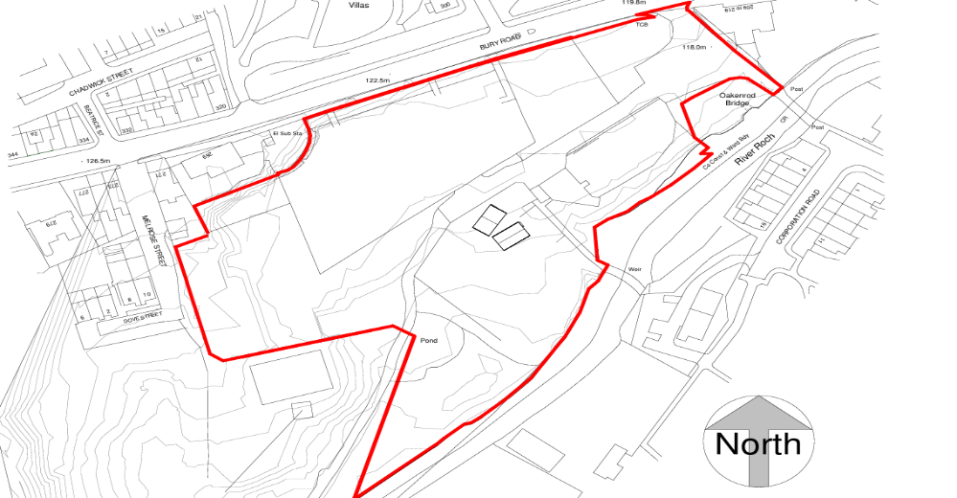

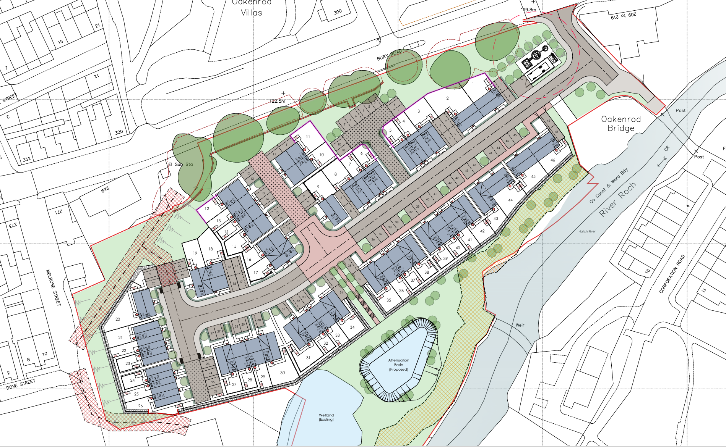

Thank you for consulting Strategic Housing.

The revised scheme proposes the erection of 46 dwellings consisting of 17no. 2-bed houses, 23no. 3-bed houses and 6no. 4-bed houses.

The application confirms that all dwellings are to be for social rent. Strategic Housing strongly supports the delivery of a 100% social rent scheme, in accordance with national and local priorities.

Rochdale Council has declared a housing crisis and there is a critical need within the borough for 3 and 4 bedroomed houses for social rent. As at August 2026, there are circa 3000 households on the Rochdale Housing Register in priority bands 1-3.

The table below details current demand of property size within the whole Rochdale Borough:

Total number of applicants in Priority Need (Bands 1-3) (across all areas in Rochdale Borough) | 3,121
Applicants in priority need requiring a 1-bedroom property (across all areas in Rochdale Borough) | 1,193
Applicants in priority need requiring a 2-bedroom property (across all areas in Rochdale Borough) | 910
Applicants in priority need requiring a 3-bedroom property (across all areas in Rochdale Borough) | 752
Applicants requiring 4+ bedroom property (across all areas in Rochdale Borough) | 266

The table below details how many properties in the Rochdale Borough became available for let to applicants on the housing register in 2025/26 (April-March), and the average number of bids per property.

Whole Rochdale Borough - Lettings & Average Number of Bids
(1st April 2025 – 31st March 2026)
1 Bedroom | Properties available for let = 464  Average Bids Per Property = 169
2 Bedroom | Properties available for let = 205  Average Bids Per Property = 324
3 Bedroom | Properties available for let = 135  Average Bids Per Property = 432
4 Bedroom + | Properties available for let = 4  Average Bids Per Property = 367

In the financial year 25/26, only four 4 bed or larger dwellings were advertised through Rochdale Council’s Choice Based Lettings system, emphasising the urgent need for 4 bedroom or larger properties for social rent. Strategic Housing therefore welcomes the inclusion of a number of 4 bed properties for social rent within the development.

The application confirms all dwellings will meet Nationally Described Space Standards (NDSS) and will be constructed to M4(2) standard. None of the homes are specified as M4(3) standard and Strategic Housing would therefore require a quantum of properties to be constructed to this building regulation standard as there is a particular need for larger M4(3) properties to accommodate households that have disabilities requiring a fully adapted home.

As at August 2026, 60 households in priority need are still awaiting fully wheelchair adapted accommodation in the borough and 17 of these are a 3 or 4 bed need.

Overall, Strategic Housing is supportive of the proposed scheme, taking into account the points made above.

Strategic Housing
Rochdale Borough Council

