
Biodiversity gain plan
Submit a biodiversity gain plan to show how your development will achieve biodiversity net gain.
When to use this form
A biodiversity gain plan shows how a development will achieve 10% biodiversity net gain (BNG). Submit this form to your local planning authority after they approve your planning application.

Unless your development is exempt, you cannot start the development until the LPA approves your biodiversity gain plan and biodiversity metric calculation tool.

1. Submission details
1.1 Date
For example, 3/11/2023
18/09/2026
1.2 Planning application reference number
PL/2026/0188
1.3 Local planning authority (LPA)
Rochdale Borough Council
1.4 Development site address
If the site does not have an address, enter the OS grid reference.
Land at Ashworth Valley Scout Camp, Ashworth Road, Rochdale, OL11 5UP

1.5 Describe the development
Tell us about the proposed development and any changes of use (250 words).
The proposals comprise the construction of four wooden tents and a round house on an area of modified grassland.

2. Developer details
2.1 Applicant name
Ben Lee (District Treasurer)
2.2 Company name
Ashworth Valley Scout Campsite
c/o Pennine District Scout Council
2.3 Address
Ashworth Valley Scout Camp, Ashworth Road, Rochdale,
OL11 5UP

2.4 Email address
treasurer@pennine.gmnscouts.org.uk

2.5 Telephone number
07980355417
2.6 Declaration
By signing this declaration, you confirm that the information you give is complete and correct. Any opinions are your genuine opinions.

2.7 Signature
Ben Lee
2.8 Date
18/09/2026

3. Responsible person details
Tell us about who is responsible for completing the biodiversity gain plan. For example, a consultancy ecologist or planning agent.

3.1 Name
Verity Webster
3.2 Company name
Verity Webster Ltd.
3.3 Address
8 Bent Row, Long Lane, Heath Charnock, PR6 9EW

3.4 Email address
verity@ecologyconsultant.co.uk
3.5 Telephone number
07917852401

3.6 Declaration
By signing this declaration, you confirm that the information you give is complete and correct. Any opinions are your genuine opinions.

3.7 Signature
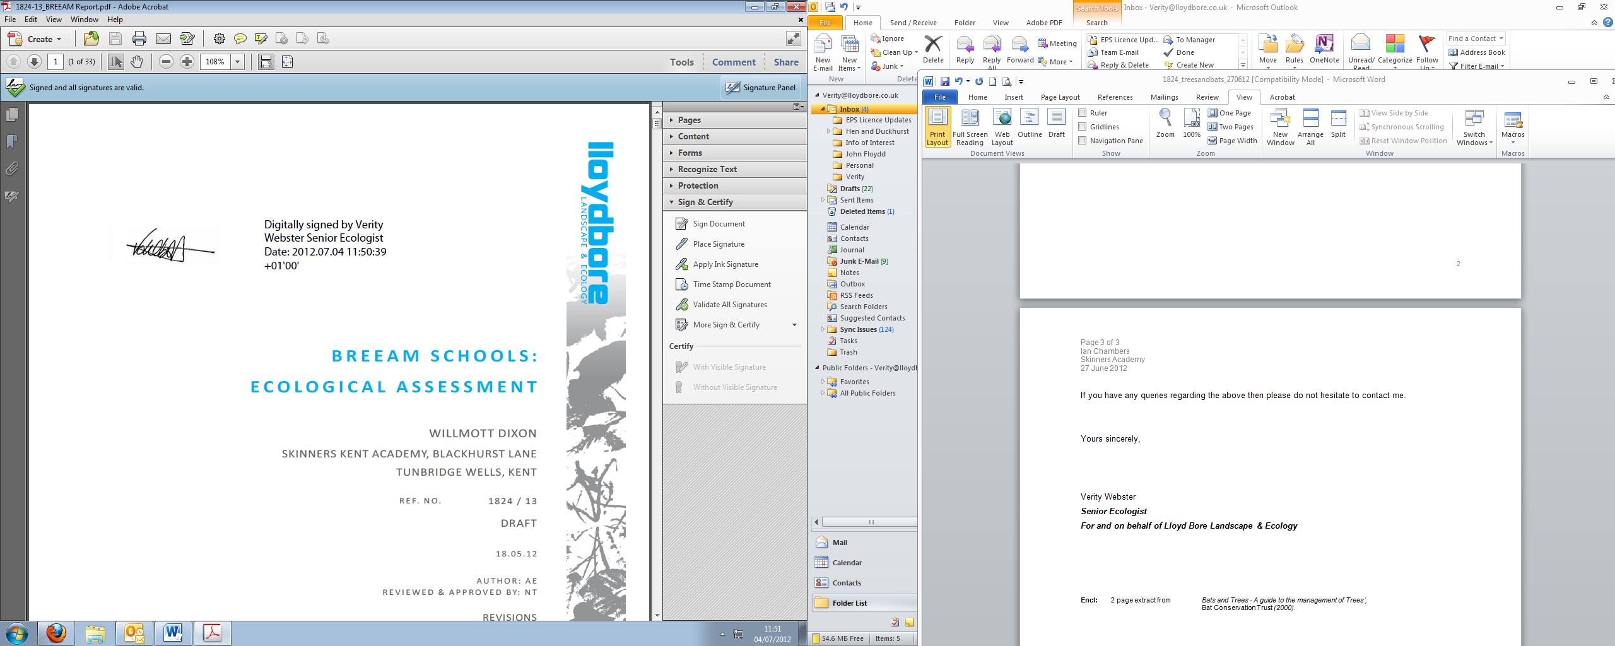
3.8 Date
18/09/2026

4. Biodiversity net gain strategy
4.1 Is the relevant date for the pre-development biodiversity value the same date as the planning application?
☒ Yes
☐ No

4.2 If no, what earlier date did you agree with the LPA?

4.3 How have you met the guidance on ‘what counts towards your BNG’?
Find out what you can count towards a development’s BNG
Creation of woodland and planting of rural trees
4.4 How will you avoid or minimise impacts to habitats?
Tell us about the steps you’ve taken on site, including to avoid or minimise the impact on irreplaceable habitats.
Woodland, trees and hedgerows were avoided when designing the proposal. The development includes loss of modified grassland only.
4.5 Did you use your local nature recovery strategy to inform the strategic significance of habitats?
This includes other specified strategies if you do not have a local nature recovery strategy.
☒ Yes
☐ No
4.6 How will you achieve the target net gain percentage?
☒ On-site
☐ Off-site
☐ Both
4.7 Are any of your on-site enhancements considered ‘significant’?
Find out what counts as a significant on-site enhancement.
☒ Yes
☐ No

4.8 If yes, tell us about the significant on-site enhancements
Include the appropriate planning condition or how you’ve secured the habitat.
Woodland and rural trees will be planted. This habitat will be managed by Ashworth Valley Scouts long-term under the HMMP.

4.9 How many off-site biodiversity units do you need to meet 10% net gain?
None

4.10 Explain why you’re using off-site biodiversity units
Only answer this question if you’re planning to use off-site biodiversity units (250 words).

4.11 Explain why you’re planning to use statutory biodiversity credits
Only answer this question if you’re planning to use statutory biodiversity credits (250 words).

4.12 Do you have a habitat management and monitoring plan?
☒ Yes
☐ No

4.13 Have you used the statutory biodiversity metric tool?
☒ Yes
☐ No

4.14 Biodiversity metric calculation
Send your biodiversity metric calculation to the LPA and enter the file name.
Statutory_Metric_Macro_Enabled_1.0.4 AV Scouts Rev B
4.15 Condition assessments
Send your condition assessments to the LPA and enter the file name.
Habitat_Condition_Assessments_AVScouts
4.16 Pre-development habitat survey report and map
Send your baseline habitat survey report and map to the LPA. Enter the file name.
Ashworth Valley Scouts BNG Round House Feb 26.pdf
4.17 Post-development habitat map or landscape plan
Send your post-development habitat survey report and map to the LPA. Enter the file name.
Ashworth Valley Scouts BNG Round House Feb 26.pdf
4.18 Have you included an approved habitat degradation in the baseline?
If yes, include the relevant consenting body and reference number.
☐ Yes
☒ No

Consenting body

Reference number

5. Irreplaceable habitats
5.1 Does the development impact any irreplaceable habitats?
If yes, tell us if you’ve submitted an approved compensation plan.
☐ Yes
☒ No

5.2 Have you submitted an approved compensation plan?
☐ Yes
☒ No

6. On-site habitat enhancements
Answer this section if your development includes on-site habitat enhancements.
6.1 Survey date
For example, 3/11/2023
15/01/2026
6.2 Survey constraints
For example, access issues, weather, or seasonal constraints.
The survey work was undertaken in January 2026. A proportion of higher plants are visible in January, but some species are more conspicuous or only present at certain times of the year, and some species may have been missed. The species list constructed is not comprehensive, but given the habitat types expected, is sufficient to inform the BNG Assessment in this case.

6.3 Total pre-development biodiversity value
Enter the number from the headline results in your statutory biodiversity metric calculation.

Number of area habitat biodiversity units
0.56
Number of hedgerow biodiversity units
0.00
Number of watercourse biodiversity units
0.00
6.4 Total post-development biodiversity value
Enter the number from the headline results in your statutory biodiversity metric calculation.

Number of area habitat biodiversity units
0.63
Number of hedgerow biodiversity units
NA
Number of watercourse biodiversity units
NA
6.5 Total net change in biodiversity units
Enter the number from the headline results in your statutory biodiversity metric calculation.

Area habitat biodiversity units
0.06
Area habitat biodiversity units % change
11.10%
Hedgerow biodiversity units
NA
Hedgerow biodiversity units % change
NA
Watercourse biodiversity units
NA
Watercourse biodiversity units % change
NA
6.6 Will you register and allocate any biodiversity units from your site to other developments?
If yes or provisionally, give details.
☐ Yes
☒ No

6.7 Give details
Tell us about the amount of biodiversity units and the development location (250 words).

7. Off-site habitat enhancements
Answer this section if your development includes off-site habitat enhancements.

7.1 Tell us about the off-site habitat enhancements
Include whether you’re delivering the off-site enhancements or buying biodiversity units.

7.2 Biodiversity gain site register reference number

7.3 How have you secured the off-site habitat enhancements?
Tell us about any responsible bodies and whether you’ve used an S106 or conservation covenant.

7.4 Total baseline biodiversity value
Enter the number from the headline results in your statutory biodiversity metric calculation.

Number of area habitat biodiversity units

Number of hedgerow biodiversity units

Number of watercourse biodiversity units

7.5 Total biodiversity value post-intervention
Enter the number from the headline results in your statutory biodiversity metric calculation.

Number of area habitat biodiversity units

Number of hedgerow biodiversity units

Number of watercourse biodiversity units

7.6 Total net change in biodiversity units
Enter the number from the headline results in your statutory biodiversity metric calculation.

Area habitat biodiversity units

Area habitat biodiversity units % change

Hedgerow biodiversity units

Hedgerow biodiversity units % change

Watercourse biodiversity units

Watercourse biodiversity units % change

8. Statutory biodiversity credits
Answer this section if you need to use statutory biodiversity credits.
8.1 Do you need to use statutory biodiversity credits?
☐ Yes
☒ No

8.2 How many statutory biodiversity credits do you need?
Tell us the unit shortfall by tier, including the spatial risk multiplier. Enter the number from the headline results in your statutory biodiversity metric calculation.

A1

A2

A3

A4

A5

H

W

8.3 What evidence is there that no units are available through the market?
Send a message from at least 3 habitat providers, or a search result from online registers.

8.4 Proof of purchase
Send proof of purchase and enter the reference number.

9. Trading summary
9.1 Distinctiveness group
Tell us if you met the BNG trading rules on habitat compensation for each distinctiveness group. If you did not meet the trading rules, tell us if you agreed bespoke habitat compensation.

Check the rules on habitat compensation in the statutory biodiversity metric user guide.

Very high
NA
High
NA
Medium
NA
Low
Yes

10. Sharing data (optional)
10.1 Can we share your ecological survey data with the Local Environmental Records Centre or other bodies?
☒ Yes
☐ No

