Proposed application for a ménage at Harwood Fields Farm, Castle Hill Road, Birtle, BL9 6UL

Proposed Ecological Enhancement

Reference SR.280926.A

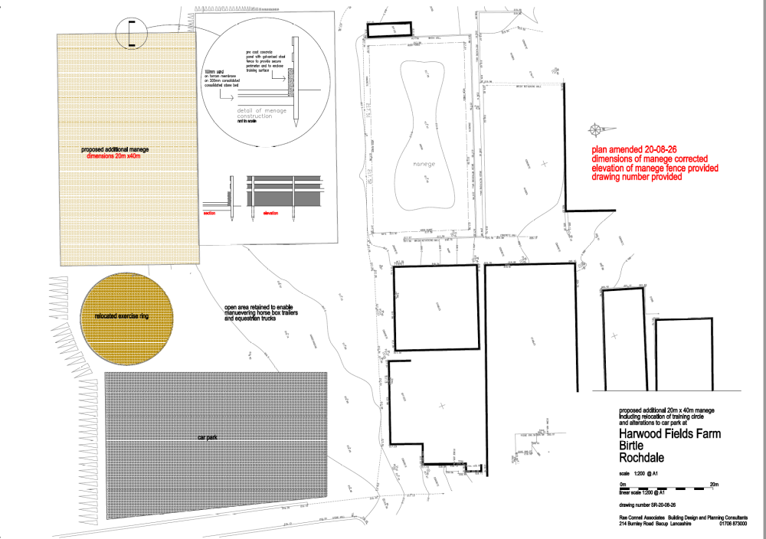

The development site, being less than 0.2 ha, is exempt from BNG.

Nevertheless, policy N2 of The National Planning Policy Framework (2026) (the Framework) states that ‘to contribute positively to the natural environment, and support nature’s recovery, development proposals should:
a. Consider the environmental qualities of land proposed for development, including habitats, landscape character and the natural beauty of the countryside, and identify opportunities for those qualities to be conserved or enhanced (including through requirements for biodiversity net gain where these apply);

Therefore, the proposal is to plant hawthorn hedging along the slope to the existing car park and as shown coloured green on the attached plan (taken from the submitted, amended proposed site plan), and in accordance with the following details

Hedging
Hedge planting as shown on the plan and on the inside of the boundary fencing.

% | Botanic | Common | Nursery size
50 | Crataegus monogyna | Hawthorn | Min 750mm
50 | Prunus spinosa | Blackthorn | Min 750 mm

Planting to be in two rows 1 metre apart and at 0.75 metre centres, staggered.
Plants shall be ordered to suit site requirements and only in accordance with the schedule spacings. Any plant substitutions to be agreed with the Local Planning Authority prior to planting.
All planting material shall generally be planted between November and March in open cool weather. Planting shall not take place in frosty, snowy or waterlogged conditions. Pot or container grown plants may be planted outside the described season, but adequate watering shall be supplied. Torn or damaged roots or branches shall be clearly pruned prior to planting.
Planting to be properly carried out in all cases as described in BS 4428: 1989 5.8 woodland, 5.9 Shrubs.
All plants shall be planted at the same depth, or very slightly deeper, as they were grown. Roots shall not be bent, broken or forced into inadequate pits or notches. Plants shall be upright, firmed and in wind resistant, with no air pockets around roots.
Whips shall be mulched around the bases.
All pots and root wrappings shall be carefully removed prior to planting. All pots and wrapping arising shall immediately be picked up and stored ready for removal to tip. Plants shall be planted at the specified centres.
Timetable
Planting to take placea nd to be completed in th first planting season following the first use of the manege
Maintenance
Any plants failing within first 5 years to be replaced by same
NB While the proposed ecological enhancement is outside the red edge of the location plan, it is within the blue edge and ownership of the applicant

